Ansible

1. Set up one master and two worker nodes in ansible.

I have generated ssh-keygen in my master by using this commands

cd .ssh

ls

cat id_ed25519.pub

Copy the key and paste it in my slaves/nodes in .ssh directory in vi authorized_keys.

ansible --version

34 sudo mkdir -p /etc/ansible

35 sudo touch /etc/ansible/ansible.cfg

36 sudo nano /etc/ansible/ansible.cfg

[defaults]

inventory = /etc/ansible/hosts

host_key_checking = False

retry_files_enabled = False

37 ansible --version

38 sudo touch /etc/ansible/hosts

39 sudo nano /etc/ansible/hosts

40 ansible all -m ping

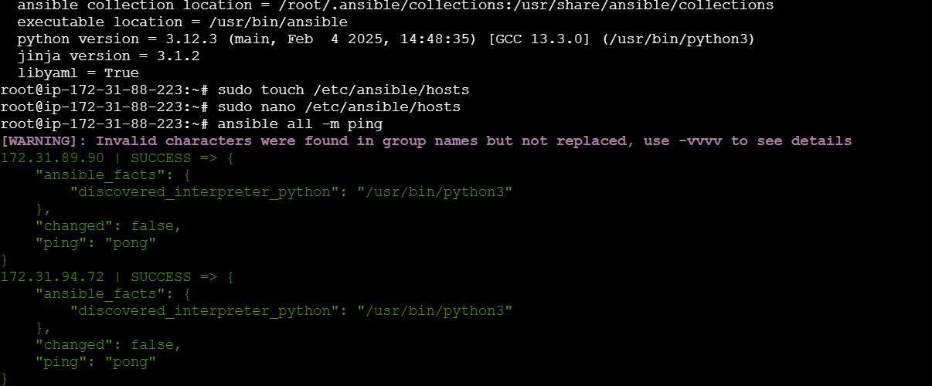

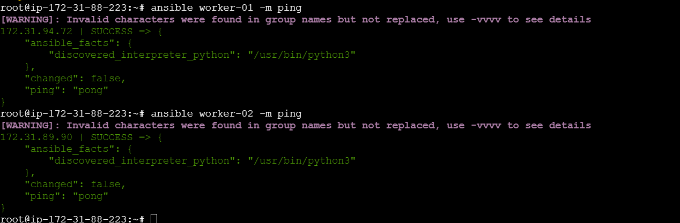

2. Execute the adhoc commands

Ansible -m setup

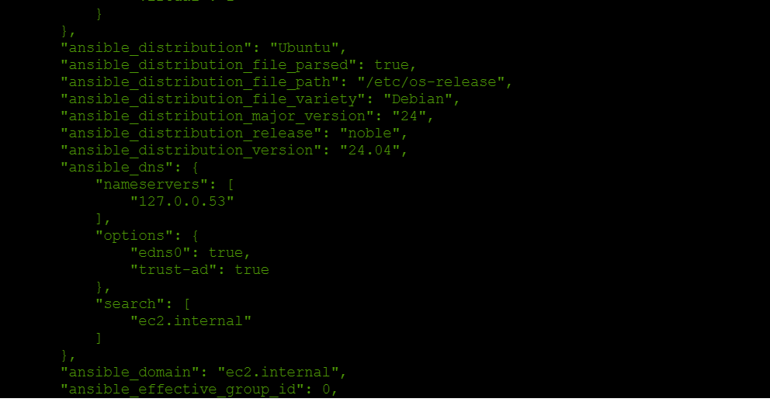

ansible all -a uptime

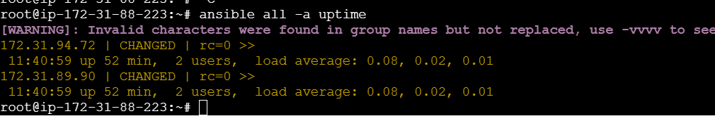

ansible all -a “free -m”

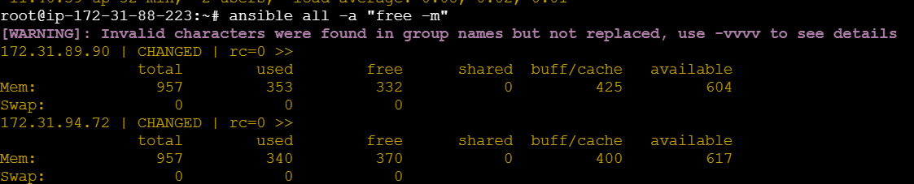

touch ansible_hosts

ls -l ansible_hosts

nano ansible_hosts

ansible all -m ping -i ansible_hosts

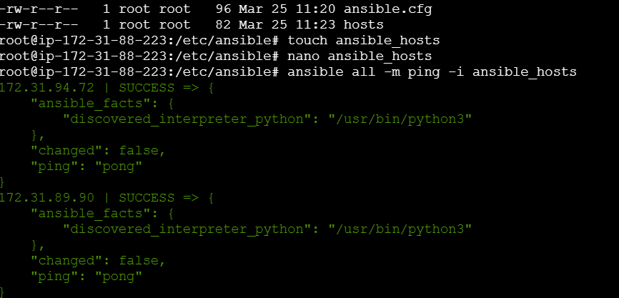

ansible all -m ping --user=ansadm --ask-pass

apt install sshpass -y

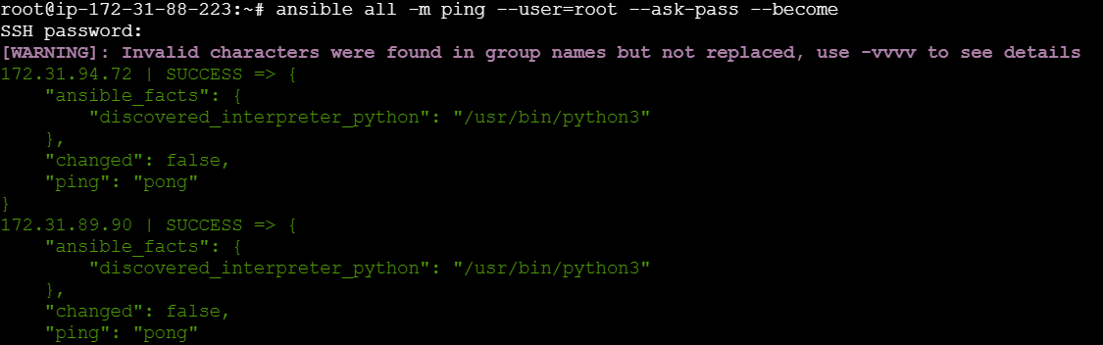

ansible all -m shell -a "cat /etc/passwd|grep -i ansadm" -s --ask-sudo-pass

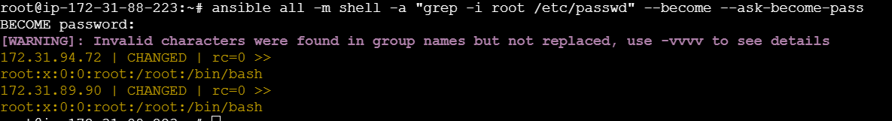

ansible all -m shell -a "cat /etc/passwd|grep -i ansadm" -b -K

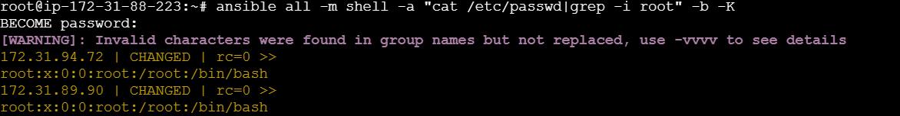

ansible all -m apt -a "name=apache2 state=latest"

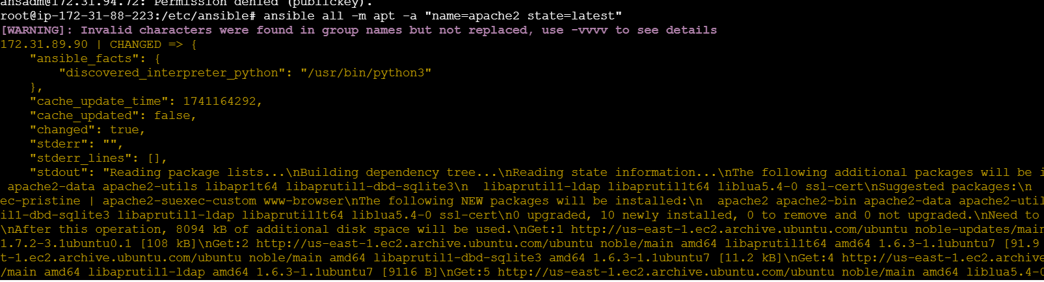

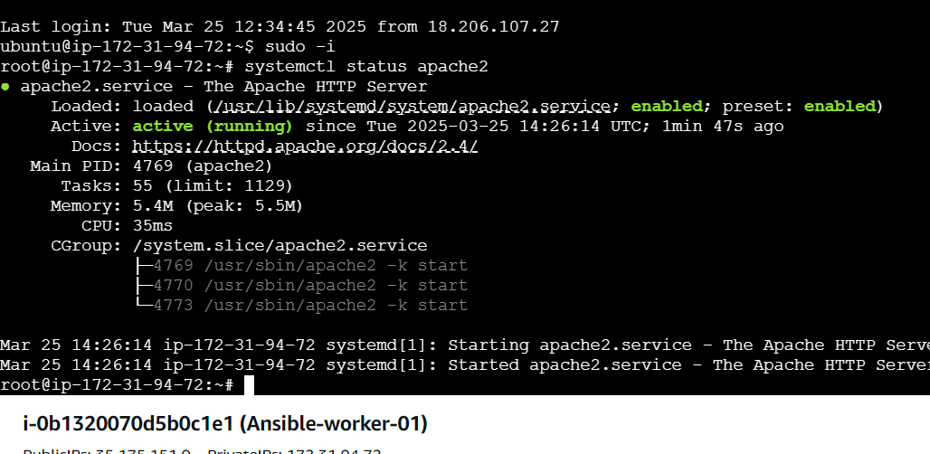

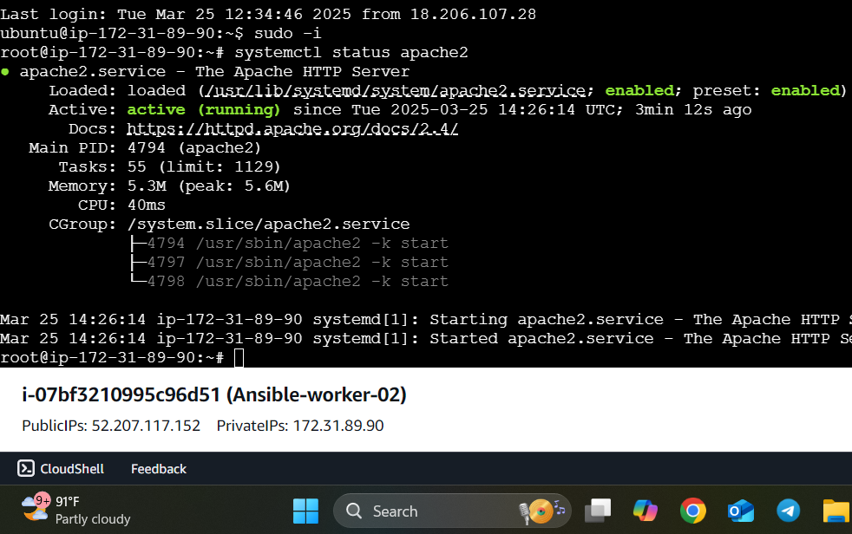

ansible all -m apt -a "name=apache2 state=stopped”

