Auto-Scaling

1) Create one vpc in N.virginia region.

I have created my own vpc with CIDR range 192.168.0.0/24

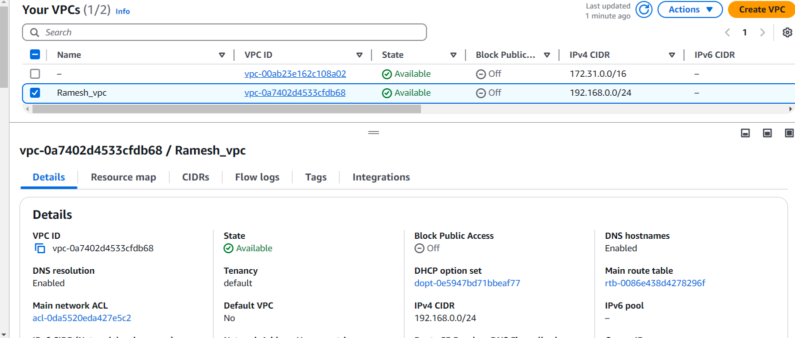

2) Create two subnets.

One Public subnet and one private subnet.

I have created my own public and private subnet within my CIDR range

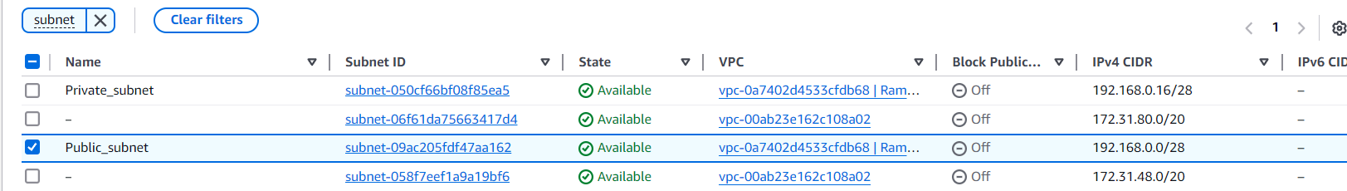

3) Provide the IGW to the vpc.

I hsve created a internet gateway and i have attached to my own VPC

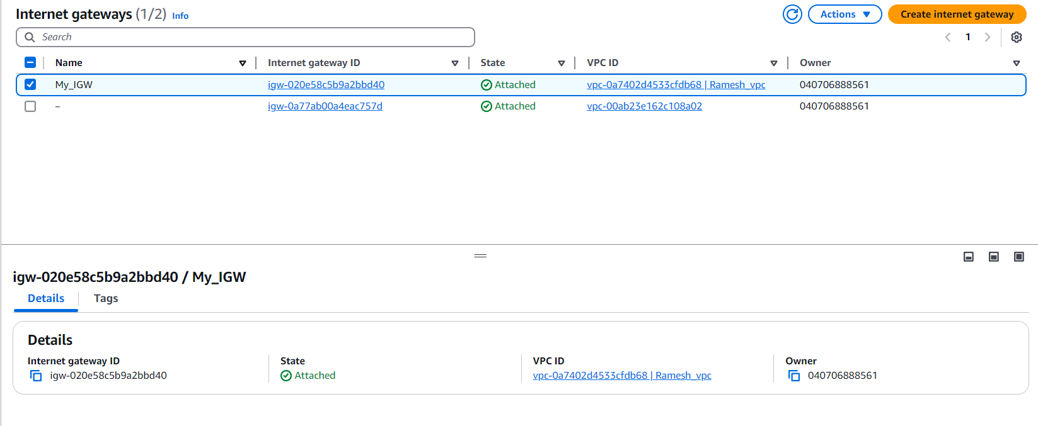

4) Create One public RT and one private RT.

I have created a one public route Table and private route table to route the traffic to our subnets and i associated with my subnet associations

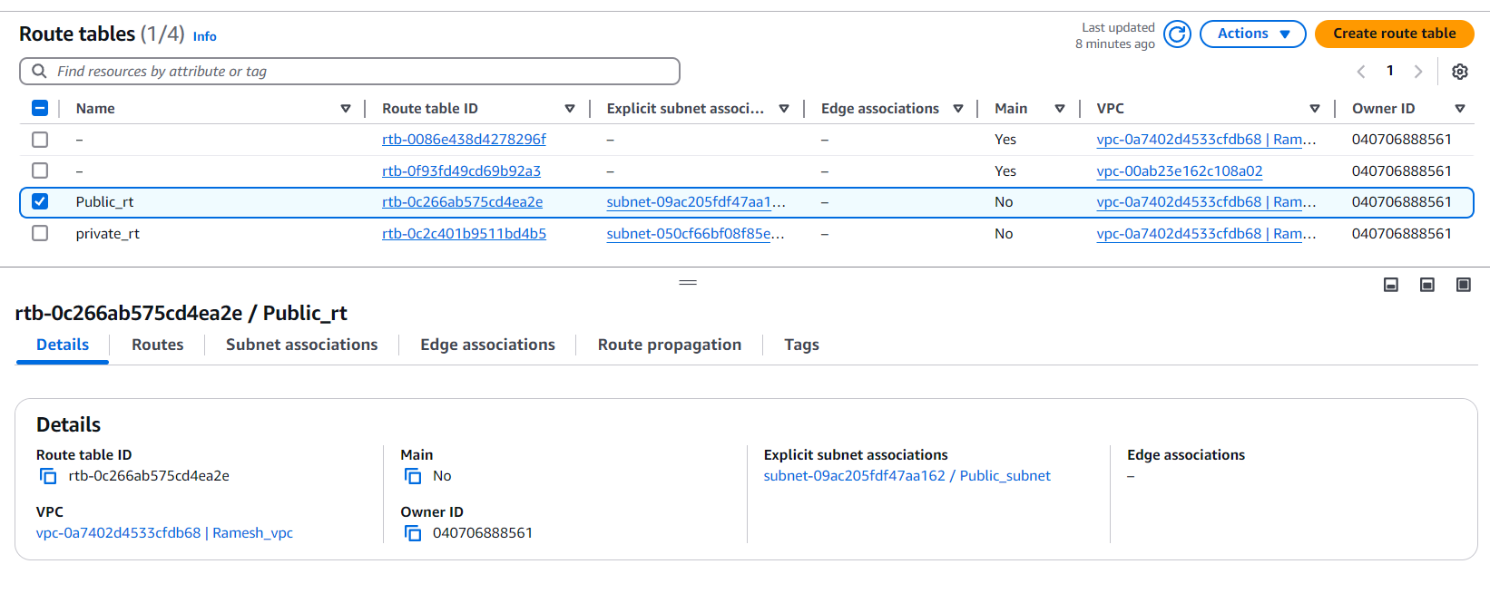

5) Deploy NAT gateway on public subnet and attach the NAT gatewat to private subnet.

I have created a nat gateway on public subnet and i attached to the private route table it will associated with private subnet.

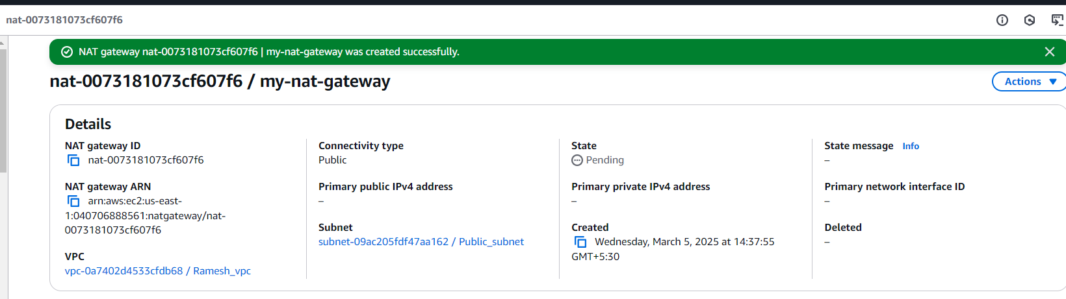

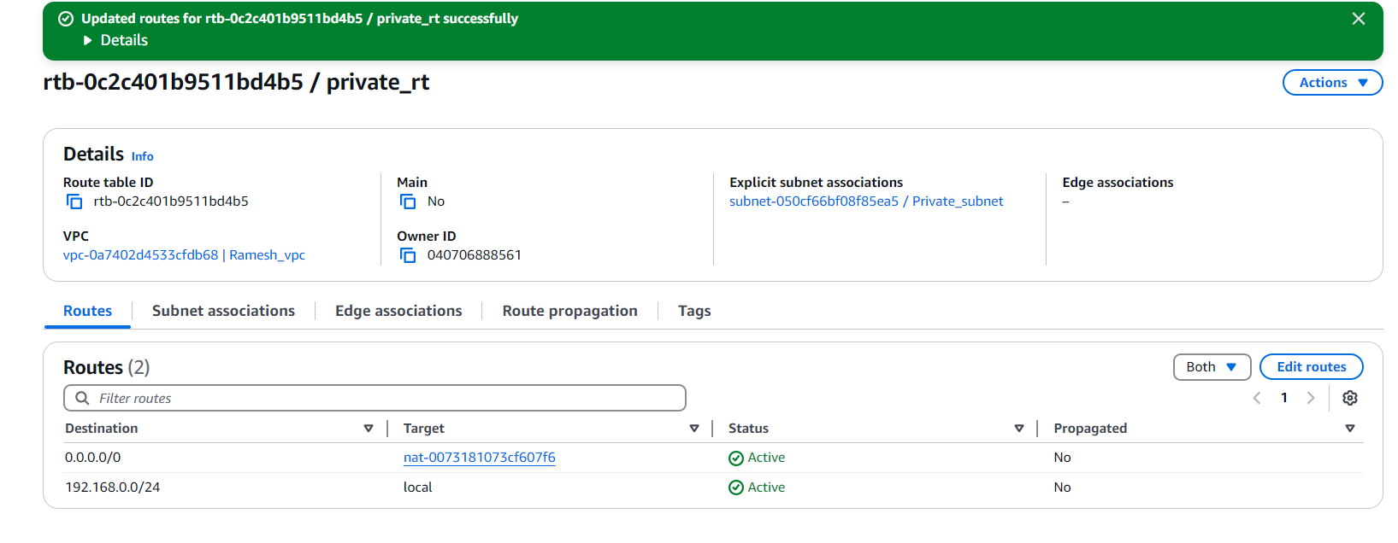

You can see my resource map so you can understand .

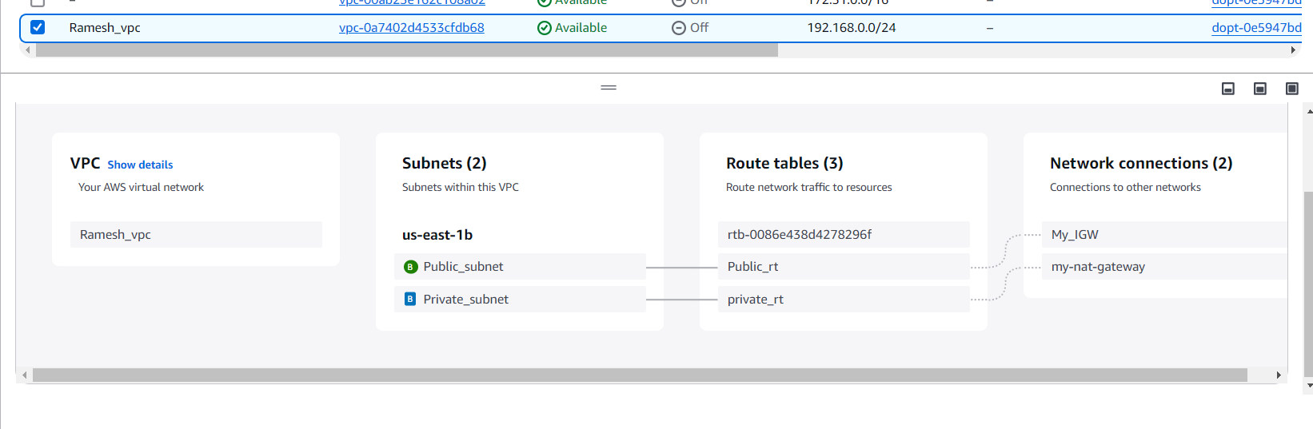

6) Create Two instances,one in public subnet and one in private subnet.

I have launched one server by using my public subnet

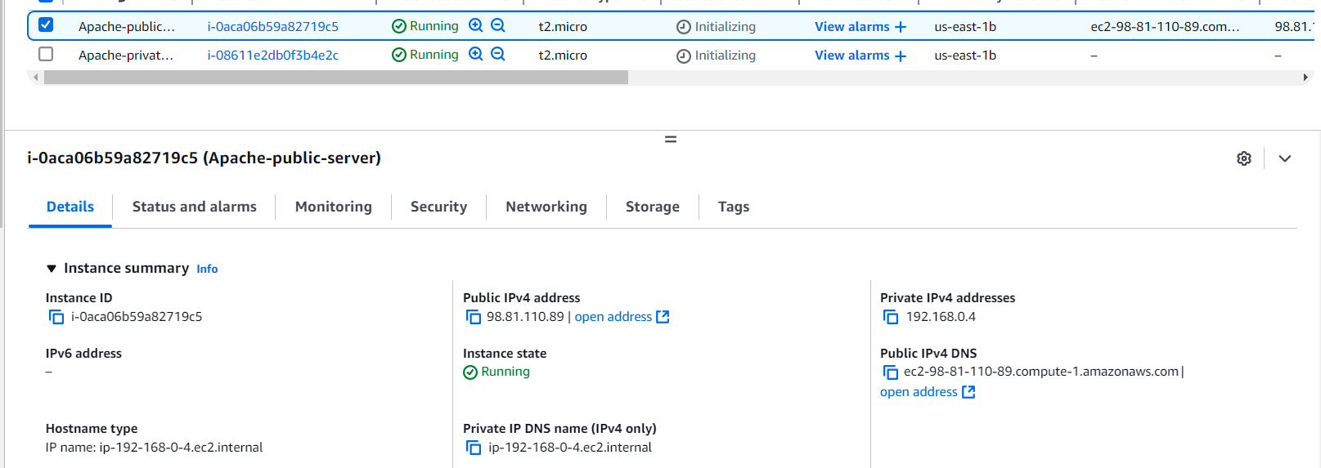

I have launched one server by using private subnet

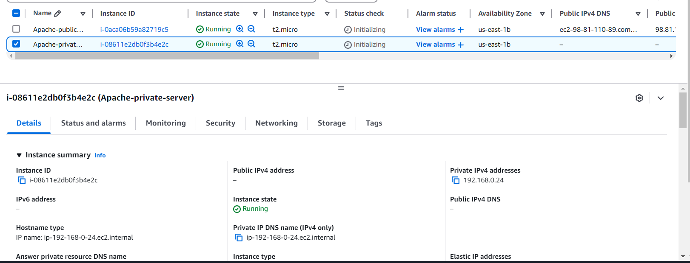

7) Deploy Apache server on both the ec2 instances with sample index.html file.

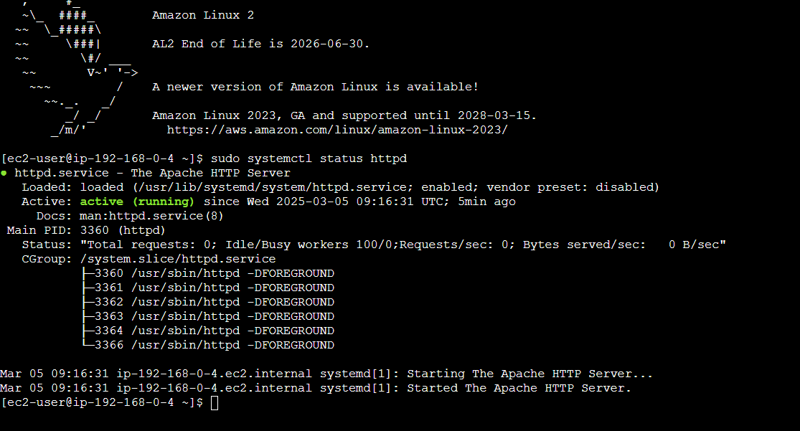



After login into my public server with the help of jump server concept i jump tom public to private server.

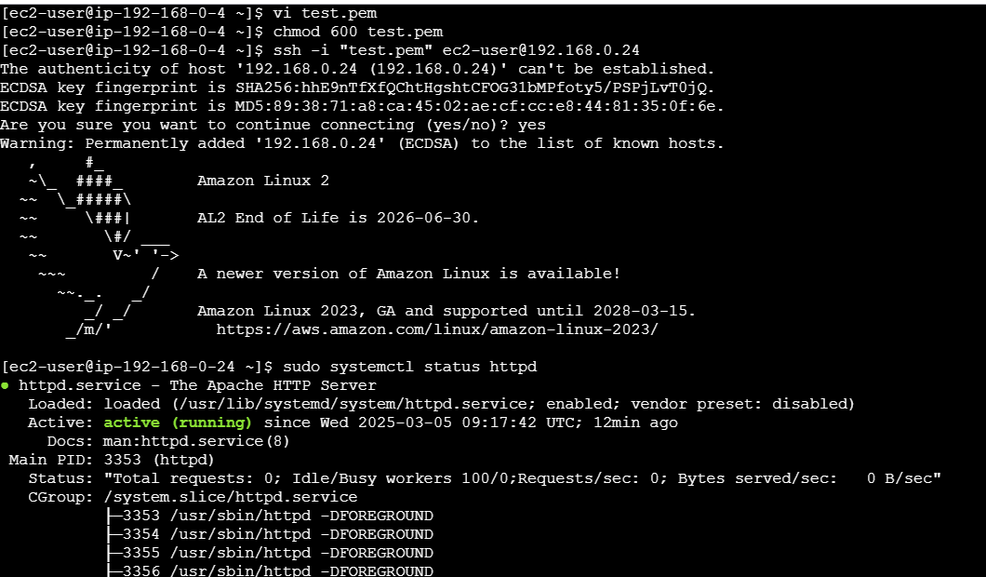

This is my deployment page same for both public and p-rivate server

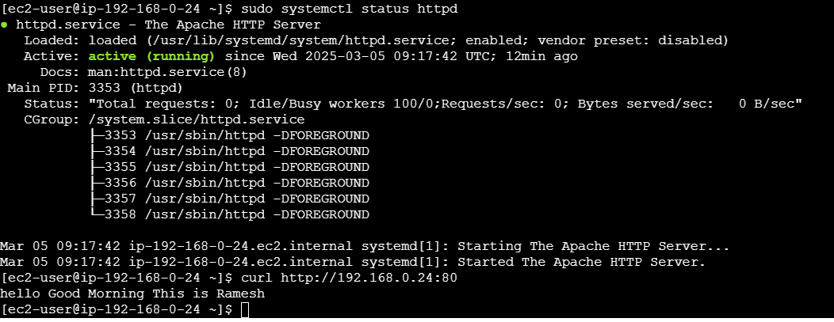

8) Create one application load balancer and attach the load balancer to both the ec2 instances.

I have created one apache-alb load balancer and attached both the servers in public and private

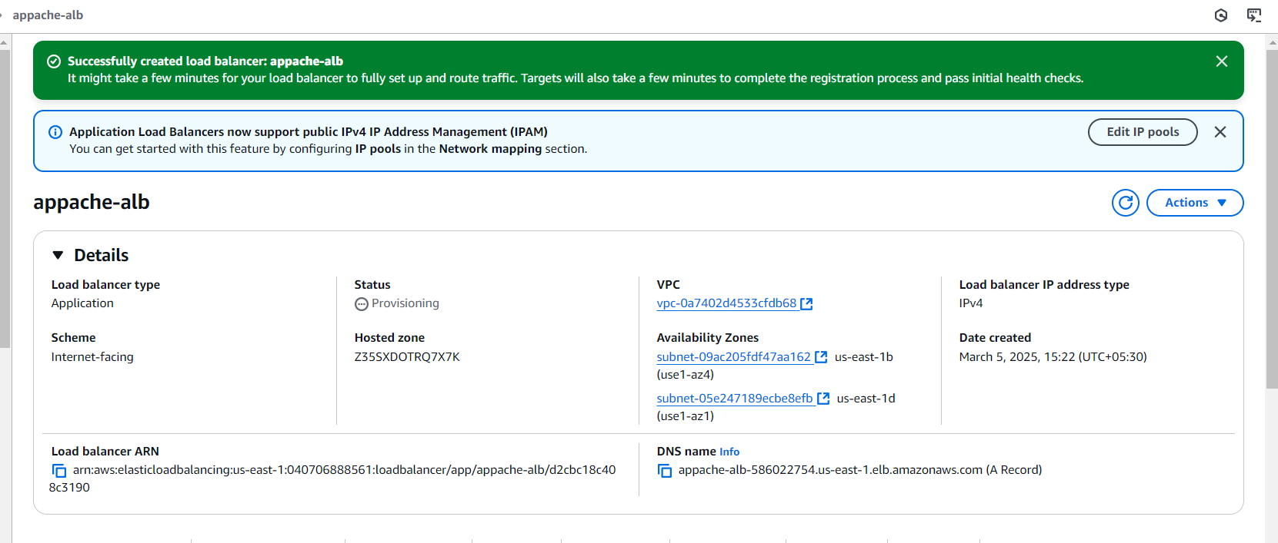

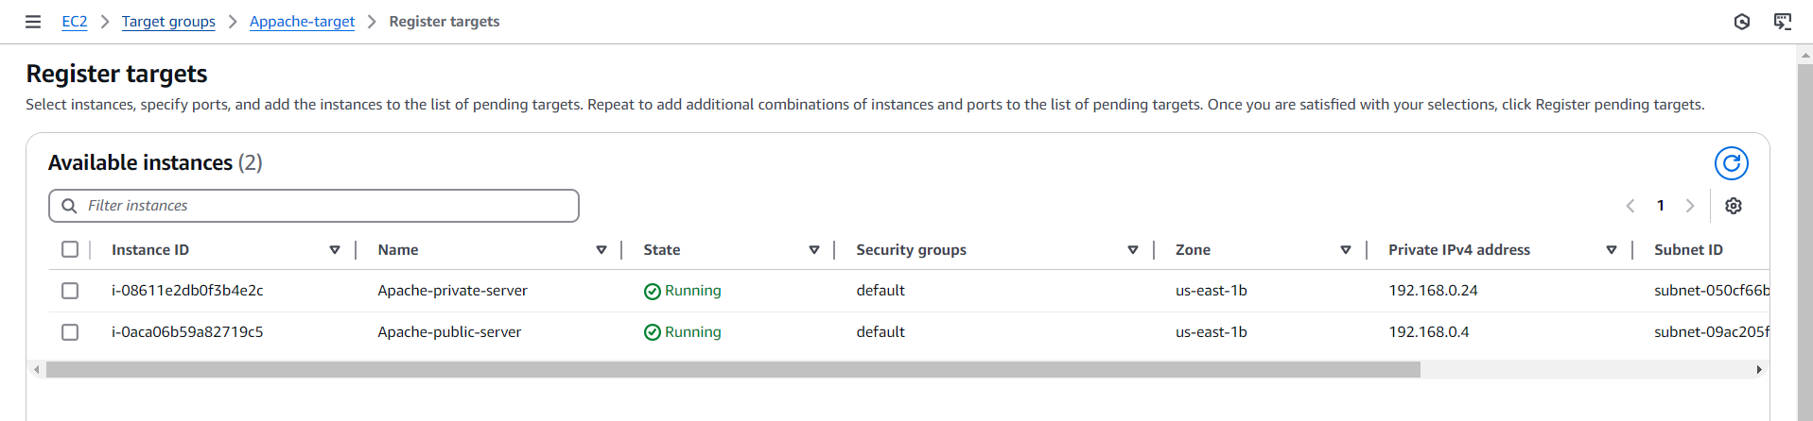

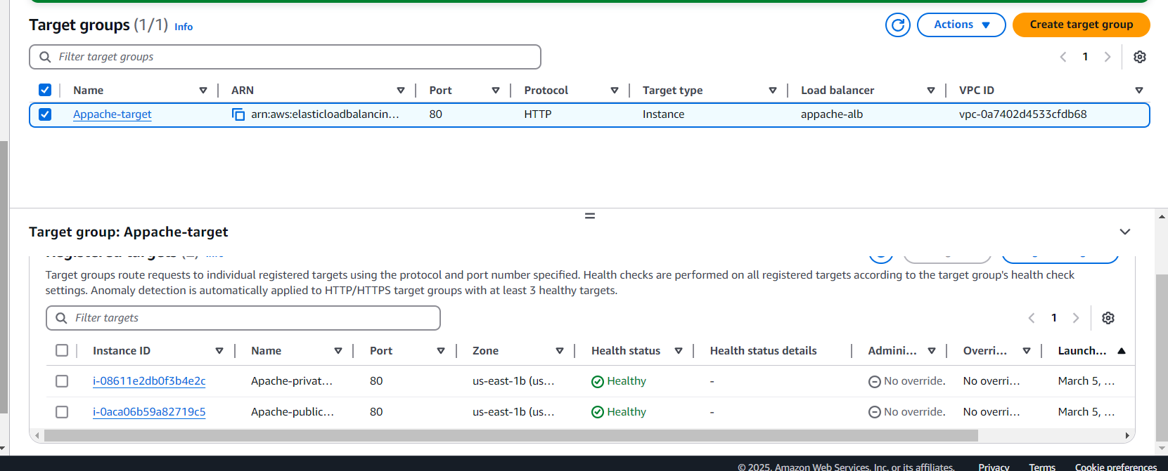



9) Store Application load balancer logs to s3

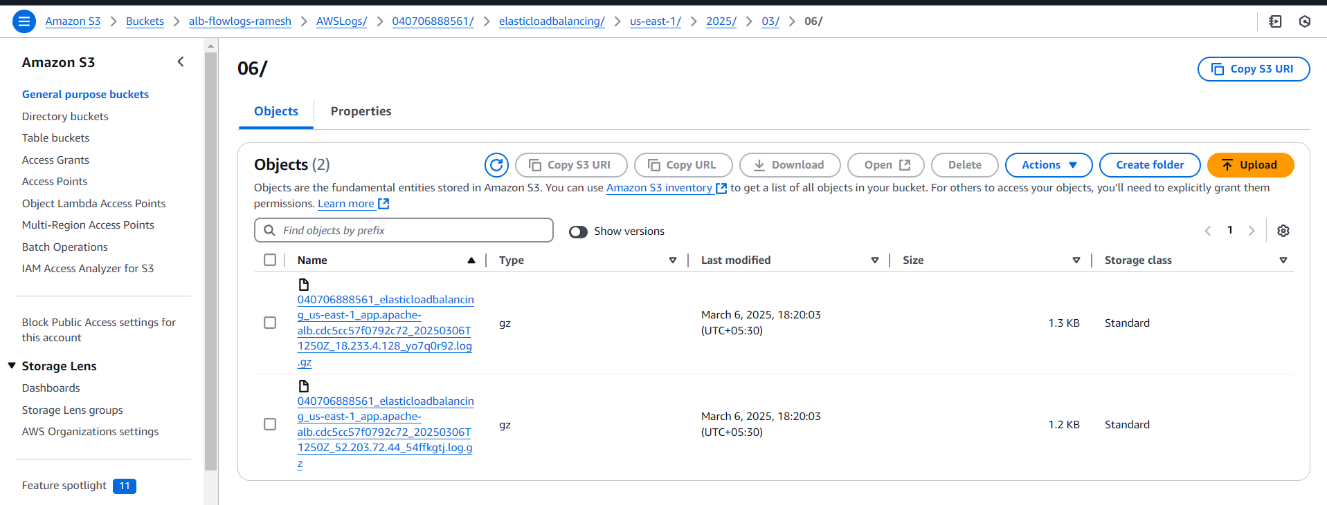

10) Store the vpc flow logs to cloudwtach group.

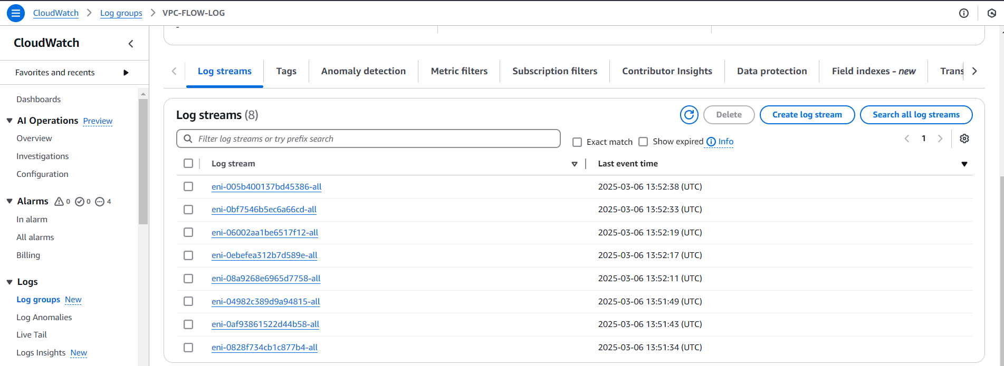

{

"Version": "2012-10-17",

"Statement": [

{

"Effect": "Allow",

"Action": [

"logs:CreateLogGroup",

"logs:CreateLogStream",

"logs:PutLogEvents",

"logs:DescribeLogGroups",

"logs:DescribeLogStreams"

],

"Resource": "\*"

}

]

}

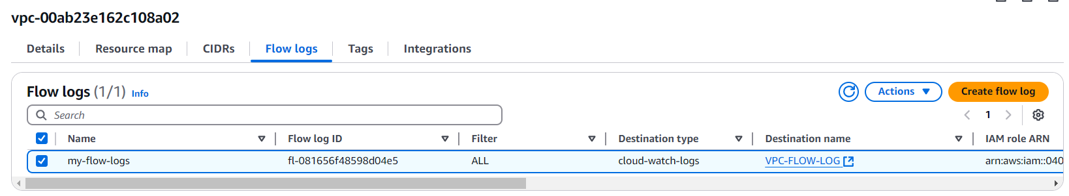

11) Create Monitoring Dashboards to monitor cpu utilization and to monitor apache service.

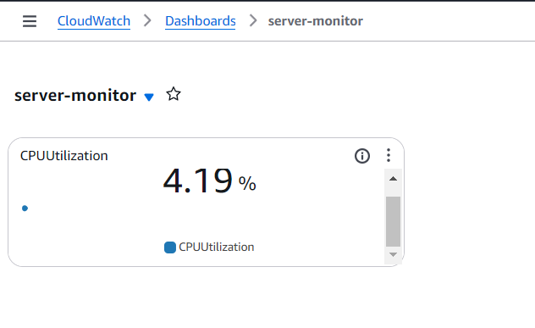

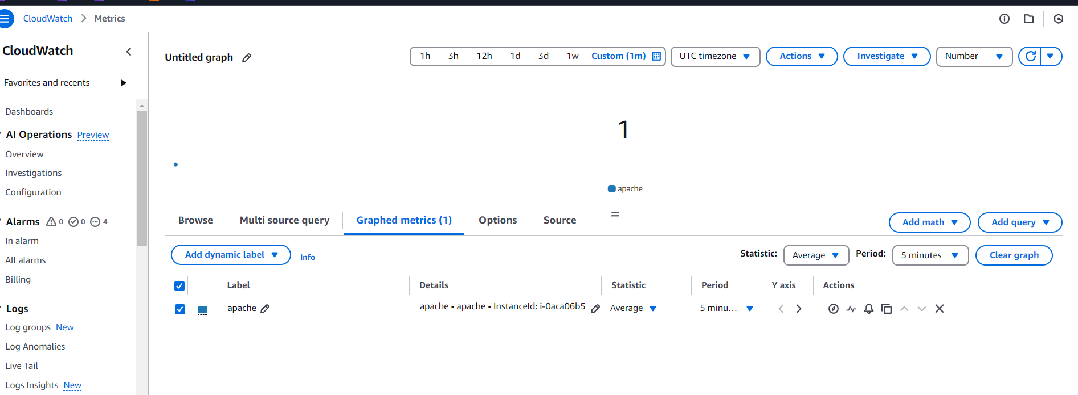

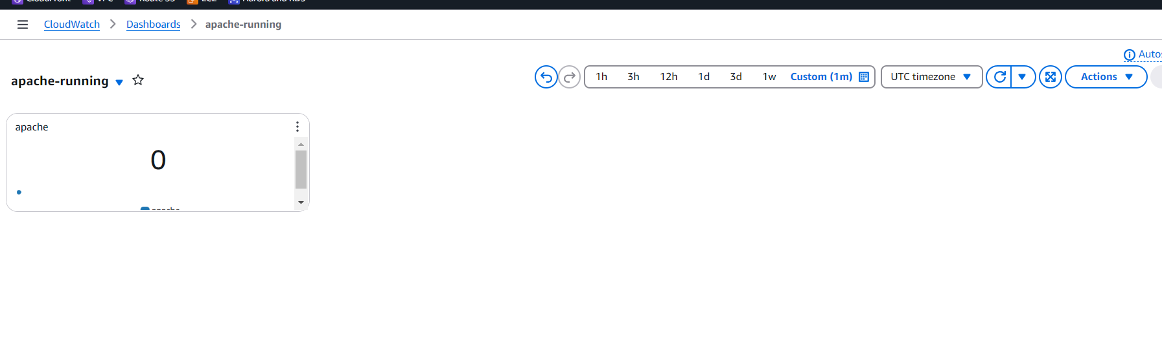

12) CPU utilizationis more than 70% then it should triggere Autoscaling and launch new instance.

