JENKINS-TASK03

1) Create one jenkins job using the below code and create three stages.

stage1: Git clone to download the source code.

stage2: Sonarqube Integration to check the quality of code

stage3: Slack Integration to send the alerts to slack.

URL: <https://github.com/betawins/VProfile-1.git>

stage1:

I have launched one server and installed jenkins in it and successfully clone the repo in my jenkins

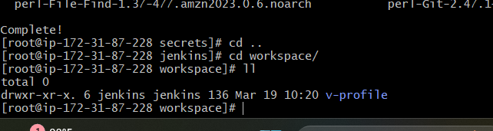

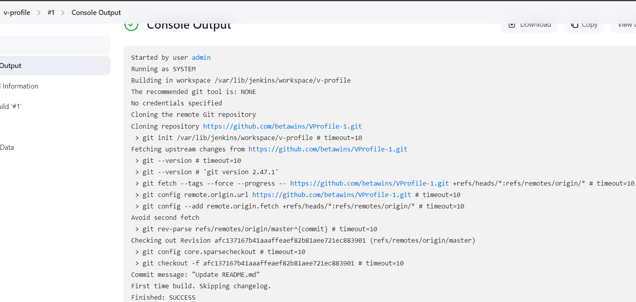

Step 2 : Sonarqube Integration

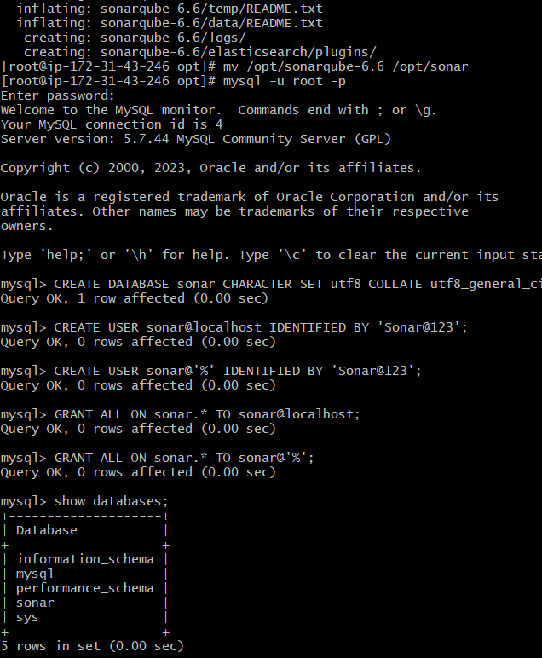

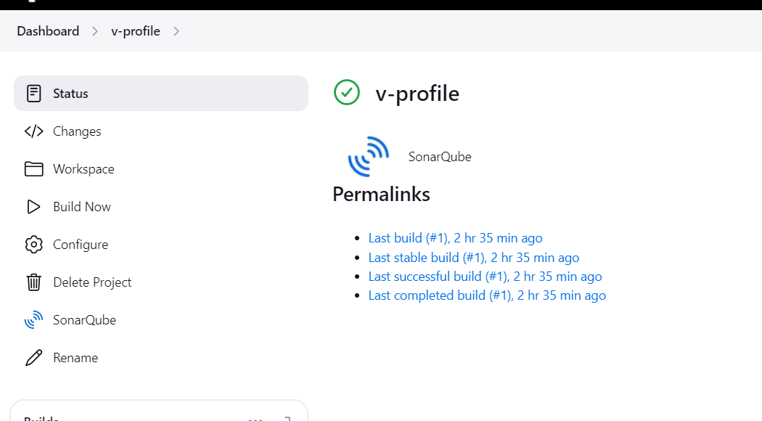

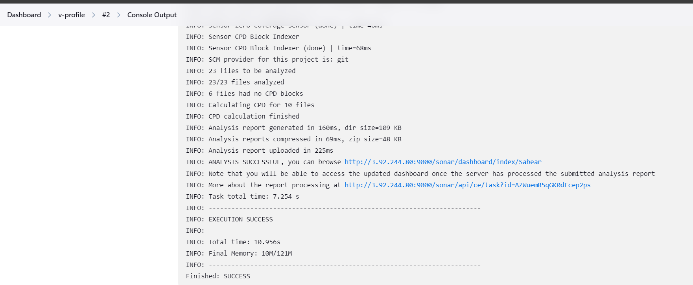

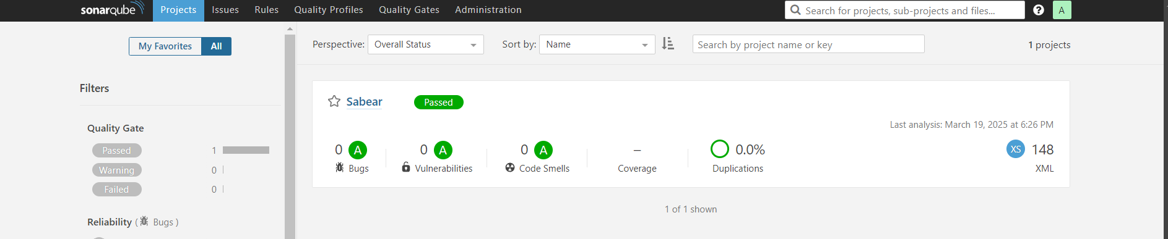

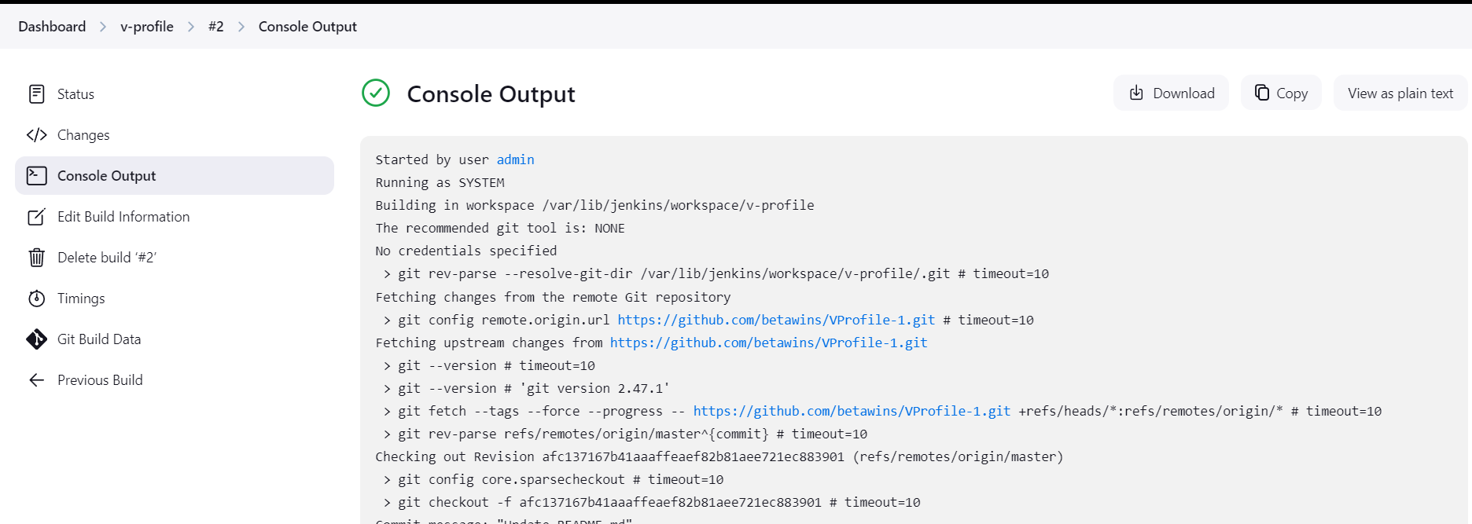

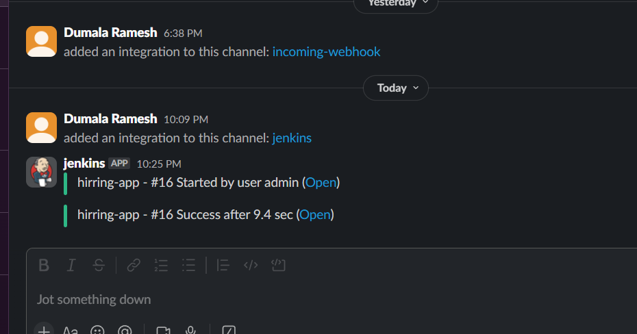

2) 1) Create one jenkins job using the below code and create three stages.

stage1: Git clone to download the source code.

stage2: Sonarqube Integration to check the quality of code

stage3: Slack Integration to send the alerts to slack.

URL: <https://github.com/betawins/hiring-app.git>

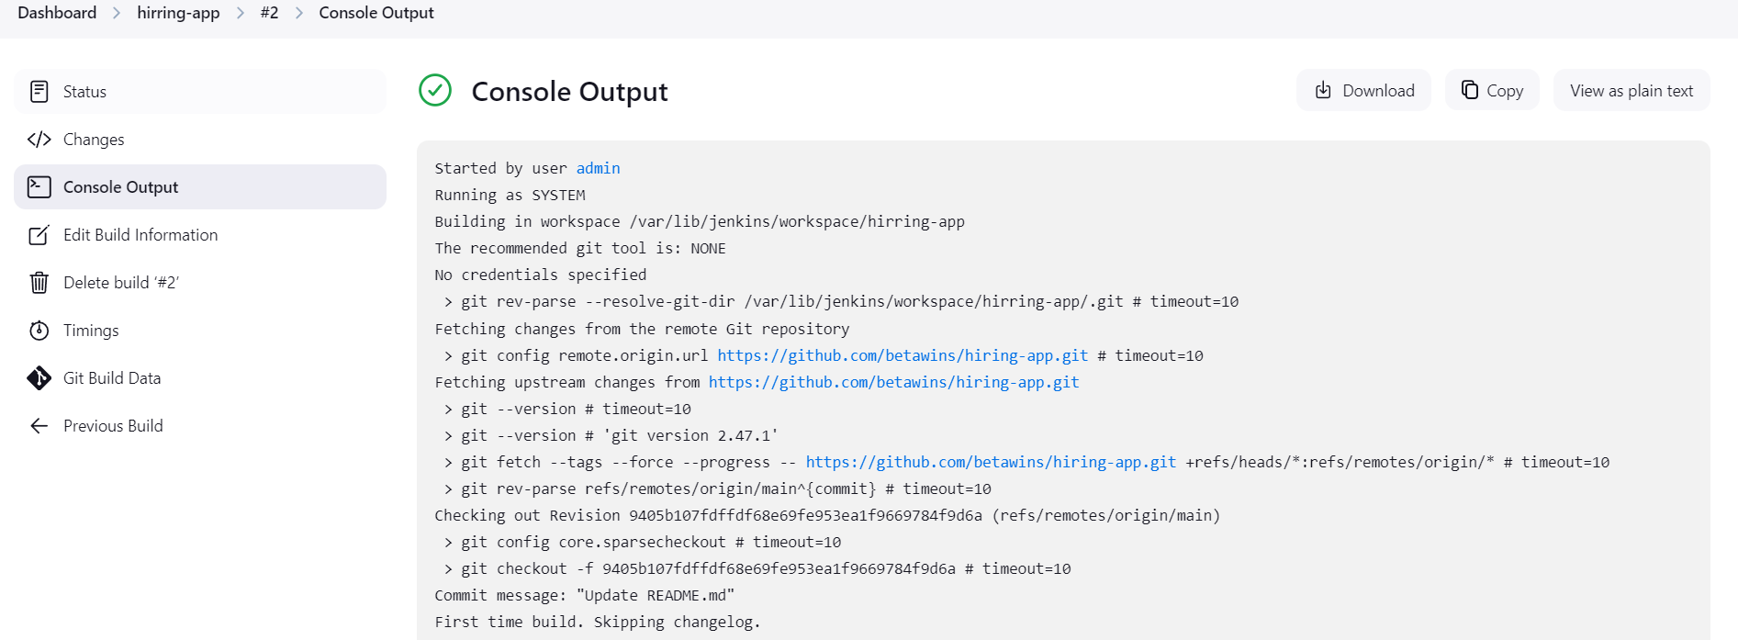

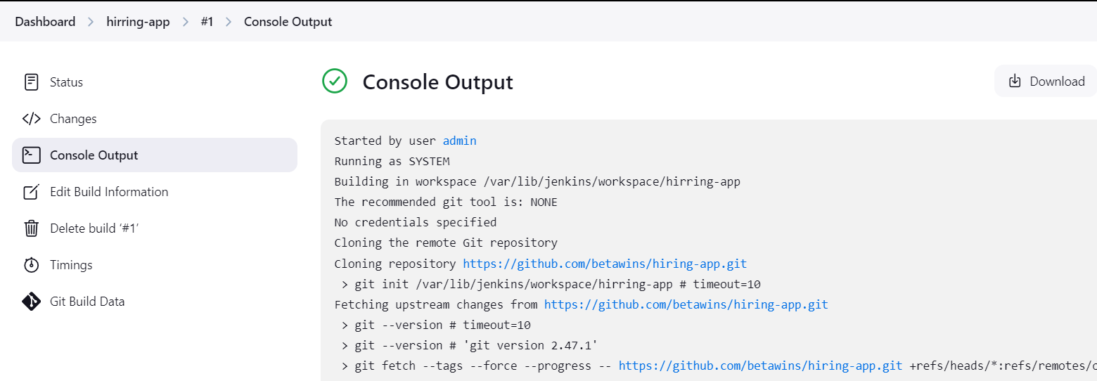

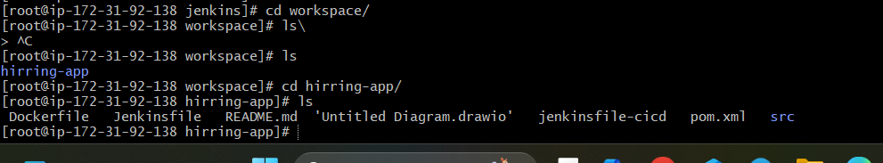

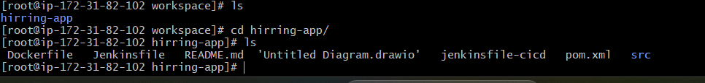

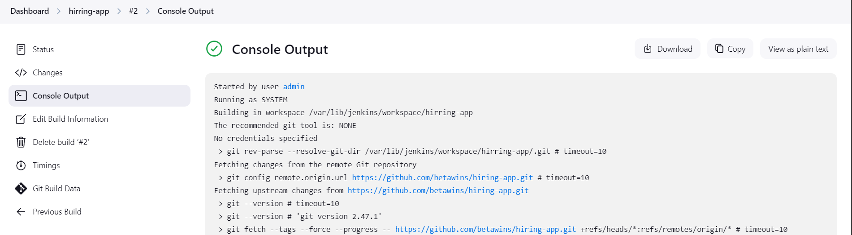

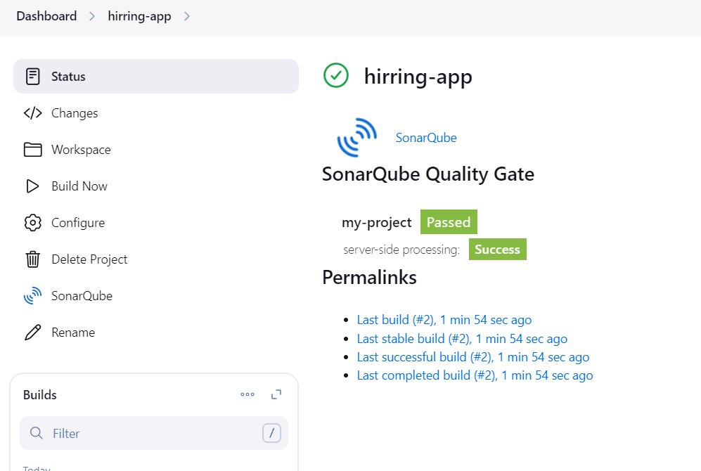

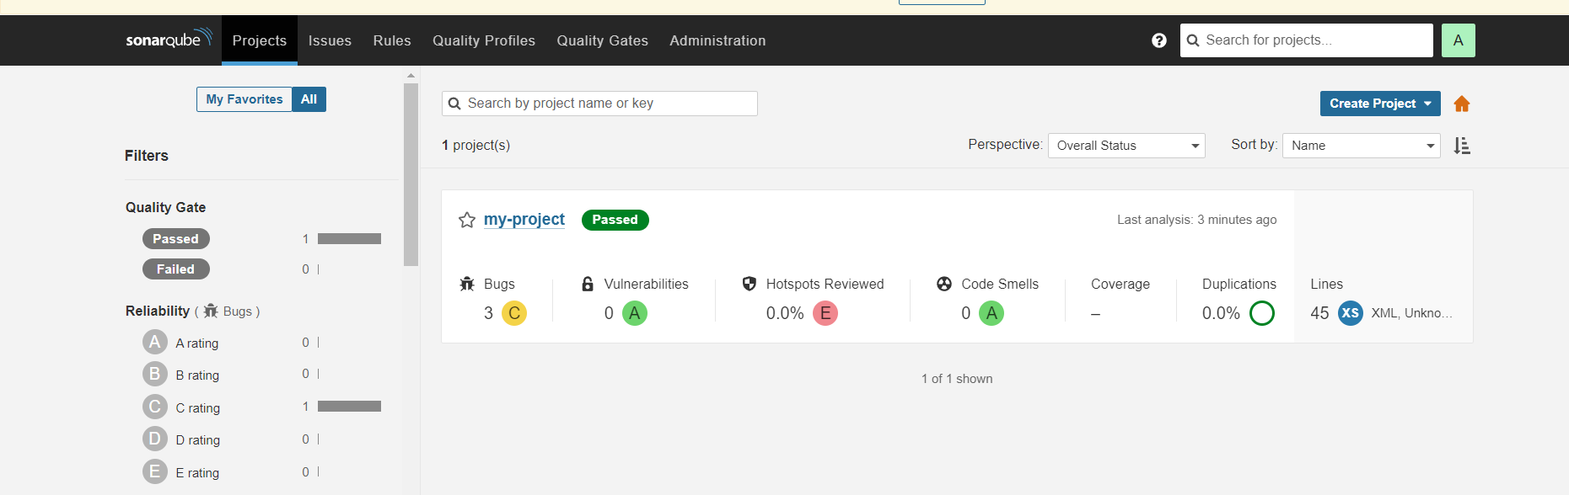



#!/usr/bin/env sh

#

# SonarScanner Startup Script for Unix

#

# Required ENV vars:

# JAVA_HOME - Location of Java's installation, optional if use_embedded_jre is set

#

# Optional ENV vars:

# SONAR_SCANNER_OPTS - Parameters passed to the Java VM when running the SonarScanner

# SONAR_SCANNER_DEBUG_OPTS - Extra parameters passed to the Java VM for debugging

real_path () {

target=$1

(

while true; do

cd "`dirname "$target"`"

target=`basename "$target"`

test -L "$target" || break

target=`readlink "$target"`

done

echo "`pwd -P`/$target"

)

}

script_path=`real_path "$0"`

sonar_scanner_home=`dirname "$script_path"`/..

# make it fully qualified

sonar_scanner_home=`cd "$sonar_scanner_home" && pwd -P`

jar_file=$sonar_scanner_home/lib/sonar-scanner-cli-4.6.2.2472.jar

# check that sonar_scanner_home has been correctly set

if [ ! -f "$jar_file" ] ; then

echo "File does not exist: $jar_file"

echo "'$sonar_scanner_home' does not point to a valid installation directory: $sonar_scanner_home"

exit 1

fi

use_embedded_jre=true

if [ "$use_embedded_jre" = true ]; then

export JAVA_HOME="$sonar_scanner_home/jre"

fi

if [ -n "$JAVA_HOME" ]

then

java_cmd="$JAVA_HOME/bin/java"

else

java_cmd="`which java`"

fi

if [ -z "$java_cmd" -o ! -x "$java_cmd" ] ; then

echo "Could not find 'java' executable in JAVA_HOME or PATH."

exit 1

fi

project_home=`pwd`

#echo "Info: Using sonar-scanner at $sonar_scanner_home"

#echo "Info: Using java at $java_cmd"

#echo "Info: Using classpath $jar_file"

#echo "Info: Using project $project_home"

exec "$java_cmd" \

-Djava.awt.headless=true \

$SONAR_SCANNER_OPTS \

$SONAR_SCANNER_DEBUG_OPTS \

-classpath "$jar_file" \

-Dscanner.home="$sonar_scanner_home" \

-Dproject.home="$project_home" \

org.sonarsource.scanner.cli.Main "$@"