JENKINS-TASK1

1) Install jenkins and run jenkins on port number 8081.

I have installed jenkins on my ec2 server with prerequisite java installed 17 versions because when i installed 11 versions my jenkins is not working so that’s the reason i have installed 17 version.

To change the port number for jenkins use this command and search for the default port number and change it

sudo nano /lib/systemd/system/jenkins.service

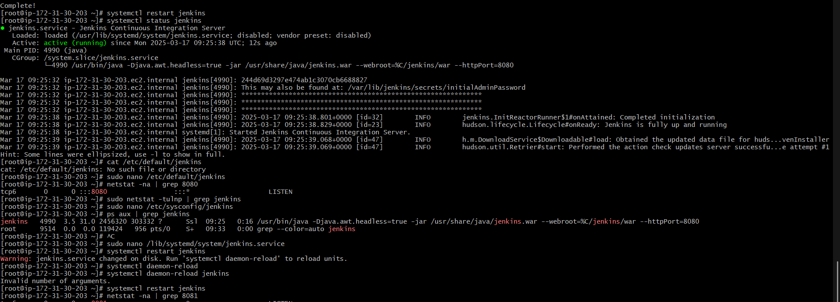

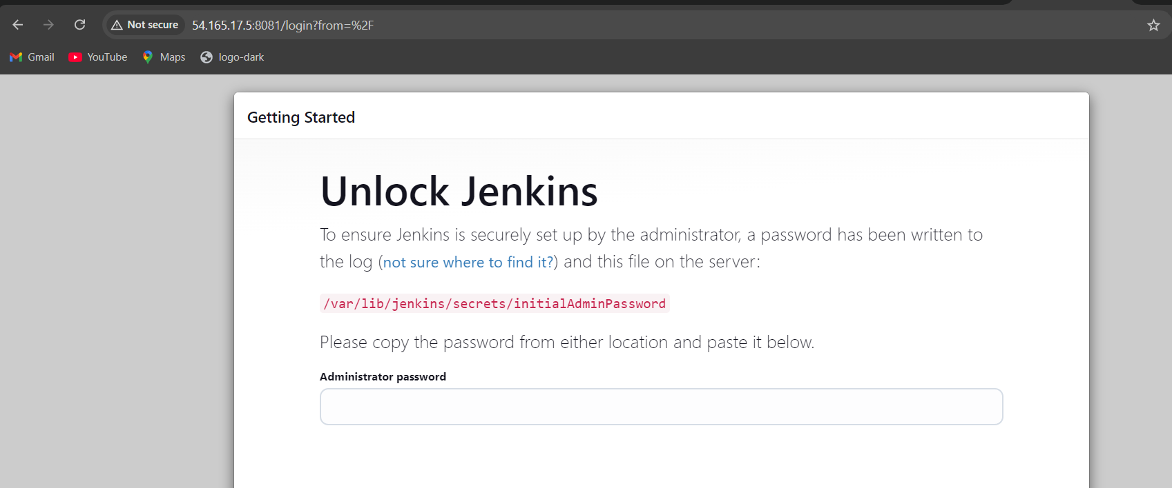

2) Secure Jenkins server

I have removed the initialadminpassword after login with my credentials



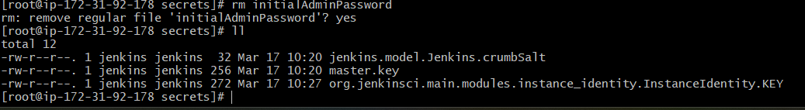

3) Create users called Devops, Testing in Jenkins with Limited access.

I have created two users Devops and testings and i have given read access only for both the users and also enabled the build for jobs

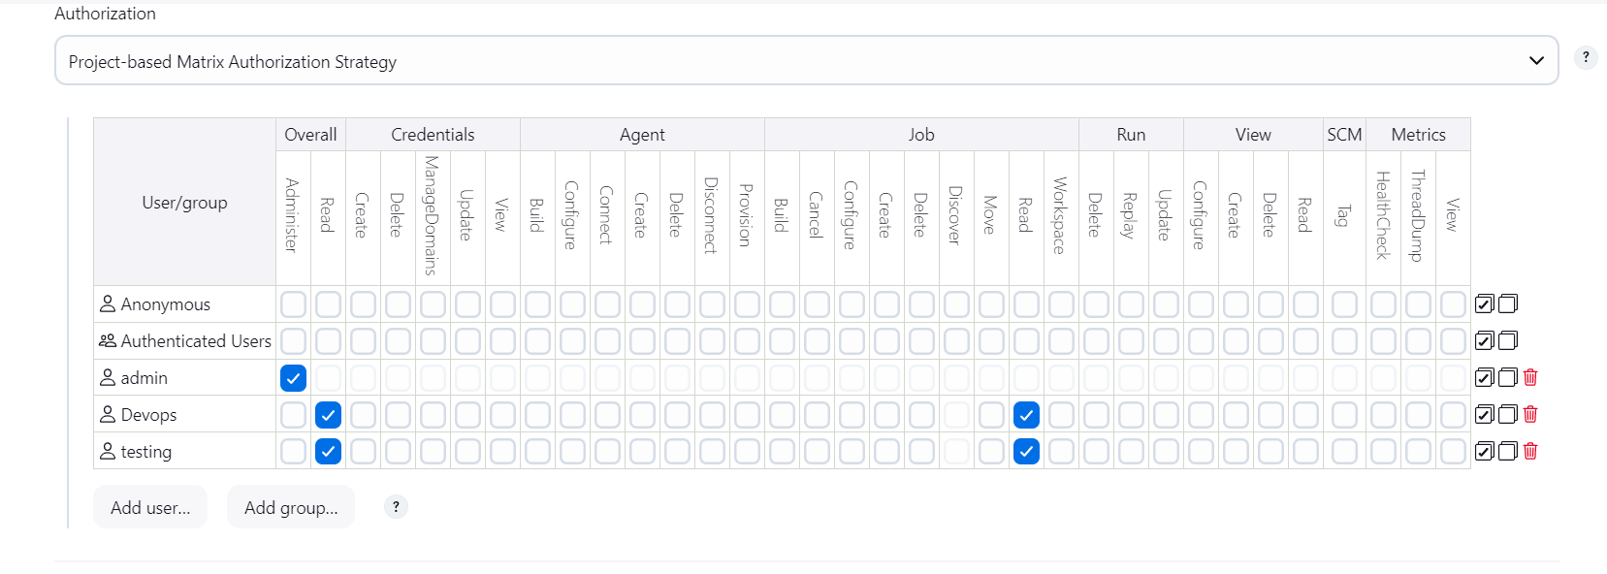

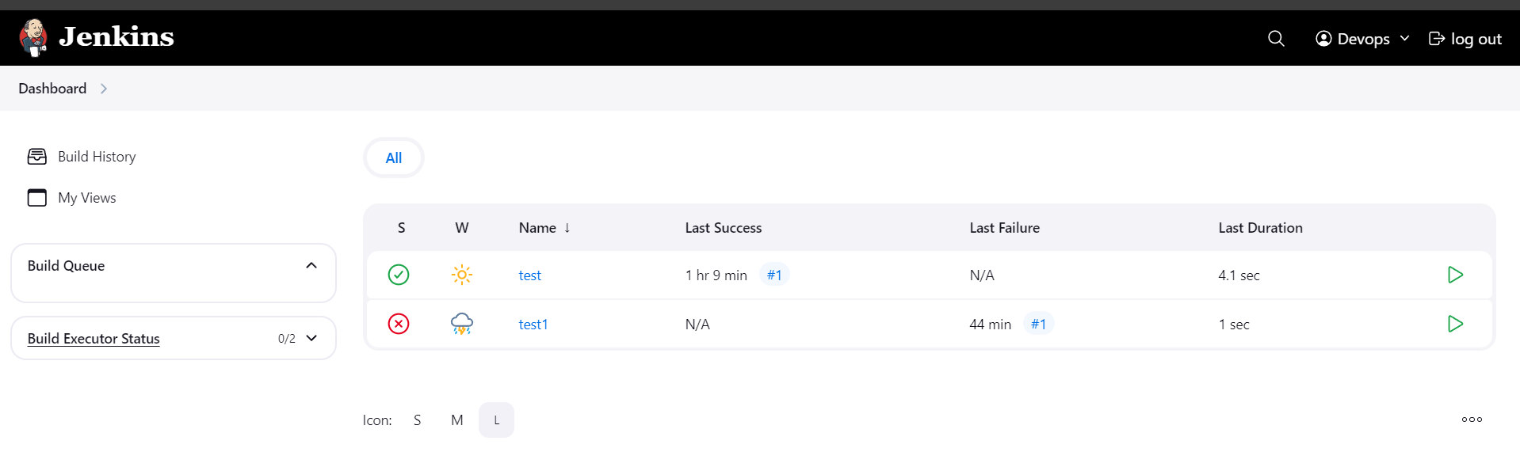

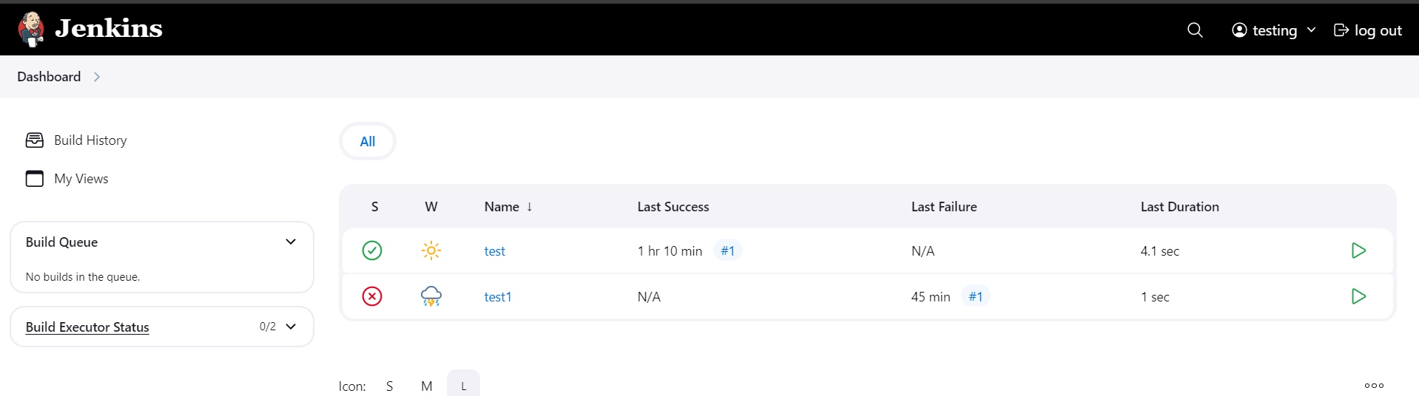

4) Configure labels and restrict the jobs to execute based on label only.

I have created a name called main and i have restricted a test2 and given label to test1 after installing node and label parameter and i have given only build jobs with label expressions

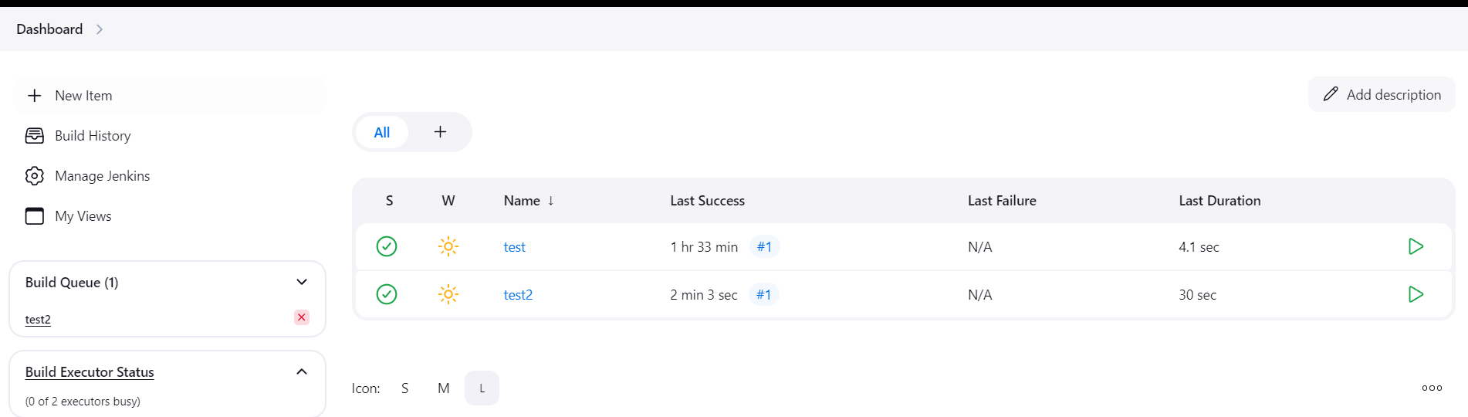

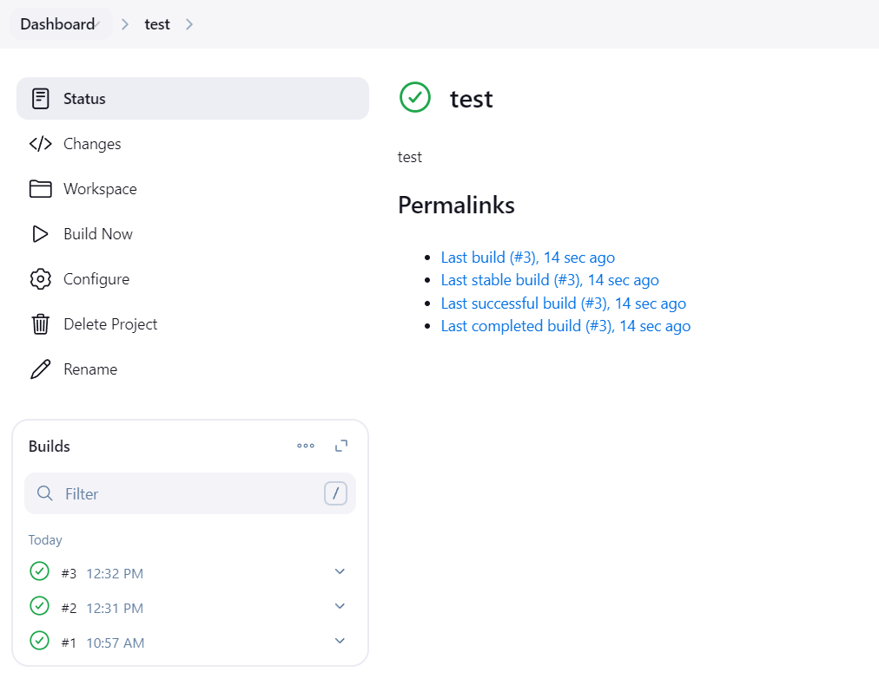

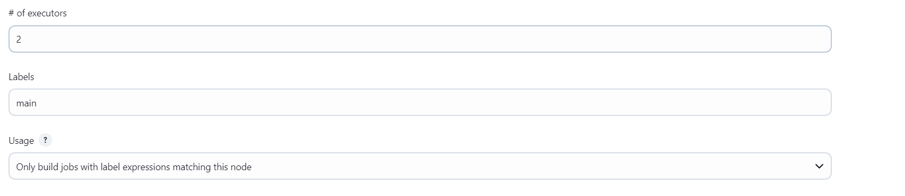

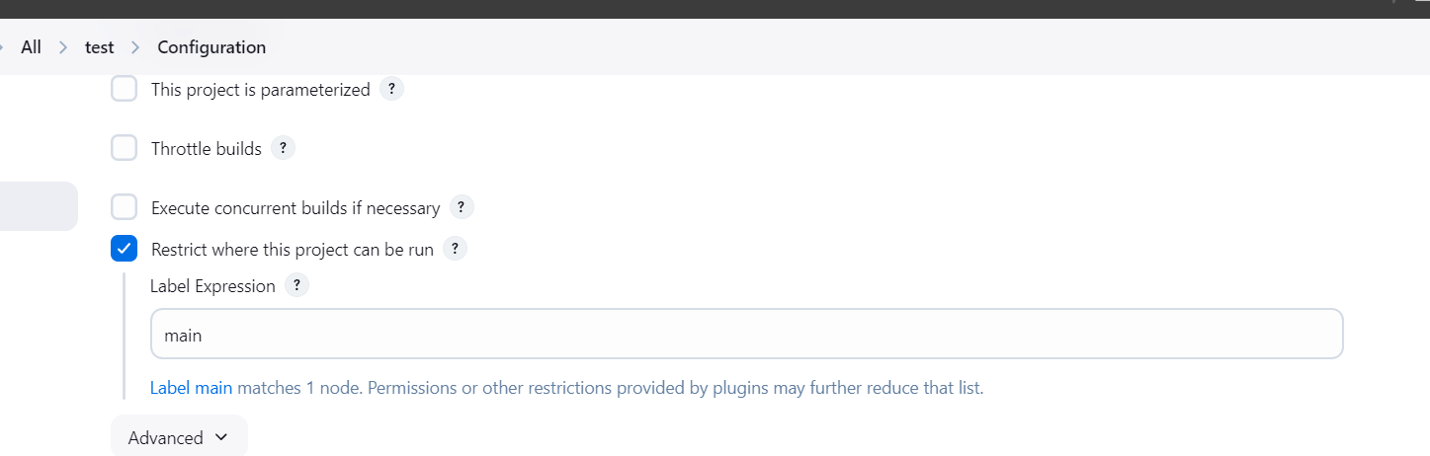

5) Create Three sample jobs using the below URL.

<https://github.com/betawins/Techie_horizon_Login_app.git>

I have created a 3 jobs by using above git url

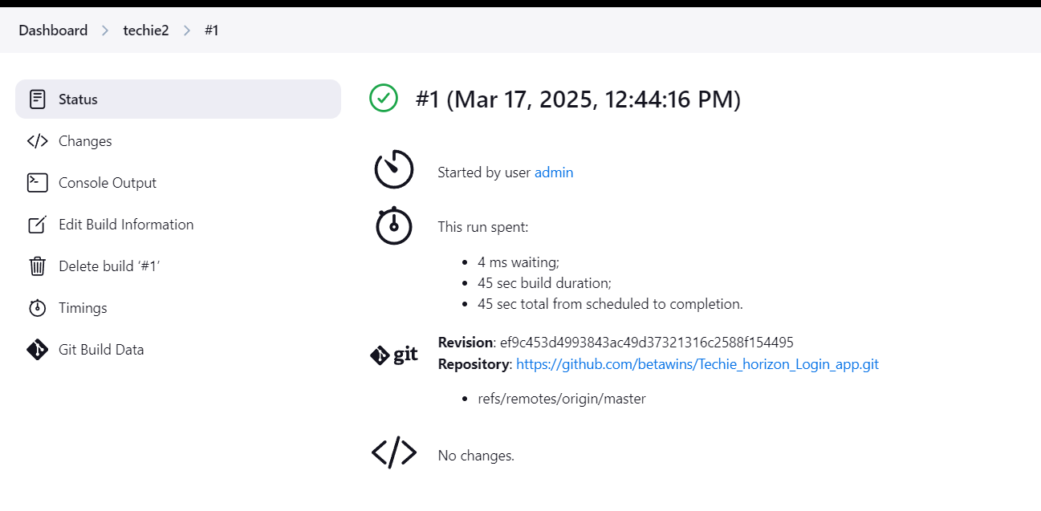

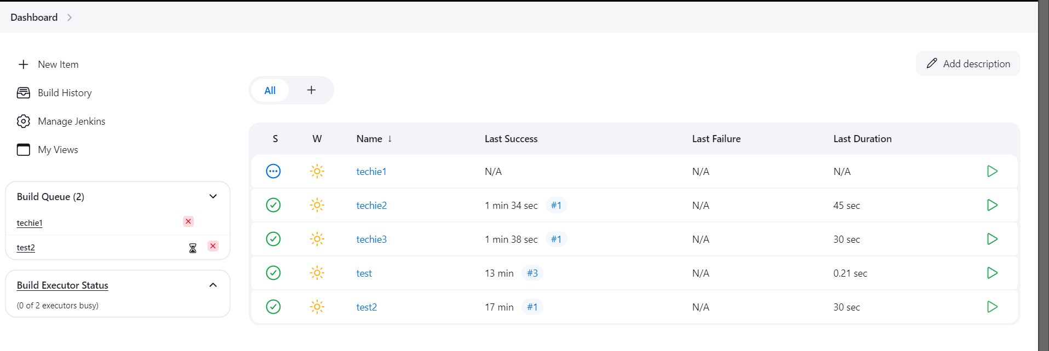

6) Create one jenkins job using git hub Private repository.

I have created a new repo with private and i have created a personal token access and executed a build also

git clone https://ghp\[email]/RameshDumala1/rameshp.git

