**Name: Ramesh Kumar  
Reg# 24109114  
Course: Digital Forensics  
SZABIST**

**Assignment # 2**

# Contents

Level 0 3

Level 0 → 1 3

Level 1 → 2 4

Level 2 → 3 4

Level 3 → 4 4

Level 4 → 5 5

Level 5 → 6 5

Level 6 → 7 5

Level 7 → 8 6

Level 8 → 9 6

Level 9 → 10 6

Level 10 → 11 7

# Level 0

**Objective:** Connect to the game using SSH on port 2220 with the following credentials:

* **Username**: bandit0
* **Password**: bandit0

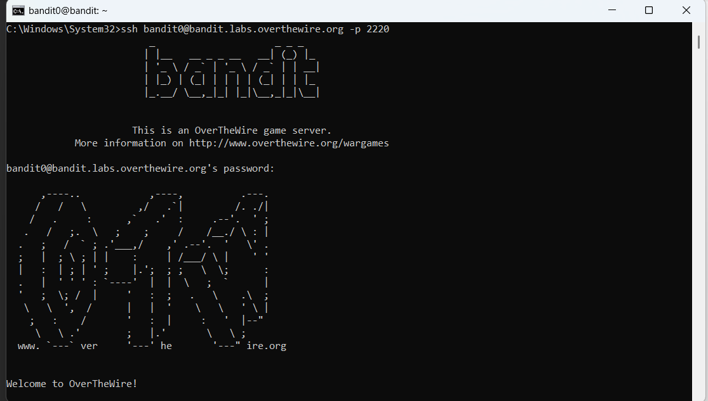

# Level 0 → 1

**Objective:** Locate the password saved in a file named readme located in the home directory

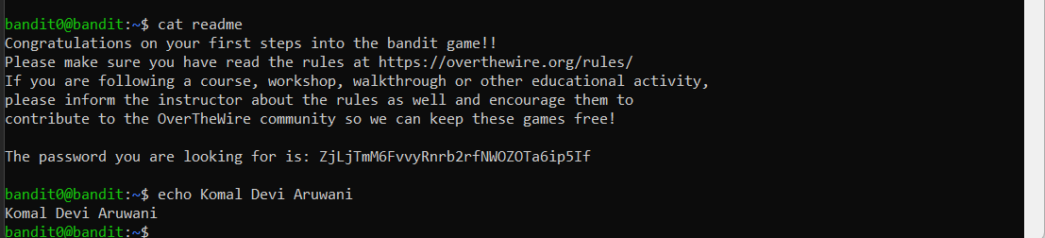

# Level 1 → 2

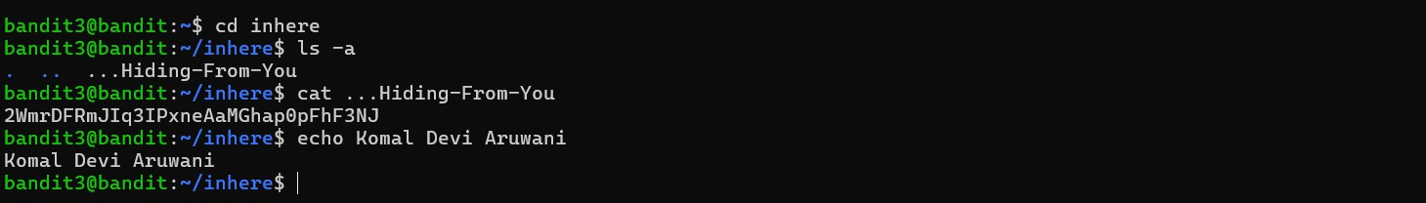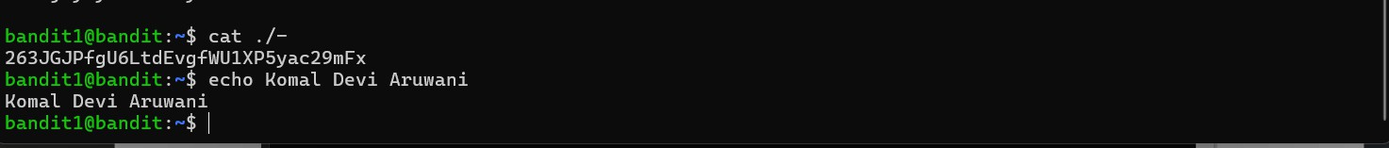

**Objective:** The password is stored in a file named -, which is a special and unconventional filename.

# Level 2 → 3

**Objective:** The password for the next level is stored in a file named spaces in this filename, which is located in the home directory.

# Level 3 → 4

**Objective:** The password for the next level is located in a hidden file within the inhere directory.

# Level 4 → 5

**Objective:** Locate a human-readable file inside the inhere directory

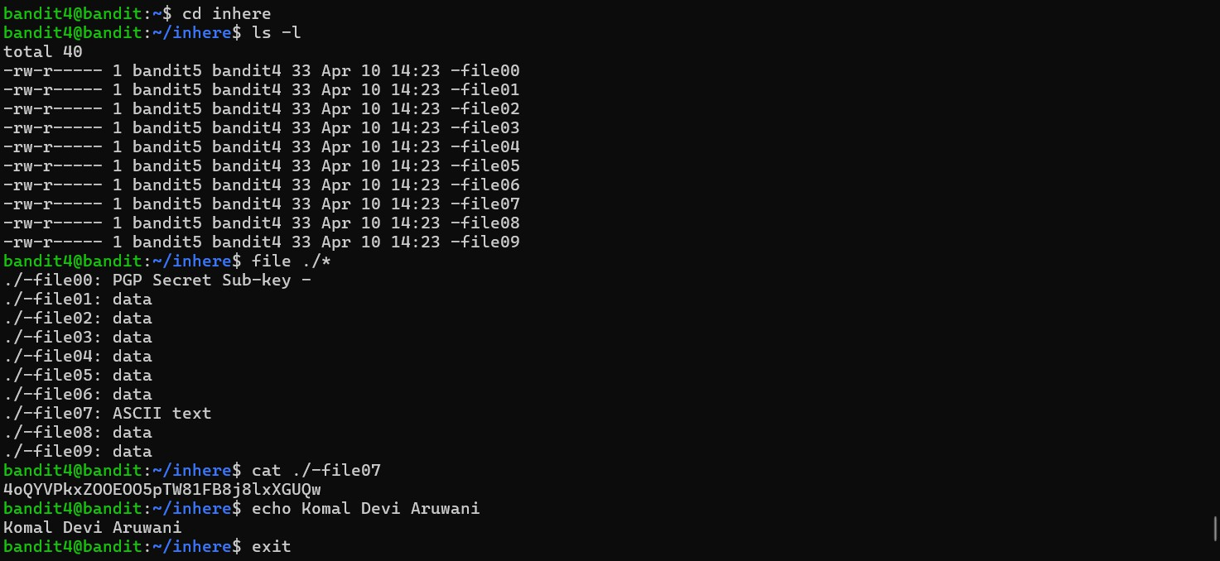

# Level 5 → 6

**Objective:** Find a 1033-byte file in inhere subdirectories

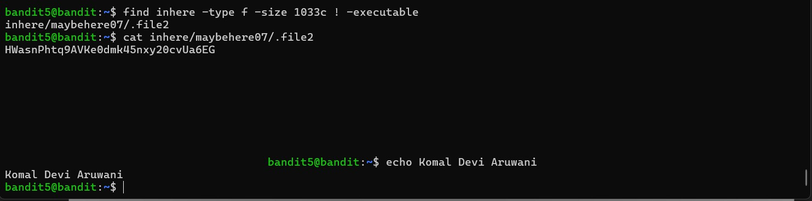

# Level 6 → 7

**Objective:** Find a file owned by bandit7, group bandit6, size 33 bytes

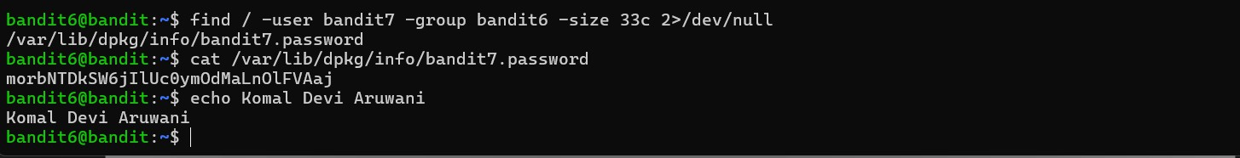

# Level 7 → 8

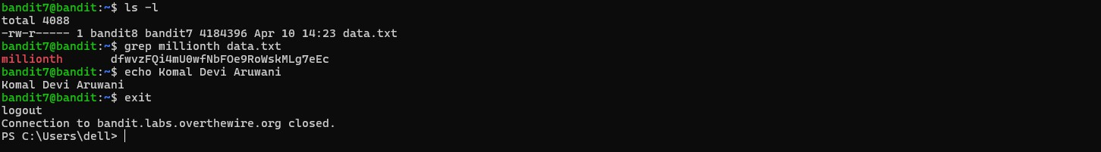

**Objective:** The password for the next level is located in the file data.txt, right next to the word "millionth".

# Level 8 → 9

**Objective:** The password for the next level is found in the file data.txt and is the sole line of text that appears only once.

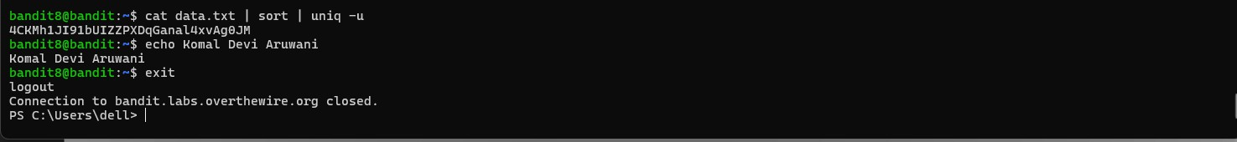

# Level 9 → 10

**Objective:** The password for the next level is located in the file data.txt among the few human-readable strings, and it is preceded by a series of = characters.

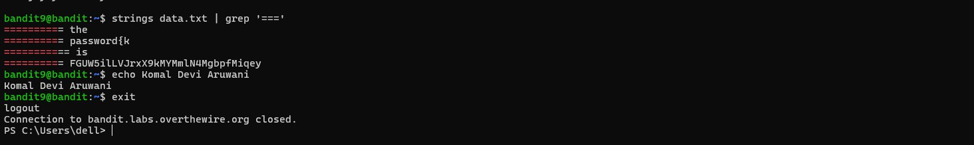

# Level 10 → 11

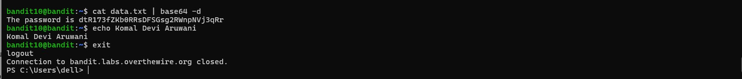

**Objective:** The password for the next level is inside the file data.txt, which contains data encoded in base64 format.