**R-Console:**

The last line of the output includes the > prompt. This is where you enter in commands that tell R what you want it to do. From here you use commands to do everything from reading in your data to creating graphs to carrying out statistical tests.

**The R GUI?**

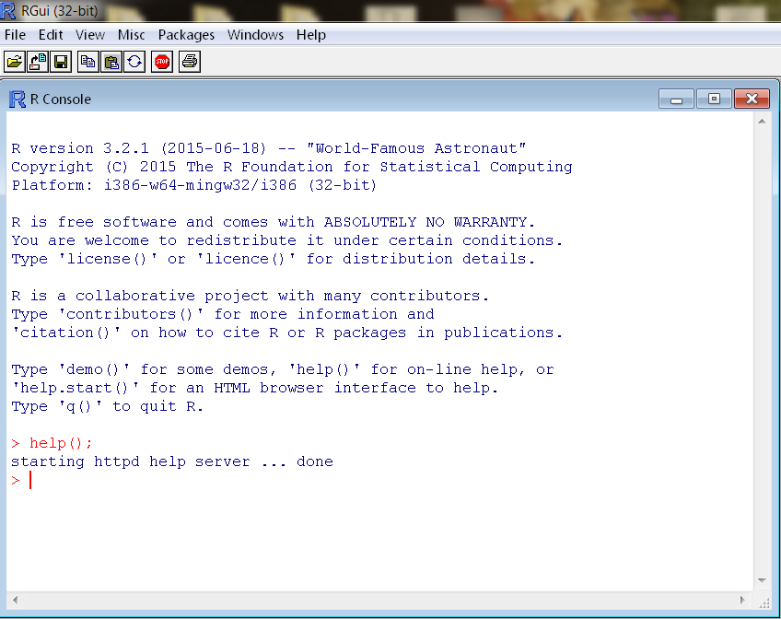

***Getting Started with R Console:***

An R workspace is a file containing a set of R objects from a previous session. When you start the R Console it will load the R workspace from the current directory (if it exists). When you complete a session of using the R Console you will be prompted to either save the updated workspace (in memory objects) to disk.

Workspace directory can be changed by using the Change Dir… in File Menu.

R Console Window Information up to the last command or work can also be stored using Save to File…

There should be 2 files .RData and .Rhistory created in the directory if you exit from R.

***R History file:***

The .Rhistory file will maintain a list of R expressions from your previous R session.

***R Workspace File:***

The .RData file contains the R objects (data and functions) from your previous R session. You cannot view the contents of this file in a text editor, but the R Console will load it when a new session is started.

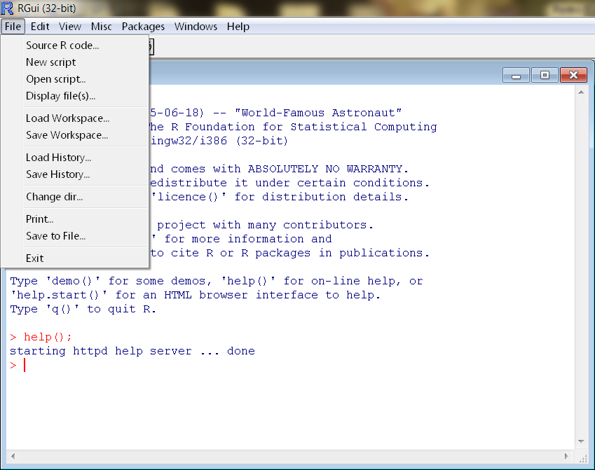

***R Edit Menu:*** 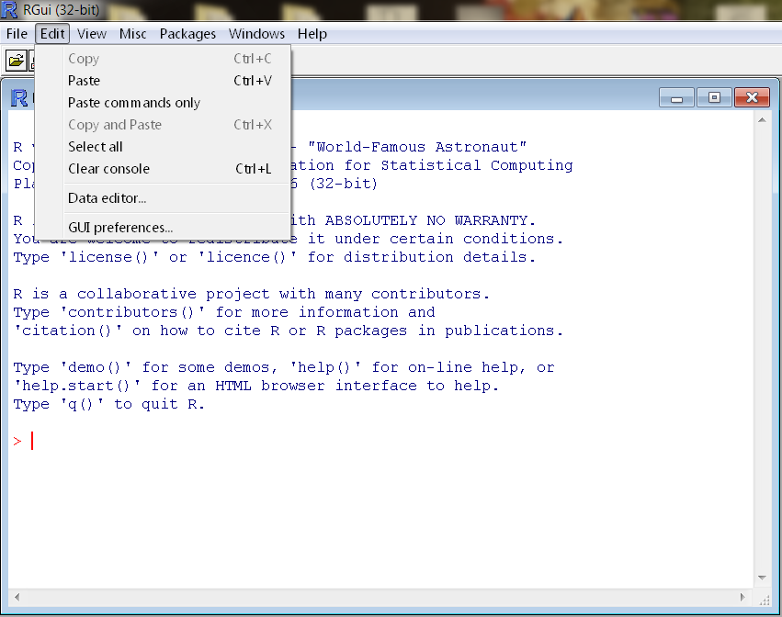

***R Computation Menu:***

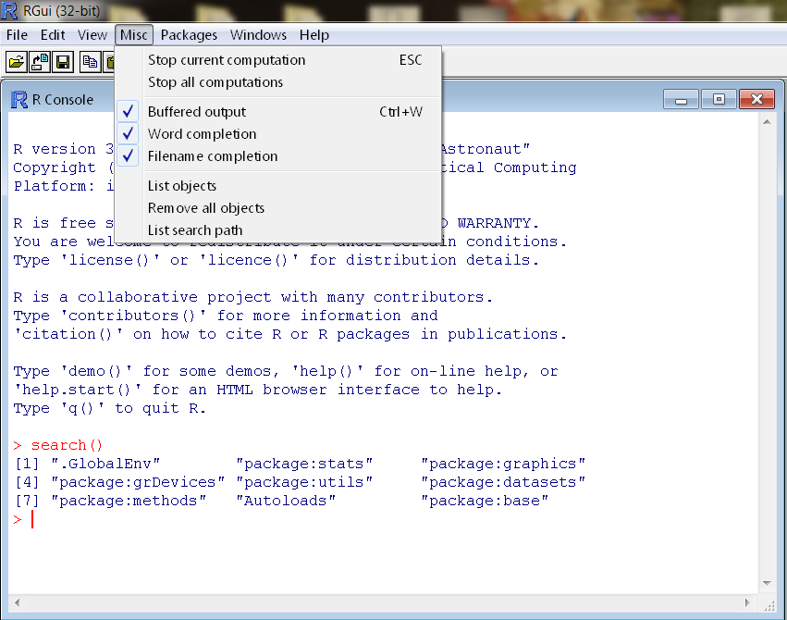

**Verify packages installed on the system.**

R comes with a base set of functionality, but it can be easily extended by installing R packages. To install R packages the install.packages() function is used, but we should not require any new packages during this lab. Note that the packages could either be made available within the Comprehensive R Archive Network (CRAN) or from a standard compressed file.

For example, if we wanted to connect to a relational database then we could install the RJDBC package using the command install.packages("RJDBC").

A **package** is a collection or group of R objects. These functions may contain functions, data structures, links to other libraries, and documentation.

To list the install packages in R, **type >library()**

To exit the command output, **type q**

These packages could either be installed in a system wide directory or in a personal directory for the user.

You can find library list by typing the command

**>library();**

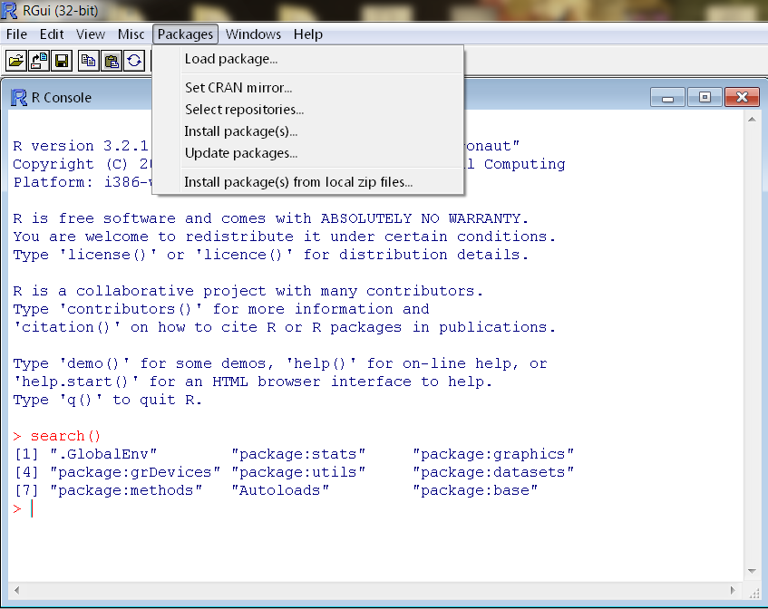

Type 'q()' to quit R.