***Jenkins:***

**User Management:**

1. Install the Role Based plug-in (Manage Jenkins---->Manage Plug-in---> Available ---> Role based)
2. Go to Manage Jenkins ---> Configure Global Security ---> select the Role Based Strategy shown below diagram click on apply and save it .

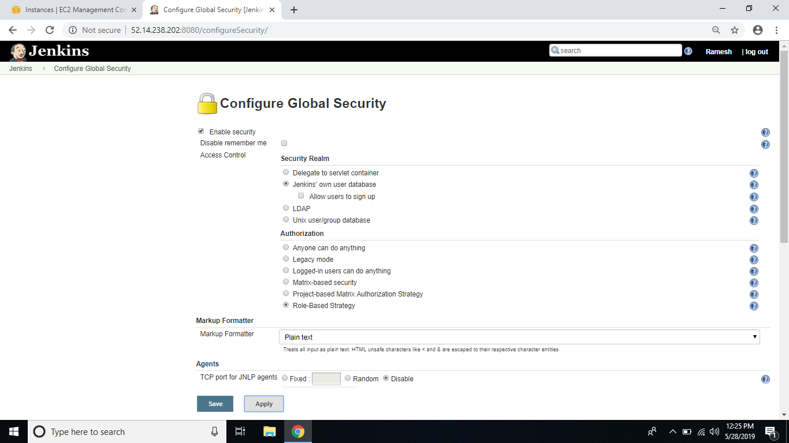

1. Go to Manage users create users like user1(Tester) and user2(Developer)

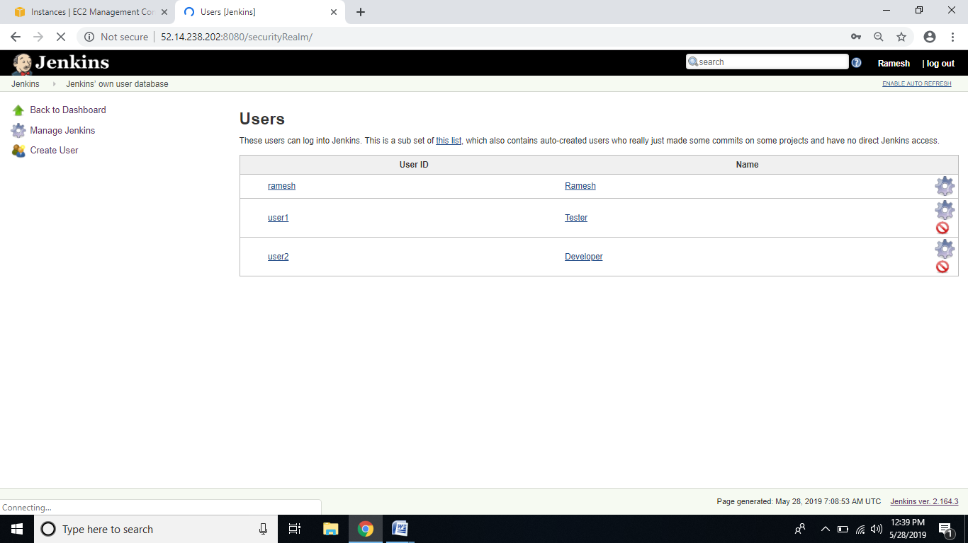

1. **Go to Manage Roles :**

**Global Roles:**

1. Create Global Roles (like:ACS_Employee give the permissions)

**Project Roles:**

1. Create test roles and dev roles and give the permissions

Please check the below picture Apply and save it.

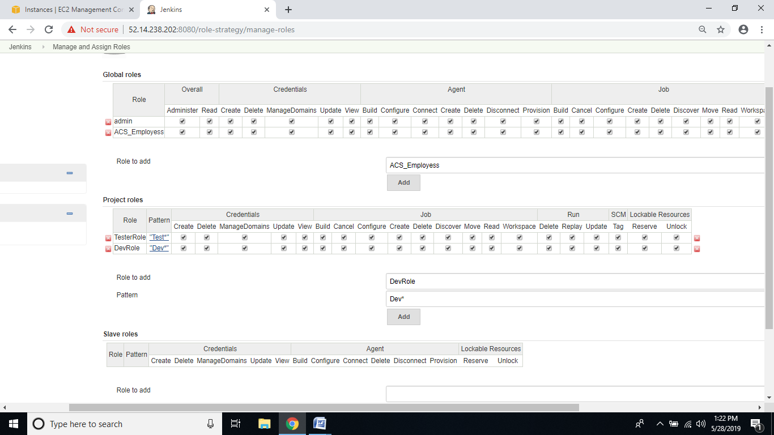

1. **Assign Roles:**

**Global Roles:** Add the user1,user2 in global roles

**Item Roles:** Add the user1, user2 in item roles like shown below diagram apply and save

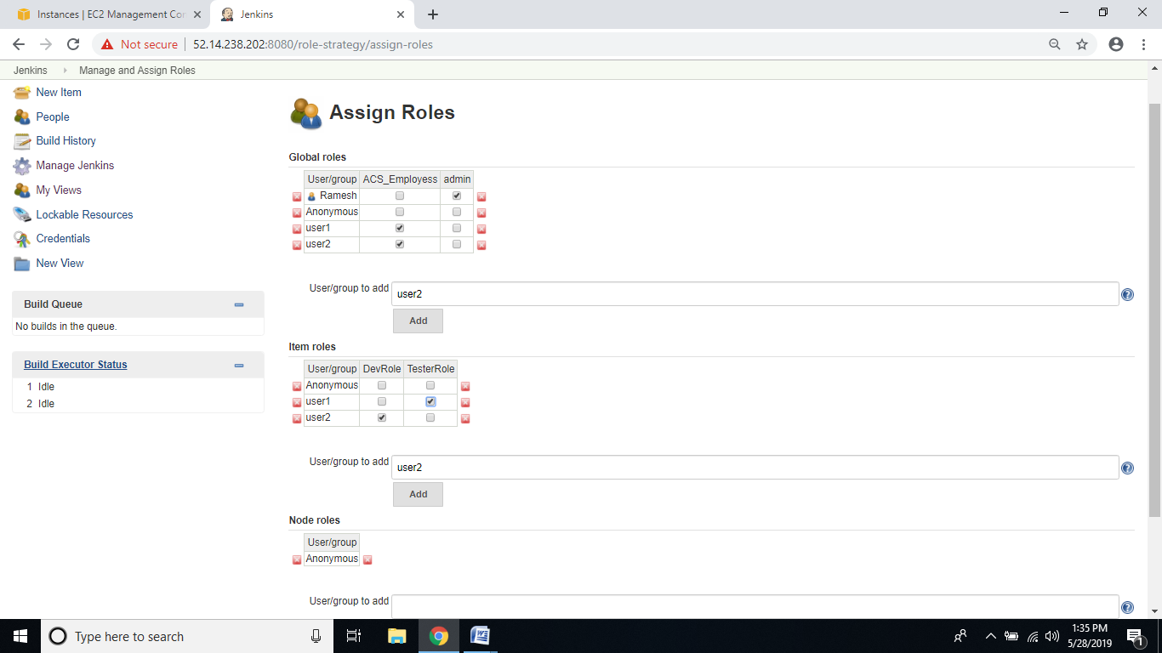

1. Create a jobs in Jenkins
2. TestJob1
3. TestJob2