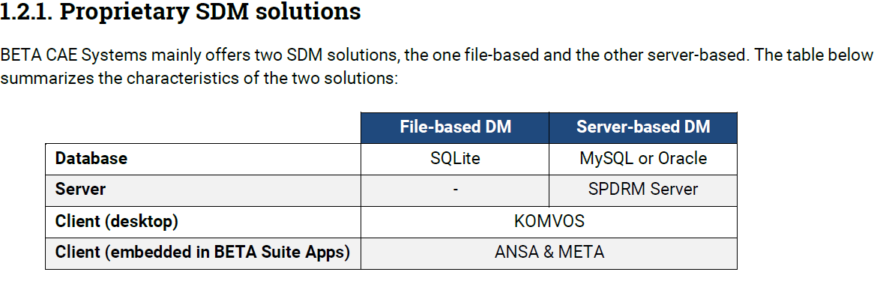

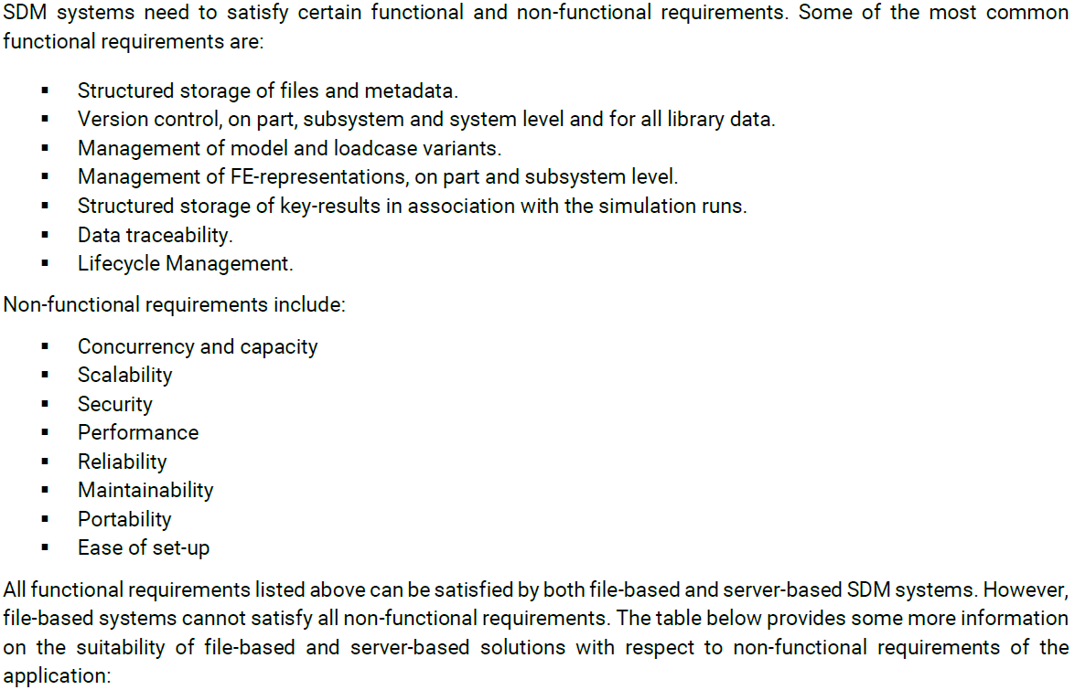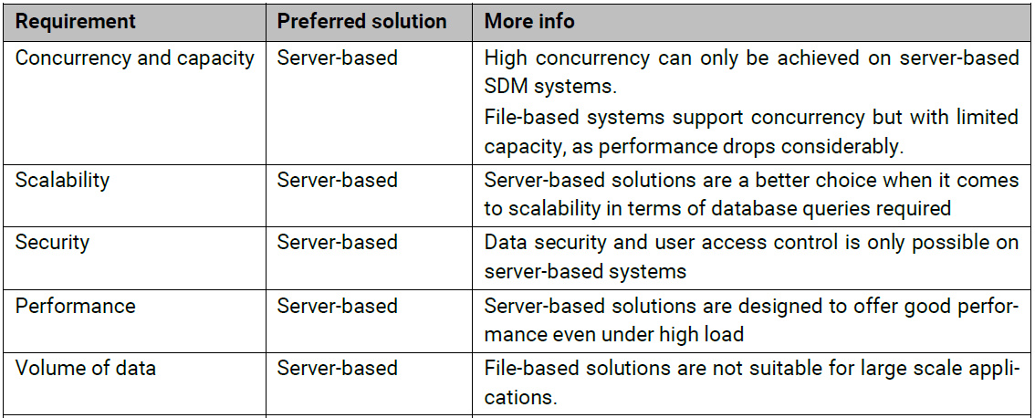

* Apart from the above-mentioned advantages. SPDRM offers a comprehensive Process Management Console which is not available out of the box in case of file-based DM. The User with help of Process manager can design save and execute complicated business processes, CAE workflows, Transactional methods etc. in order to integrate multiple different resources and applications in one place and never lose track of the data produced or consumed by each of them.
* Then SPDRM also has the multi-site architecture for globally dispersed Teams and offers seamless integration of their processes and data.
* The Users Management console of SPDRM offers setting up Different User Roles based on the privileges of their respective departments/teams and the efficient usage of multiple Access Control Lists (ACLs) for data security and appropriate access to Data/Process manager items of SPDRM.
* SPDRM back end server coupled with KOMVOS front end client has added advantages in the following:
  + Appealing data visualizations
  + Effective comparisons of different kinds of data
  + Customizable configurations and profiles to suit the exact needs of the organization
  + Process management is also made possible from KOMVOS
  + Issue Management is also made possible from KOMVOS
  + Multiple applications could be launched on different resources and process delegation is also possible.
  + Effective for DOE studies and ML infrastructure
  + Ease of access to main workspaces like
    - Home
    - Database (DM)
    - Process Management
    - Issues Manager
    - Actions (Generic/Validation/DMItem based script executions)
  + Ease of navigation from home page to multiple tabs like:
    - My Actions – for my recent Processes
    - My Jobs – for submitted HPC Jobs
    - My Processes – for my Assigned Tasks
    - History – for my recently viewed data
    - Bookmarks and Videos
    - Applications