GIT

Go to chrome->

Install GIT-

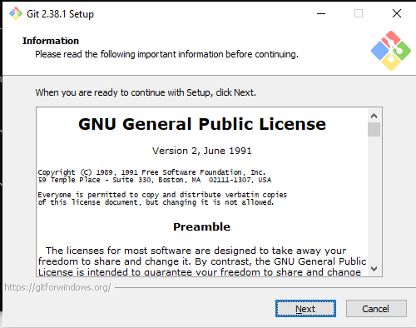

Click Next button

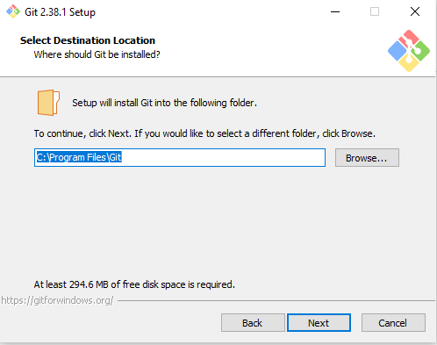

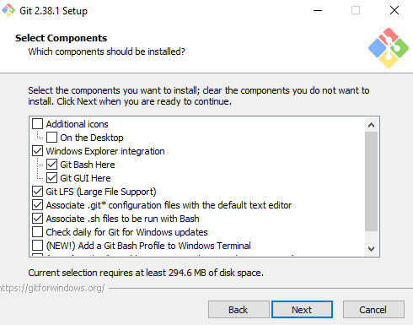

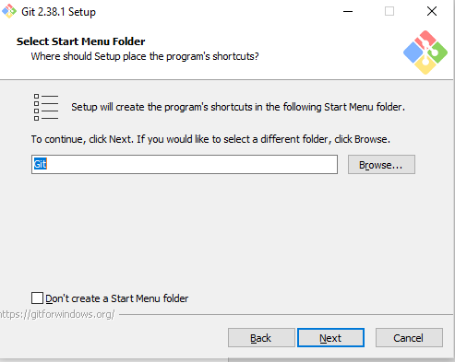

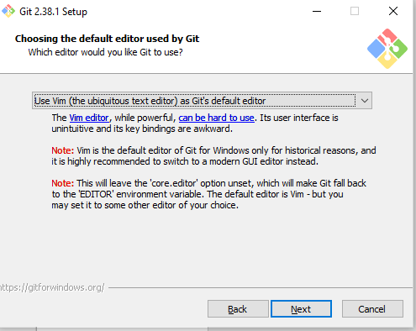

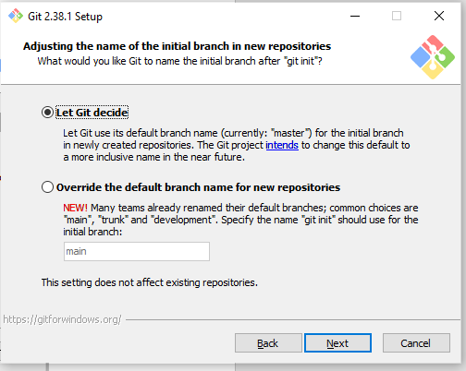

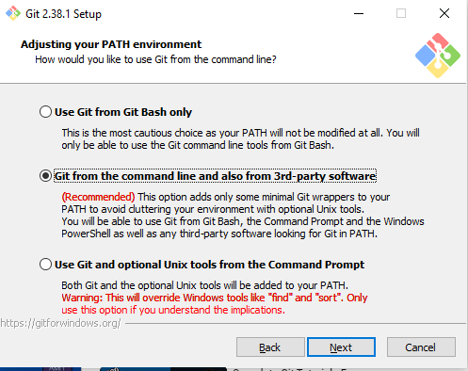

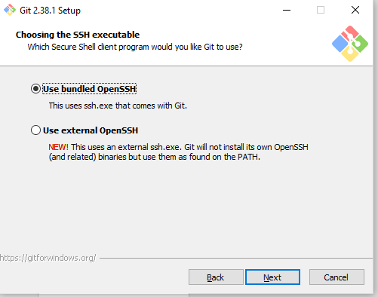

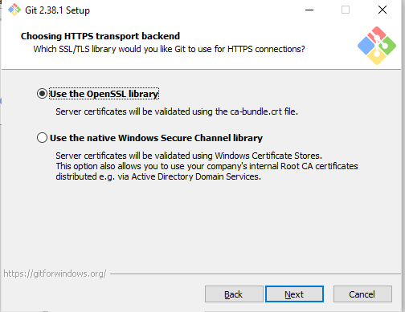

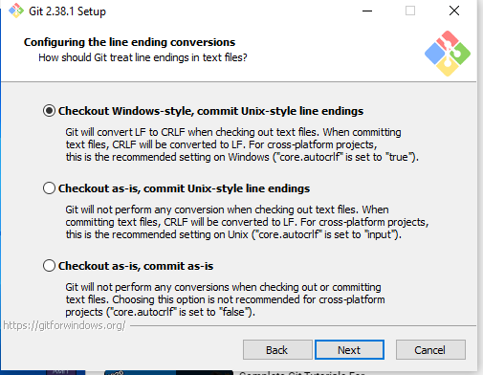

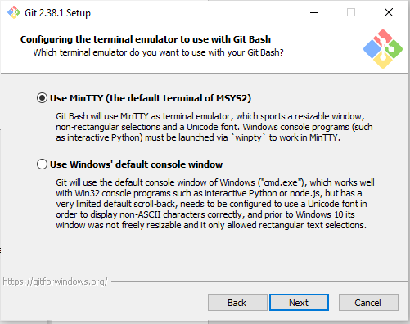

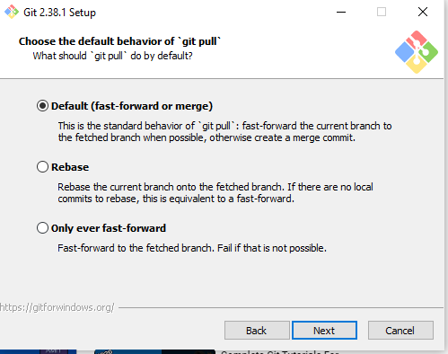

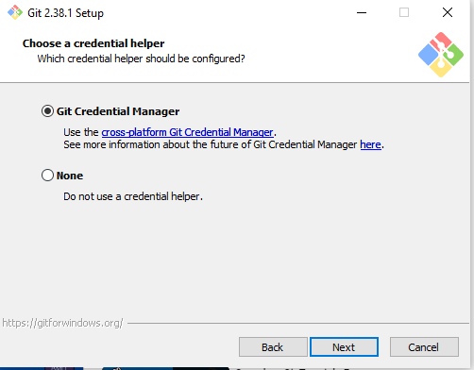

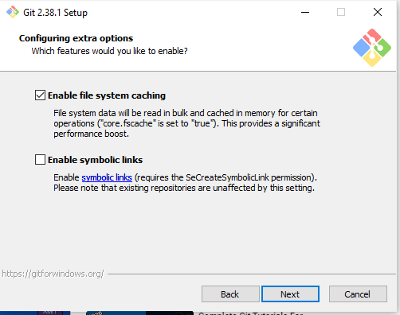

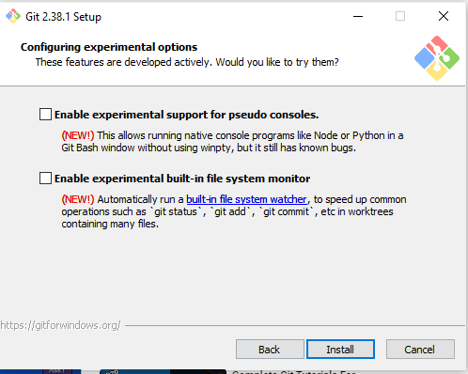

After clicking install button it is installing

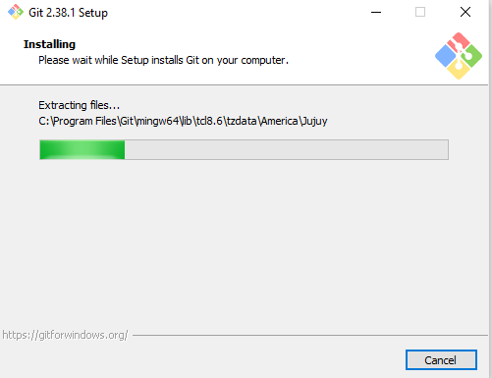

After successfully installing go to cmd prompt type “git” and observe below image

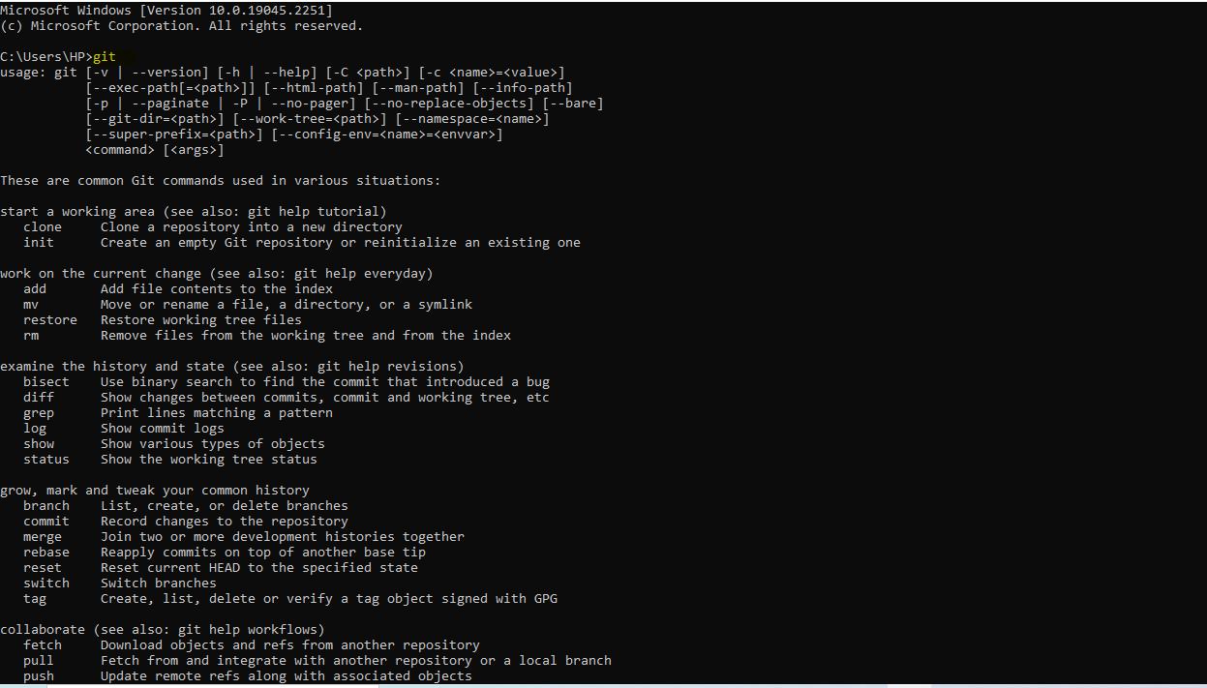

1.git init,2.git add . 3.git commit –m “message ”4,git push –u origin master

Step1:git init

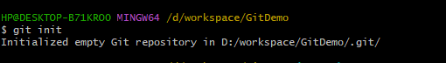

Check the status: git status

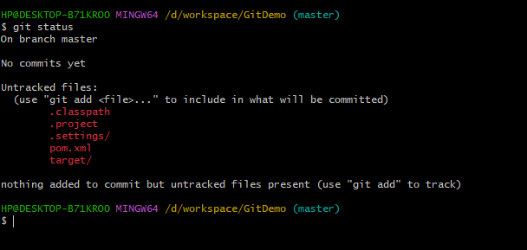

Step2: Need to add the Code from local machine to Staging

Type below command to adding the data in staging area

Open git and type 🡪 git add .



Data sucessfully added in staging area for confirmation u can type 🡪 git status

Step3:git status.

All files are added these files are called Track files these are ready to commit.

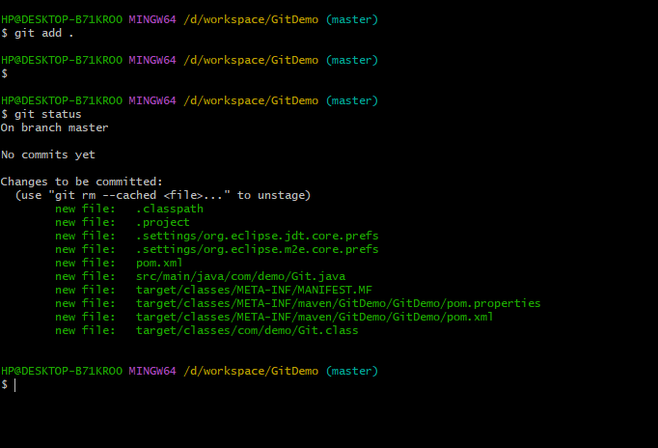

Successfully added but not committed.

Stage4:

Commit the all files from staging to local repository/master branch by using below command

git commit -m.

git commit –m “enter comments here”

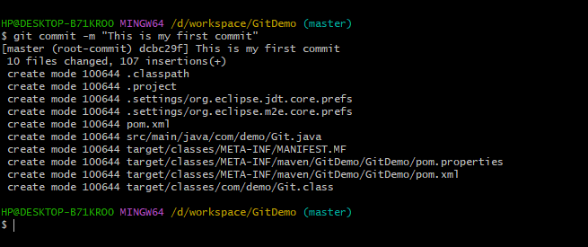

It commits the data only staging to only local repository not remote side .

If u want to push your code local repository to remote u need to follow below process

First u need git hub account and create one repositry

Click the new button

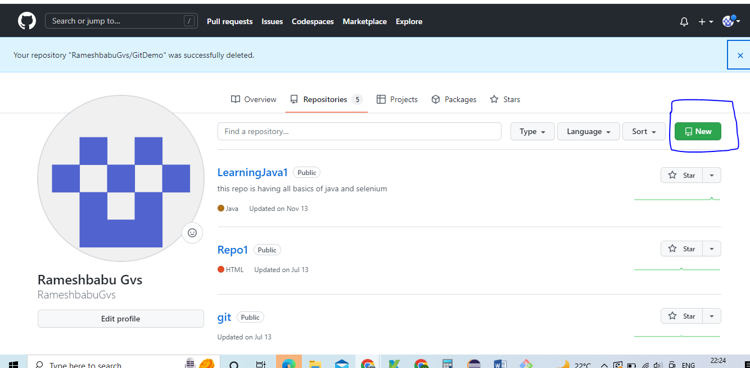

Repos name same as project name in eclipse

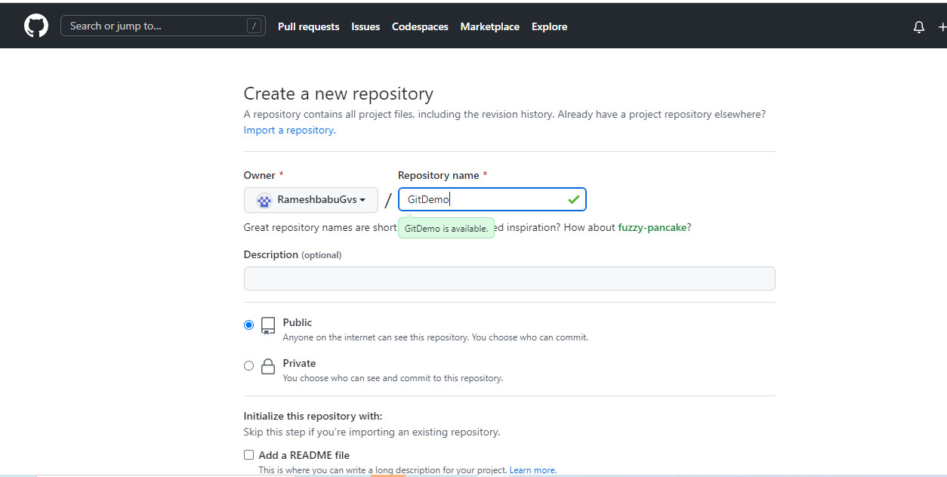

Select only public option if u are using free version

If u are using company git u can use Private and click Create repository.

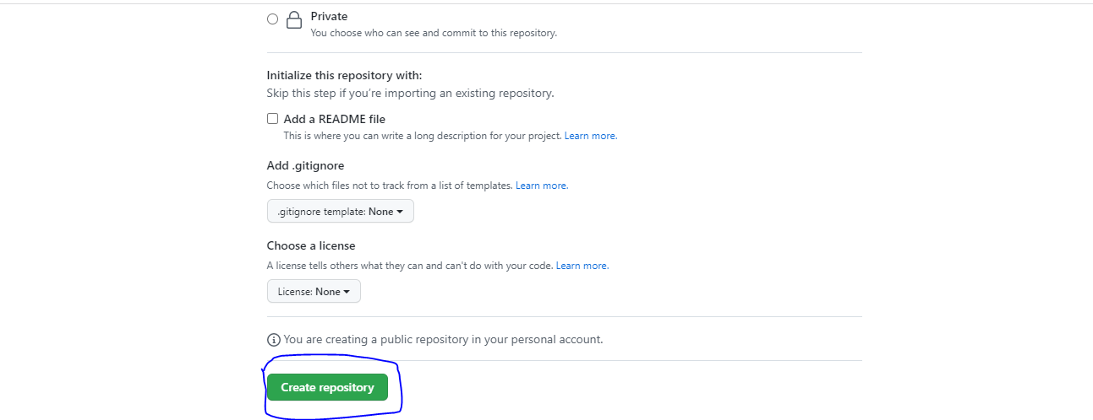

Nowu are able to see the cretated repos

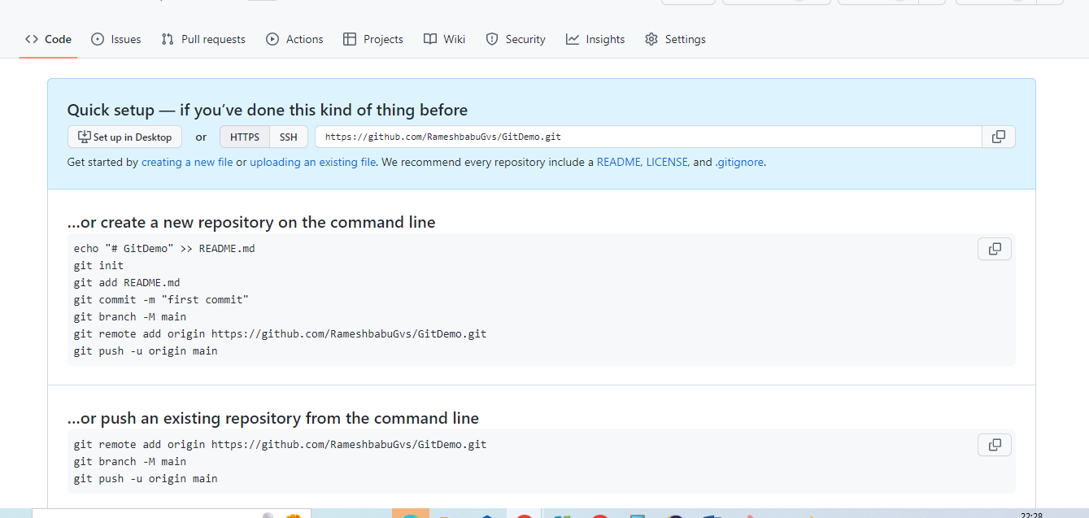

If u want to pushing the data first time u need give the path where u want push

First u need take the remote git url path ex: above image newly created repos url

U can use below command

If u are Adding the Code first time u need to use below command

**git remote add origin https://github.com/RameshbabuGvs/GitDemo.git**



Next u can push the data to remote branch

git push -u origin master



U can observe data has been successfully added

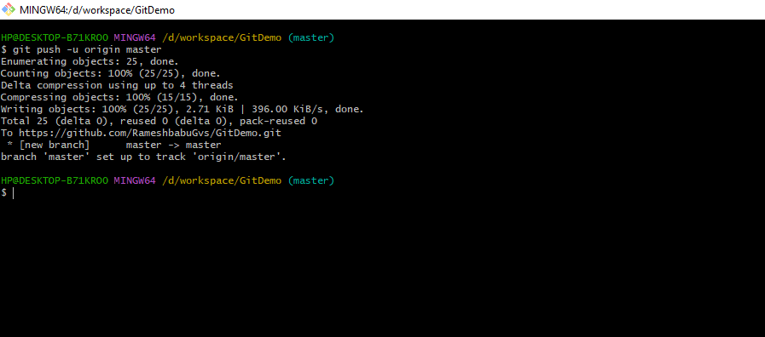

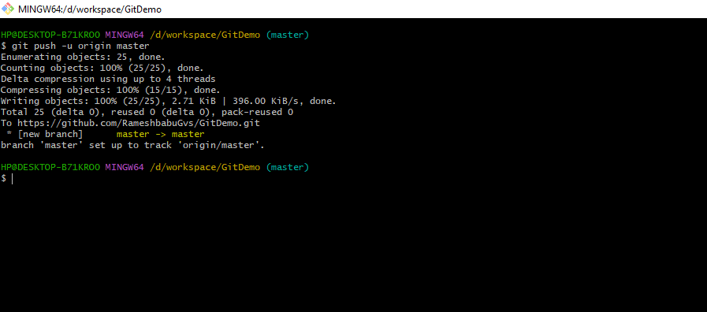 it specifes data sucessfuly moved local master to remote master

Now u can goto git hub browse refresh the browser and check code has been pushed or not.

Code has been successfully available in git hub browser

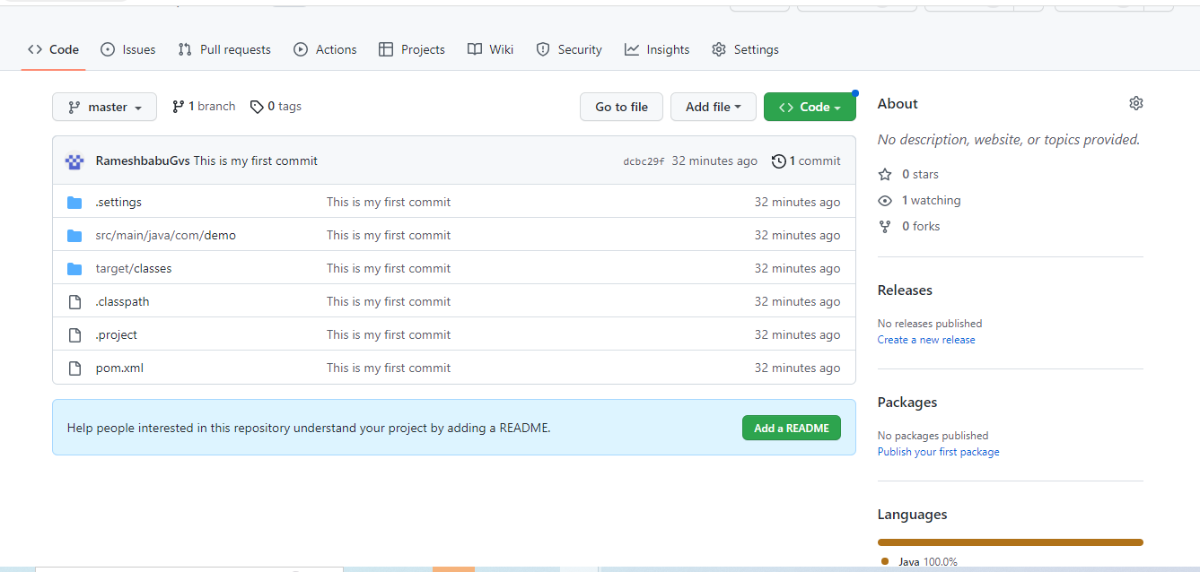

If u is adding any new files in your existing project u can follow below process

First u need to check the status of Git.it shows how many new files created and how many are ready for commiting.

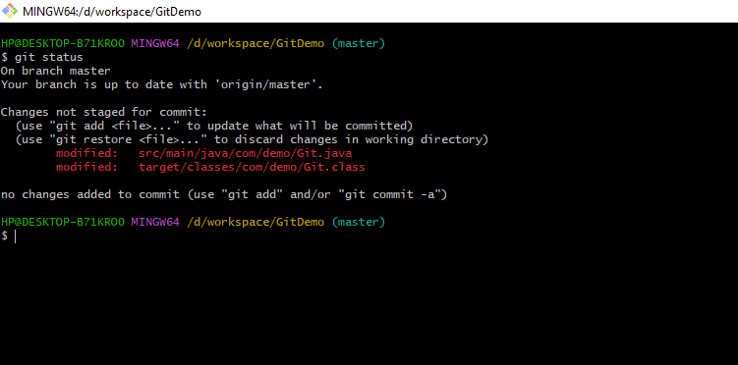

U can use below command for adding files to remote

If u want to add all files again use this command -🡪 **git add .**

If u want to add only selected l files again use this command -🡪

**git add** src/main/java/com/demo/Git.java



next commit the code git commit –m “package added”

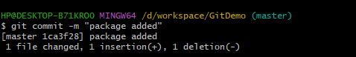

Next u can push your code to remote u can use git push origin master

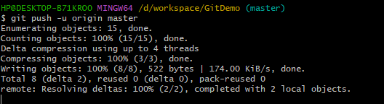

Successfully data has been added.

U can goto git hub and check data has been added or not

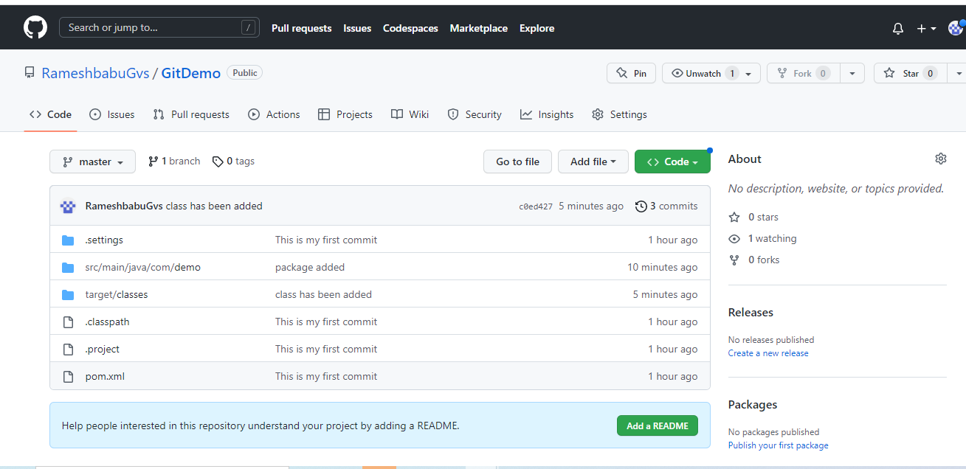

If u want to add multiple files from local to remote follow below process

Check the git status

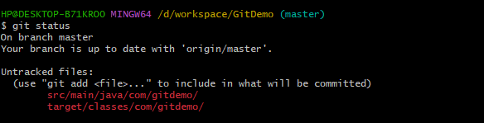

First u need to add all files side by side with one space to files

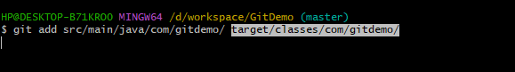

git commit –m “files added”

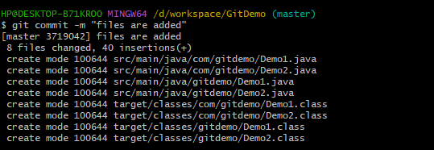

Next u can push code to remote

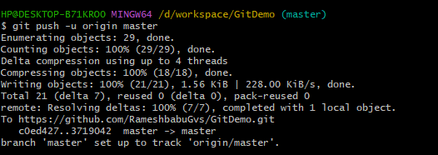

git push origin master

**Git clone**

Git clone is used for get the latest repository code from remote project. If anyone added newly to the project at the time She/he use the clone

1.Need to take GIT Hub Url

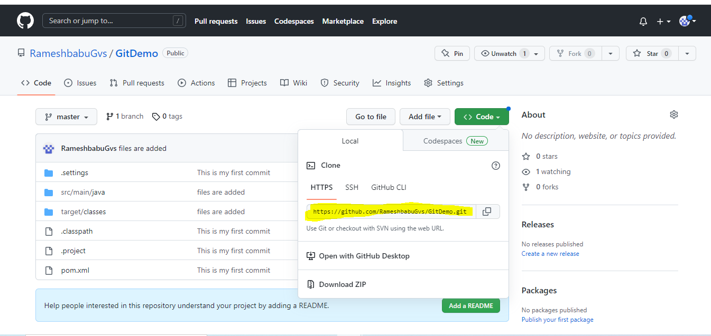

U need create the one folder in your system and open cmd

right click the 🡪mouse and 🡪select GIT Bash here option

change the directory



Check the any files available or not



U can check which directory u are in u can use pwd

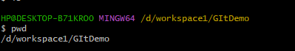

Next clone the project ---git clone project url

git clone https://github.com/RameshbabuGvs/GitDemo.git



After u can see all data has been clone to selected folder

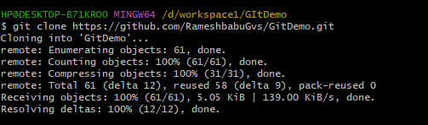

**Creation of branch in git**

git branch cartpage



Next check git branch is created or not u can use git branch

U can see two branches are available

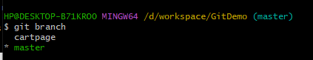

**For moving the one branch to another branch in Git**

u can use 🡪 git checkout branch name or git switch branch name

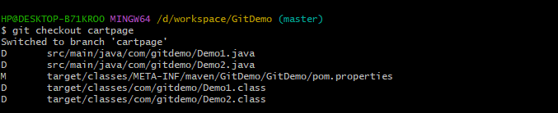

Now cartpage is main branch * indicates main branch

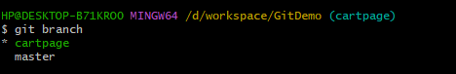

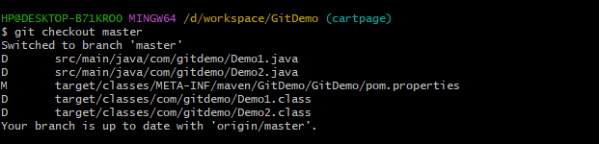

Add the files to cartpage branch

Modify the one line in existing project

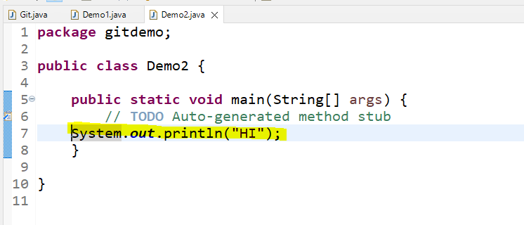

Next check the git status

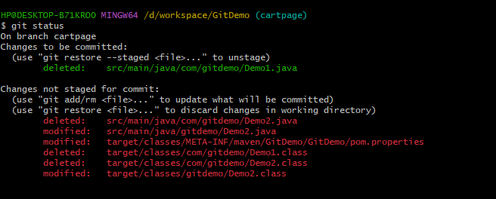

Add the all files to git

U can use git add files



After successfully adding it is showing green color line

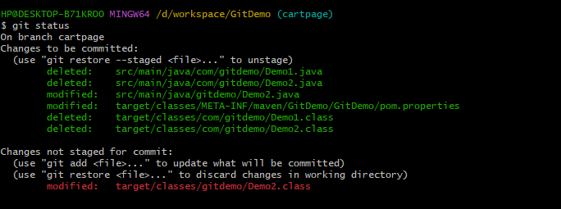

Next u can commit the code

git commit –m “give valid comment”

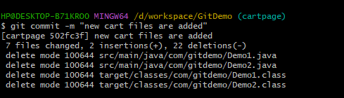

Next u can push the local to remote git cartpage branch

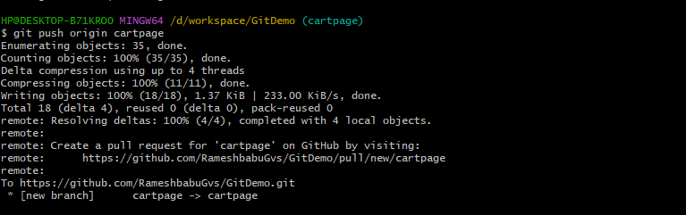

Arrow mark show data moves local cartage to remote cart page

One new pull request is coming from cartage branch to master branch

After pushing the code from local one new branch is created to git hub

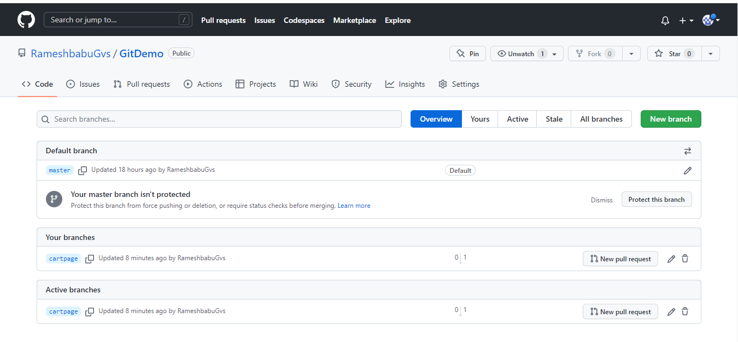

New branch is visible in GIT Hub

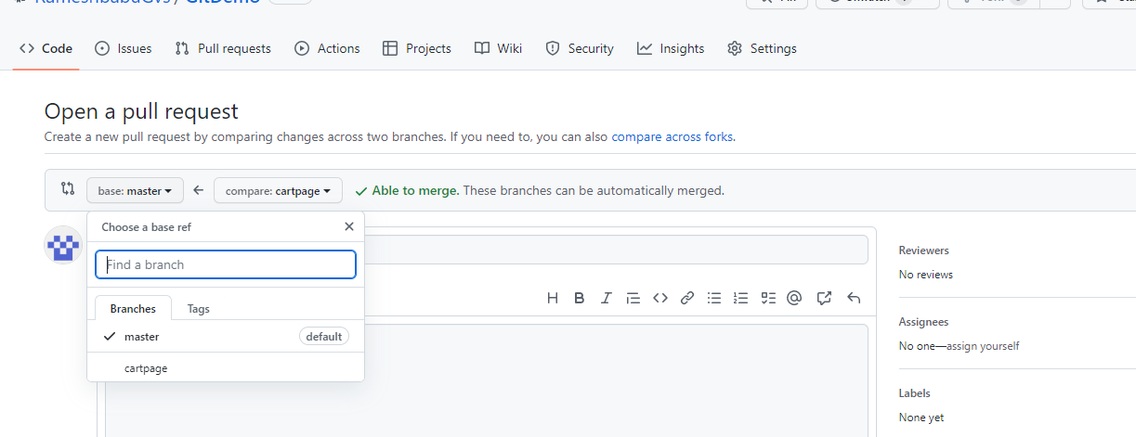

See the comment also

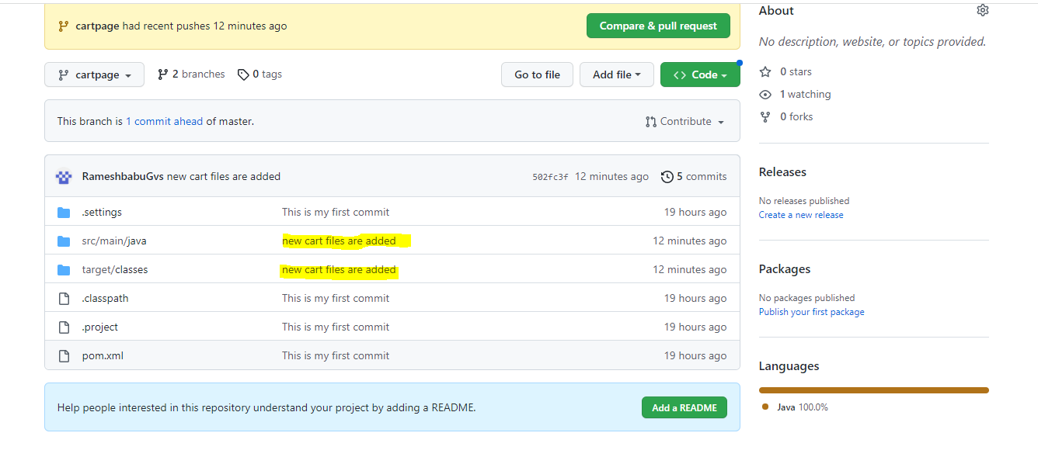

U merge the code from cart page to master branch

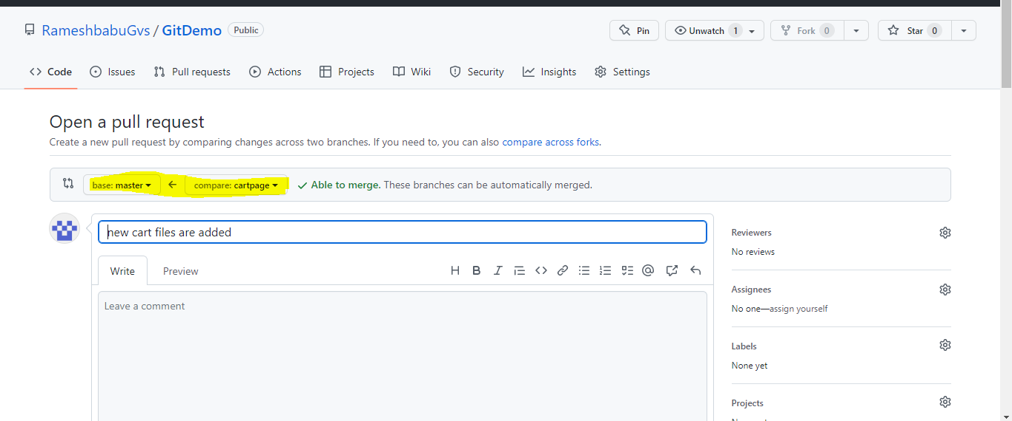

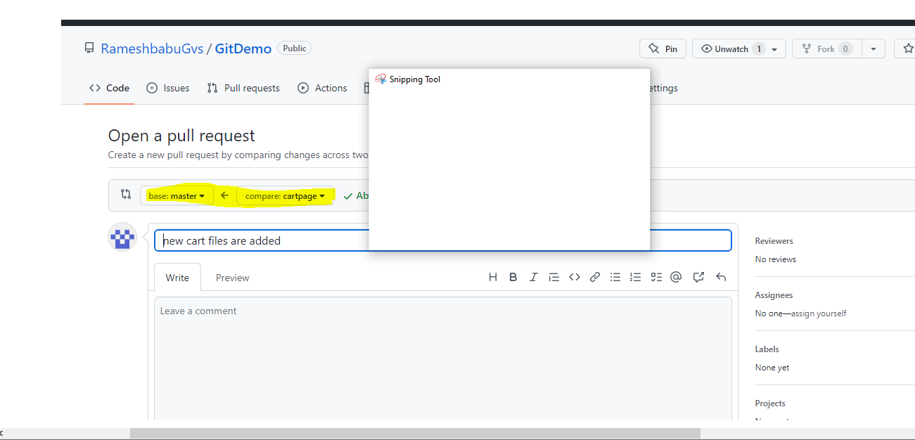

Sucessfully pull request has been raised master branch and now the status will be OPEN.

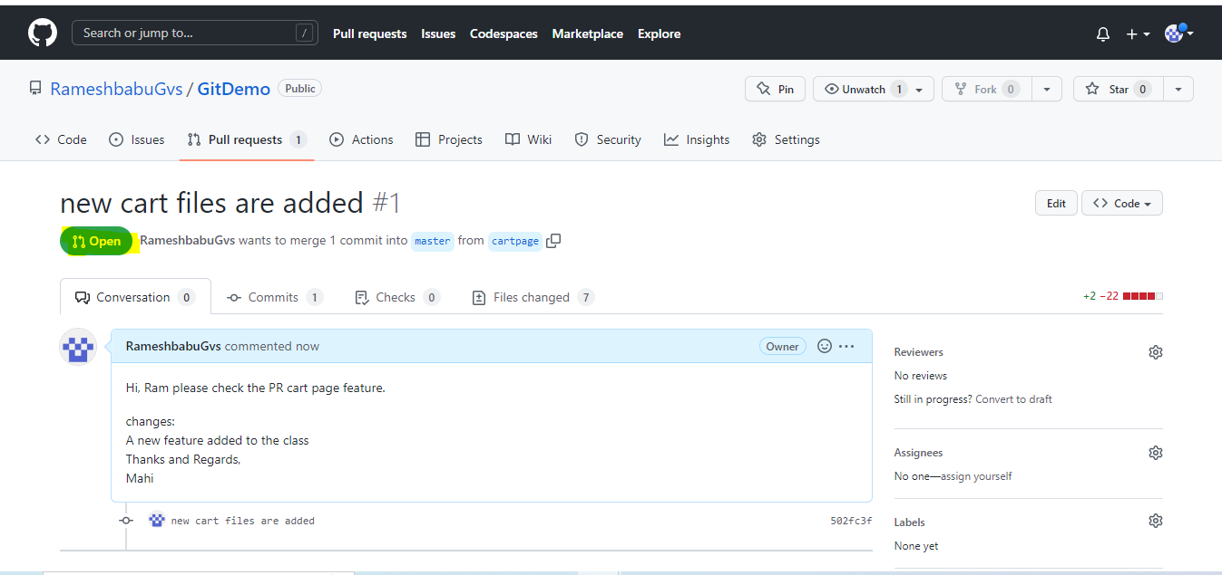

Who maintaining the git they need to approve the pull request?

Pull request visible

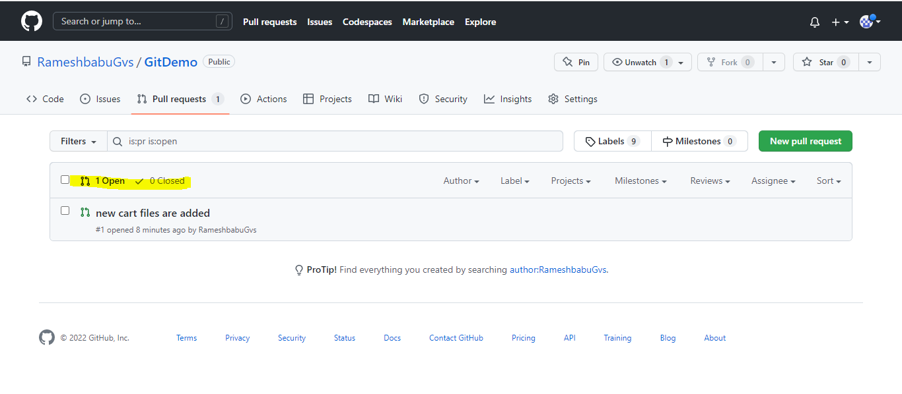

U can see the message 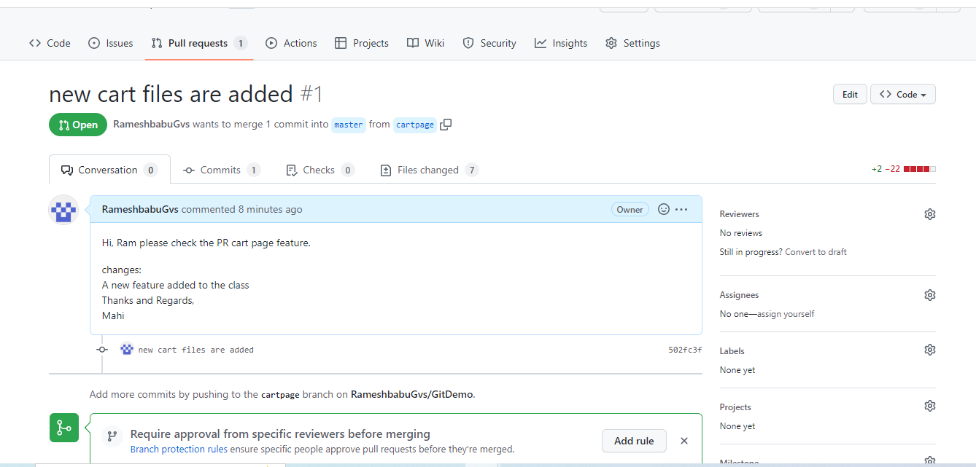

If any changes required need to add the comment select blue ’ + ’ button

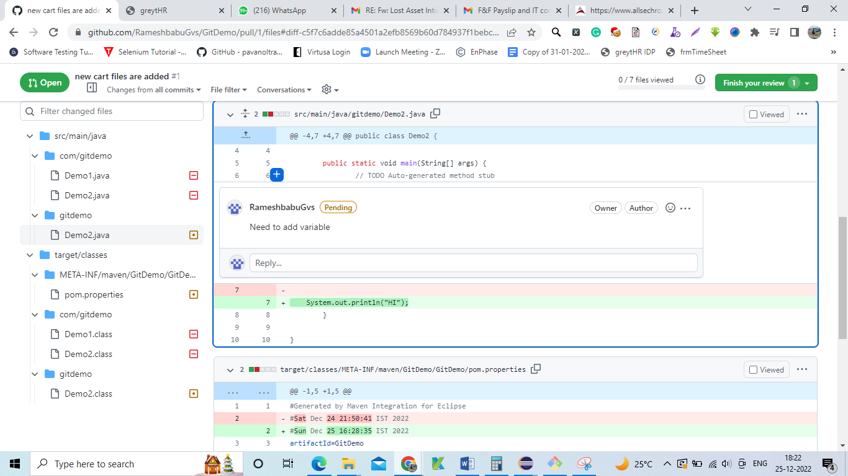

Finish your review means final review and submit the review. comment will be going to cart page.

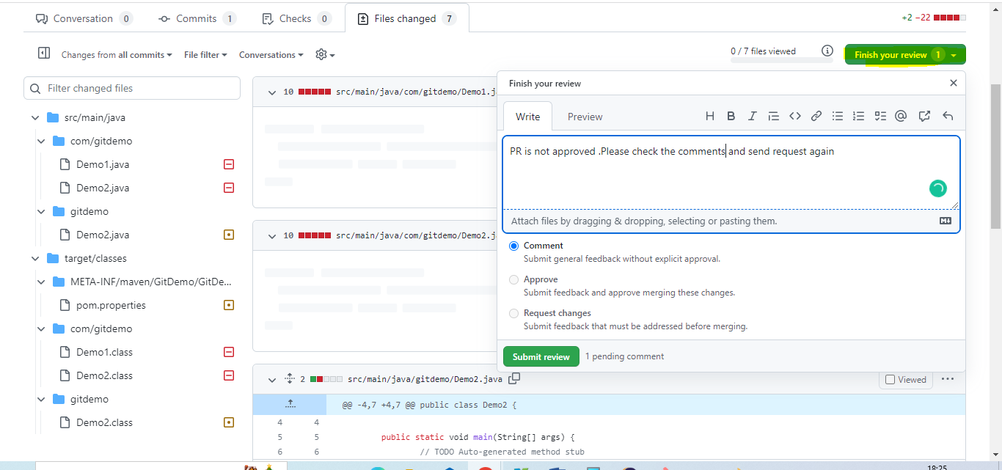

Now open the comment and see what git maintainer mentioned 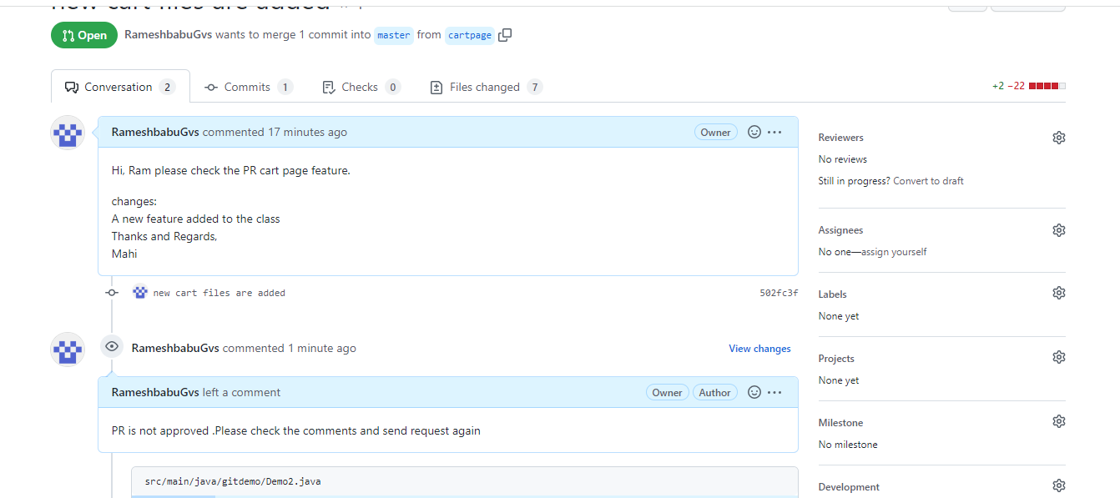

Open the eclipse and add variable

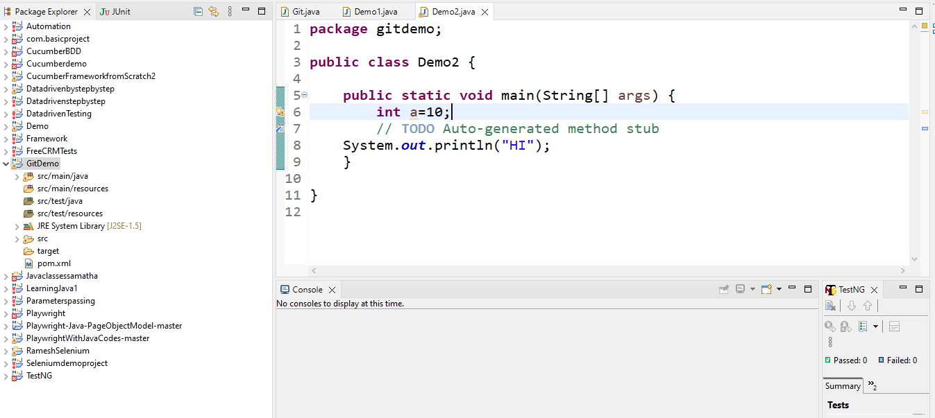

Again add the code to local and remote branch

Check the git status

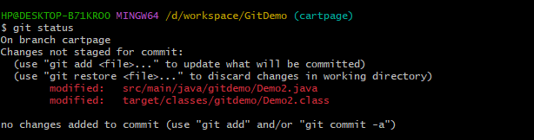

Add the files to staging



New files Added to local

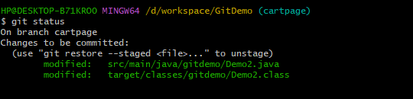

git commit –

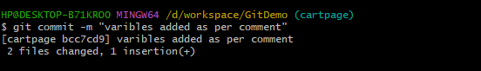

Next u can push the code cartpage

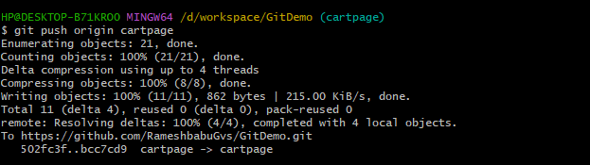

U can check code has been added to remote

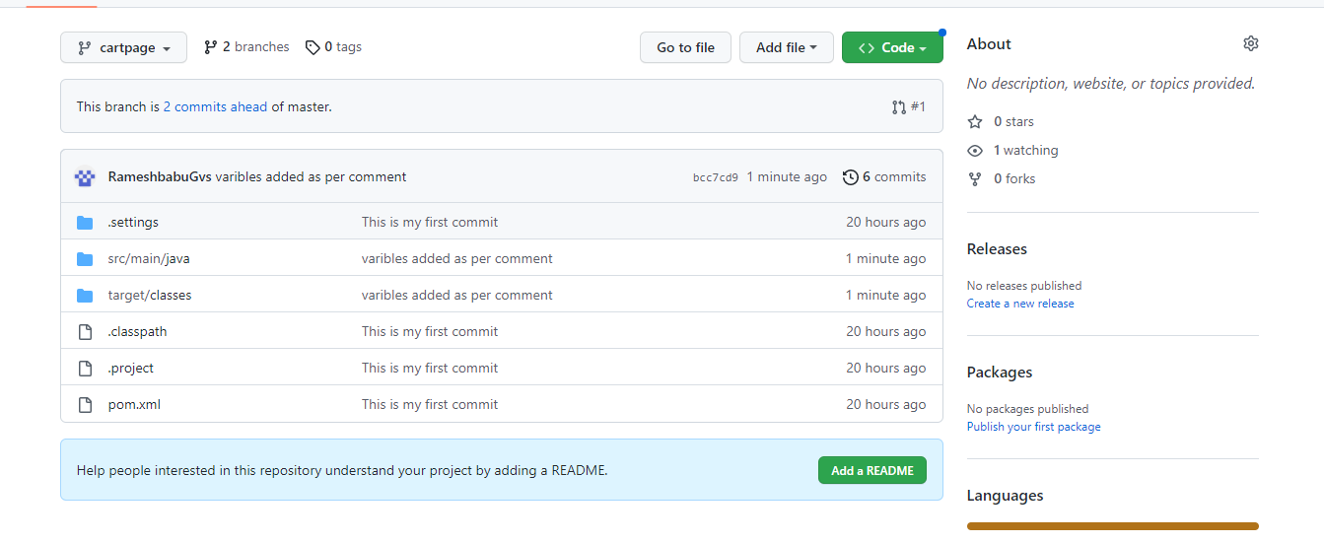

One pull request has been come to master branch u can see variable has been added

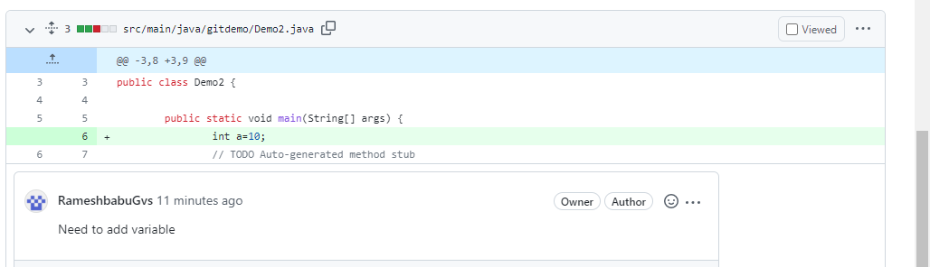

Enter comment and click submit review button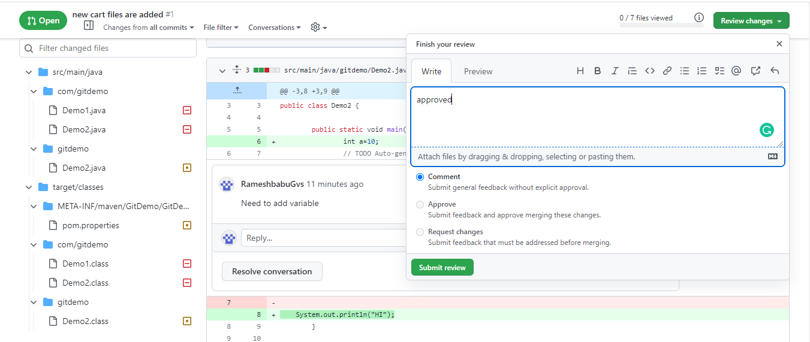

. Next any one click the Merge pull request button

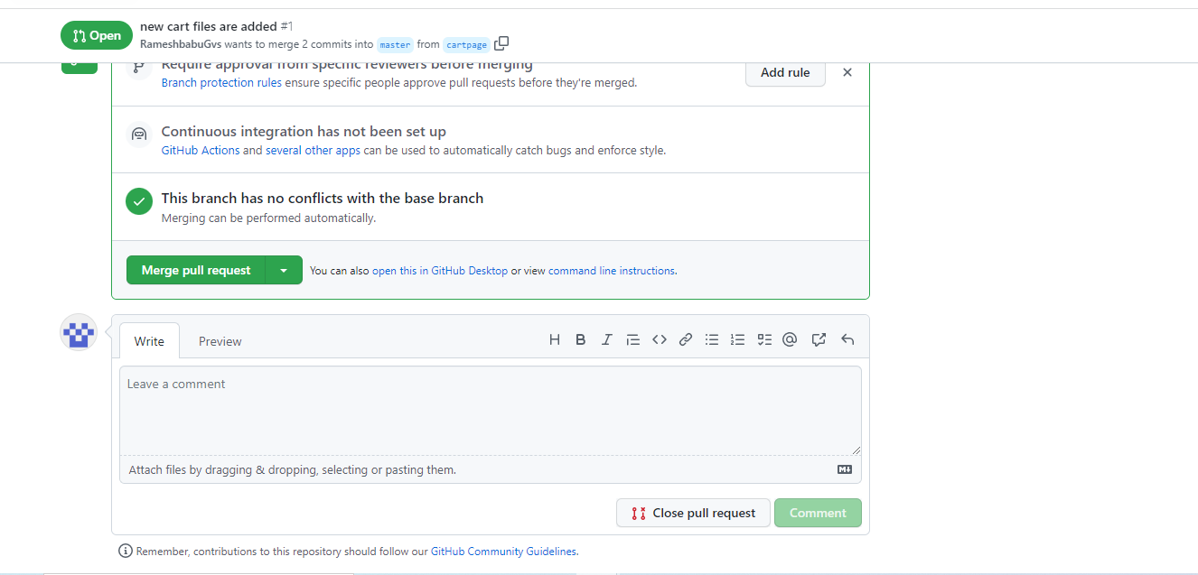

Click the confirm changes button

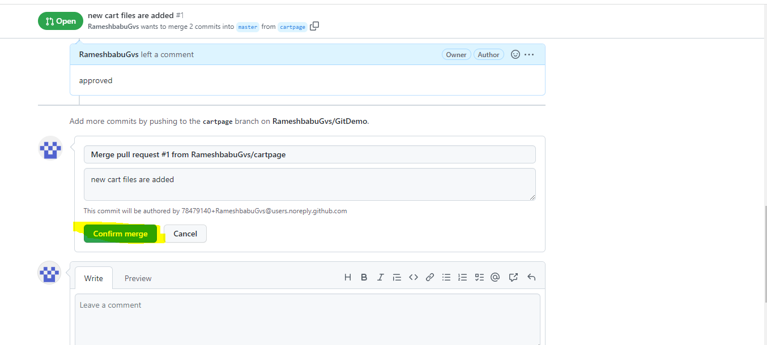

U can see the success message 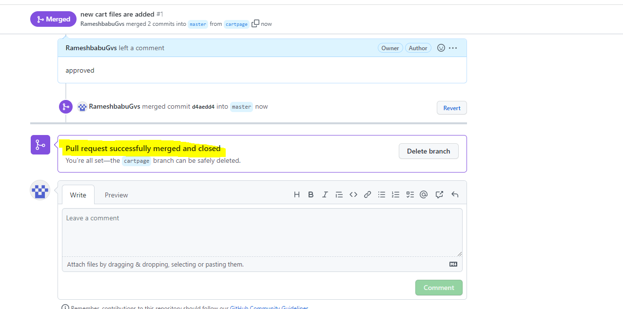

Go to master bra

nch and see the new files merged or not

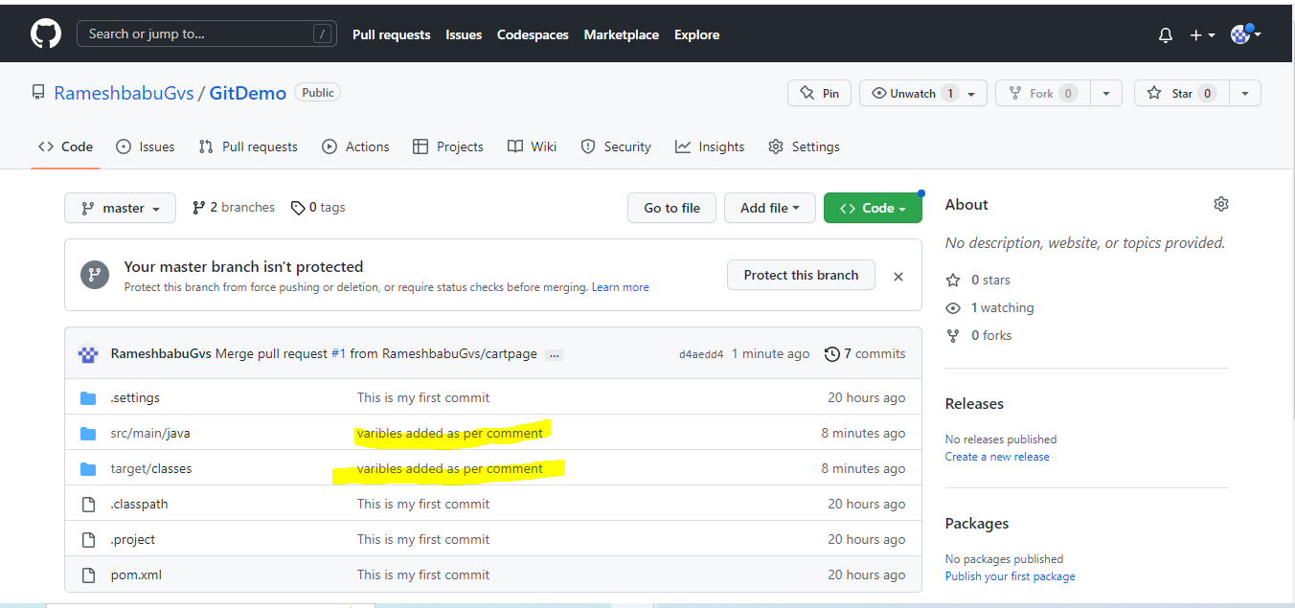

Next u can pull the code from git

git pull origin master

