**1.What is software Testing**

In Software Testing Software Contains number executable Programs in Computer is called Software.

**2.What is Testing**

A comparison between Expected Value and Actual value is called as Testing.

Expected Value: Expected Value is nothing but Client Requirement.

Actual Value: Actual value is nothing but output value.

**3.What is Error**.

Error: After completion of the development developers are checking modules wise in coding. if got any coding mistake error that is called error. Error comes under Development.

Quality: Customer or client Satisfaction is called quality.

Error free: we have a one requirement until client satisfaction we are conducting the Testing and delivering as per equipment.

**4.What is Failure.**

Failure: After delivering or deploying to the client users are facing some functional or any business are coming at the we are calling as Failure.

**5.What is Project**

Project: only specific client requirements based they are the developing the application. Only client is able to use other they are not able to use the application that is called as Project.

Ex: Bank software, Super market software, Billing software, Hospital software, Insurance application. etc.

**6.What is Product.**

Product: As per the Market requirement based developing application is called as Product.

Ex: Mobiwik, Amazon, UPI apps, WhatsApp, Facebook, Google etc.

**7.What is Verification.**

Verification: it is process verifying the developing project or Product is called as Verification and also called as Static Testing. Verification conducted by Testers.

**8.What is Validation**

Validation: it is a process of Validating the developed Project or Product is called as Validation it is also called Dynamic Testing. Verification conducting by Testers.

**Severity:** Severity is coming under Functionality

**Priority:** Priority is coming under Business level.

**9.What is the Roles and Responsibilities for tester.**

1.Writing the Test cases and Test Scenarios as per the requirement.

2.Conducting the Testing in Positive way and Negative way also.

3.Need to write more Negative Test case.

4.Need to follow the Testing standards,

5.Need conducting the Testing different ways.

6.Need conduct the all Testing (Smoke,Re-Testing, Regression functional and Non functional etc.)

7.Need to follow Testing methods and Technquies.

8.Need to follow Testing methodologies.

9.Need conducting the testing all possible ways.

**10.What is Qulity:**

Customer or Client Satifaction Is is called as Quality is called a Qulity.

**11. How much testing is enough? Or when you are stopping the Testing.**

1.Untill expected result==Actual Result.

2.Upto client satisfaction

3.bug less free.

4.As per requirement.

5.Upto Tester Ratification as per requirements full fill.

**12.What is the Differences between Manual and Automation Testing.**

**Manual Testing**

Manual Testing Means need to involve the Manual Intervention .if we are performing Manual Testing we need Man power without Manpower we can’t do.

Manual Testing takes time.

By using Manual Testing, we can perform both Functional and Non-functional Testing.

**What is Functional Testing:** Functional Testing means when we are performing any action in application if it is performs any response or action is called as Functional Testing.

Ex:Click button, Text box,url etc.

**What is Non Functional tesing**: Non Functional Testing means when we are performing any action in application if it is doesn’t performs any response or action is called as Non-Functional Testing.

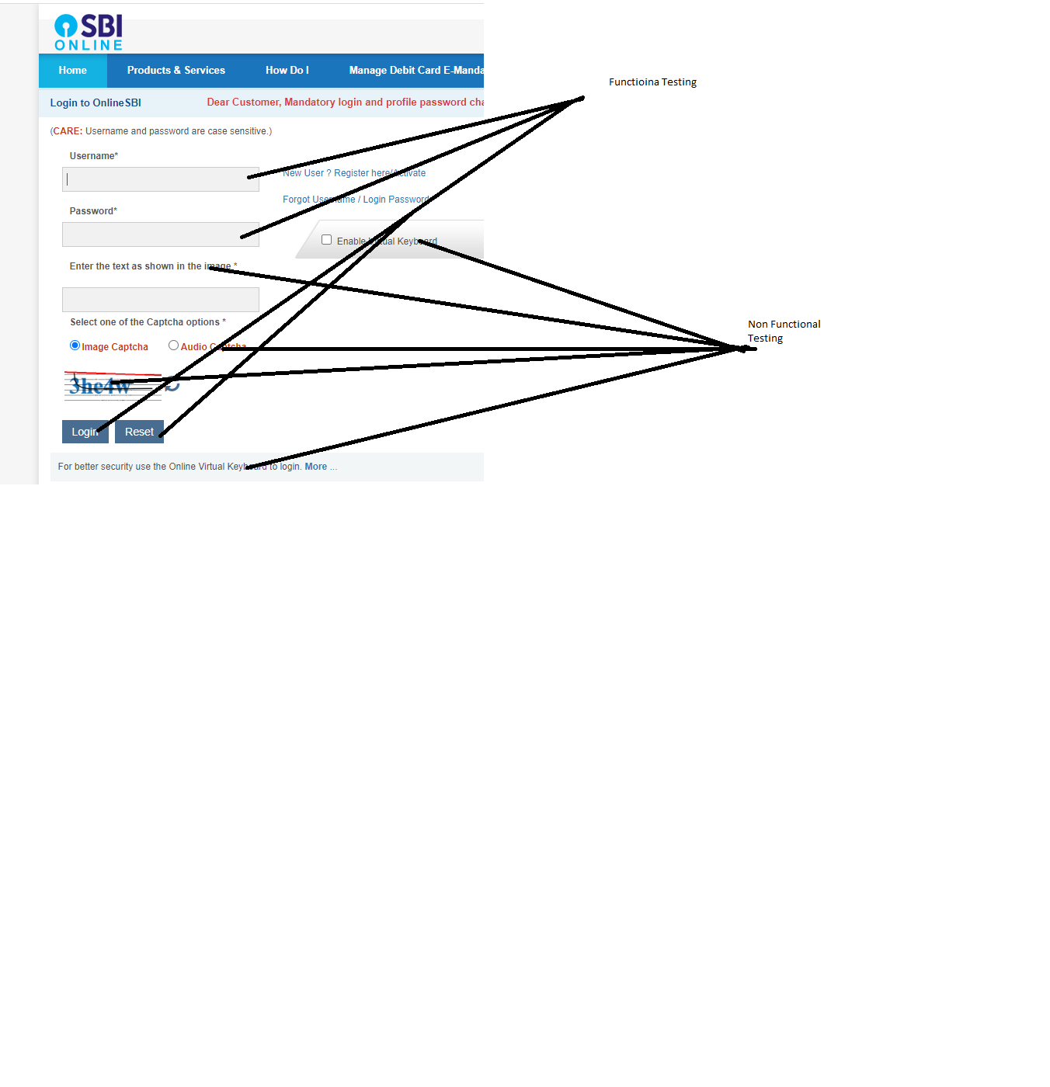

**What is Automation testing**

In Automation Testing we need use any one tool for performing the Testing. If we are using the automation, we can save the time and speed up the process also. But if u is using we need any basic coding (ex: Java or Python or C#) knowledge and any one scripting (Selenium or Groovy) language. By using Automation Testing we are able to perform only Functional Testing.

Tools: Selenium with java, Selenium with Python, Selenium with C#, Tosca, Cypress, Playwright, Katalon etc.

**13.What is Test Scenario:**

Test scenario is nothing but one-line order information is called as Scenario

Ex: I want to book the train ticket from Hyderabad to Delhi.

**14.What is Test case:**

Test case is nothing but step by step process of Test scenario is called as Test case.

Ex:1. Open Browser.

2.Navigate to url.

3.Enter valid username, Password, Click Login button

4.Select from and Destination locations

What is Software Testing Methodologies?

* What is White Box Testing. –it is conducted by developers only

Here they are checking coding in Module wise. Why only developers conduct the testing they knows the entire in line wise. if any Tester Have Coding knowledge they can also do.

* What is Black Box Testing. –It is conducted by Testers only.

Here the Testers are conducting the Testing in Functolity as per client requirement

* What is Grey Box Testing.

Grey box Combination of Black Box Testing and White Box Testing.

**15.What is Smoke Testing**

Smoke Testing is nothing but Initial Testing or Build Verification Testing. Here we need to check the basic functionalities of the Application, whenever the developer Is given the build at that time we are performing Smoke Testing.

Basic Functionalities

1.Url Navigation

2.Login Functionality

3.if u are using E-commerce application Trying click search an one product

Build is nothing but Url([**https://www.amazon.in/gp/help/customer/display.html?nodeId=200507590&ref_=nav_cs_help**](https://www.amazon.in/gp/help/customer/display.html?nodeId=200507590&ref_=nav_cs_help))

**16.What is Re-Testing**

We need to check the Same functionality again again two or more times is called as Re-Testing.

Here validates bug is fixed.

When we are conduct the Re-Testing whenever we are raise bug once developer is fixed the bug at the time  we are conduct Re-Testing.

**17.What is Regression Testing**

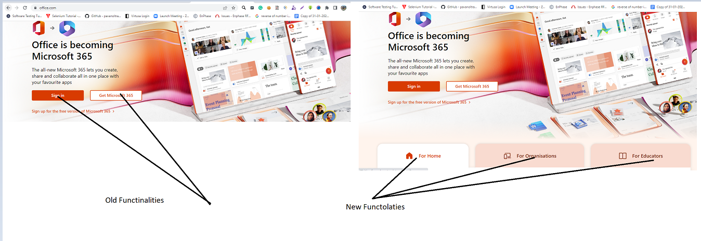

In Regression Testing we need to validate Old Functionalities and New functional ties also. why because of the Reason we need to check is there any effect occurs in the old functionalities due to adding the New functionalities.

**18.When we are conducting Re-Testing.**

When the developer is adding new functional ties at the time we are conducting Regression-Testing.

**19.Difference between Regression Testing Vs Re-Testing.**

|  |  |
| --- | --- |
| Regression Testing | Re-Testing |
| If any new feature is added at the time we are conducting only Regression Testing. | If any bug is Occurred at the time we are conducting only Re-Testing. |
| Every build releases at the time we are conducting Regression Testing. | Every Bug Occurs at the time we are conducting Re-Testing. |
|  |  |

**20.Difference between Smoke Testing Vs Sanity Testing.**

|  |  |
| --- | --- |
| **Smoke Testing** | Sanity Testing |
| Whenever the new build is Releases at the only we are conduct only Smoke Testing | Before Releases the applications at the time only we are conduct the testing only Sanity Testing |
| We are checking only Basic Functionalities of the Respective application | We are checking All Functionalities of the Respective application |
|  |  |

**21.What is AdhocTesting**

 If we have less time or lack of time to perform the Testing at the time we are prefer Adhoc Testing. We are not maniating rules.

**22.What GUI Testing**

GUI means –Graphical User Interface testing. Here we need Validate  Designing part of the Application During Testing ex:Verifying colors, Spelling mistakes, Back ground colour etc.

**23.What is Usability Testing.**

Usability Testing means (User Easy to use the application) and it also called as User-friendly Testing.

In this type of Testing we are performing user point of view user able easily accessible or not.

Ex: Samsung Phone, IPhone

Ex: Windows, Linux

**24.What is Alpha Testing and Beta Testing**

**Alpha Testing**

1.It is Suitale for Project

2.it is also called a first level of testing

3.Alpha is performed by Business Analyst.

4.it is applicale for only project level

5.It is not suitable for market level.

6.we change the requirements easily

7.we can validate only environment

**Beta Testing**

1.it is Suitable for Product.

2.it is also called as last level of testing

3.Client perform Beta Testing

4.Beta perform Client premises

5.it is not suitable for Project

6.We can’t change the requirements easily

7.we can validate Virtuall environment also.

**25.STLC –Software Testing life cycle**

**1.TestPlanning**

**2.TestAnalysis**

**3.TestDesign**

**4.TestEnvirnoment**

**5.Test Execution**

**6.Defect Reporting**

**7.Testcloser.**

**Defect Template**

Defect Heading: Add to Card button is not working

Defect Description: When I am trying to purchase the product in Amazon application after selecting the product I try to click the Add to cart button but Add to cart button is not working as expected.

Steps:1. Open Browser,2. Navigate to url,3. If u have Registered Account login by using valid credentials,4. Select the product with specification (Size, colour, Brand, Price etc.),5.Click Add to cart button.

Expected Result: User able to navigate Payment Page

Actual Result: User not able to navigate Payments page.

Priority: High

Severity: High

Screenshot of the Bug

1. **- How do you identify the test cases which are suitable for automation:**

1.Functional test case case are we are able to automate.

2.Non-functional test case are we are not able to automate.

3.Which task are u want daily execute those functionality are we are able to automate.

4.OTP ,Capthaca functionality are not able automate.

1. **- What all things can you automate?**

1.Functional test cases are we are able to automate by using selenium with java.

1. **- When is Automation testing useful?**

1.for doing repeated functionalities. ex: Registration form filling.

2.When u are performing Re-Testing, Regression Testing at the time Automation Testing is useful.

1. **- How to decide the tool that one should use for Automation testing in their projects?**

1.depends upon the project budget.

2.prefer open source tool.

3.We need to take the project requirement.

If the project have only web application testing,Mobile application

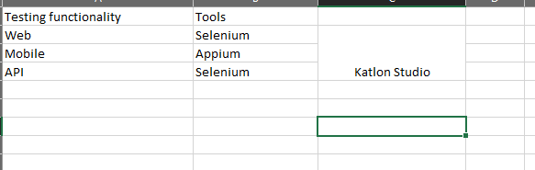

**5.- Currently I do not have any automation in place in my project, but now I want to implement automation, what would be my steps?**

1.u need identify the teases for automation

2.identify the repeated test functionalities.

3.first u need Select the one open source tool. Why because of the reason it is open source and company no need to pay the money.

U need to do one POC(Proof of the concet).after completion of that u need show company .if they are approving u have acces doing entire automation**.**

1. **- Once you identify the tool what would be your next steps?**

1.Need to take the requirements.

2.need to identify & which teases are able to automate.

3.take all the inputs from manual team.

1. **- Any kind of test which you think should not be automated?**
2. OTP ,Capthaca functionality are not able automate.
3. Non-Functional testing we are not able to perform.
4. **- Do you think that testing can be done only at the UI level?**
5. By using automation We can do only UI level functionalities

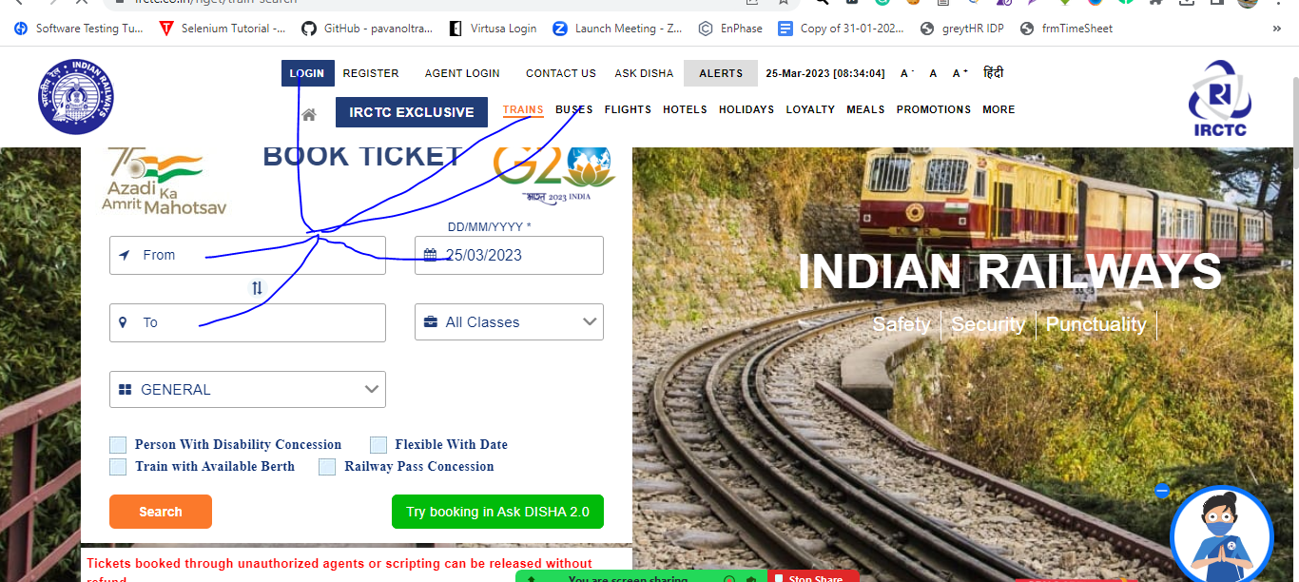

1. **- When do you prefer Manual testing over Automation testing?**

1.To overcome the speed of the execution.

1. **- Is Automation testing in agile Methodology useful or not?**

1.It is useful why because of the reason we can develop the script with in sprint time period.

1. **- Can we do Automation testing without a framework? If yes, then why do we need a framework?**

1.We can do without frame work also but we are not following any frame work standards. if u are following any framework we can develop the automation script with standards.

**13 - How will you automate basic “login” functionality test cases for an application?**

1.We need to write Positive cases and negative cases also.

**14- Is Automation testing a Black box testing or White-box testing?**

Automation testing is comes under Black box testing

**15 - What factors determine the effectiveness of Automation testing?**

1.Speed of work,2.Quality of Testing.

**16 - Which test cases can be automated?**

1.Repative functionalities,Functional Test case we can able to automate.

**17 - What are the phases in Automation testing Life Cycle?**

1.Need to identifi the tecases

2.Need to identify the tool.

3.Need to identify the coding langauage.

4.Need to identify the framework.

5.Need to identify pre-conditions.

6.Maintain the scripts.

**18 - What is an Automated test script?**

1.it is group of the programs.

**19 - On what basis you can map the success of automation testing?**

1.Saving execution time.

2.reduce the resource.

3.Maintance also less.

**20 - What are the five common solutions for software developments problems?**

1.Requirments

2.Resource.

3.Environments

**21 - Why does software have bugs?**

1.during development if developers are not developed as expected the time tester are identifying the bugs**.**

**22 - How can new Software QA processes be introduced in an existing organization?**

1.Need prepare proper documentation of the new Software.

2.Need to give the proper demo.

3.Need give the training session.

4.Conduc the practical session etc.

**23 - What kinds of testing should be considered in manual testing.**

1.We can conduct both Functional and Non-Functional Testing also.

**26 - What makes a good test engineer?**

1.For identify the requirements.

2.Conduct the execution in testing standards,

3.Follow the all Testing techqnies for Testing

4.Identify the all bugs

5.Conduct the testing until client satisfaction and client requirment.

**27 - What's the role of documentation in QA?**

1.U need to Write tescase and Tetscenarios.

2.Need to prepare the RTM

**28 - What if the software is so buggy it can't really be tested at all?**

1.Need to take the all bugs.

2.Need to take the approval from manager for testing.

3.need to conduct the testing again.

**29 - How can it be known when to stop testing?**

1.If all the bugs are closed. If it error less. we can stop testing.

**30 - What if there isn't enough time for thorough testing?**

1.perform Monkey testing and Exploratory testing