**Step 1**: Download vehicle sales data from below link.

https://github.com/shashank-mishra219/Hive-Class/blob/main/sales_order_data.csv

**Step 2**: Copied the data set from laptop to Linux machine using FileZilla.

Path: /home/maria_dev

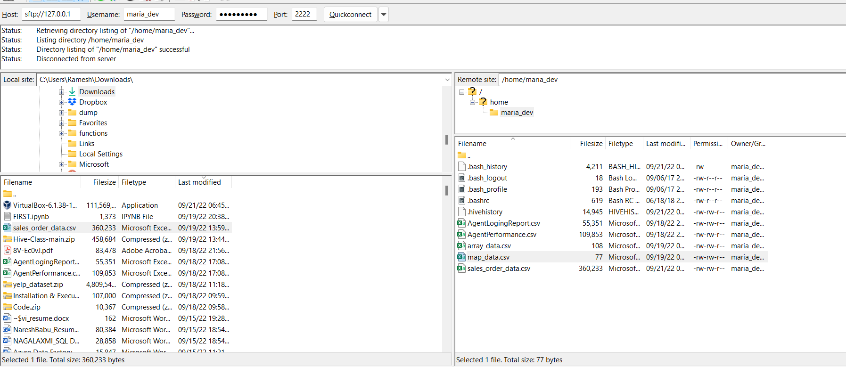

**Step 3**: Created directory to store the Data set into Hadoop.

Hadoop fs -mkdir /apps/hive/data



S**tep 4**: Copied dataset from local to Hadoop directory.

hadoop fs -copyFromLocal /home/maria_dev/ sales_order_data.csv /apps/hive/data

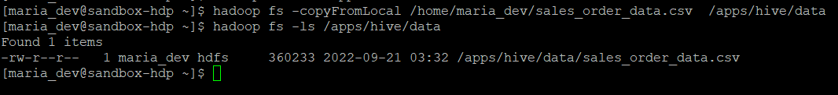

**Step 5**: Create database in hive.

create database sales_order;

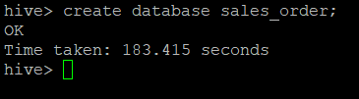

**Step 6**: Use hive_assignment, to create the table in particular database.

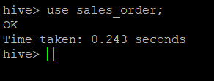

**Step 7**: Create table sales_order_csv.

CREATE TABLE sales_order_csv (ORDERNUMBER int, QUANTITYORDERED int, PRICEEACH float, ORDERLINENUMBER int, SALES float, STATUS string, QTR_ID int, MONTH_ID int, YEAR_ID int, PRODUCTLINE string, MSRP int, PRODUCTCODE string, PHONE string, CITY string, STATE string, POSTALCODE string, COUNTRY string, TERRITORY string, CONTACTLASTNAME string, CONTACTFIRSTNAME string, DEALSIZE string)

row format delimited

fields terminated by ','

tblproperties("skip.header.line.count"="1"); --this is uses to skip the first line in csv file.

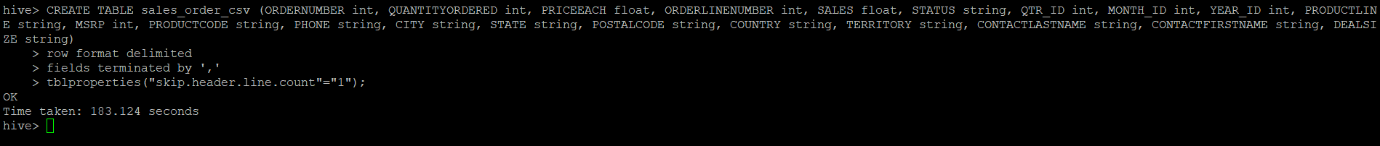

**Step 8:** Load Data into table.

LOAD DATA INPATH '/apps/hive/data/sales_order_data.csv' into table sales_order_csv;



**Step 9**: Create ORC format table.

CREATE TABLE sales_order_orc (ORDERNUMBER int, QUANTITYORDERED int, PRICEEACH float, ORDERLINENUMBER int, SALES float, STATUS string, QTR_ID int, MONTH_ID int, YEAR_ID int, PRODUCTLINE string, MSRP int, PRODUCTCODE string, PHONE string, CITY string, STATE string, POSTALCODE string, COUNTRY string, TERRITORY string, CONTACTLASTNAME string, CONTACTFIRSTNAME string, DEALSIZE string)

stored as ORC;



**Step 10**: inserting data in ORC format.

from sales_order_csv INSERT OVERWRITE TABLE sales_order_orc SELECT *;

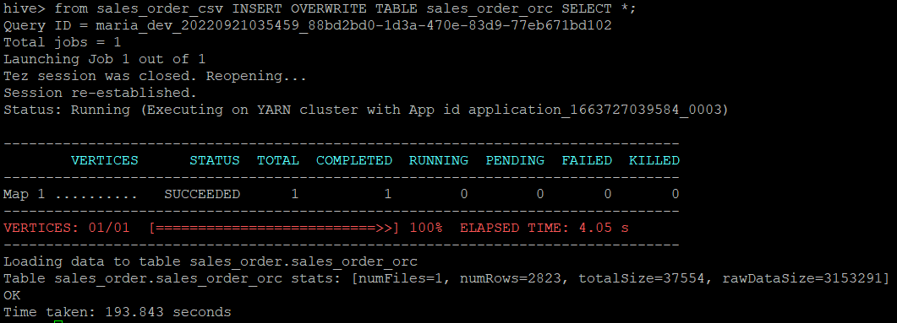

**Now let’s start writing queries from table “sales_order_orc”**

1. **Calculate total sales per year**

select year_id as Year, ROUND(SUM(sales),2) as Total_sales from sales_order_orc

group by year_id;

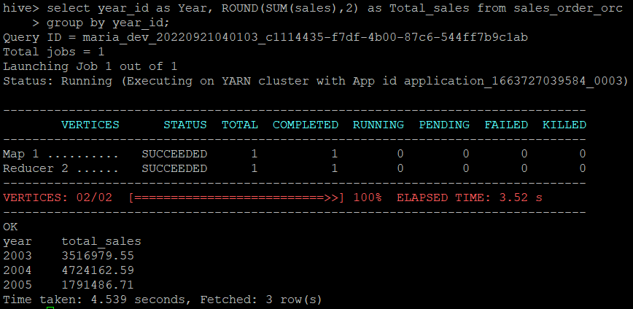

1. **Find a product for which maximum orders were placed**

select quantityordered, productline, productcode from sales_order_orc

where quantityordered in (select max(quantityordered) from sales_order_orc);

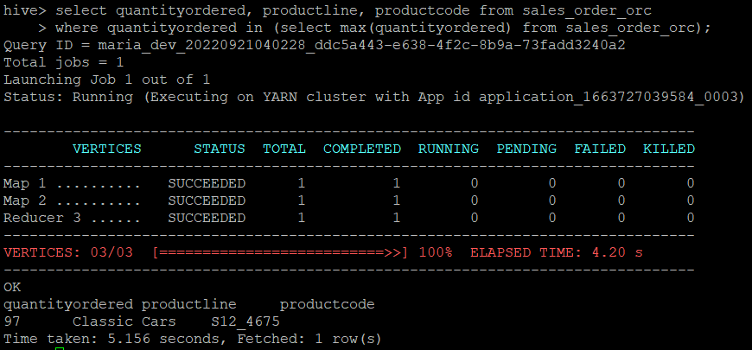

1. **Calculate the total sales for each quarter**

select qtr_id as Quarter, ROUND(SUM(sales),2) as Total_sales from sales_order_orc

group by qtr_id;

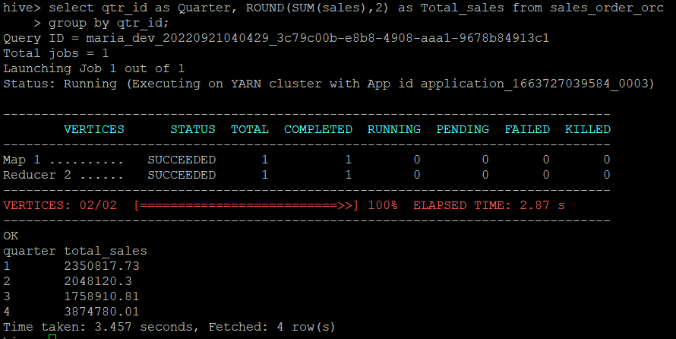

1. **In which quarter sales was minimum**

select qtr_id as Quarter, ROUND(sum(sales),2) as total_sales from sales_order_orc

group by qtr_id

order by total_sales asc limit 1;

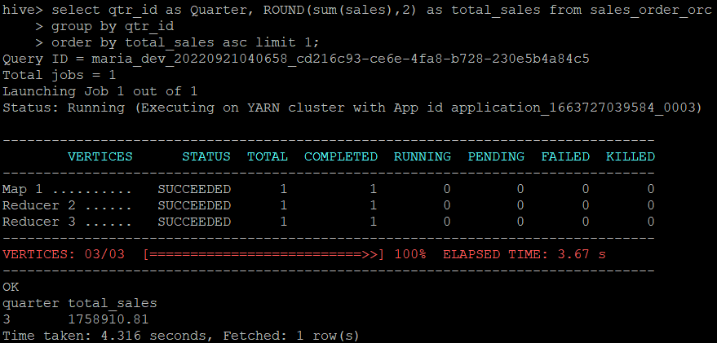

1. **In which country sales was maximum and in which country sales was minimum**

select *

from(

select country, ROUND(sum(sales),2) as min_sales

from sales_order_orc

group by country

order by min_sales asc limit 1) tmp

union

select *

from(

select country, ROUND(sum(sales),2) as max_sales

from sales_order_orc

group by country

order by max_sales desc limit 1) tmp1;

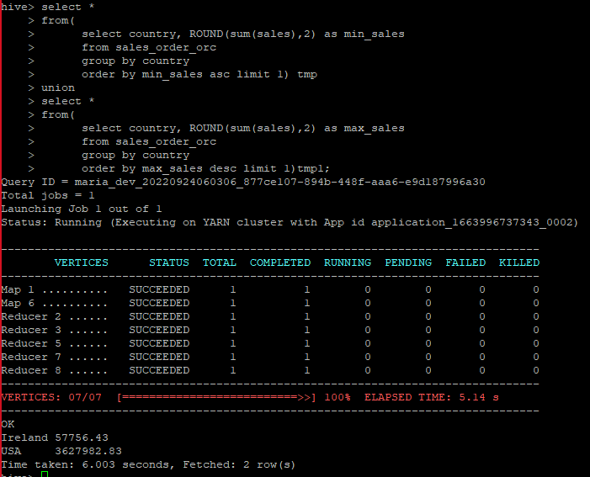

1. **Calculate quarterly sales for each city**

select qtr_id as Quarter, ROUND(SUM(sales),2) as Total_sales, city from sales_order_orc

group by qtr_id, city;

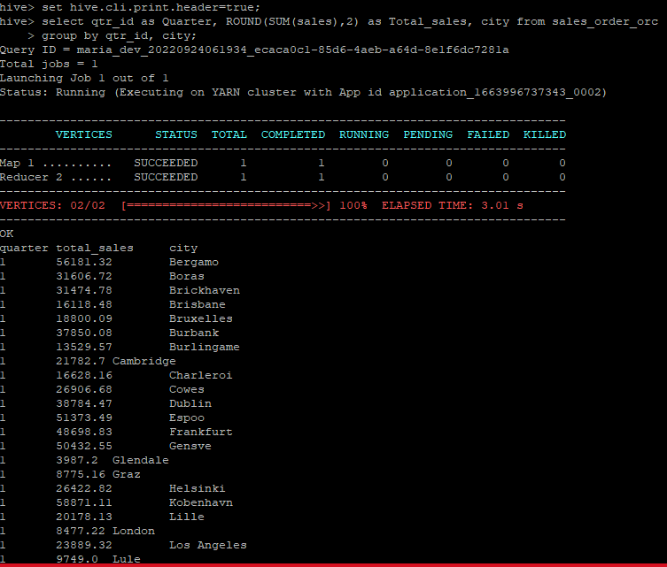

1. **Find a month for each year in which maximum number of quantities were sold**

select year_id, month_id, quantityordered from sales_order_orc a

where quantityordered in (select max(quantityordered) from sales_order_orc b where a.year_id=b.year_id )

group by year_id, month_id, quantityordered;

