CPU Usage Prediction — Q3 Report

Workflow
...

Metrics
MAE: 0.00893013663543244
MSE: 0.0006878779584930252
RMSE: 0.02622742759961459
R2: 0.8315563461424365

Figures
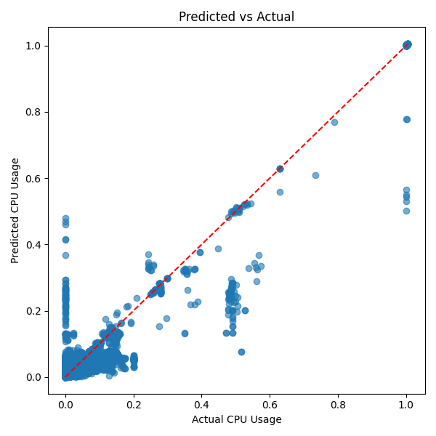
plots/pred_vs_actual.png
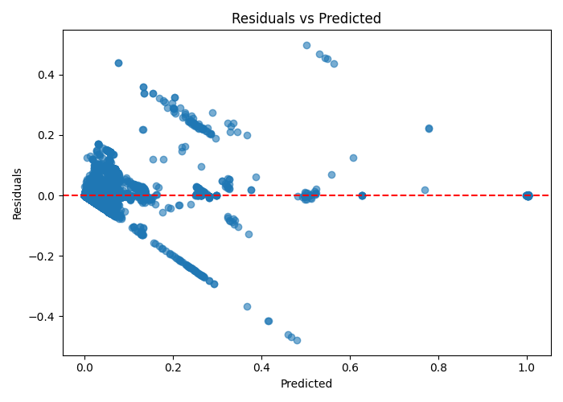
plots/residuals.png
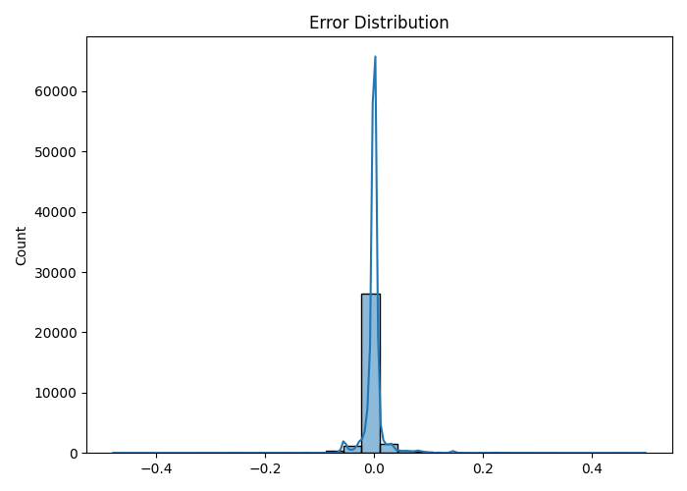
plots/error_distribution.png

