SKILL8: Writing JPQL Queries using Spring Data JPA Derived Query Methods (findBy, updateBy, deleteBy, countBy)
NAME : Rameshkumar Kandula
ID : 2400031595

Let’s clearly understand the difference between:
- Predefined / Built-in Spring Data JPA Methods
- Derived Query Methods

Built-in Spring Data JPA Methods
These are already provided by Spring Data JPA through the JpaRepository interface.

Example:
public interface UserRepository extends JpaRepository<User, Long> {
}
You automatically get:
- save()
- findById()
- findAll()
- deleteById()
- count()
- existsById()

Example Usage:
userRepository.save(user);
userRepository.findById(1L);
userRepository.findAll();

Characteristics
- Predefined methods
- No custom method naming needed
- No JPQL or SQL writing
- Works for basic CRUD operations

Derived Query Methods
These are custom methods where:
Spring generates the query
Based on the method name
You don’t write JPQL or SQL,
but you define method names carefully.

Example Entity
@Entity
public class User {
private Long id;
private String name;
private String email;
private String status;
}

Repository with Derived Queries
public interface UserRepository extends JpaRepository<User, Long> {

List<User> findByName(String name);

void deleteByEmail(String email);

long countByStatus(String status);

boolean existsByEmail(String email);

List<User> findByNameAndStatus(String name, String status);

List<User> findByNameLike(String name);

List<User> findByIdGreaterThan(Long id);
}
Spring converts them automatically into JPQL queries at runtime.

Characteristics
- Custom methods
- Query derived from method name
- No need to write @Query
- Supports:
  - And / Or
  - Between
  - Like
  - GreaterThan
  - LessThan
  - OrderBy
  - In
  - Not
  - IsNull
  - etc.

Common Derived Query Keywords
Keyword | Purpose
findBy | Fetch records
deleteBy | Delete records
countBy | Count records
existsBy | Check existence
And, Or | Combine conditions
Between, Like, GreaterThan | Conditions
Note: There is no direct updateBy method in derived queries. Updates require @Modifying + @Query.

Example Derived Query → JPQL Mapping
Method Name | JPQL Generated
findByCourse("Java") | SELECT s FROM Student s WHERE s.course = 'Java'
countByCourse("Python") | SELECT COUNT(s) FROM Student s WHERE s.course = 'Python'
deleteByEmail("a@gmail.com") | DELETE FROM Student s WHERE s.email='a@gmail.com'

Important Points
- Derived queries are converted into JPQL, not SQL
- Method names must follow naming conventions
- updateBy does not exist in derived queries
- Updates require @Modifying + @Query
- @Transactional is mandatory for delete and update queries

Project Details
File New Spring Starter Project
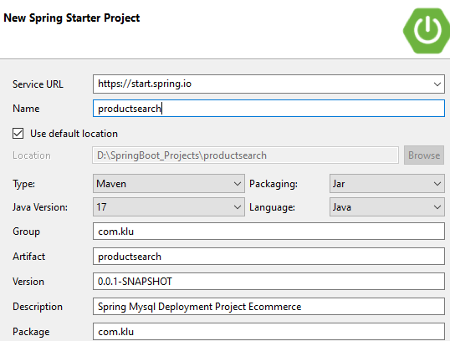

Dependencies
✔ Spring Web
✔ Spring Data JPA
✔ MySQL Driver
✔ Lombok (optional)

Create Spring Boot Project

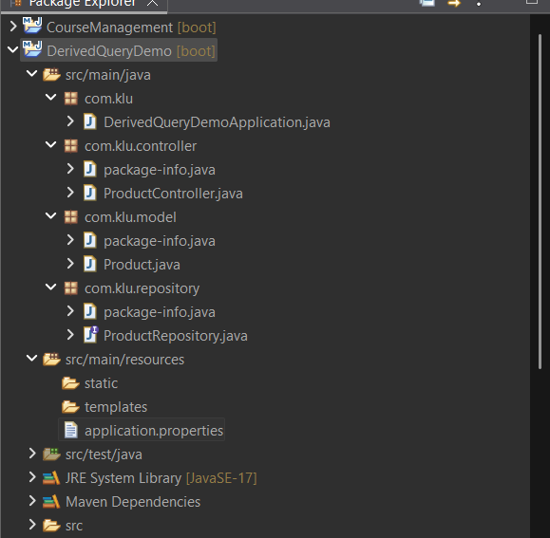

MySQL Database Setup
===========================================
CREATE DATABASE productdb;
USE productdb;

===========================================================

Configure application.properties
----------------------------------------------------------------------------------------------
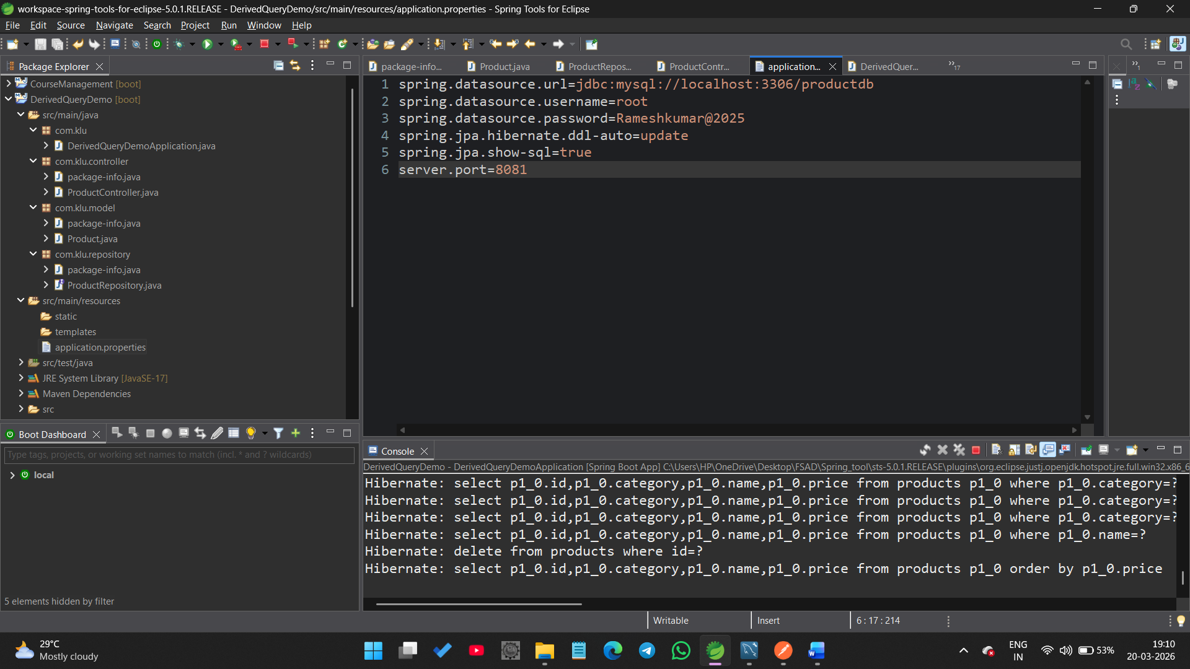---------------------------------------------------------------------

Create Entity Class

Product.java
=================================================
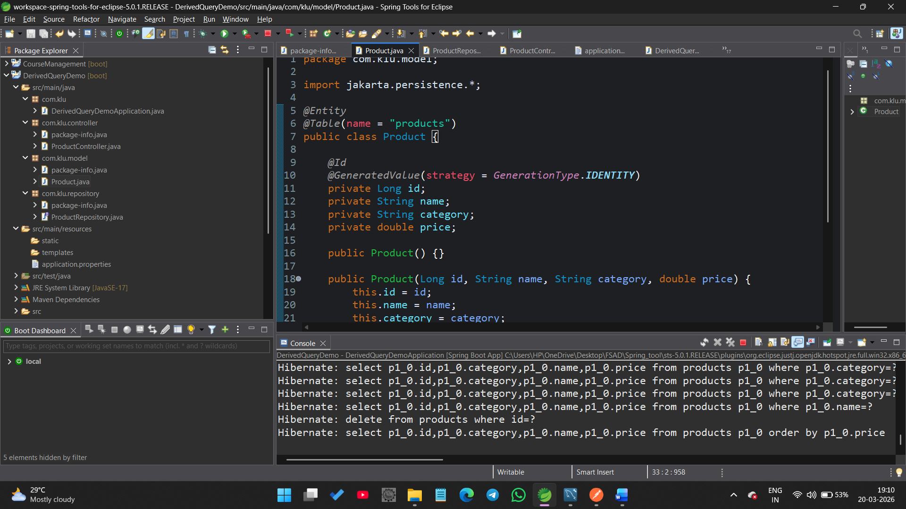
====================================================================

Controller Layer

ProductController.java
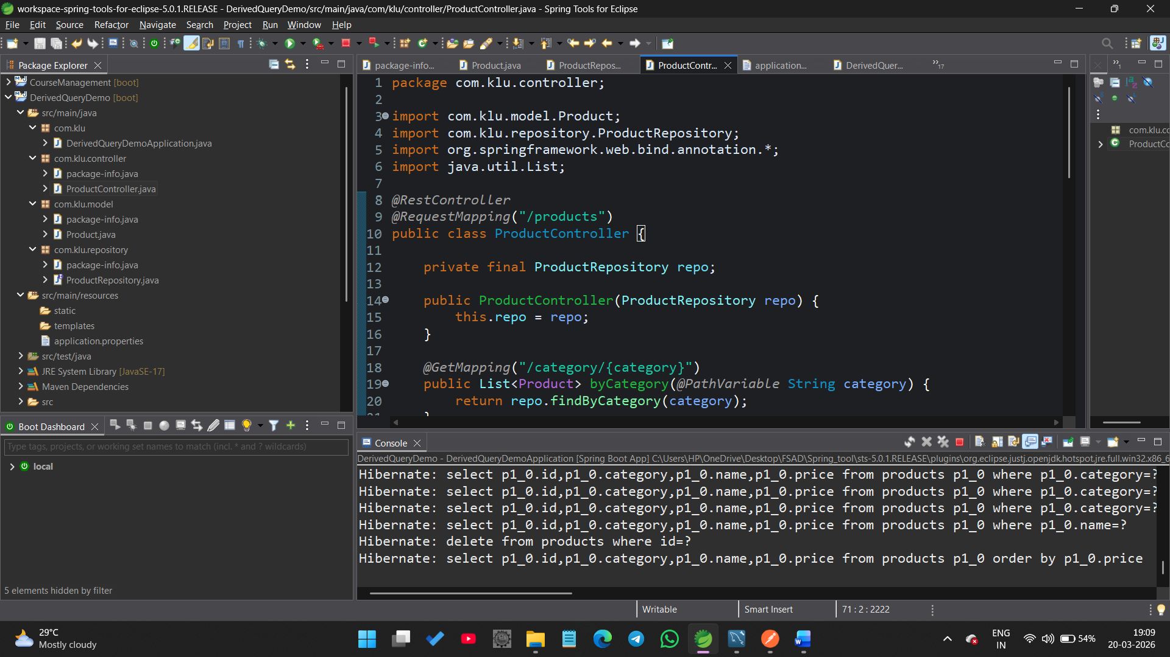

Insert Sample Product Records Using MySQL

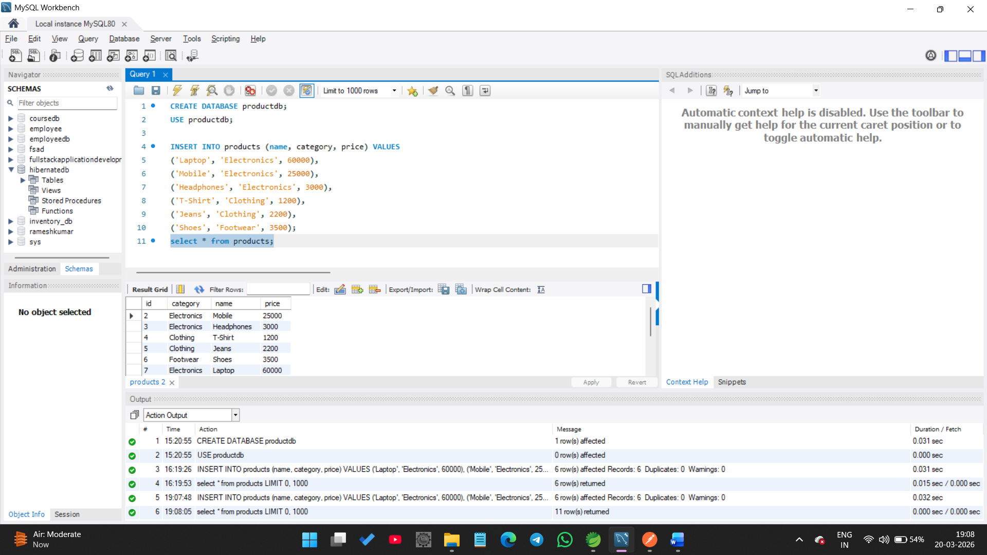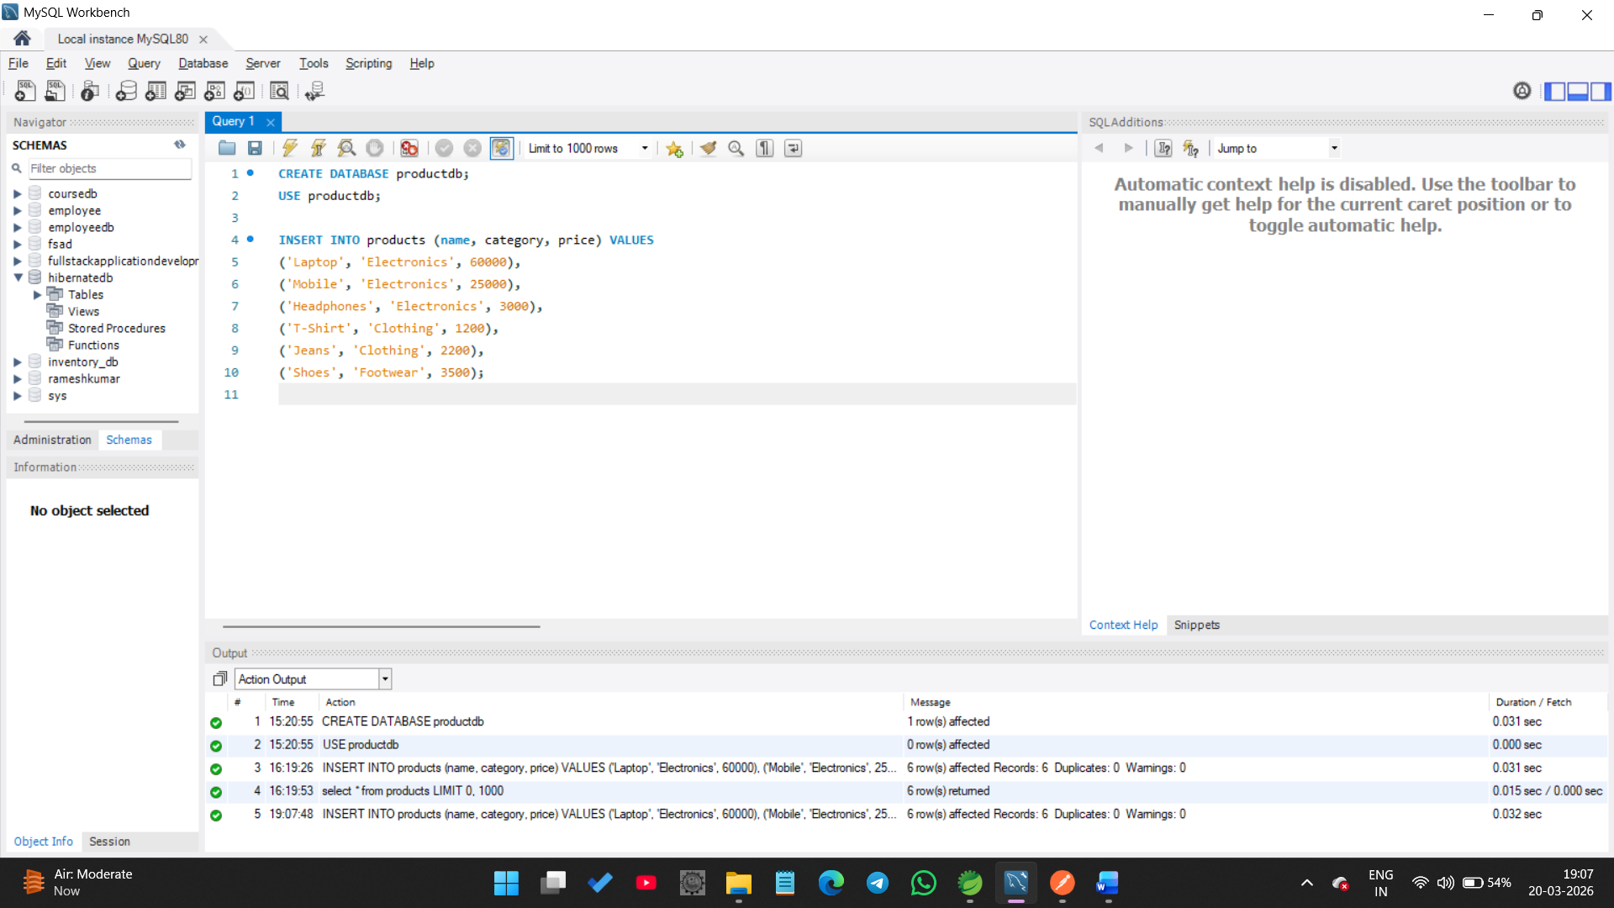
===========================================

Execution of Derived Query Methods

Output URLs (Testing through Postman)
http://localhost:8081/
Operation | URL
findByCategory | /products/category/Electronics
findBy And | products/category/Electronics/price/3000
findBy Or | /products/or?category=Clothing&name=Shoes
Between | /products/filter?min=1000&max=5000
Like | /products/search?keyword=Lap
GreaterThan | /products/expensive/20000
countBy | /products/count/Electronics
existsBy | /products/exists/Laptop
deleteBy | DELETE /products/delete/Laptop
JPQL sort | /products/sorted
