#SKILL - 15 Implementing JWT-Based Authentication s Role Authorization
ID : 2400031595
NAME : Rameshkumarkandula
Experiment structure:- It is in STS
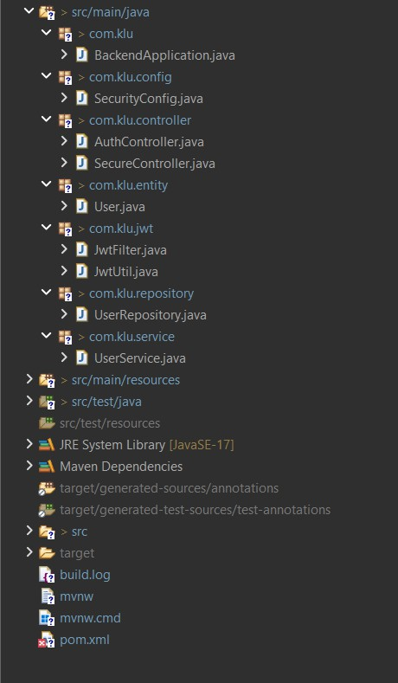

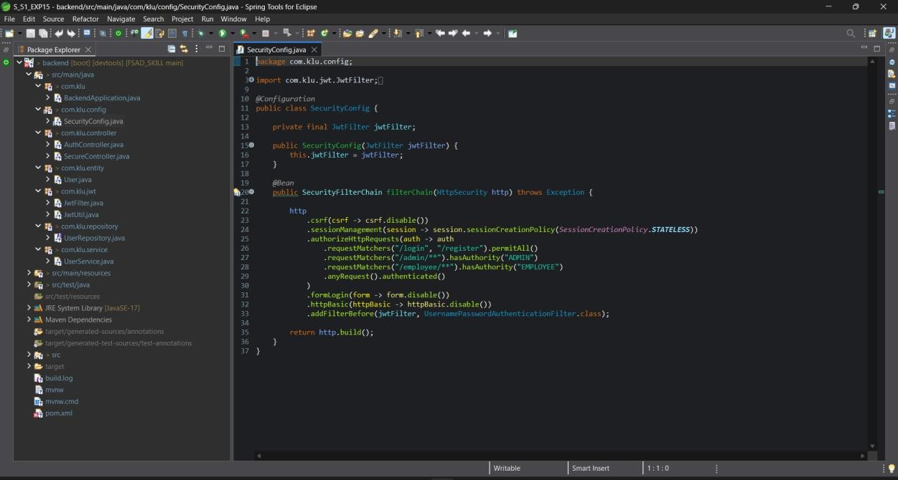
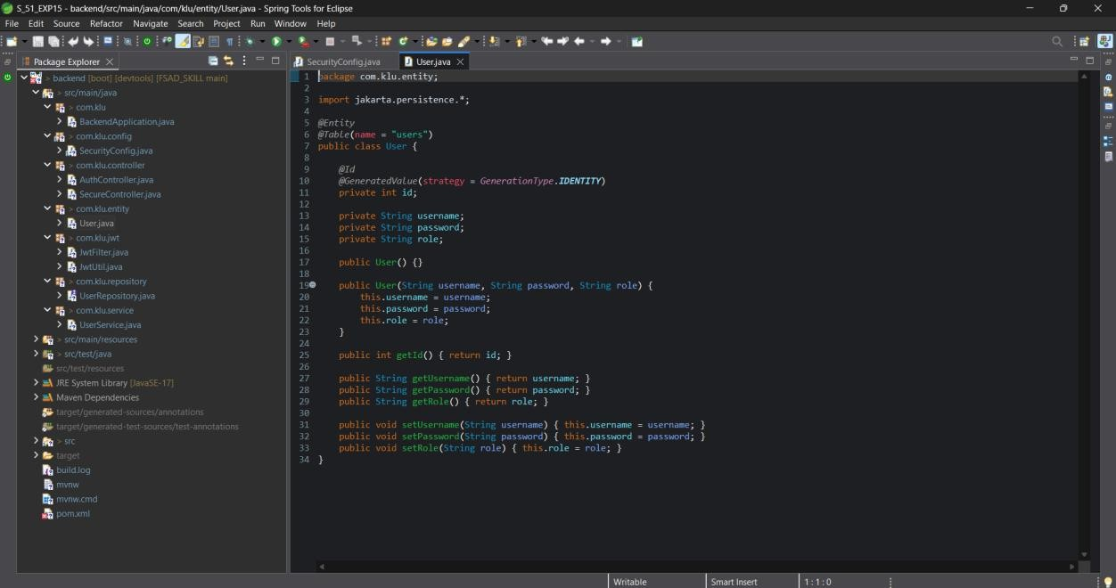

Ouput:-
We got the token after the user registered we have checked in Postman .
