SKILL 7 : REST API – CRUD Operations using ResponseEntity

NAME :Rameshkumar Kandula
ID : 2400031595
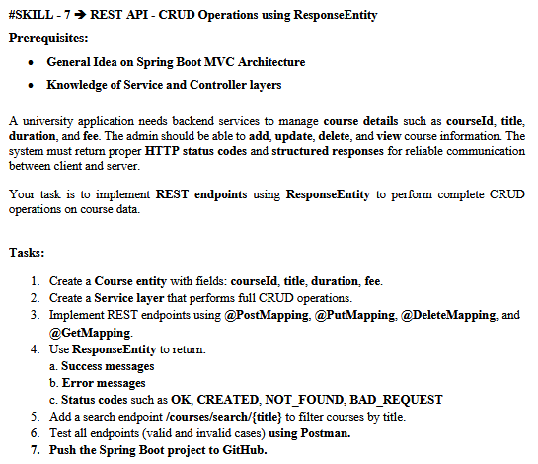

- Open Eclipse IDE
- Go to File → New → Spring Starter Project
Fill details:
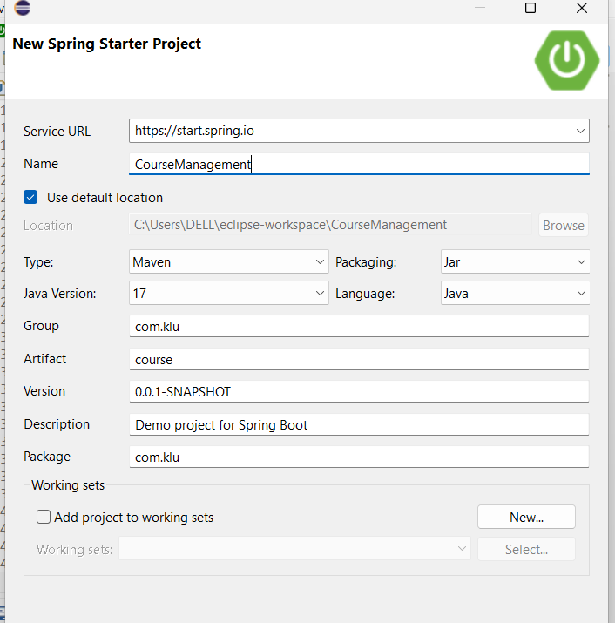
2. Add Dependencies
Select these dependencies:
- Spring Web
- Spring Data JPA
- MySQL Driver
- Lombok (optional)
Click Finish
Eclipse will create the project.
Create the following :
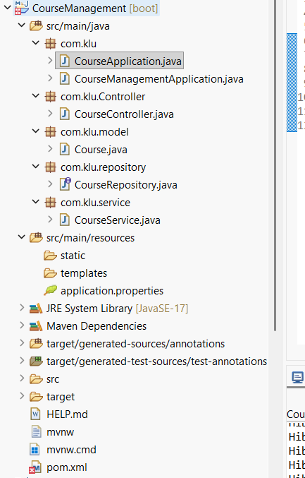
CourseApplication.java:
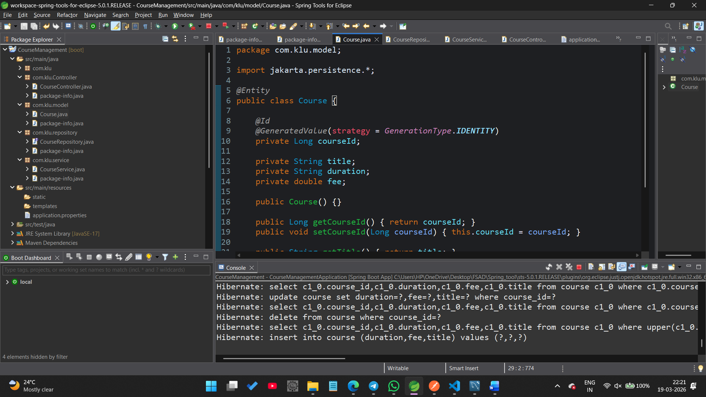
CourseController.java:
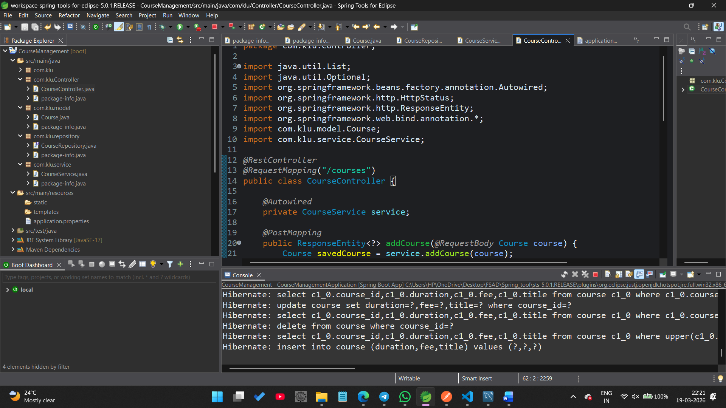
=========================================================================CourseRepository.java:
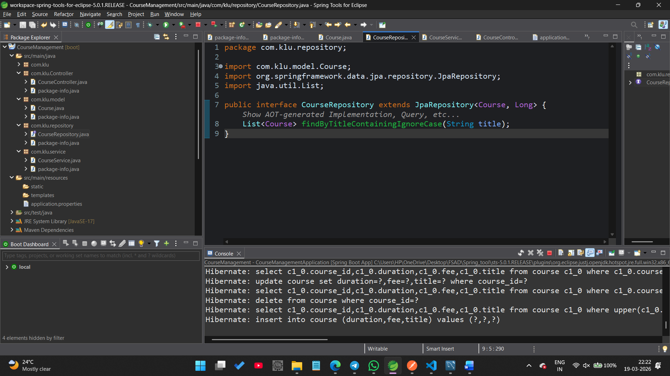CourseService.java:
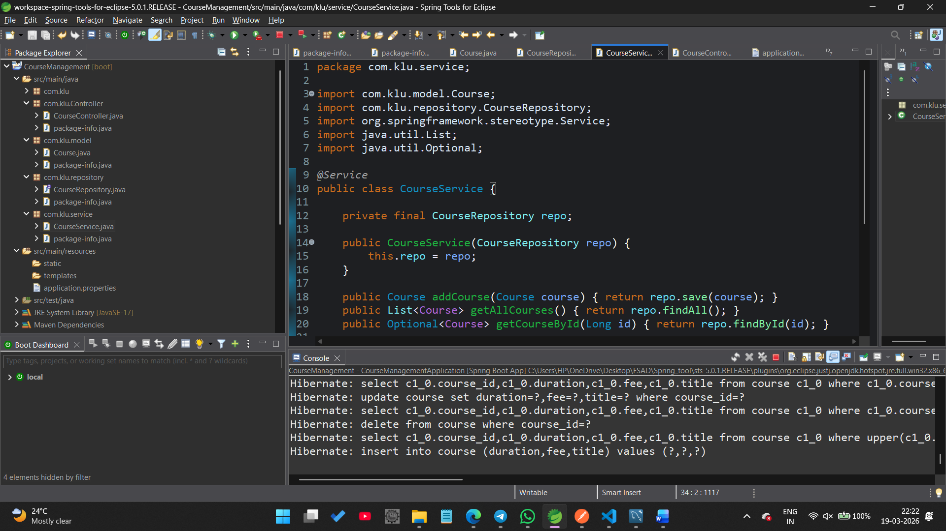application.properties:
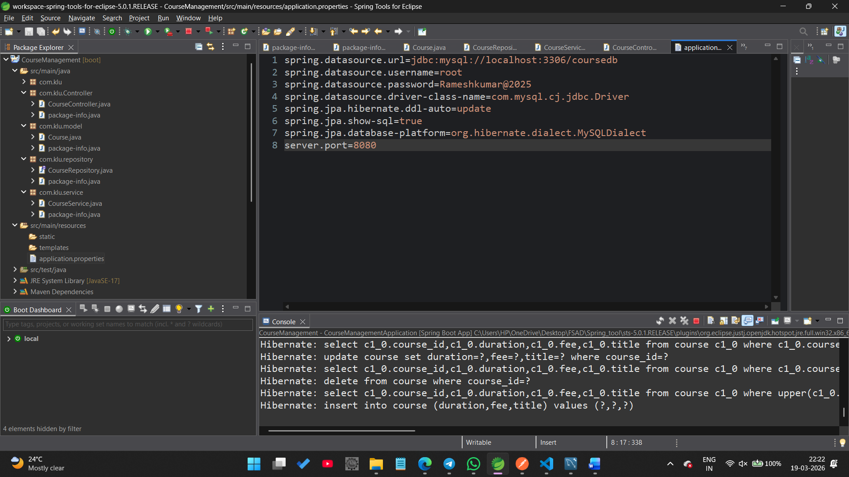
=========================================================================
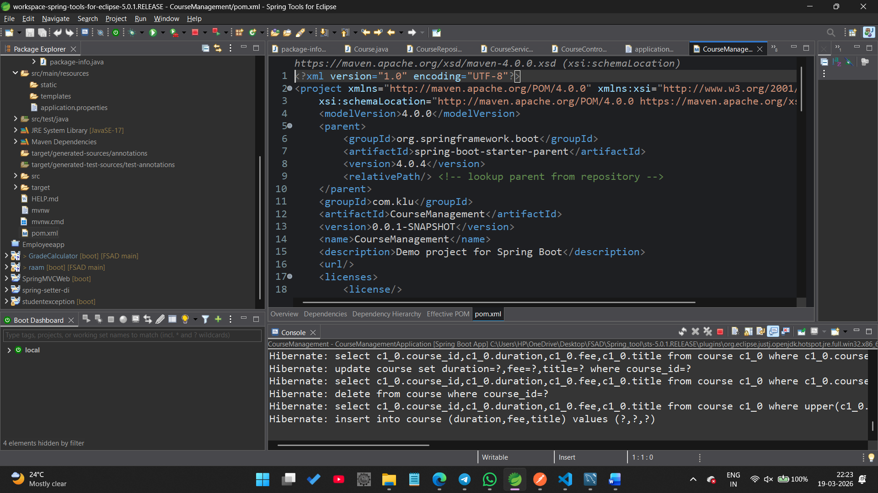After
Run the project:
CourseApplication.java
Run As → Spring Boot App
Now Go To the My SQL workbench:
Step 1: Create Database
Open MySQL Workbench or MySQL terminal and run:
CREATE DATABASE coursedb;
Step 2: Run Application
Run: CourseApplication.java
Step 3:
USE coursedb;
SHOW TABLES;
#Spring Boot creates the table automatically.
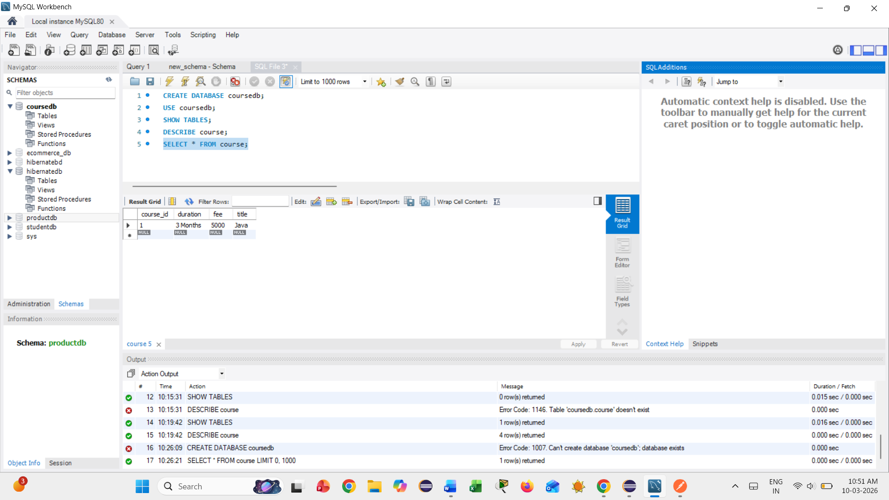
NOW IN THE POSTMAN APP:
1️⃣ Add Course (POST)
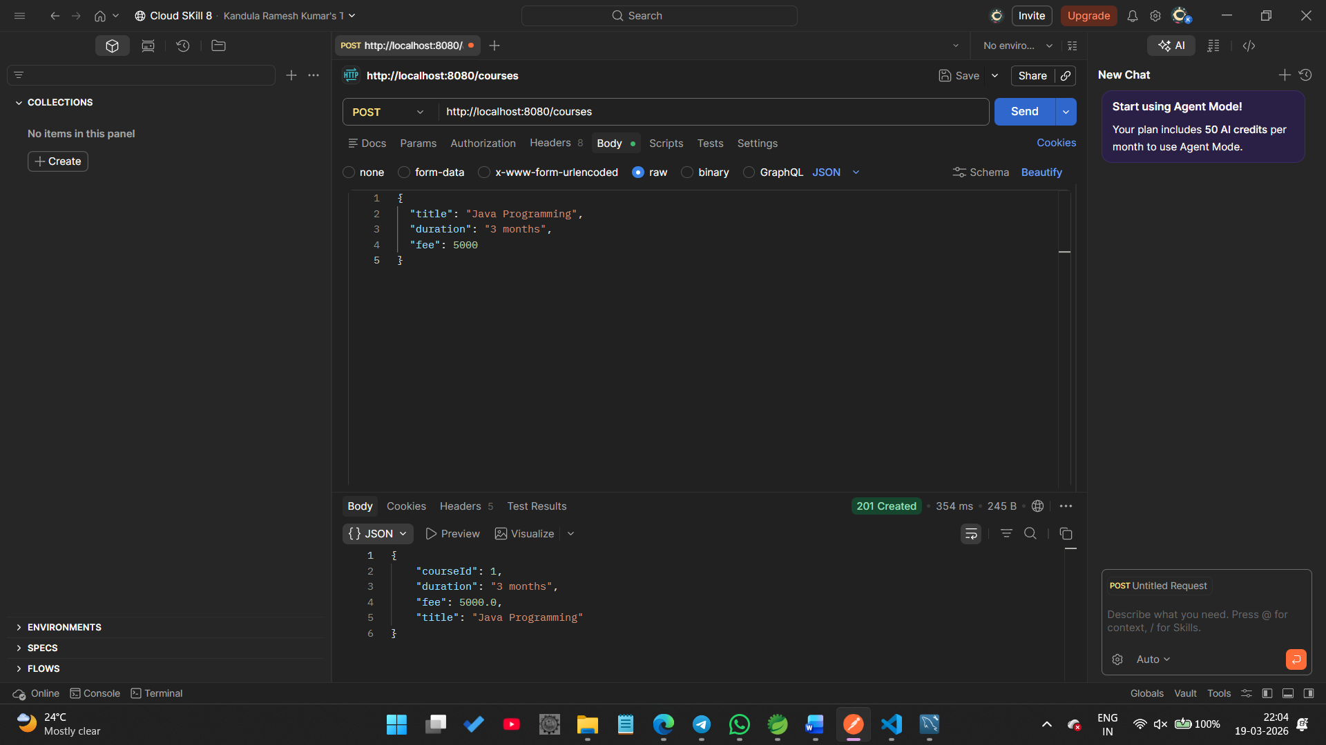
2️⃣ View All Courses(GET)
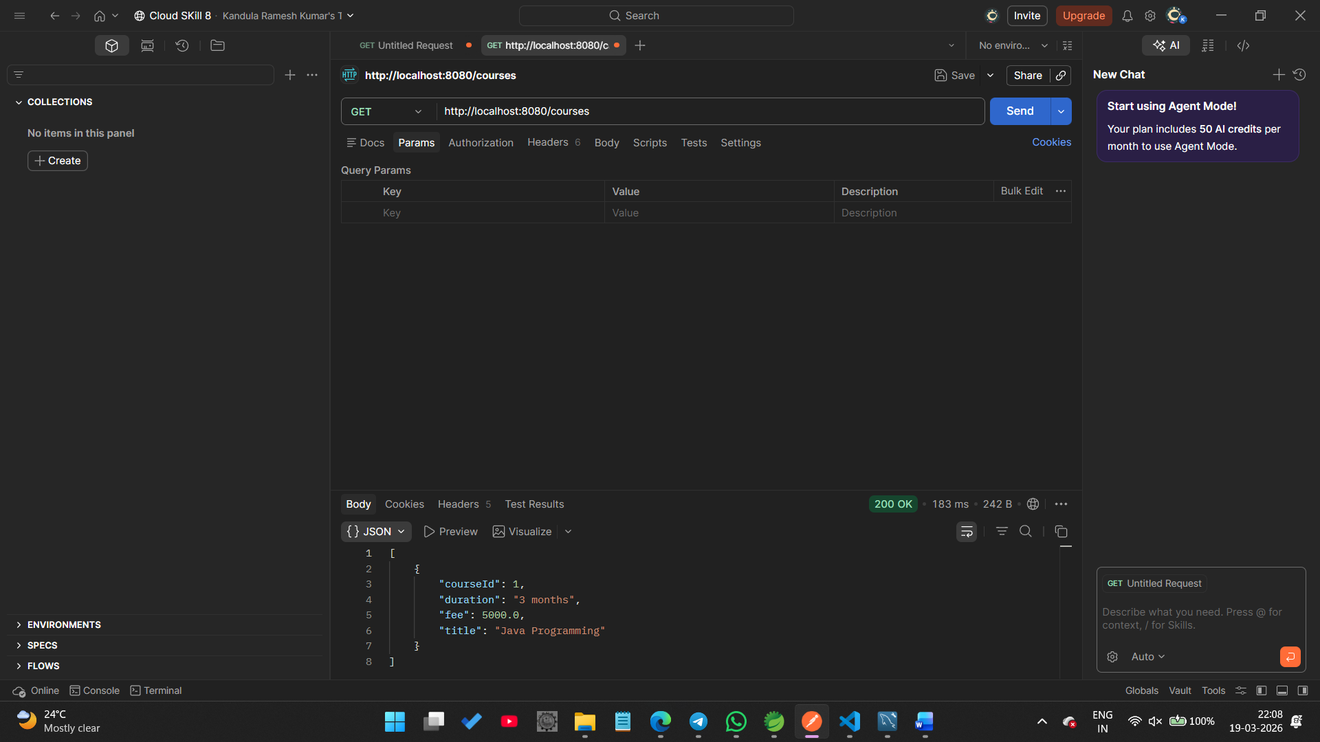===================================================================
3️⃣ Get Course by ID:(GET)
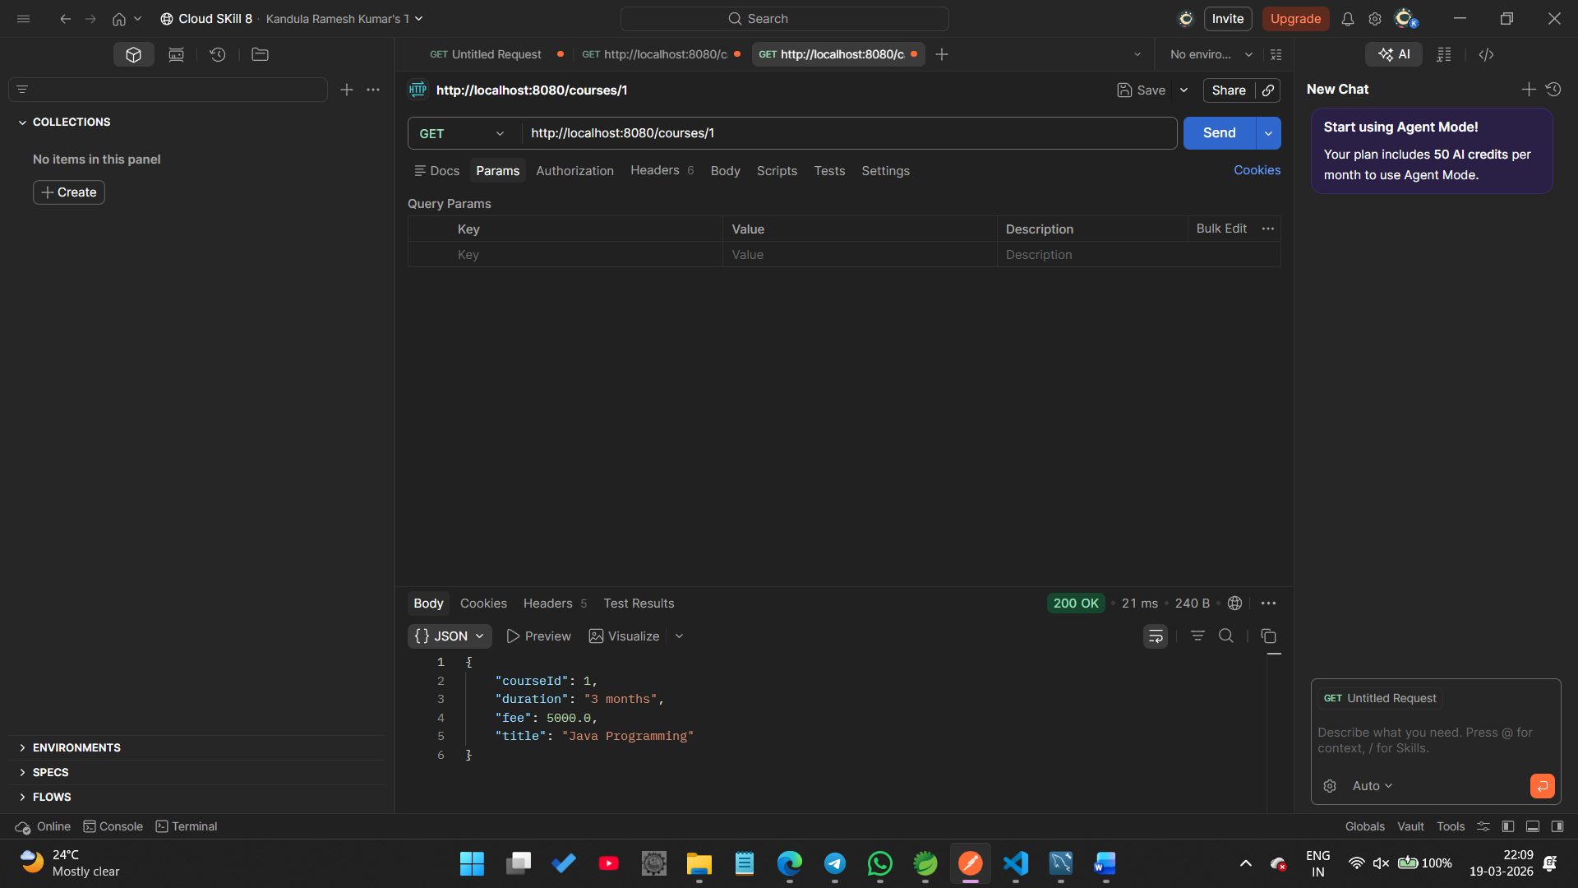

Update Course(PUT):
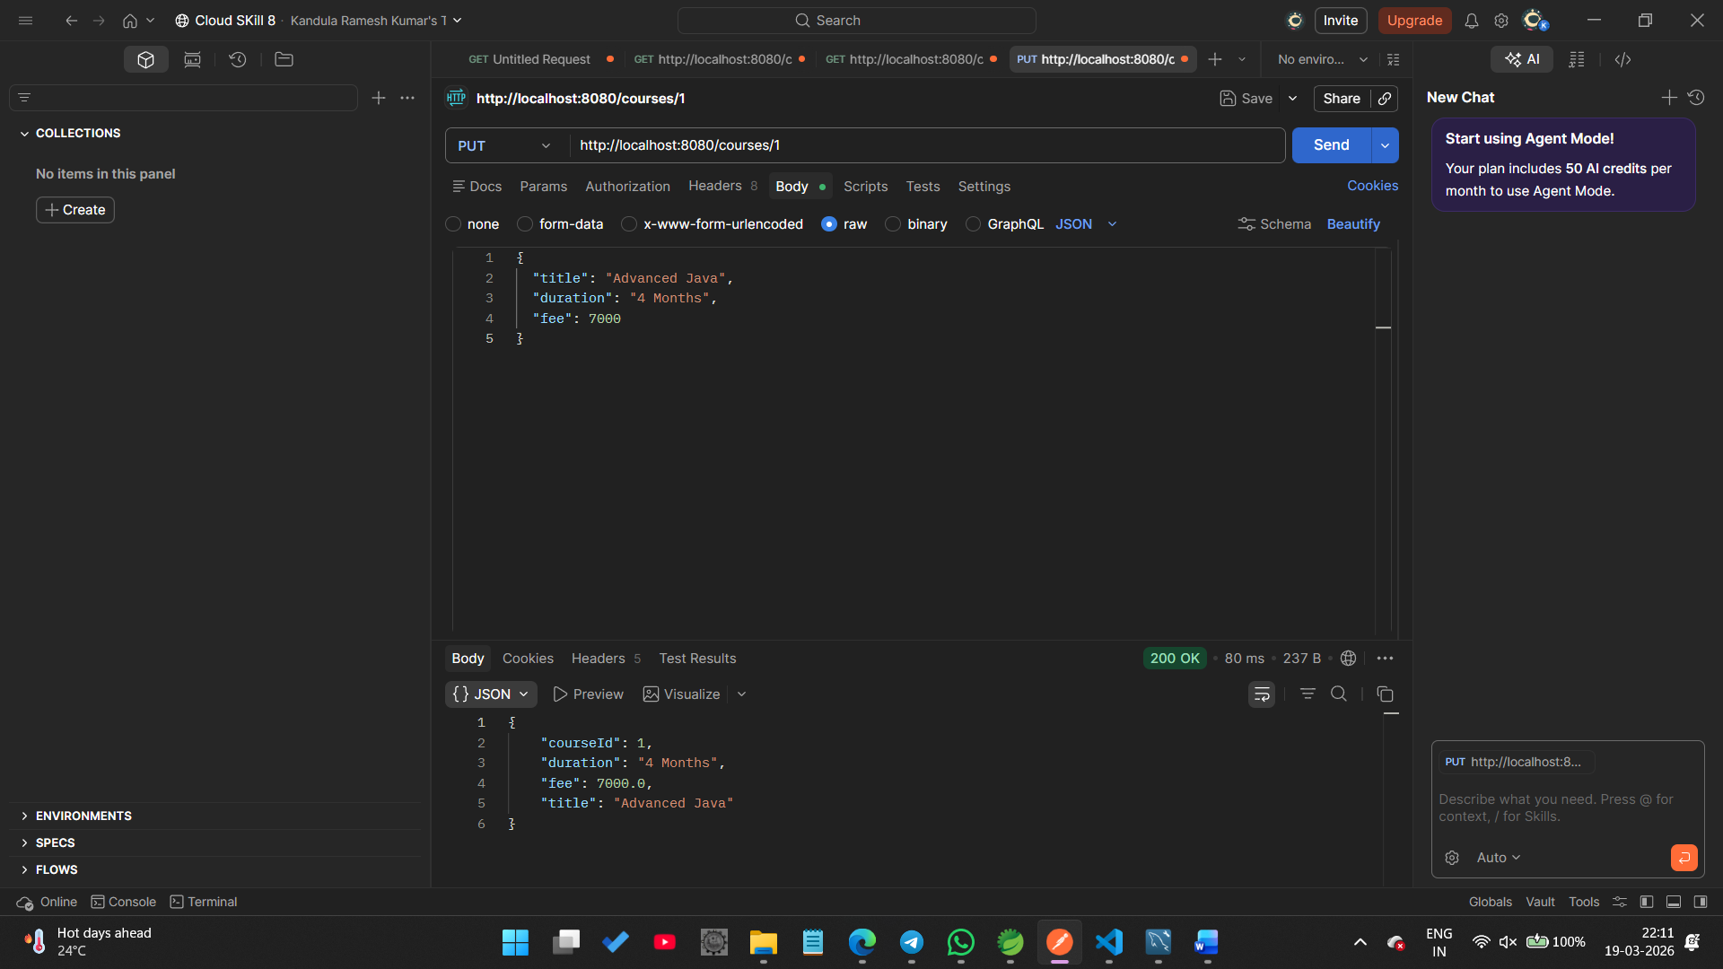
Delete Course(DELETE):
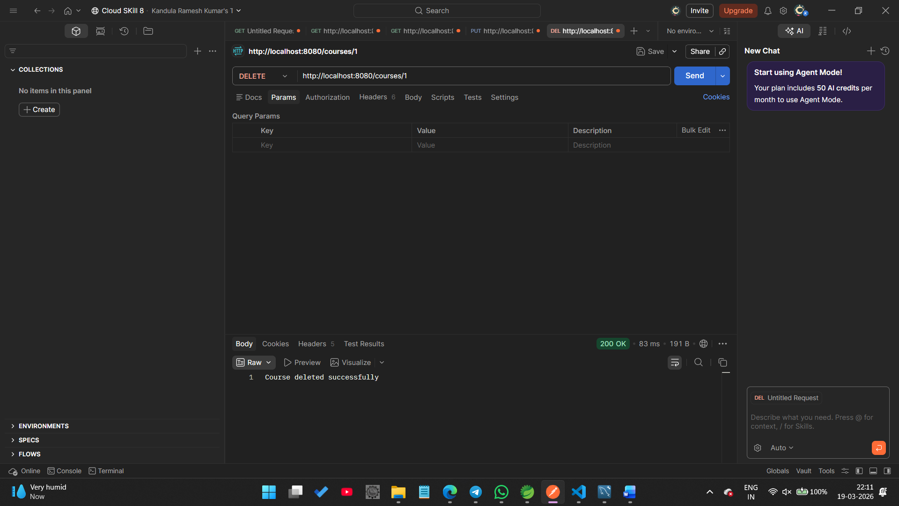

Search Course by Title:(GET):
