SKILL 10 : React State Management using useState Object
ID : 2400031595
Name : Ramesh kumar kandula
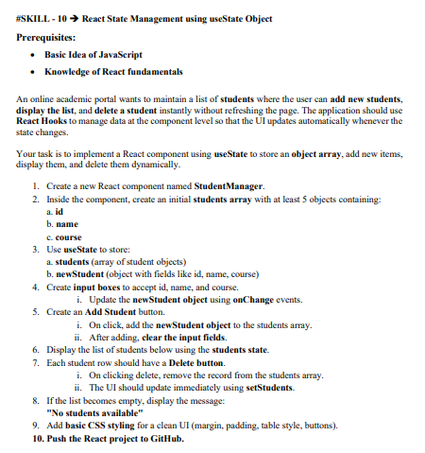
Create Project in VS code Using Vite
Open terminal and run:
npm create vite@latest student-manager
Select:
Framework : React
Variant : JavaScript
In bash run:
cd student-manager
npm install
npm run dev
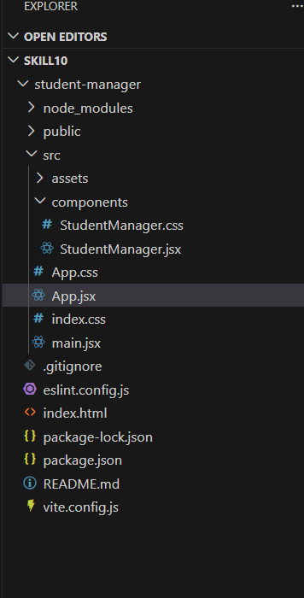
===========================================================================
StudentManager.jsx
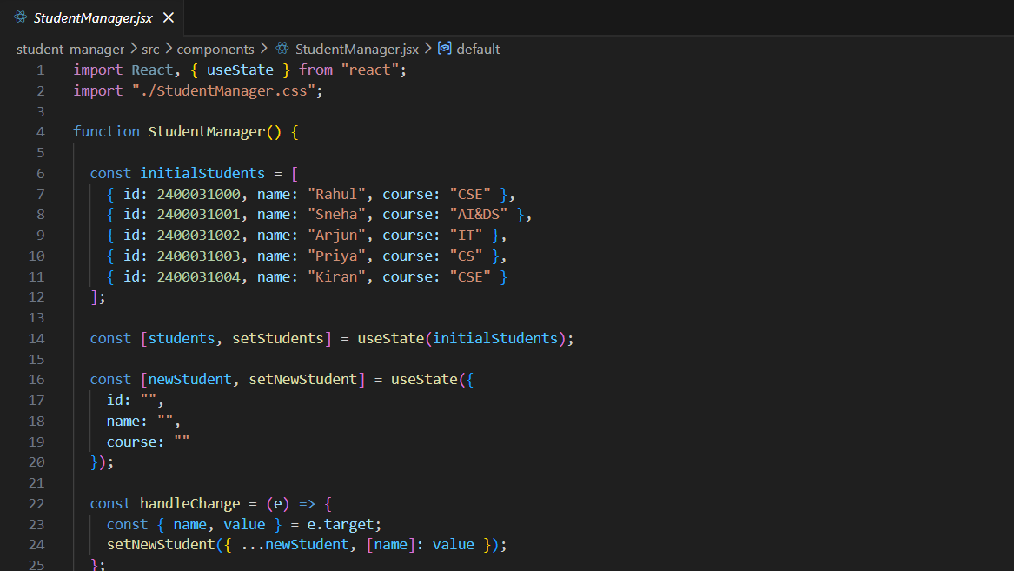===========================================================================
StudentManager.css
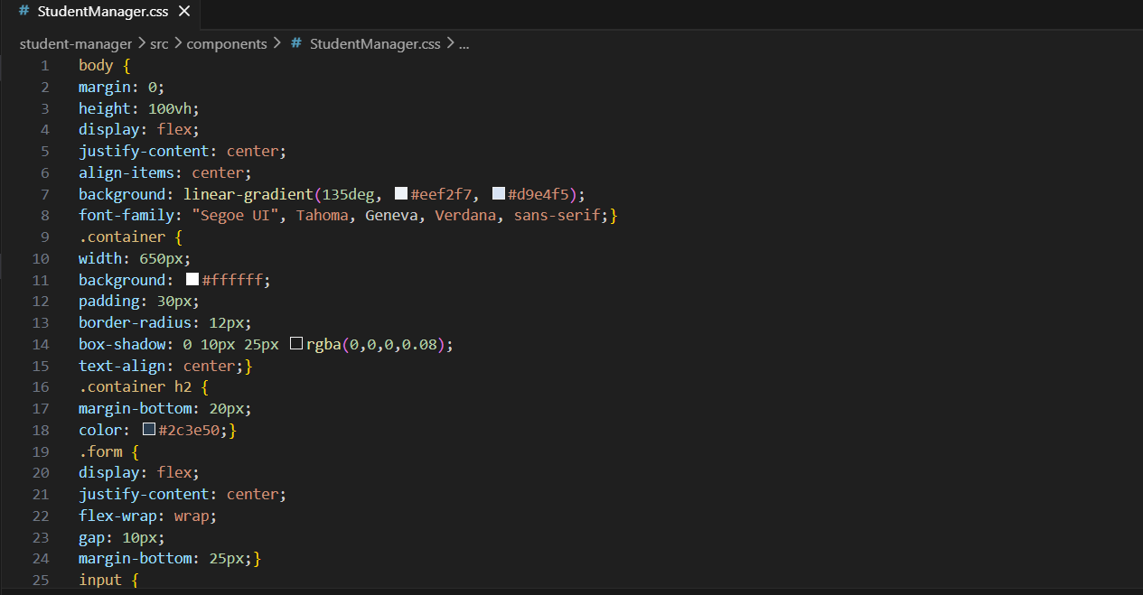===========================================================================
Run the Application
- Open terminal in project folder: npm run dev
- Open browser: http://localhost:5173

===========================================================================

Output:
