SKILL 9 :Global Exception Handling using @ControllerAdvice
ID : 2400031595
Name : Ramesh kumar kandula

Step 1 — Create Spring Boot Project
Open Spring Tool Suite, Eclipse IDE, or Visual Studio Code.
1. Click
File → New → Spring Starter Project
2. Enter project details
Field | Value
Name | studentexception
Type | Maven
Packaging | Jar
Java | 17
Group | com
Artifact | klu

3. Select Dependency
✔ Spring Web
Click Finish.
The project will be created.
Step 2 — Project Structure
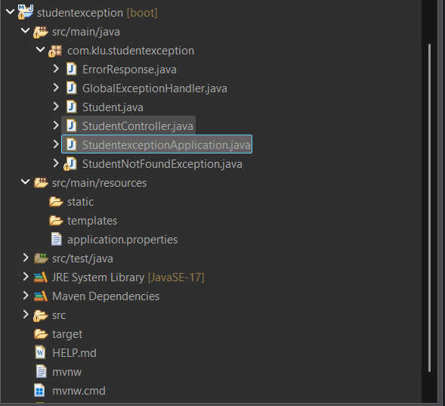

Step 3 — Create Student Class
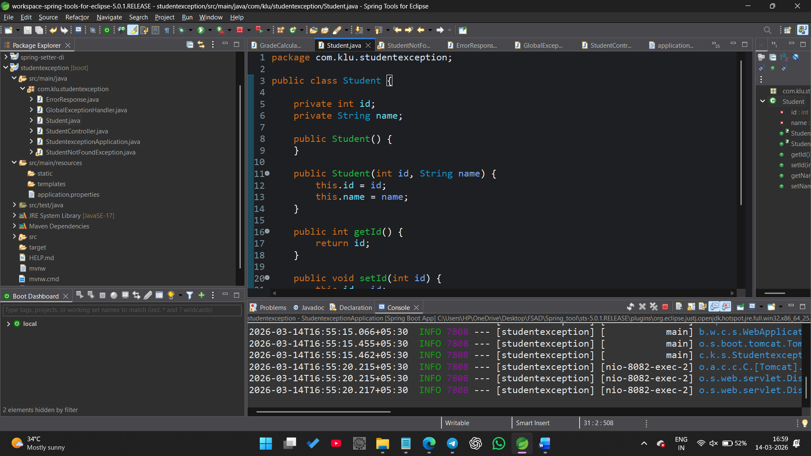Step 4 — Create ErrorResponse Class
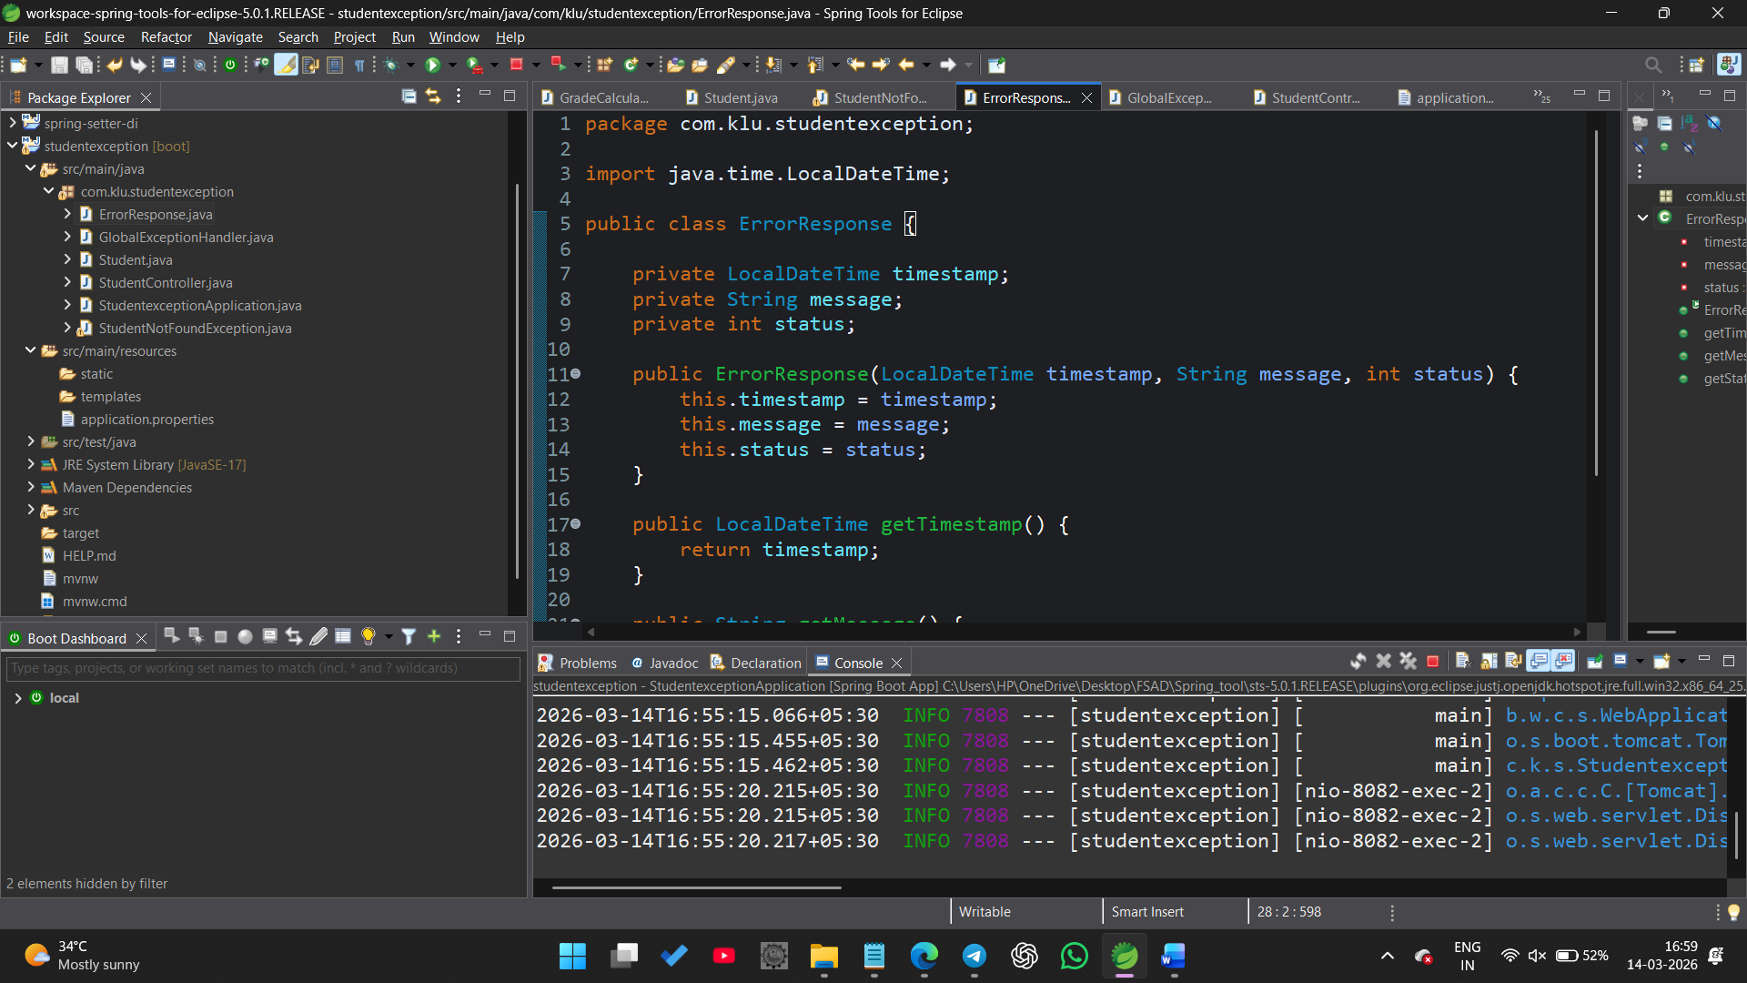Step 5 — Create Custom Exception
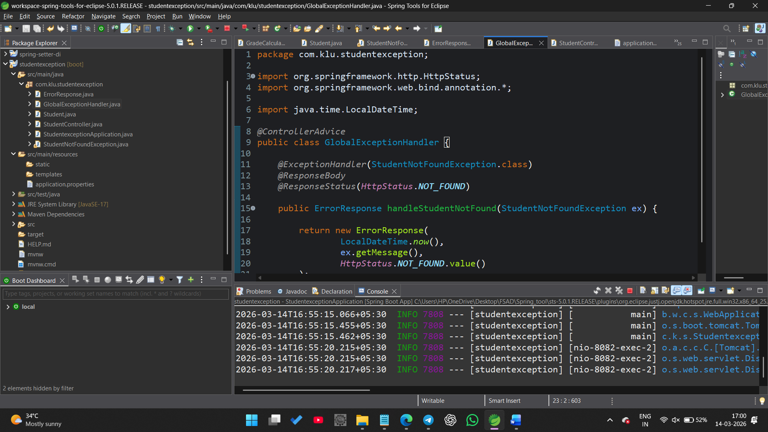Step 6 — Create Second Custom Exception
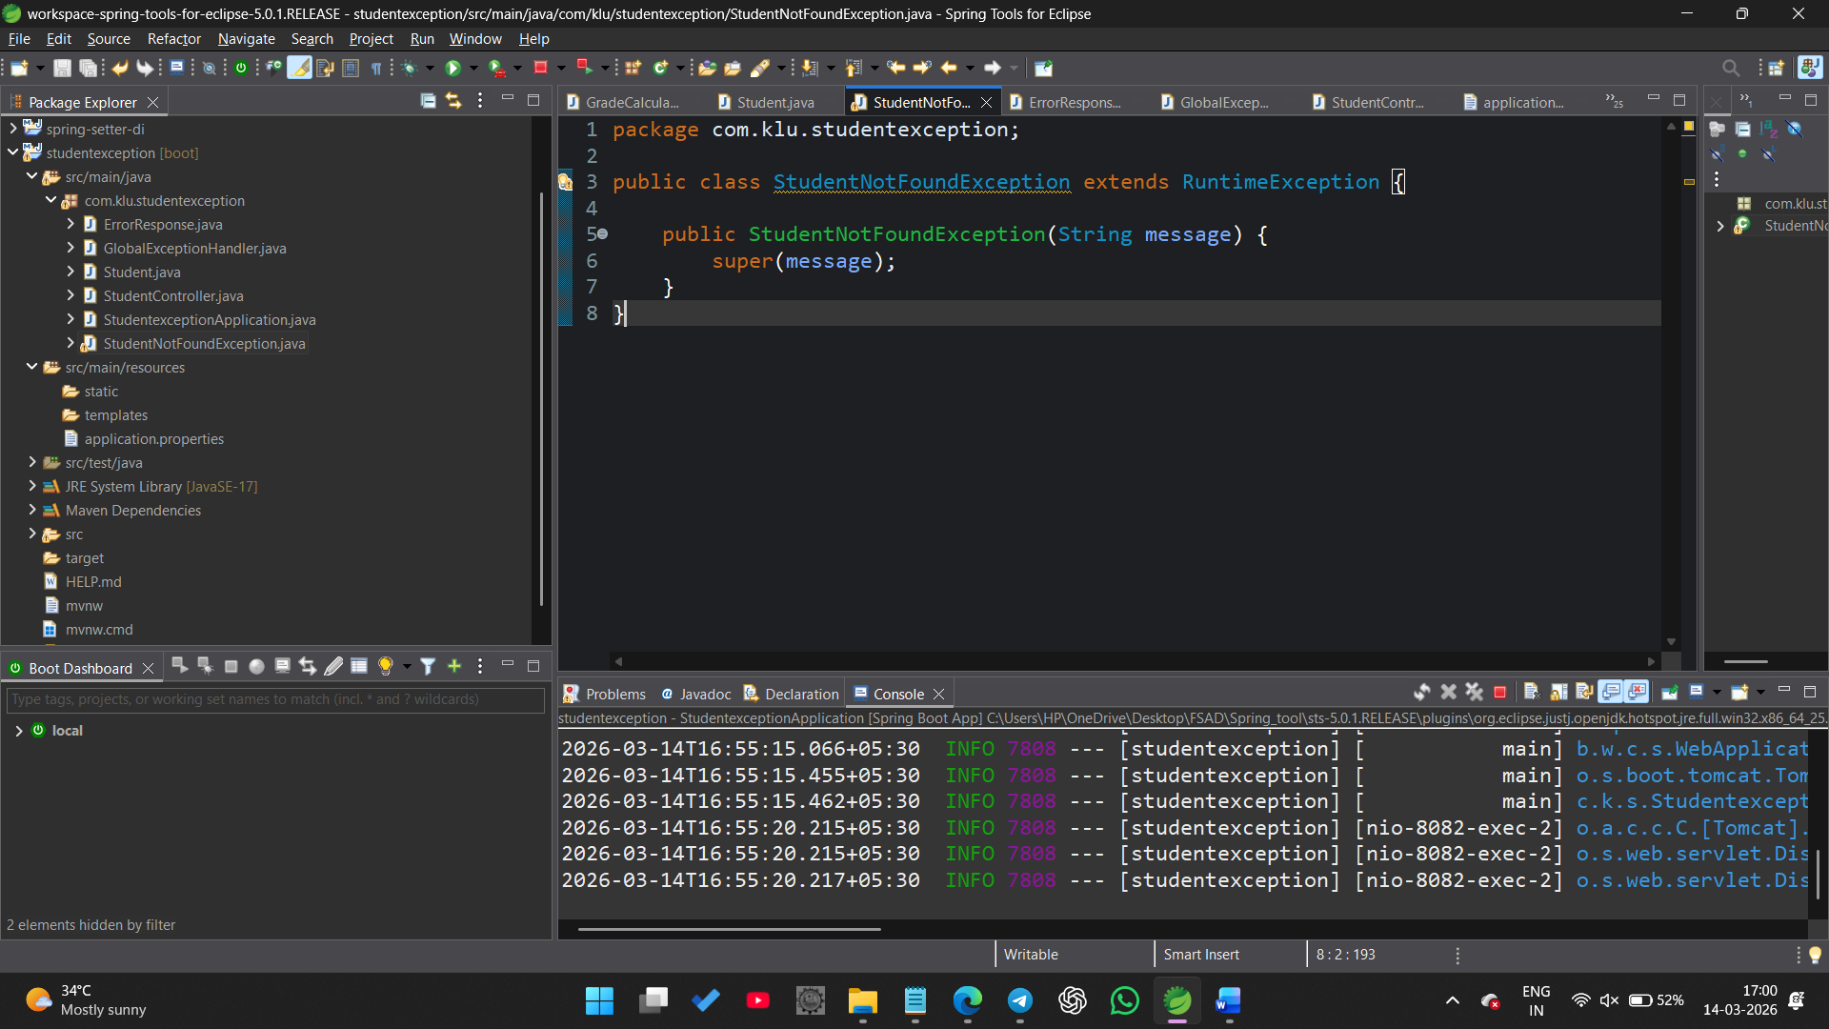

Step 7 — Create REST Controller
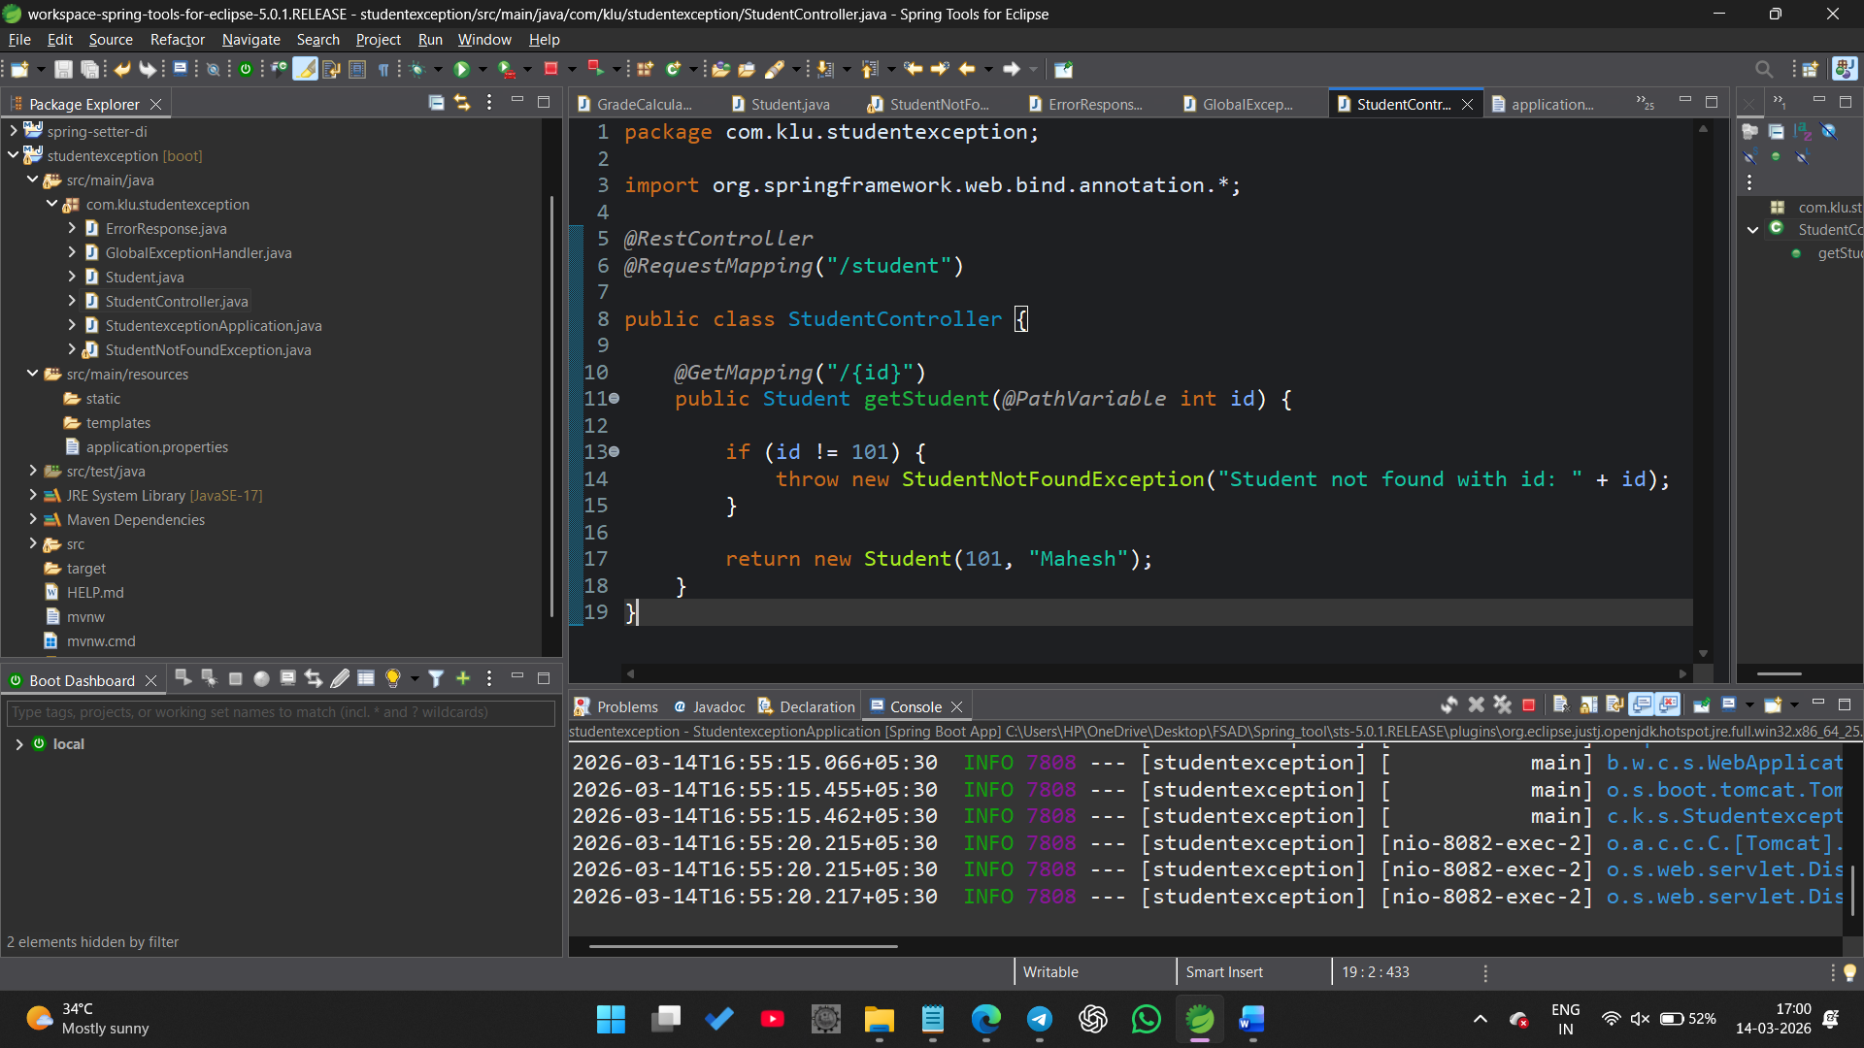Step 8 — Create Global Exception Handler
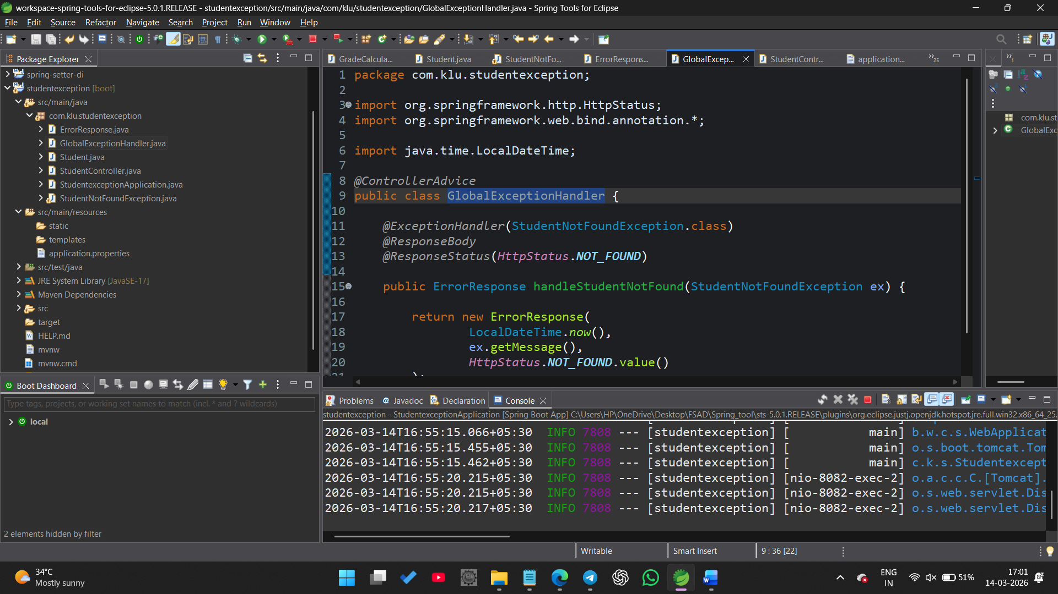
Step 9 — Run Application
Run:
StudentexceptionApplication.java
Server starts:
http://localhost:8080
