**Day 0ne of Firmware Development[Embedded Programs]:14/02/2024**

**In this Module we will learn about basics**

1.] **RAM**->expands Random Access Memory is a Primary Storage.

2.]Hardware is a Secondart storage Device [Volatile-Memory].

3.]Clock is a Heartbeat of CPU.

4.]There is 2 types of Random Access Memory thet is S-RAM and D-RAM.

5.]S-RAM is Flip-Flop (made of) STATIC.

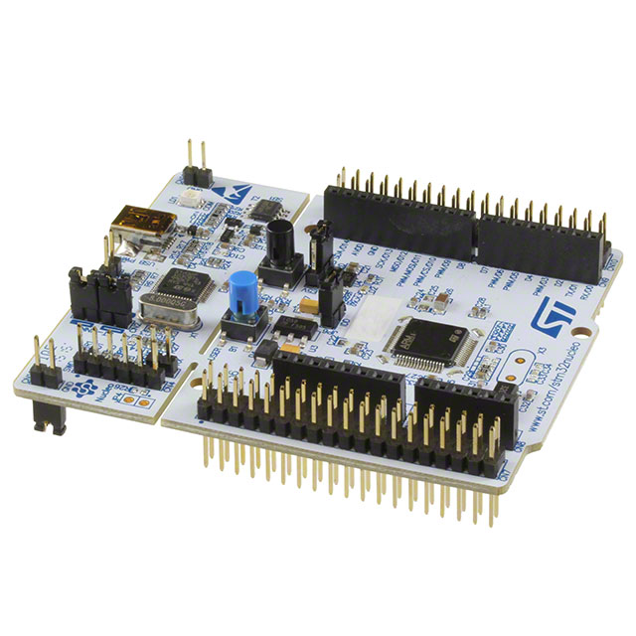6.]D-RAM is Capacitors (made of) DYNAMIC.

**ARM CORTEX M4 180MHz:**

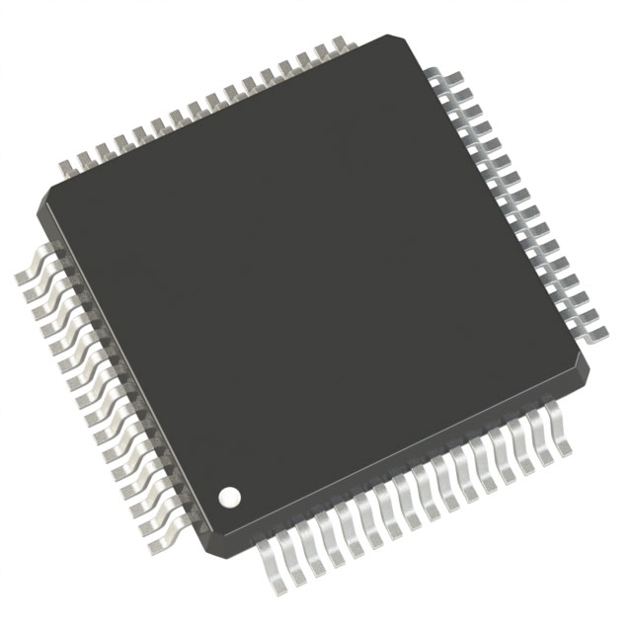

ARM Stands for cortex A->Application cortex R->Real Time Application cortex M->Microcontroller [Processor only]

Formula to calculate Time T=1/F I.E.,F=180MHz

T=1/180(10)^6 [(10)^6]->M

Static RAM is faster than Dynamic RAM.

BUS -> is used to communicate between CPU & Computer(Medium).

PHERIPHERALS:-GPIO=>To Communicate outside the environment

*These are sent by "System BUS" (S BUS)

AHB1 ->180MHz(Maximum)

| |_______>CLOCK RATE

|_______________________________>2 Types

| |

AHB/APB2 <------------------AHB/APB1

| ^ | |

| |----DOUBLE THE (PB1) | |

|___> 90MHz [maximum] |_____>45MHz [maximum]

GPIO

1.]Reading digital signals -->INPUT.

2.]Issuing interrupts.

3.]Generating triggers for external Components.

|______>Output Devices [LED,Motor]

**Generic pin:V**alues consists of one or two Voltage settings

(HIGH OR LOW)

**MULTIPLEXING:---->**The pins use this method.

**Generic port:**All the pins are connected to port.

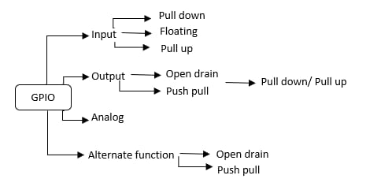

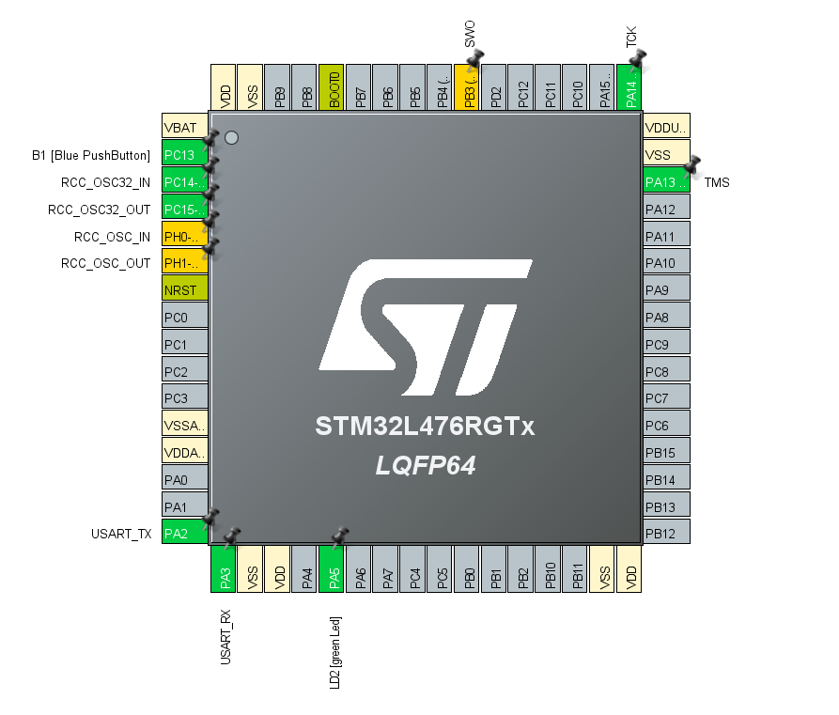

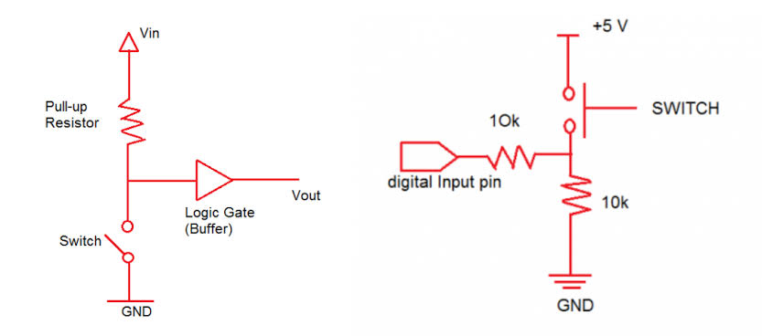

**Input mode[High z]---->Cannot be predicted**

[May be zero’s or one’s] known as **HIGH Z**

**INPUT MODE:-**

**=>Internal pull up <-------[inside pin]**

**|-------->RESISTOR**

**=>Internal pull down**

**|-------->RESISTOR**

**outside pin----->External**

**Output mode:- Open Drain State**

**=>Pull up resistor ------>always use or give 0 not 1**

**\***Gate Drain Source(GDS)

(or)

=>**PUSH PULL CONFIGURATION**(AUTOMATIC)

*Enable (activate) the clock to access the pin.

**Example:** **GPIO PORT H -->T**o activate this pin ,we enable the **AHB1’S clock** to access as it is connected to **(AHB1 => Bus)**

**2^1 => 2 values**

**2^1 => 4 values**

**2^1 => 1024 values**

**2^32 => 2^10 2^10 2^10 2^2 --->4 Giga Address**

**|_____> 0 X 0000 0000**

**:**

**0 X FFFF FFFF**

**==>MEMORY MAPPED I/O:**

Using memory to access the input and output making position in memory with address.

[27 registers ==> structure=>type def=>made as structure pointer =>named as RCC

(AHB1ENR-->member)

Using address we can access .

**PROGRAM:-**

**RCC->AHB1ENR |= 1;**

**|__>RCC->AHB1ENR = RCC->AHB1ENR | 1;**

**(or)**

**RCC->AHB1ENR |=(1<<28);**

**Value < ___| |____>Bit address Count**

**(or)**

**#define PA5_enable (1<<28);**

**RCC->AHB1ENR |= PA5_enable;**

**GPIOA -> MODER |= (0<<11)**

**GPIOA -> MODER |= (0<<10)**

**LED BLINKING PROGRAM:**

**#include "stm32f4xx.h"**

**void delayMs(int n);**

**int main(void)**

**{**

**RCC->AHB1ENR |= 1; /* enable GPIOA clock */**

**GPIOA->MODER &= ~0x00000C00;**

**GPIOA->MODER |=0x00000400;**

**while(1)**

**{**

**GPIOA->ODR |= 0x00000020;**

**delayMs(500);**

**GPIOA->ODR &= ~0x00000020;**

**delayMs(500);**

**}**

**}**

**/* 16 MHz SYSCLK */**

**void delayMs(int n)**

**{**

**int i;**

**for (; n > 0; n--)**

**for (i = 0; i < 3195; i++) ;**

**}**