Preliminary setup: Loading ICA Client for Internet Explorer

To load the ICA Client for Citrix:

Launch Internet Explorer and type in the following address:
https://vo.c-sgroup.com
We strongly suggest book marking this address for future use.

On the bottom right hand side of the screen you will see a link to ICA Web Client for 32-bit Windows. Click this link to install the Citrix client.

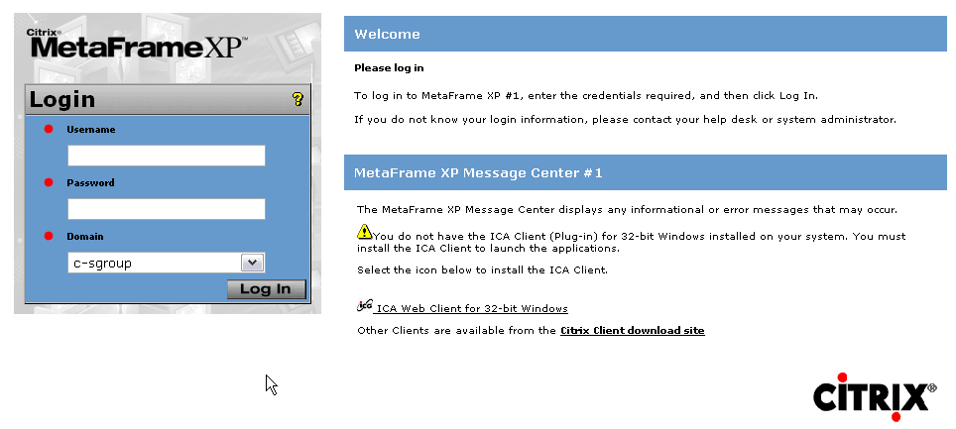
Click the ‘Run’ or ‘Open’ button on the window that pops up:

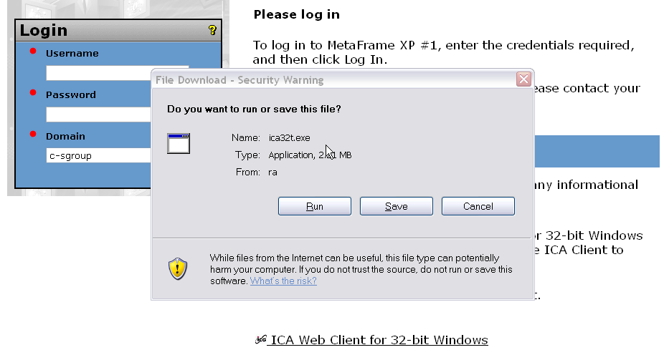
Allow the program to download (no more than a couple of minutes, except if dial-up is used) and then click ‘Run’ again if you should get another prompt:
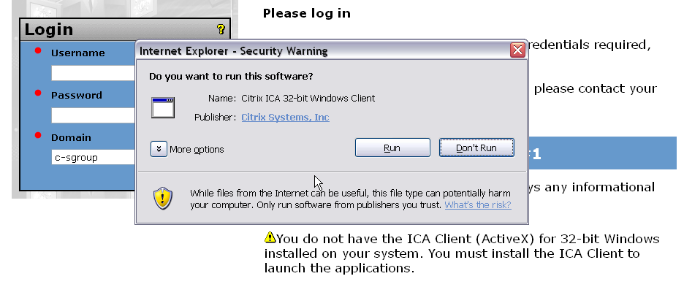

Confirm the installation by clicking ‘Yes’:

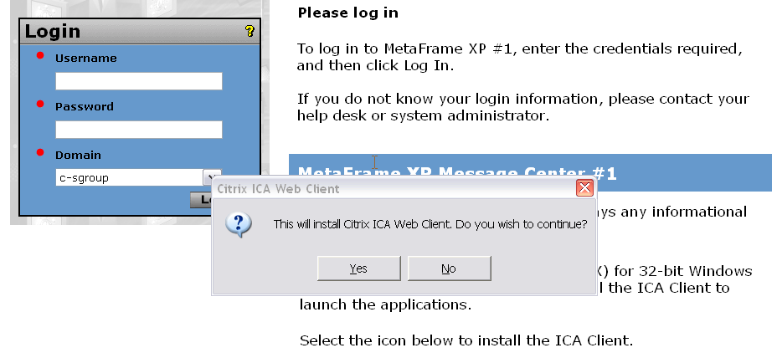

Accept the License agreement by clicking ‘Yes’:

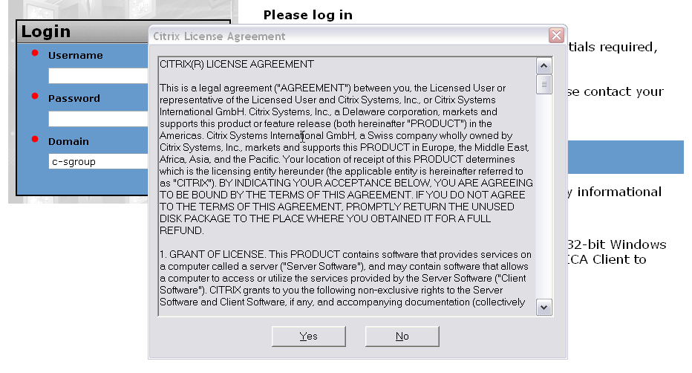

Allow the program to install and then click ‘OK ‘ after it completes.
Exit Internet Explorer and start it again.
Type the address or use the bookmark for https://vo.c-sgroup.com

End

