**Assignment 4**

**Problem Statement 1: StopWatch Application**

**Create a simple stopwatch with Start, Stop, and Reset buttons.**

**Requirements:**

o The Start button starts the timer.

o The Stop button pauses the timer.

o The Reset button resets the timer to zero.

o The timer should update every second when running.

o Pressing Stop should pause the timer without resetting it.

o Pressing Reset should stop the timer and reset it to "00:00".

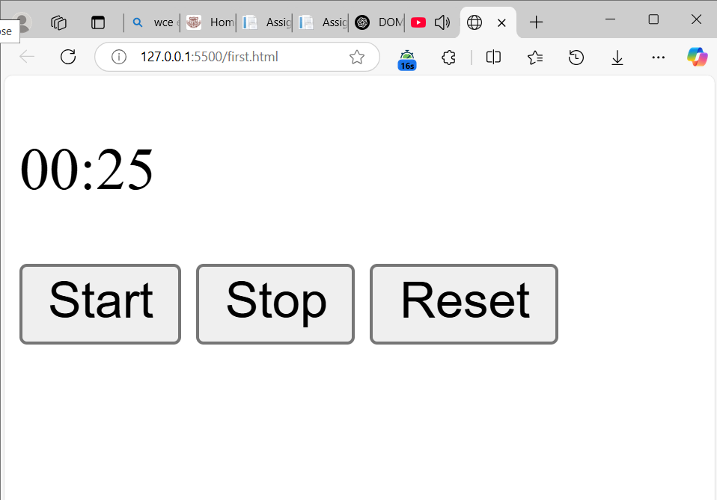

**Problem 2: Image Carousel Build an image slider that cycles through multiple images. Requirements:**

o Include Next and Previous buttons to navigate between images.

o Automatically change images every 3 seconds. o Add navigation dots below the images to indicate the current position.

o Clicking Next or Previous should change the displayed image.

o The slider should automatically move to the next image every 3 seconds.

o Clicking a navigation dot should move to the corresponding image.

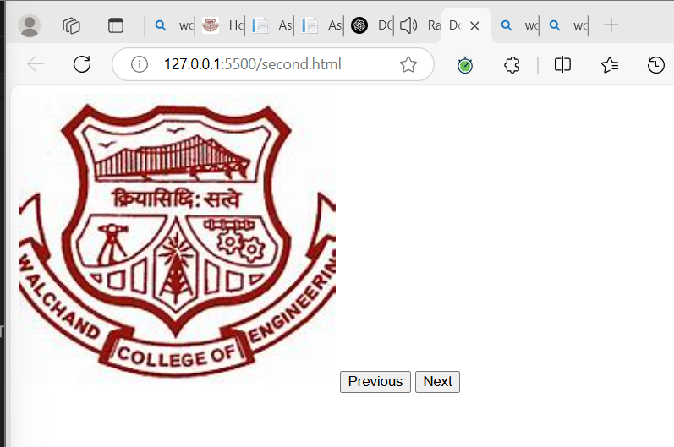

**Problem 3: Form Validation Design a user registration form with the following fields:**

o Name (at least 3 characters) o Email (must contain "@" and ".")

o Password (at least 6 characters)

o Confirm Password (must match Password)

o Submit Button o Show error messages if inputs are invalid.

o Prevent submission if any validation fails.

o Show a success message if the form is correctly filled out.

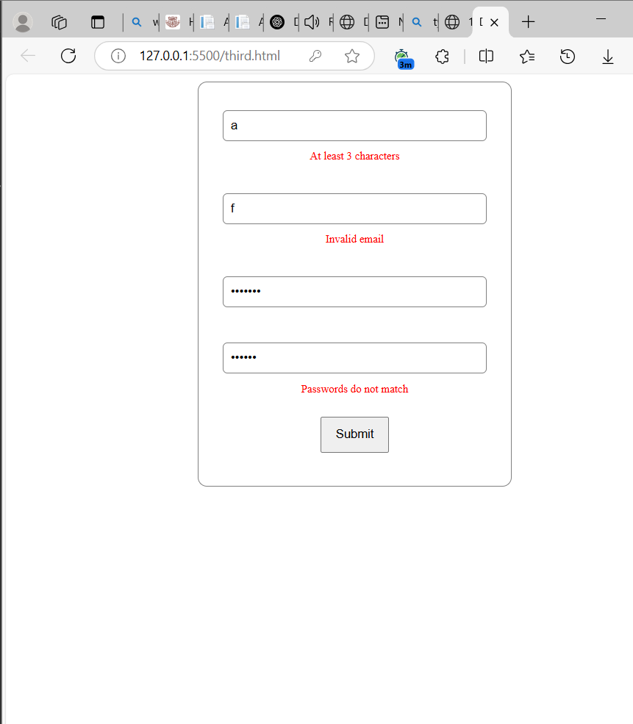

**Problem 4: To-Do List with Local Storage Create a to-do list where users can add, remove, and mark tasks as completed.**

o Use localStorage to save the tasks so that they persist even after refreshing the page.

o Add a "Clear All" button to remove all tasks.

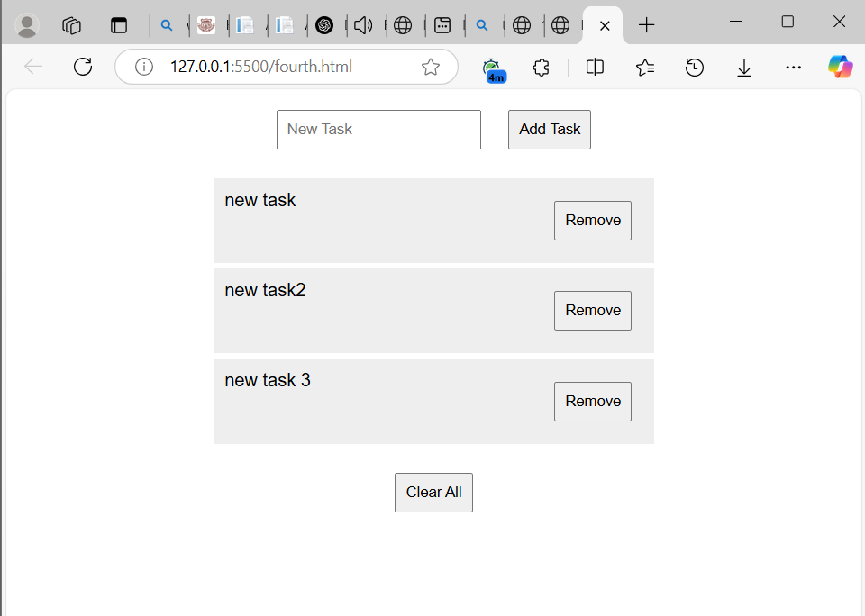

**Problem 5: Drag and Drop File Uploader Create a file uploader where users can drag and drop files into a designated area. The file types it will take will be only .pdf, .doc/docx, jpg/jpeg o Highlight the drop area when a file is dragged over it.**

**o** Show a preview of the uploaded file (if it’s an image).

o Allow users to remove the uploaded file before submission. o Users can either drag & drop or click to select a file.

o Display a preview if an image is uploaded.

o Clicking Remove should clear the uploaded file.

o If the file is not in the allowed format, show an error message.

