Here’s the JavaScript code for all the problem statements:

**Problem 0: Basics of DOM**

**What is the DOM?**

The **Document Object Model (DOM)** is a programming interface for web documents. It represents the page so that programs can change the document structure, style, and content dynamically.

**What is the DOM Tree Structure?**

The DOM represents the document as a tree structure where:

* The **root** node is document.
* **Branches** are elements like <html>, <head>, and <body>.
* **Leaves** are text, attributes, and comment nodes.

Example DOM tree structure:

**Examples:**

* **Accessing the DOM:**
* let heading = document.getElementById("title");
* **Manipulating the DOM:**
* heading.textContent = "New Title";
* **Event Handling:**
* document.getElementById("btn").addEventListener("click", () => alert("Clicked!"));
* **Traversing the DOM:**
* let parent = document.getElementById("list").parentElement;

**Performance Considerations:**

* Minimize DOM reflows and repaints.
* Use documentFragment for batch updates.
* Avoid using .innerHTML for frequent updates.

**Common Methods and Properties:**

* .getElementById(), .querySelector()
* .appendChild(), .removeChild()
* .classList.add(), .classList.remove()

**Problem 1: Dynamic Content Update**

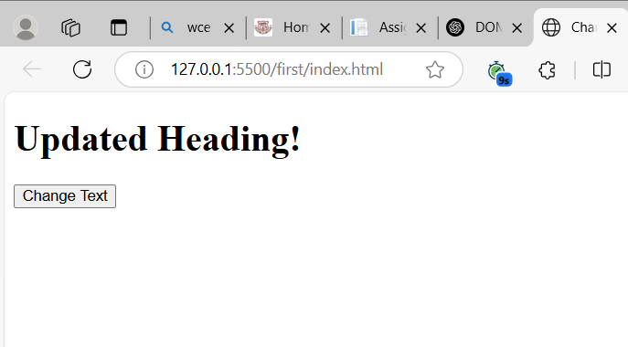

**Problem 2: Real-Time Character Counter**

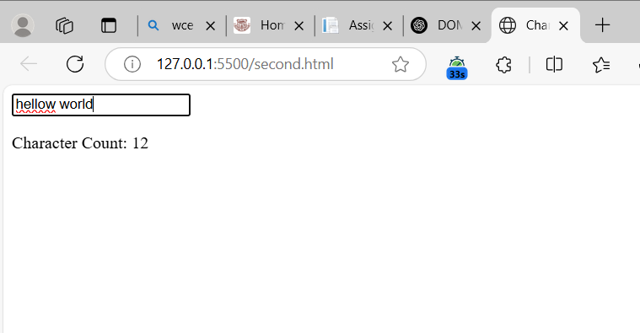

**Problem 3: Add and Remove List Items**

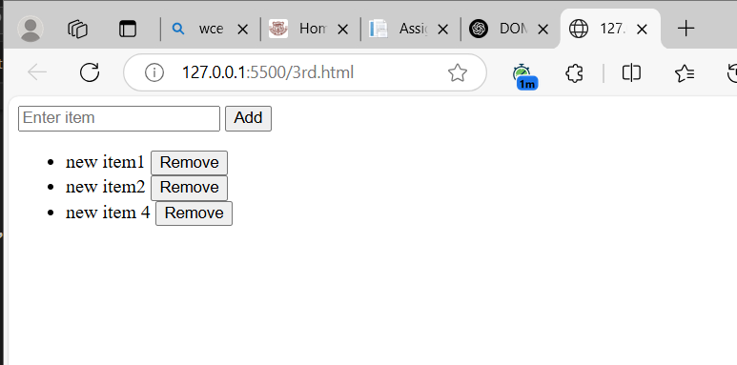

**Problem 4: Change Background Color**

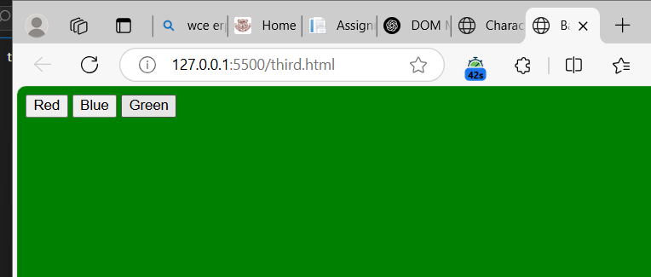

**Problem 5: Toggle Dark Mode**

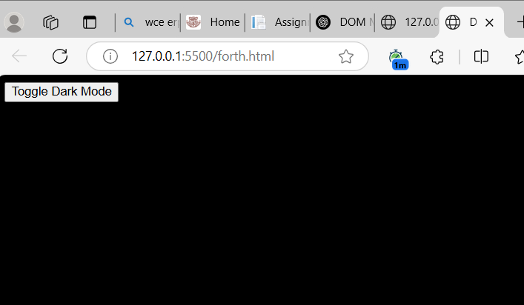

**Problem 6: Simple Quiz Application**

