Lab6 - Ultrasonic Distance Detection

Introduction

Experiment : Measurement of the maximum distance that can be measured to an obstacle at different angles
We measured the maximum distance of detectable obstacles at different angles within a range of 0 to 400 centimeters from the obstacle and plotted the data into a radar chart to intuitively display the detection range in various directions.

Theory and Technical Background
To achieve ultrasonic distance measurement, the main components we use are the HC-SR04 ultrasonic distance measurement module and the SG90 servo motor.
The HC-SR04 ultrasonic distance measurement module consists of an ultrasonic transmitter and a receiver. The transmitter sends ultrasonic waves in a specific direction. When the ultrasonic waves encounter an obstacle, they are reflected back, and the receiver captures the reflected waves. By calculating the time difference between the emission and reception of the ultrasonic waves, combined with the speed of sound, the distance can be determined. When the ultrasonic wave is emitted, the Echo pin becomes high. When the ultrasonic wave is received by the receiver, the Echo pin becomes low. By measuring the duration of the high state of the Echo pin, the time of ultrasonic wave propagation can be obtained.
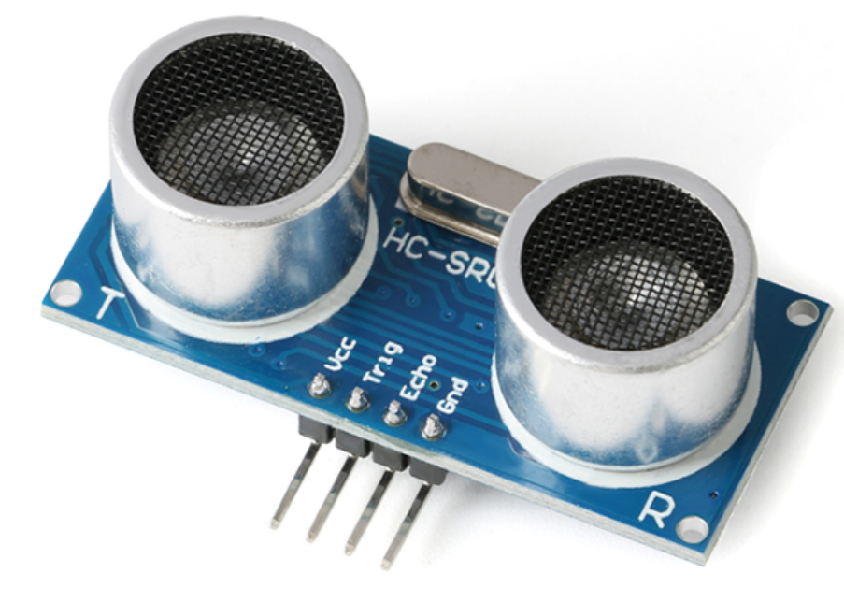
      - HC-SR04 ultrasonic distance measurement module
The SG90 servo motor is a position (angle) servo driver, suitable for control systems that require continuous angle changes and the ability to maintain a specific angle. It is mainly composed of a casing, circuit board, DC motor, gear reduction set, and position detection element (control circuit), forming an automatic (closed-loop) control device.
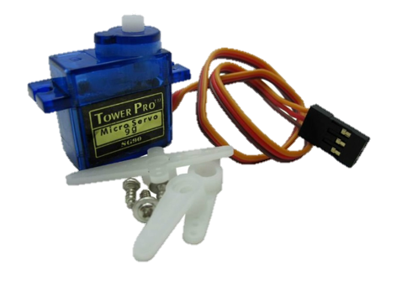
      - SG90 servo motor

Method：
Abridge | Full Name
ADC | Analog-to-Digital Conversion
IDE | Integrated Development Environment

Key words："distance-angle" radar chart，ADC，control variable，Ultrasonic distance measurement

Experiment : Measurement of the maximum distance that can be measured to an obstacle at different angles
To achieve the function, we have carefully designed the following circuit diagram:
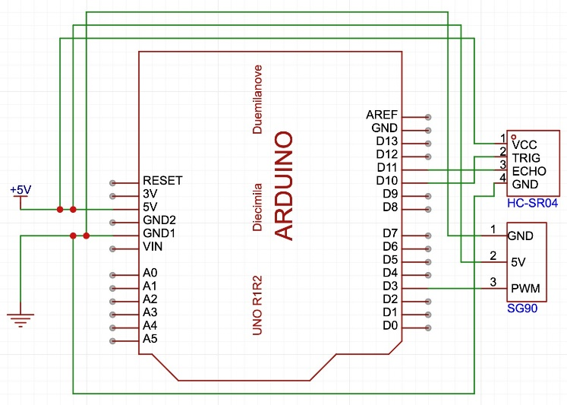
      - circuit diagram
In accordance with the designed circuit diagram, the actual wiring of our vehicle is as follows:
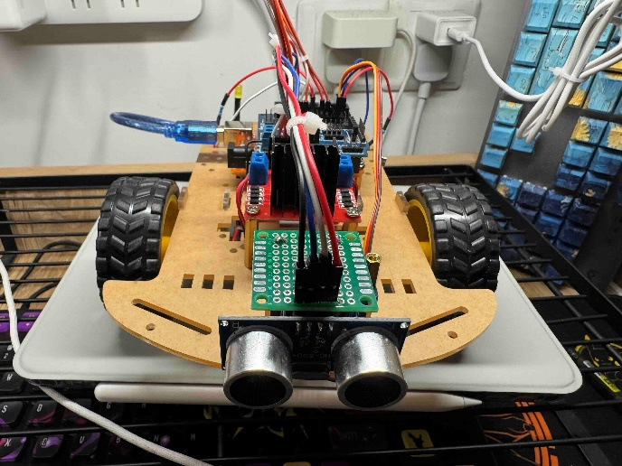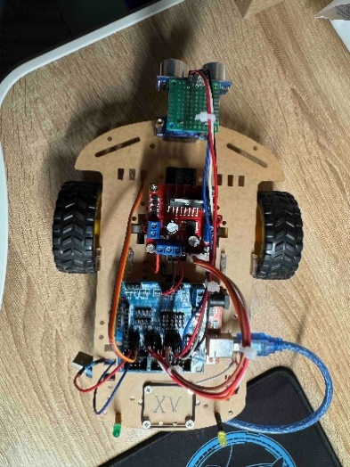
      - actual wiring of vehicle
After selecting the obstacle, measurements are taken at intervals of 40 centimeters within a range of 0 to 400 centimeters from the obstacle. The measurement angles span from 0 to 180 degrees, with the direction directly in front of the vehicle's nose defined as 90 degrees. The formulas used are as follows:

(1) | $$Distance=Velocity × Time$$ | （1）
In the experimental environment, where the air is dry and the temperature is 20 degrees Celsius, the speed of sound is approximately 343 meters per second, which is equivalent to 34,300 centimeters per second. Since the ultrasonic wave travels twice the distance from the transmitter to the target and back to the receiver, the actual distance measurement is related to the time difference as follows: a distance of 1 centimeter corresponds to a time difference of 58.3 microseconds, which can be approximated to 58 microseconds for simplified calculations.

Result
We measured three sets of data every 40cm within the range of 0 to 400cm, calculated the average of the three sets of data, and plotted them into an average radar chart, as shown in the figure below:
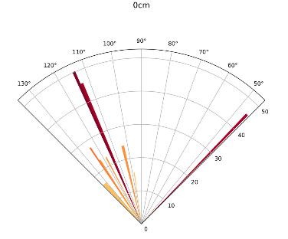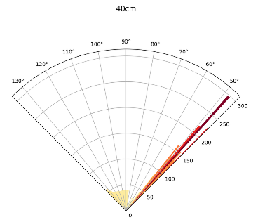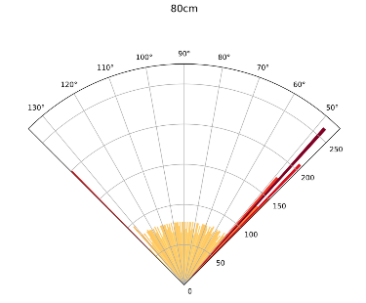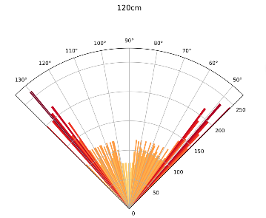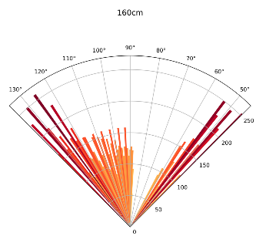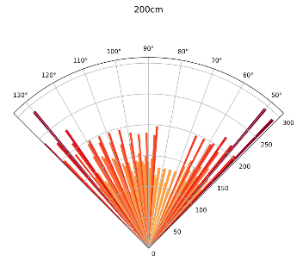
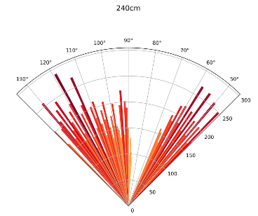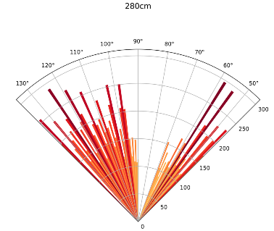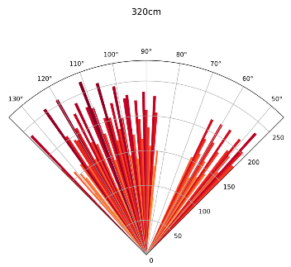
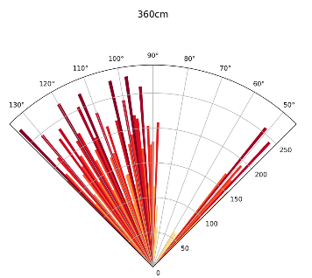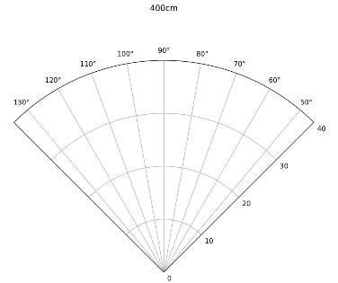
      - A "distance-angle" radar chart divided every 40cm within the range of 0 to 400cm

By integrating the data from angles ranging from 0 to 180 degrees and distances ranging from 0 to 400cm, we have created the following radar chart. It illustrates how far obstacles can be detected at different angles when the forward linear distance is the same.
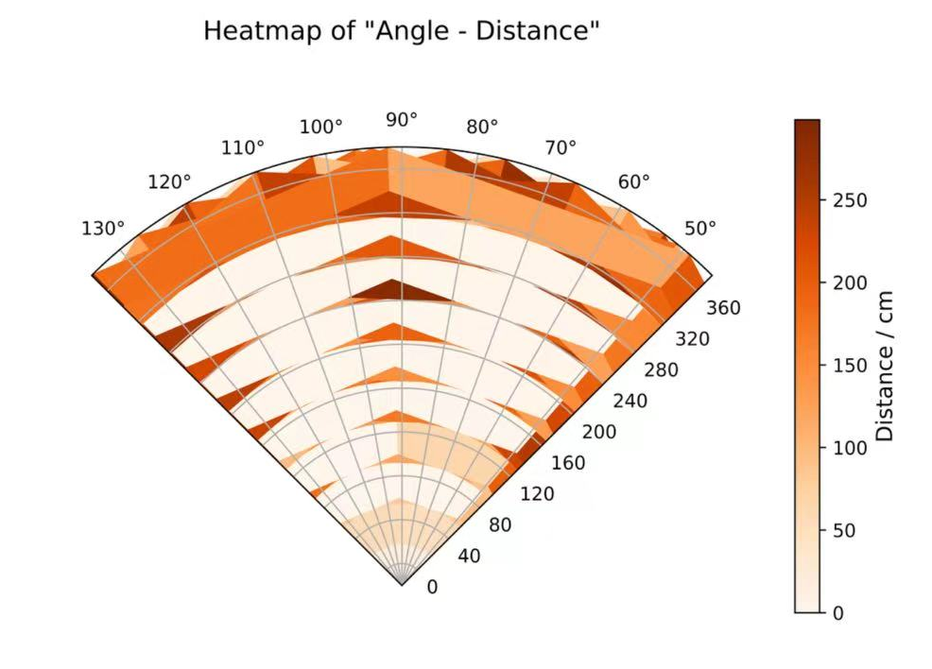
      - A distribution heatmap divided every 40cm within the range of 0 to 400cm

Taking all the data into account, we have integrated the data from 0 to 180 degrees and 0 to 400cm, and created the following radar chart to illustrate the maximum distance at which obstacles can be detected at each angle.

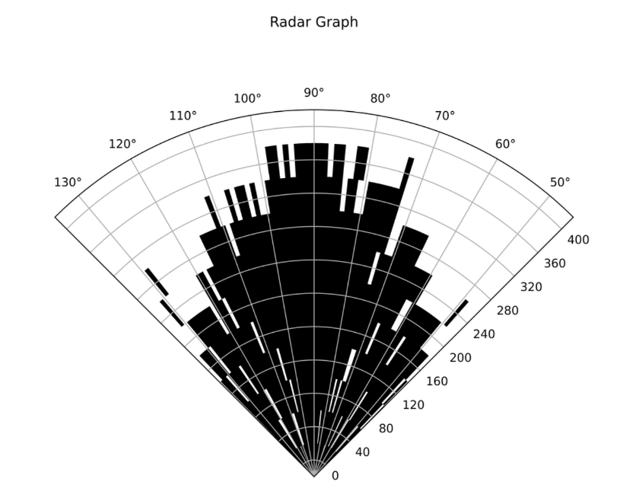
      - “Distance-Angle” Sector Radar Chart

Conclusion
- Conclusion and Summary:
In this experiment, we accomplished the following tasks:
1）We collected three sets of data at angles ranging from 0 to 180 degrees and distances ranging from 0 to 400cm from the obstacle, and then calculated the average of these three sets of data.
2）Based on the calculated averages, we created two radar charts. One illustrates the maximum distance at which obstacles can be detected at each angle, while the other shows how far obstacles can be detected at different angles when the forward linear distance is the same.

- Limitations of the experiment:
- We cannot rule out all environmental influences, as the ultrasonic waves may have reflected off objects other than the intended obstacles.
- After obtaining the experimental data, we manually removed outliers, which may have led to the inadvertent deletion of some valid values.

