

Detailed V-Model Design and Verification Report
Gesture-Based Access Control System

Students
Ramez Al Masadeh
Mohab Bani Issa
Mohammad Al Tayeb

Contents
1. Executive Summary 3
2. Project Scope and Operating Concept 3
2.1 System Purpose 3
2.2 Main Systems 3
2.3 Functional Subsystems 3
3. Detailed V-Model 5
3.1 Step 1 - Stakeholder Need 5
3.2 Step 2 - System Requirements 5
3.3 Step 3 - System Architecture 6
3.4 Step 4 - Subsystem Design 6
3.5 Step 5 - Component Design and Implementation 7
3.6 Step 6 to Step 10 - Testing and Validation 7
4. System-Level Architecture and Communications 7
4.1 End-to-End Runtime Sequence 7
4.2 Communication Interface Summary 7
4.3 System-Level Communication Rules 8
5. Subsystem-Level Design 8
5.1 Distance Sensor and Trigger Subsystem 8
5.2 Server and Password Subsystem 9
5.3 Gesture Reading and Comparison Subsystem 9
5.4 PLC Relay Subsystem 10
6. State Machine and Control Logic 11
6.1 State Descriptions 11
6.2 Final Main Program Logic 12
7. Verification and Testing Plan 12
7.1 V-Model Test Mapping 12
7.2 Unit and Component Tests 12
7.3 Subsystem Tests Using Working Code 13
7.4 System Acceptance Test 13
8. Implementation Evidence from Working Code 14
8.1 Gesture Detection Test 14
8.2 Gesture Password Test 14
8.3 Final Integration Traceability 14
9. Integration Risks and Engineering Notes 15
10. Conclusion 15
Appendix A. Test Case Matrix 16
Appendix B. Code Traceability Summary 16

1. Executive Summary
This report defines a detailed V-model for a gesture-based access control prototype. The prototype combines a distance/IR trigger, NI myRIO, Raspberry Pi, a password server, MediaPipe gesture recognition, and PLC relay actuation. The V-model is used to connect every design decision on the left side with a matching test activity on the right side.
The final operational sequence is intentionally simple and robust: the system waits for a user detection trigger, fetches the current password from the server, opens the camera, reads the gesture, compares the detected 5-bit finger pattern or gesture name with the password, and sends an access-granted command to the PLC only if the gesture is correct.
- No lockout state is included in the design.
- No maximum number of password attempts is included.
- If the password is incorrect, the attempt ends and the user must reactivate the sensor to start a new attempt.
- The Raspberry Pi is the central runtime controller because it coordinates the trigger, server, camera, gesture comparison, and PLC command.

2. Project Scope and Operating Concept

2.1 System Purpose
The system provides contactless access control. Physical presence is detected first to avoid running the camera continuously. Authentication is then performed with a single hand gesture. After successful authentication, a PLC output energizes a relay that can represent a door lock, lamp, actuator, or demonstration load.

2.2 Main Systems
System | Responsibility | Main interface
myRIO | Detects user presence and produces a trigger decision. The sensor signal is converted into an active-high digital event. | Sensor digital output and myRIO/Pi digital input, communicates directly with raspberry pi using digital pins.
Raspberry Pi | Coordinates the complete authentication process and runs the Python control program. | GPIO trigger input, HTTP client, USB/CSI camera, Modbus TCP client. Have its IP address for communication with the rest of systems.
Server / website | Stores the current password as a gesture name or 5-bit finger array. | HTTP request/response. Have its IP address for communication with the rest of systems.
PLC | Executes the industrial output command after access is granted. | Modbus TCP coil/register write. Have its IP address for communication with the rest of systems.

2.3 Functional Subsystems
Subsystem | Why it exists | Output to next subsystem
Distance sensing and trigger | Prevents unnecessary camera processing and starts authentication only when a user is close. | Active-high trigger to Server and password synchronization to fetch password.
Server and password synchronization | Ensures that the Raspberry Pi compares the gesture against the current password, not an old local value. | 5-bit finger array to gesture reading subsystem.
Gesture reading and comparison | Convert camera frames into hand landmarks, finger states, and a gesture decision. | Boolean result: correct or incorrect, if correct sends to PLC relay actuation subsystem.
PLC relay actuation | Making the authentication result affect the physical system. | Relay/output ON after correct gesture.

3. Detailed V-Model
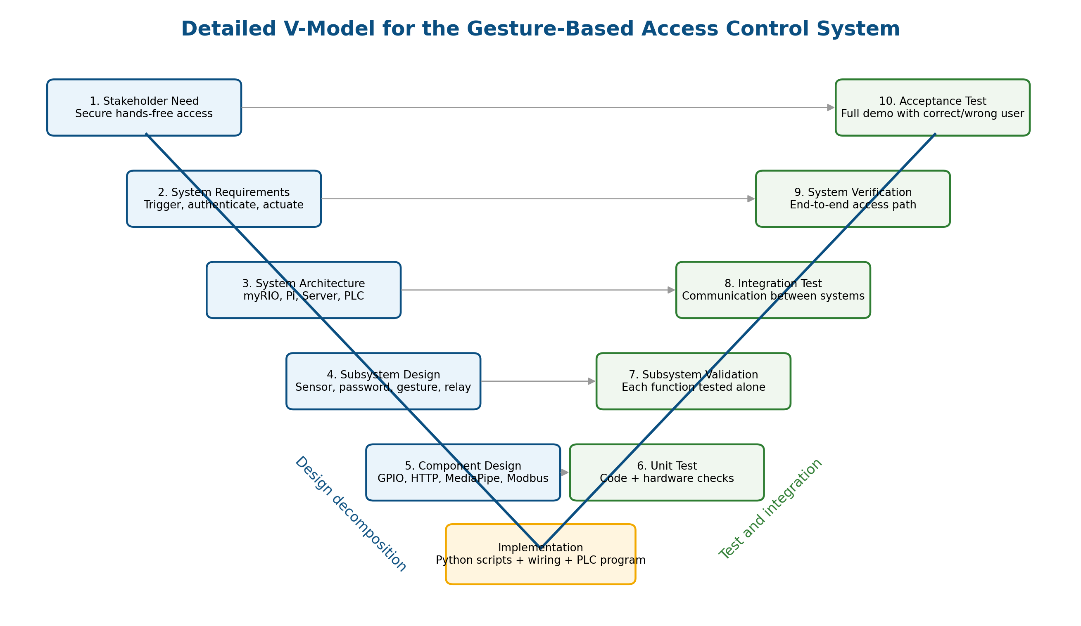
Figure 1. V-model showing design decomposition on the left and matching verification activities on the right.

3.1 Step 1 - Stakeholder Need
The stakeholder need is a safe demonstration system that allows access only when a person is present and performs the correct gesture. The system should show realistic industrial integration by using a PLC and relay, while still being simple enough to debug in the lab.

3.2 Step 2 - System Requirements
Requirement ID | Requirement | Verification method
SYS-01 | The system shall remain idle until the distance/IR trigger is active high. | Sensor trigger test
SYS-02 | The Raspberry Pi shall fetch the current password after the trigger is received. | Server synchronization test
SYS-03 | The system should open the camera and run gesture recognition only during authentication. | Gesture subsystem test
SYS-04 | The system shall compare one detected gesture against one current password. | Password comparison test
SYS-05 | The PLC relay output shall be energized only after access is granted. | PLC output test
SYS-06 | If the gesture is incorrect, the system shall return to waiting for a new trigger. | State-machine test
SYS-07 | The design shall not include lockout or a maximum-attempt counter. | State-machine inspection and test

3.3 Step 3 - System Architecture
At the architecture level, each physical system is assigned a clear responsibility. The Raspberry Pi acts as the coordinator because it has access to the camera, server, and PLC network command. The myRIO is responsible for sensor-side triggering or for generating an active-high signal that tells the Raspberry Pi when to start authentication.
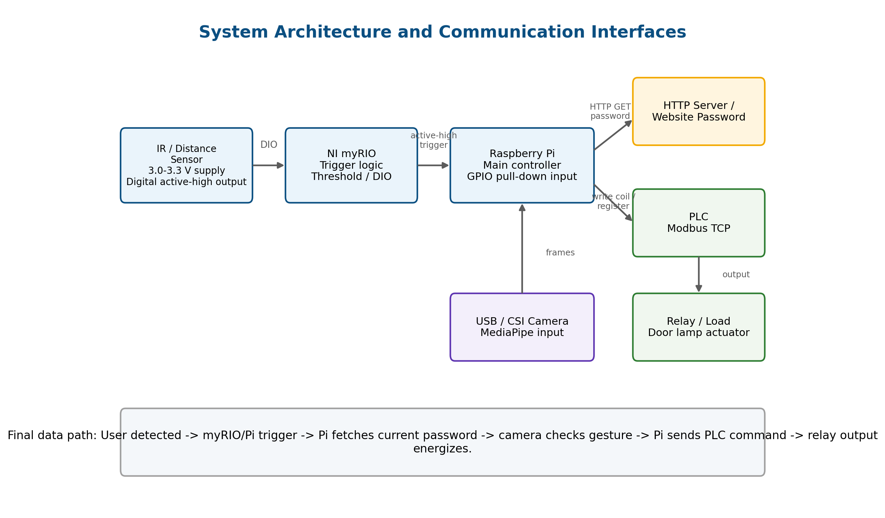
Figure 2. Communication architecture between the sensor/myRIO, Raspberry Pi, server, PLC, and relay output.

3.4 Step 4 - Subsystem Design
Subsystem design decomposes the architecture into functional blocks that can be individually implemented and tested. This avoids debugging the entire system at once. Each subsystem has a defined input, processing step, output, and acceptance criterion.

3.5 Step 5 - Component Design and Implementation
Component design maps the subsystem requirements to real hardware pins, Python functions, and protocol calls. Implementation is the bottom of the V-model: wiring, Python files, MediaPipe model files, server endpoint configuration, and PLC address configuration.

3.6 Step 6 to Step 10 - Testing and Validation
The right side of the V-model confirms that the implementation satisfies the left side. Unit tests verify individual code and hardware components. Subsystem tests verify each functional block. Integration tests verify communication between systems. The final acceptance test verifies the complete access-control behavior from user detection to relay output.

4. System-Level Architecture and Communications

4.1 End-to-End Runtime Sequence
- The system is idle and the Raspberry Pi waits for a trigger.
- The IR/distance sensor detects a nearby user and the myRIO/Pi trigger line becomes active high.
- The Raspberry Pi reads the active-high trigger using a GPIO input configured with a pull-down default state.
- The Raspberry Pi sends an HTTP request to the server to fetch the current password.
- The Raspberry Pi opens the camera and starts MediaPipe hand-landmark detection.
- The gesture module converts landmarks into finger states: thumb, index, middle, ring, and pinky.
- The detected gesture or 5-bit array is compared with the password fetched from the server.
- If correct, the Raspberry Pi writes to the PLC using Modbus TCP.
- The PLC energizes its output and the relay/load turns ON.
- If incorrect, the attempt ends and the system returns to waiting for a new sensor activation.

4.2 Communication Interface Summary
Link | Direction | Signal / protocol | Meaning
IR sensor -> myRIO / Pi trigger input | Sensor to controller | 3.3 V digital active-high signal (Internal Pull down) | User close enough to start authentication
myRIO -> Raspberry Pi | Trigger controller to Pi | Digital active-high trigger | Start the authentication program step
Raspberry Pi -> Server | Pi to website/server | HTTP GET/response | Fetch the current password after trigger
Camera -> Raspberry Pi | Camera to Pi | USB video frames | Hand gesture input
Raspberry Pi -> PLC | Pi to PLC | Modbus TCP write coil/register | Command access-granted output
PLC -> Relay | PLC output to load | Digital output voltage/current through relay module | Physical access action

4.3 System-Level Communication Rules
- The server password is fetched after the trigger, not once at startup, so the authentication reference is current.
- The PLC is not commanded by the server directly. The Raspberry Pi commands the PLC only after local gesture comparison succeeds.
- The camera does not run during the idle state, reducing computation and avoiding unnecessary video processing.
- The trigger line is treated as active high: LOW means idle, HIGH means start the authentication attempt.
- Wrong password does not send any PLC command and does not keep the camera running for repeated attempts.

5. Subsystem-Level Design

5.1 Distance Sensor and Trigger Subsystem
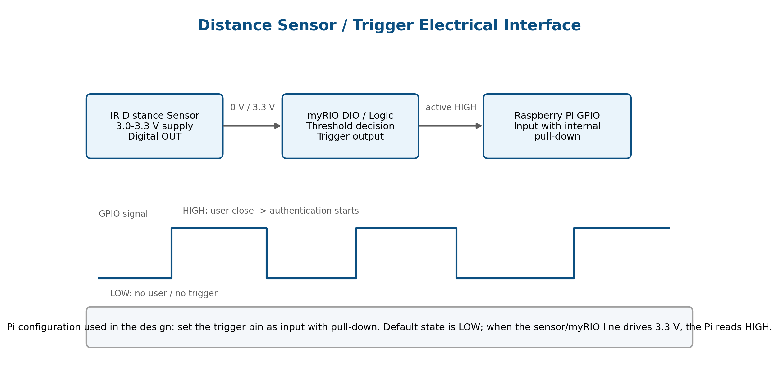
Figure 3. Active-high trigger electrical interface with default pull-down input behavior.
The distance sensor subsystem is the first gate in the system. The IR sensor module is powered from approximately 3.0-3.3 V and provides a digital output from its comparator stage. In this design, the digital output is interpreted as active high: approximately 0 V means no valid user trigger and approximately 3.3 V means the user is close enough.
The Raspberry Pi GPIO input is configured with a pull-down resistor so that the default reading is LOW when the trigger line is not driven. When the sensor/myRIO output drives the line to 3.3 V, the Pi reads HIGH and starts the next step. This avoids floating input behavior.
Detail | Design decision
Supply level | Use 3.0-3.3 V logic to remain safe for Raspberry Pi GPIO inputs.
Output type | Digital active-high trigger. HIGH starts authentication.
Input protection | Do not apply 5 V directly to a Raspberry Pi GPIO input.
Pull-down behavior | GPIO default is LOW; a valid trigger must actively drive HIGH.
Functional output | Boolean trigger status such as ON/OFF or HIGH/LOW.
# Trigger input concept on Raspberry Pi
GPIO.setup(TRIGGER_PIN, GPIO.IN, pull_up_down=GPIO.PUD_DOWN)
status = GPIO.input(TRIGGER_PIN)
if status == GPIO.HIGH:
# user detected: start authentication
...

5.2 Server and Password Subsystem
The server stores the current password as either a gesture name or a 5-bit finger array. The 5-bit format is ordered as [thumb, index, middle, ring, pinky]. A value of 1 means the finger is open/raised and a value of 0 means it is closed/folded. The Raspberry Pi fetches this password only after the trigger is received.
Gesture example | 5-bit representation | Meaning
FIST | [0, 0, 0, 0, 0] | All fingers closed
OPEN_HAND | [1, 1, 1, 1, 1] | All fingers open
ONE | [0, 1, 0, 0, 0] | Index finger open
PEACE | [0, 1, 1, 0, 0] | Index and middle fingers open
THREE | [0, 1, 1, 1, 0] | Index, middle, and ring open
THUMBS_UP | [1, 0, 0, 0, 0] | Only thumb open
ROCK | [1, 0, 0, 0, 1] | Thump, Pinky
SPIDERMAN HAND | [1, 1, 0, 0, 1] | Thump, Pinky, index
# Final integrated concept
password_fingers = fetch_password_fingers()
# Example result: [0, 1, 1, 0, 0] for PEACE
# This is the reference used for the current authentication attempt.

5.3 Gesture Reading and Comparison Subsystem
The gesture subsystem runs on the Raspberry Pi or laptop during testing. It opens the camera, reads frames, flips the frame for natural user interaction, converts BGR to RGB, and sends the image to MediaPipe Hand Landmarker in video mode. The detected hand landmarks are then converted into finger states.
Processing step | Description | Evidence from working test code
Open camera | Uses OpenCV VideoCapture to access the webcam or DroidCam source (for testing). | cap = cv2.VideoCapture(0)
Convert frame | Frame is flipped and converted from BGR to RGB before MediaPipe processing. | frame = cv2.flip(frame, 1); rgb = cv2.cvtColor(frame, cv2.COLOR_BGR2RGB)
Detect landmarks | MediaPipe HandLandmarker detects hand landmark points. | landmarker.detect_for_video(mp_image, timestamp_ms)
Finger states | Landmark y-positions are compared to determine open/closed fingers. | index tip compared with index PIP joint, etc.
Stability check | The same gesture must remain stable for a short time before accepting it. | STABLE_TIME_SECONDS = 0.8 in the password test
Compare | Detected gesture/finger array is compared with password from the server. | Correct -> access granted; wrong -> denied and reset
In the standalone password test, supported gestures were FIST, OPEN_HAND, ONE, PEACE, THREE, and THUMBS_UP. This was useful for proving the gesture logic before connecting the server and PLC.

5.4 PLC Relay Subsystem
The PLC subsystem is the actuation stage. It does not decide whether the password is correct; it only receives the access-granted command from the Raspberry Pi. Modbus TCP is used as the industrial communication method. In practice, the Pi writes a coil or holding register at a configured PLC IP address and address number.
PLC design item | Description
Protocol | Modbus TCP over the local network.
Command source | Raspberry Pi after successful gesture comparison.
PLC target | Coil or register assigned to the relay/output logic.
Output behavior | Relay energizes only after access is granted.
Safety behavior | Wrong gesture sends no PLC command, so relay remains OFF.
# PLC output concept
if gesture_is_correct:
send_access_granted_to_plc() # writes the configured PLC coil/register
else:
# no PLC command is sent
pass

6. State Machine and Control Logic
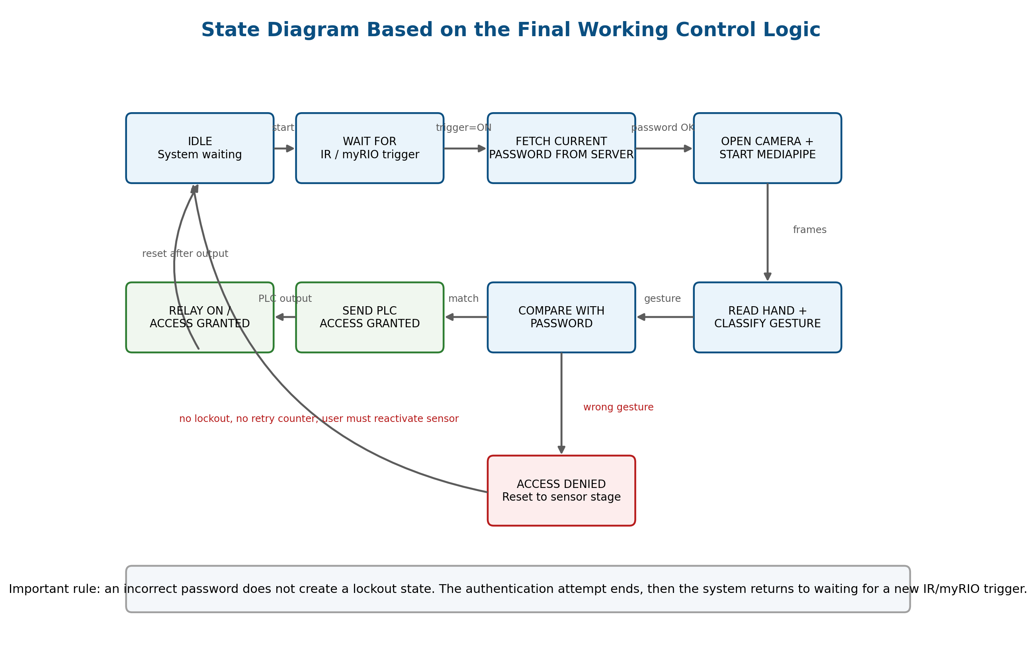
Figure 4. State diagram derived from the final control logic and requested behavior.

6.1 State Descriptions
State | Entry condition | Exit condition
IDLE / waiting | System powered and no valid trigger. | Trigger becomes active high.
Wait for IR/myRIO trigger | Raspberry Pi monitors trigger input. | Trigger status is ON/HIGH.
Fetch current password | Trigger received. | Server returns password successfully.
Open camera and start MediaPipe | Password is available. | Camera frame stream and landmark detector are ready.
Read hand and classify gesture | Camera is active. | A supported stable gesture is detected.
Compare with password | Detected gesture is available. | Decision is correct or incorrect.
Send PLC access granted | Gesture matches password. | PLC write succeeds.
Relay ON / access granted | PLC output is active. | Output time ends or system resets.
Access denied | Gesture does not match password. | System returns to waiting; user must reactivate sensor.

6.2 Final Main Program Logic
from get_ir2 import wait_for_ir_trigger
from password_client import fetch_password_fingers
from gesture_camera import run_gesture_camera
from plc_output import send_access_granted_to_plc
while True:
status = wait_for_ir_trigger()
if status == "ON":
password_fingers = fetch_password_fingers()
correct = run_gesture_camera(password_fingers)
if correct:
send_access_granted_to_plc()
else:
# No lockout and no internal retry loop.
# User must move away / reactivate the IR sensor for a new attempt.
pass

7. Verification and Testing Plan

7.1 V-Model Test Mapping
V-model test level | What is tested | Pass criterion
Unit test | Individual code functions and hardware pins. | Each function/pin works alone.
Component test | Camera, trigger input, server client, PLC client. | Each component produces the expected output.
Subsystem validation | Distance trigger, password sync, gesture recognition, PLC output. | Subsystem meets its local requirement.
Integration test | Communication between myRIO, Pi, server, camera, PLC. | Data moves correctly across system boundaries.
System acceptance test | Complete user scenario from approach to relay activation. | Correct gesture activates relay; wrong gesture does not.

7.2 Unit and Component Tests
Test ID | Component | Procedure | Expected result
UT-01 | IR sensor output | Move hand/object close and far from the sensor. | Digital output changes LOW/HIGH.
UT-02 | Pi trigger input | Read GPIO with pull-down enabled and apply active-high signal. | GPIO reads LOW by default and HIGH when triggered.
UT-03 | Camera | Run OpenCV camera test. | Camera window opens and frames are read.
UT-04 | MediaPipe landmark detector | Run hand detection test and show hand. | Landmarks and connections appear on screen.
UT-05 | Password client | Call fetch_password_fingers() after setting server password. | Returned array matches website/server value.
UT-06 | Gesture classifier | Show each supported gesture. | Classifier returns expected gesture or 5-bit array.
UT-07 | PLC client | Run safe test command to assigned coil/register. | PLC output or test bit changes.
UT-08 | Relay output | Activate PLC output under supervision. | Relay/load turns ON.

7.3 Subsystem Tests Using Working Code
The testing phase is based on the last working code structure from the project. The standalone tests are used before integration, then the final main loop is used for system acceptance.
Note: there are tens of test codes that cover all subsystems will not be shared, only final codes will be shared.
Subsystem | Working code evidence | Purpose in testing
Gesture detection | gesture_test.py | Verifies that the camera opens, MediaPipe detects hands, and landmarks are drawn.
Gesture password logic | Password_test.py | Verifies supported gestures, stability time, password comparison, and access granted/denied decision.
Final integration loop | main_msd.py concept | Verifies trigger -> fetch password -> run camera -> send PLC output.
PLC communication | plc_output.py concept | Verifies that a correct authentication result can write to the PLC.
Server communication | password_client.py concept | Verifies that the current password is read from the server before authentication.
IR sensor | Get_IR.py / GPIO26_test.py | First verifies that IR sensor works correctly, then verify the communication with other subsystems.

7.4 System Acceptance Test
Scenario | Steps | Expected result
Correct user gesture | User approaches sensor; Pi fetches password; user shows correct gesture; Pi sends PLC command. | Relay turns ON and access is granted.
Wrong user gesture | User approaches sensor; Pi fetches password; user shows wrong gesture. | Access denied, no PLC output, system returns to waiting for sensor reactivation.
Password changed on website | Change server password; reactivate sensor; show old gesture then new gesture. | Old gesture fails; new gesture succeeds.
No hand visible | Trigger system but do not show a hand. | No access granted; system does not write PLC output.
PLC disconnected | Correct gesture while PLC network unavailable. | Software reports PLC communication error; output does not energize unexpectedly.

8. Implementation Evidence from Working Code

8.1 Gesture Detection Test
The gesture detection test opens the camera, creates a MediaPipe HandLandmarker in video mode, reads each frame, converts it to RGB, computes a timestamp, and calls detect_for_video. If hand landmarks exist, the code draws points and lines on the hand and displays HAND DETECTED; otherwise it displays NO HAND. This verifies the computer-vision pipeline before authentication logic is added.
# gesture_test.py evidence
cap = cv2.VideoCapture(0)
result = landmarker.detect_for_video(mp_image, timestamp_ms)
if result.hand_landmarks:
# draw landmarks and connections
cv2.putText(frame, "HAND DETECTED", ...)
else:
cv2.putText(frame, "NO HAND", ...)

8.2 Gesture Password Test
The password test proves the authentication decision. It defines supported gestures, computes finger states from landmarks, classifies the gesture, applies a stability time, and compares the stable gesture against the current password. This test is used as the basis for the final gesture_camera function.
# Password_test.py evidence
SUPPORTED_GESTURES = ["FIST", "OPEN_HAND", "ONE", "PEACE", "THREE", "THUMBS_UP"]
STABLE_TIME_SECONDS = 0.8
if current_gesture == current_password:
access_result = "ACCESS GRANTED"
else:
access_result = "ACCESS DENIED"

8.3 Final Integration Traceability
Integrated function | Design requirement covered | Test evidence
wait_for_ir_trigger() | SYS-01: wait for active-high trigger | Trigger hardware/component test
fetch_password_fingers() | SYS-02: fetch current password after trigger | Server synchronization test
run_gesture_camera(password_fingers) | SYS-03 and SYS-04: camera and password comparison | Gesture detection and password tests
send_access_granted_to_plc() | SYS-05: command PLC only after correct gesture | PLC output test
else: pass/reset | SYS-06 and SYS-07: wrong password returns to sensor stage, no lockout | State-machine test

9. Integration Risks and Engineering Notes
Risk / note | Impact | Mitigation
5 V logic accidentally connected to Raspberry Pi GPIO | Can damage Pi GPIO input. | Use 3.3 V logic or level shifting; verify with multimeter before connecting.
Floating trigger input | False triggers or unstable behavior. | Use internal pull-down on Pi input and a clear active-high signal.
Server password not synchronized | Pi compares against old password. | Fetch password after trigger, not only at startup.
Camera source changes between laptop and Pi | Camera fails to open. | Keep camera index/source configurable and test with gesture_test.py first.
PLC IP or coil address wrong | Correct gesture does not activate relay. | Test plc_output.py separately with safe PLC bit before full demo.
Network instability | Server or PLC communication fails. | Print clear errors and keep relay OFF on communication failure.
Gesture ambiguity | False denied or false accepted result. | Use stable time and supported gestures with clear finger patterns.
Wrong password behavior unclear | Unexpected retry behavior. | State diagram explicitly returns to sensor activation after denial.

10. Conclusion
The detailed V-model confirms that the project is organized as an engineering system rather than only a collection of scripts. The system level describes how the myRIO, Raspberry Pi, server, camera, PLC, and relay communicate. The subsystem level explains the trigger, password synchronization, gesture recognition, and actuation in enough detail to support implementation and testing. The test plan follows the right side of the V-model and uses the working code modules as evidence for unit, subsystem, integration, and acceptance testing.
The most important final behavior is that the password is fetched from the server after the user activates the sensor, then the camera reads one gesture. A correct gesture activates the PLC relay. An incorrect gesture ends the attempt and returns the system to the trigger stage; there is no lockout and no try counter.

Appendix A. Test Case Matrix
Test case | Input condition | Expected output
TC-01 Sensor idle | No object near sensor | Trigger LOW; system remains idle
TC-02 Sensor active | Object/person near sensor | Trigger HIGH; Pi starts authentication
TC-03 Server fetch | Website password set to PEACE | Pi receives [0,1,1,0,0] or PEACE
TC-04 Camera open | Authentication started | Camera window/stream opens
TC-05 Correct gesture | Gesture equals current password | Access granted and PLC command sent
TC-06 Wrong gesture | Gesture different from current password | Access denied, no PLC command, return to sensor stage
TC-07 PLC relay | PLC command received | Relay/output ON
TC-08 Full cycle reset | After grant or denial | System waits for next sensor activation

Appendix B. Code Traceability Summary
File / module | Role in final project | Verification use
get_ir2.py | Waits for the IR/myRIO trigger and returns ON when active. | Trigger subsystem test
password_client.py | Fetches the current password as a 5-bit finger array from the server. | Server synchronization test
gesture_camera.py | Opens camera, detects hand landmarks, classifies/compares gesture. | Gesture subsystem test
plc_output.py | Sends access-granted command to the PLC using the configured protocol/address. | PLC relay subsystem test
main_msd.py | Coordinates the final sequence in an infinite loop. | System integration and acceptance test
gesture_test.py | Standalone camera and MediaPipe hand detection test. | Unit/component test for vision
Password_test.py | Standalone gesture password classification and comparison test. | Subsystem validation for gesture password logic

