For Junior

You need to create a web application with using REST API.

The application should provide the simple Web API service with CRUD operations for one business entity stored in DB.

IMPORTANT:

Your solution and architecture should be designed and implemented using the best patterns and practices.

Requirements for frameworks

Backend: .NET Core, EF Core

Frontend: Angular 4+

DB engine: MySQL or MSSQL

Full description

**Backend requirements and description:**

1. authorization/authentication needed

2. N-tier (multilayered) architecture should be implemented using any DI framework

3. DB should be created via Code First approach with migration

4. Only 1 table `User` should be added with 3 columns: `ID`, `Name`, `IsActive` (IsActive column should be used for soft delete)

5. All API endpoints should use asynchronous actions with predefined routes

6. Web API should have:

* Only 1 controller for CRUD operations
* Exception handling with their logging to file
* AutoMapper or any other object-object mapper

**Frontend requirements and description:**

1. UI should have:

*  The simple grid for review records from DB
*  `Add` button for adding new records
*  `Delete` button for each row in grid
*  Inline editing

2. All requests should use REST API

**Acceptance criteria:**

1. The application should work as expected without crashing and errors

2. Clear naming of classes, methods and variables

3. Using the best and simple approach

**Login and Registration form:**

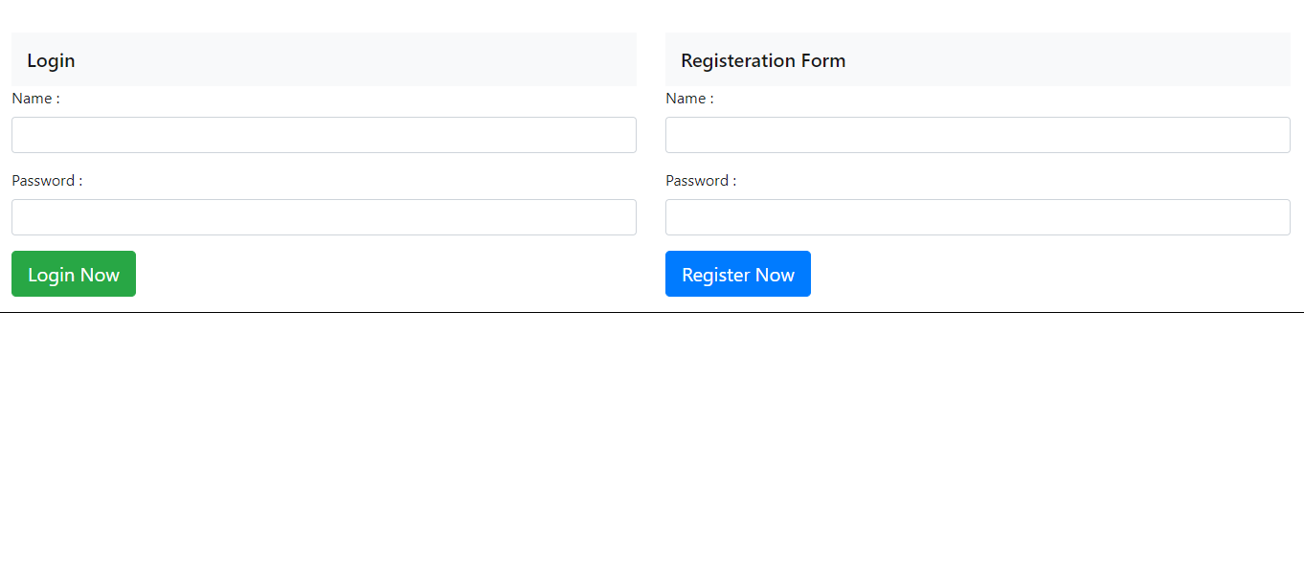

**After registration:**

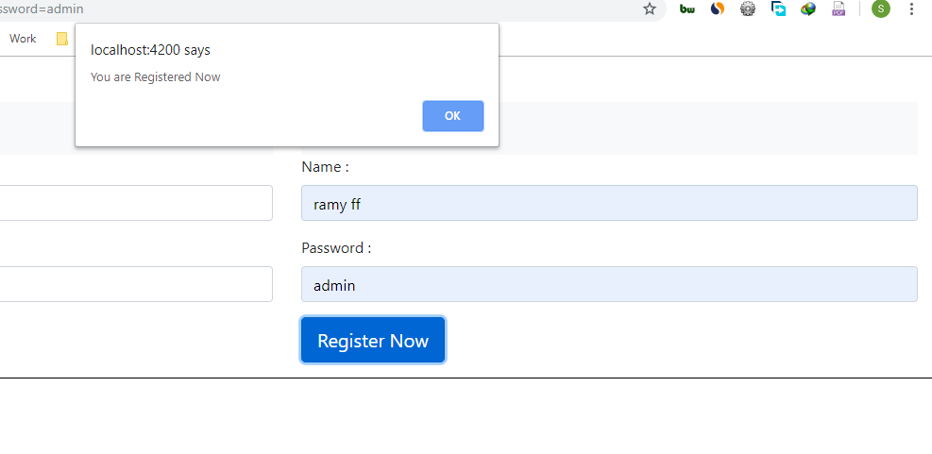

**After Login**

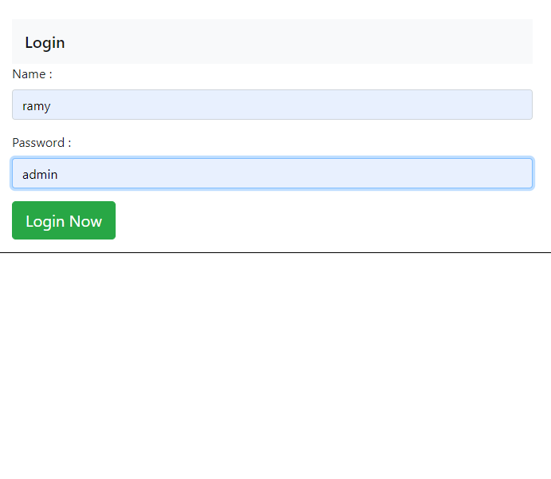

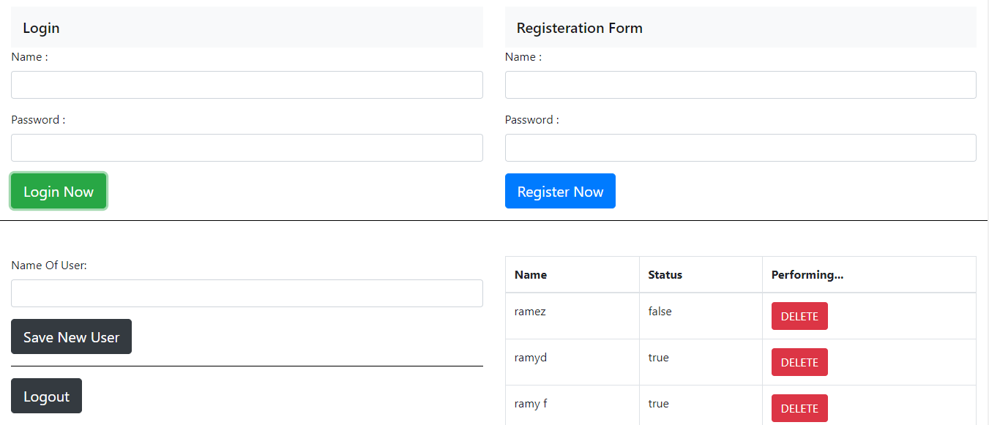

After you Login

You can add user:

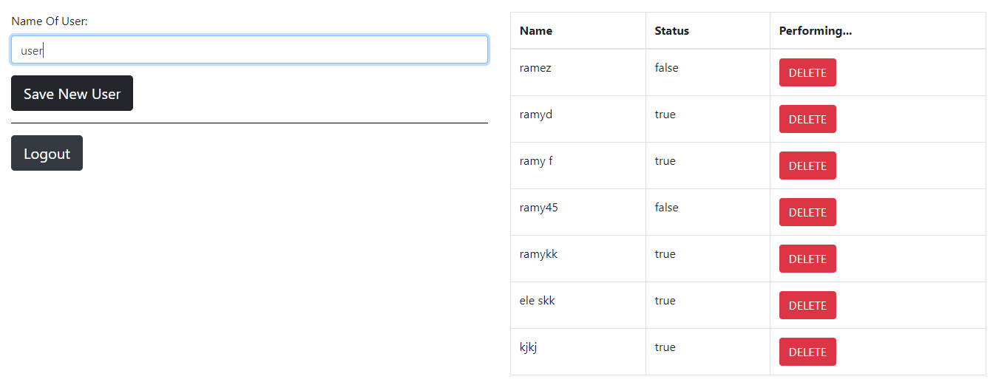

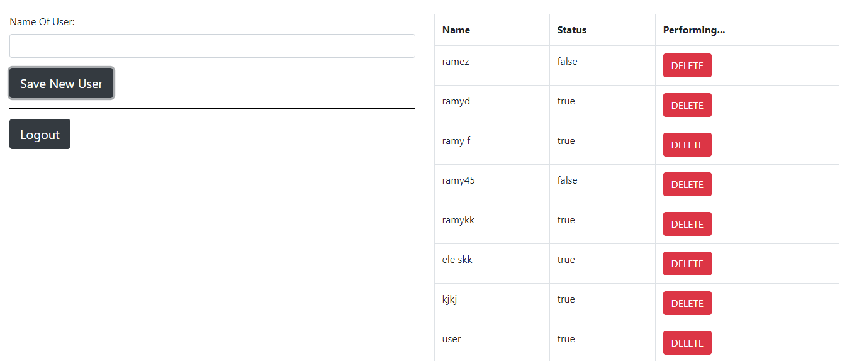

**You can Delete Logically**

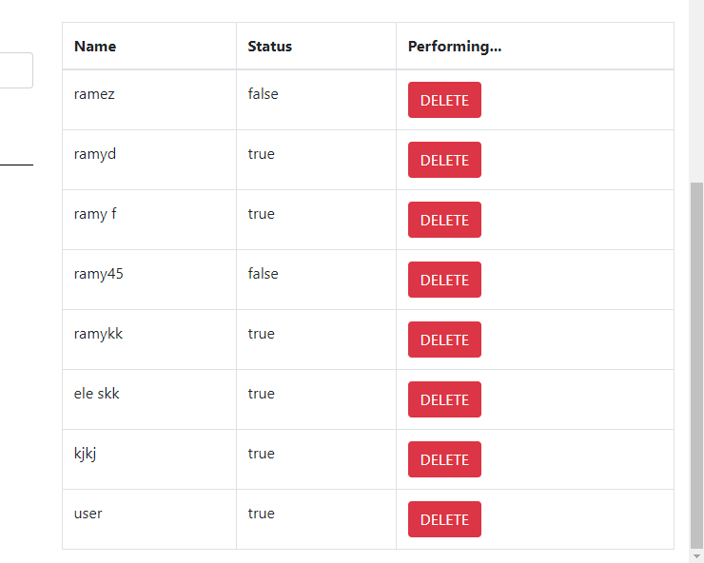

**You can Update User**

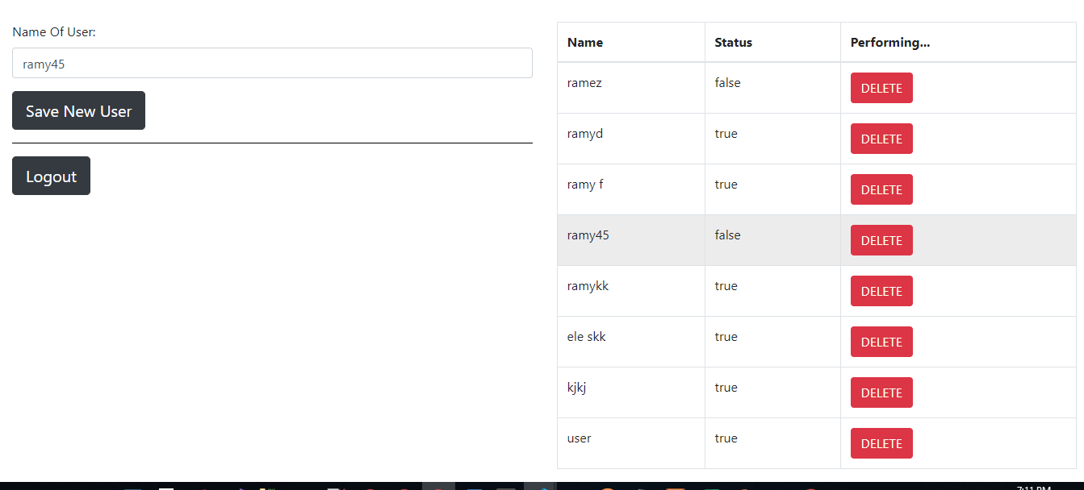

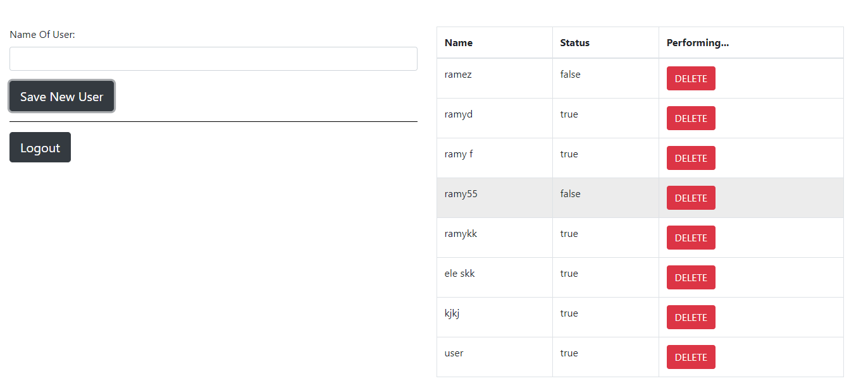

**Finally, you can Log Out**

