pos system

Technical Report

RAMEZ AL-HAWAMDEH

|  |  |
| --- | --- |
|  | **Table of content** |
| **1** | **Executive summary** |
| **2** | **Introduction** |
| **3** | **Problem** |
| **4** | **Objectives** |
| **5** | **Advantages** |
| **6** | **Recommendations** |
| **7** | **Conclusion** |
| **8** | **Methodology** |
| **9** | **Result** |

|  |  |
| --- | --- |
| **Figure** | **Description** |
| **1** | **work flow diagram** |
| **2** | **login page** |
| **3** | **dashboard page** |
| **4** | **all items page** |
| **5** | **create new item page** |
| **6** | **shows all users** |
| **7** | **create new user** |
| **8** | **selling dashboard** |
| **9** | **list of transactions** |

**Executive summary:**

In this report, I have discussed how I developed a website to facilitate and enhance business operations by offering a variety of features that allow users to handle business operations with ease. Different users in the application can handle pages and operations related to their roles. This application serves as a catalyst for business development and can help to improve business processes and access important information more efficiently.

**1. Introduction:**

A point of sale (POS) system is a critical component of any project, as it helps to monitor operations, streamline the sales process, audit accounts, and improve customer interactions. In this project, we will be developing a website-based point of sale system for a store located at Al-Hussein Technical University (HTU). This system will be used by employees with various roles to manage sales transactions and track inventory levels. The system administrator will need to have real-time access to information about total sales, transactions, and inventory levels.

**1.1 Problem:**

We are tasked with developing a website-based point of sale system for a store located at HTU. The system must be easy to use for employees with various roles, and must provide real-time information about total sales, transactions, and inventory levels to the system administrator. The system should also allow users to make and track sales, manage inventory, and manage user accounts with the appropriate permissions.

**1.2 Objectives:**

* The login page will serve as the starting point for the website, and will redirect users to the control panel.
* The informational dashboard will provide key data such as total sales, total transactions, total item count, top five most popular items, and user count.
* The sell board will feature a form for making sales, including the name of the item and the quantity being sold. Sales of items that are out of stock should be prevented.
* The sell board will also include a list of all transactions made by the logged-in user on the current day, with the ability for the user to modify or delete each transaction using action buttons.
* The inventory management page will display all items and provide all CRUD (create, read, update, delete) functionality for each item via separate pages.
* The manage transactions page will display all transactions and provide read, edit, and delete functions.
* The manage users page will display all users and provide all CRUD functionality for each user.
* Users should be able to restrict access to certain pages based on their predefined roles and control access with permissions.

**2. Advantages:**

* This website allows for easy and convenient selling and managing of items.
* Store owners have access to information, items, transactions, and users to effectively manage their store.
* Users have access to their own information and items, enabling them to perform tasks such as accounting, inventory management, and purchasing and selling.
* The user interface is compatible with tablets and smartphones.
* Users can modify their personal information.
* The website ensures the security of information, items, and transactions by preventing security attacks, using secure passwords, and protecting against XSS vulnerabilities

**3.Recommendations:**

* To make the most of this website, we suggest the following:
* Using a user-friendly interface to make it easy for people to use the store.
* Offering a variety of items for sale to customers.
* Providing extra features and services like good prices, special deals, and technical help.
* Creating ways for technical support and communication with customers to handle any questions or problems.
* Offering different payment options for customers such as credit cards, electronic payments, and cash on delivery.
* Updating the store regularly with new items, deals, and performance improvements.
* Giving special discounts and promotions to attract new customers.

**4. Conclusion:**

In this website has the potential to bring many benefits for the operations and management of the store. Customers can benefit from the wide range of items available for purchase, as well as additional services and technical support.

The store's security can be ensured by preventing security breaches and using secure passwords.

Additionally, the POS system will increase productivity, accuracy, and the overall customer experience, resulting in increased sales and a competitive edge for the store.

The website also allows for easy management and access for both customers and the store manager. With this option, it is possible to achieve complete security for information, items, and transactions. Overall, this website is an excellent choice for handling store operations and management, and the POS system will enable HTU to successfully run its store and achieve its commercial goals.

**5.Methodology:**

Technical Feasibility

Technical Feasibility Our system is a web application and the main technologies and tools that are associated with this project are:

5.1. For front-end:

* Html
* CSS
* Bootstrap

5.2. For back-end:

* PHP
* SQL

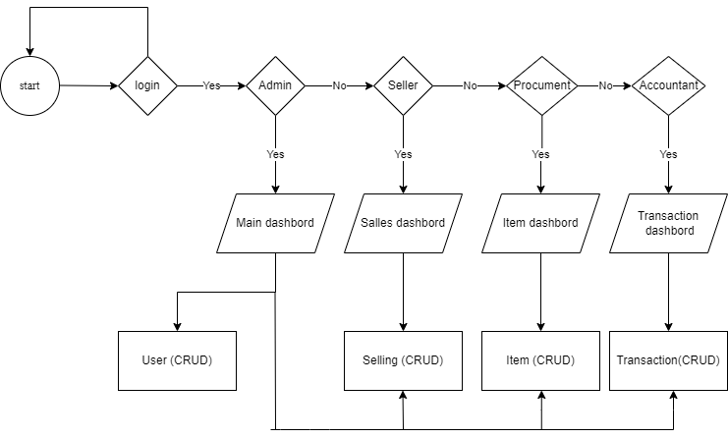

Figure [1]: work flow diagram

**6.Result:**

Figure (2) shows initial page that allows the user to interact with the system. So, there are four user roles: Admin, seller, account supervisor procumbent.

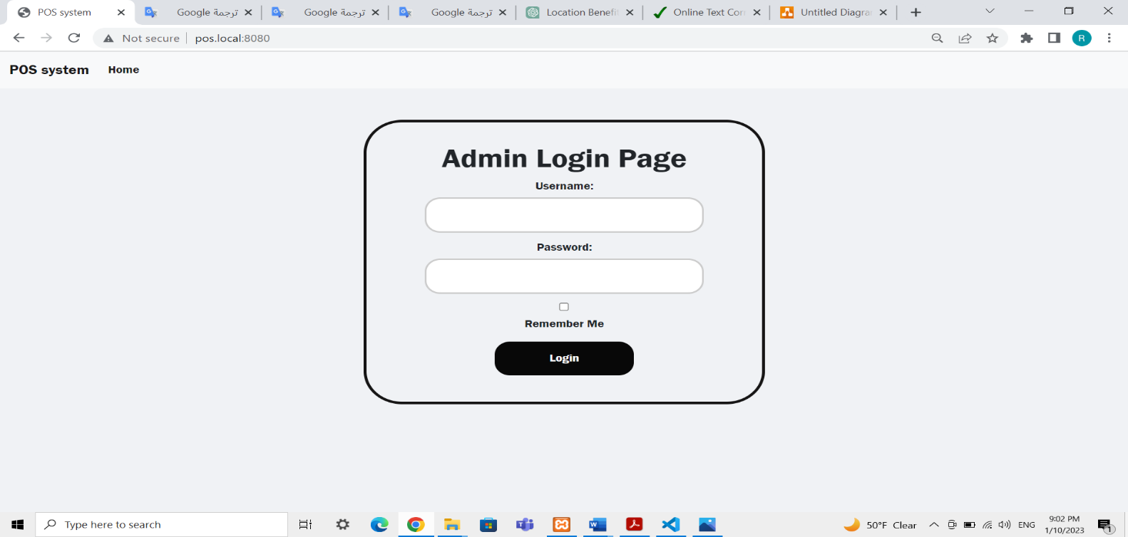

Figure [2]: login page

Figure [3] shows the dashboard admin , where the administrator may get some fast information such as "Total item number" and "Total Users number" and "Top 5 Expensive Item to Buy"

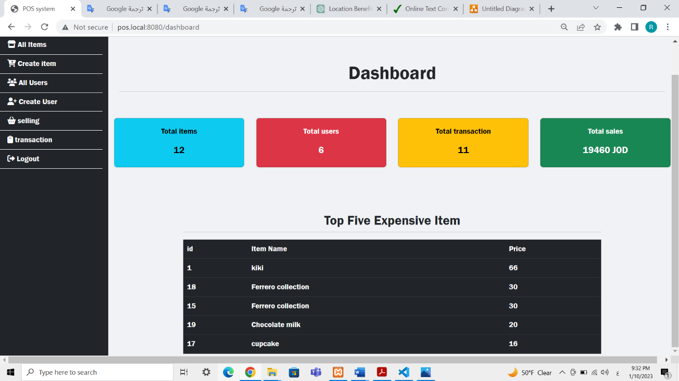

Figure [3]: dashboard page

Figure (4) shows all items page, this page display all items in the database.

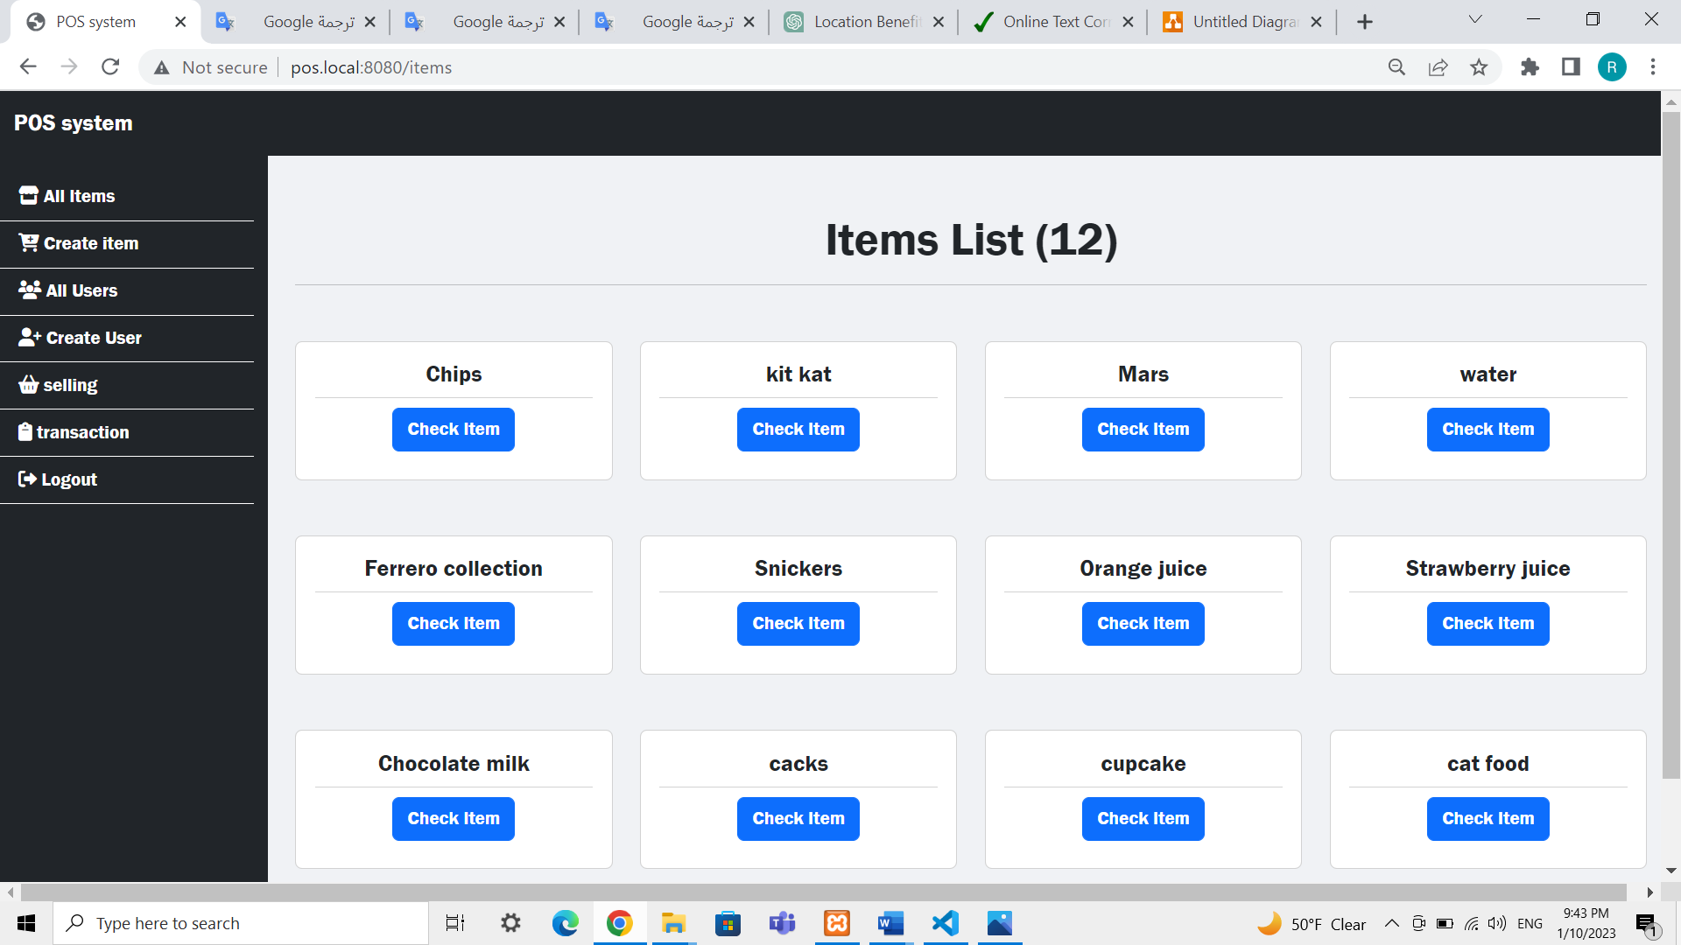

Figure [4]: all items page

Figure (5) create new item page. The admin and the procurement add new item

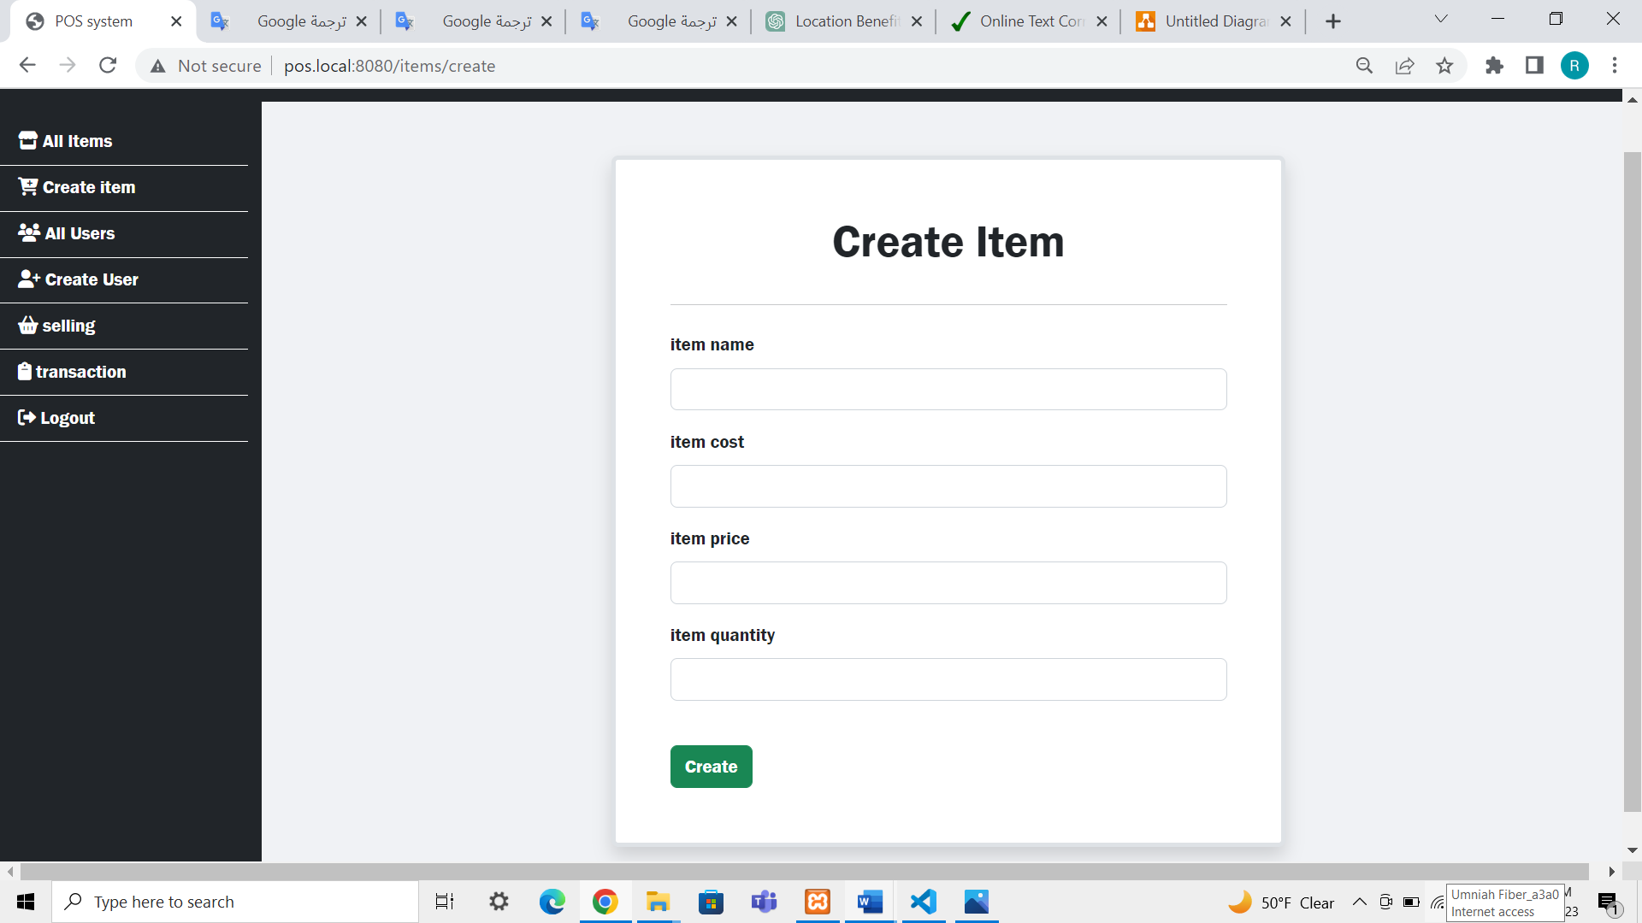

Figure [5]: create new item page

Figure (6) shows all users .

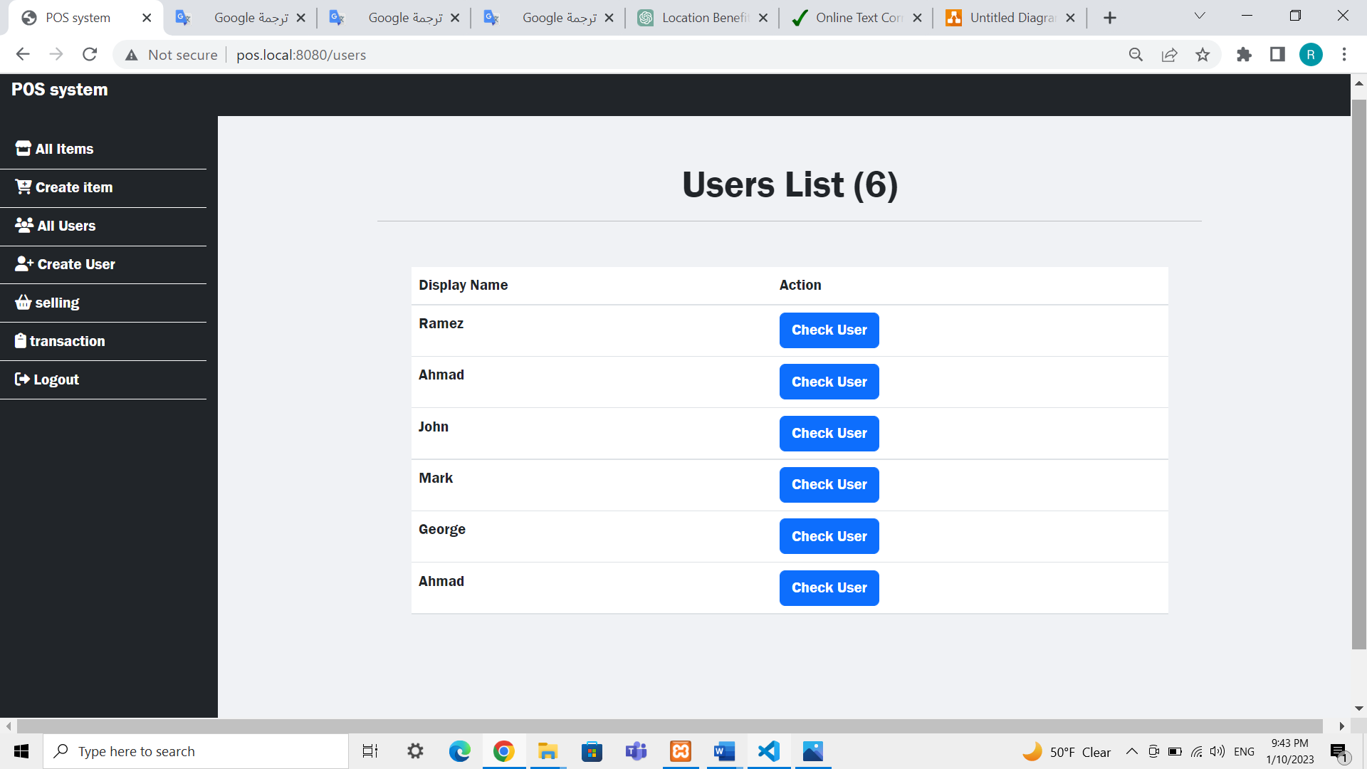

Figure [6]: shows all users

Figure (7) create new user page. The admin and the procurement add new user

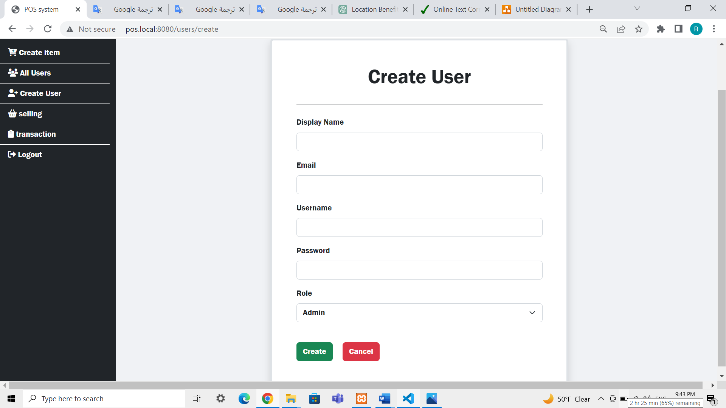

Figure [7]: create new user

Figure (8) the save button will move the transaction to the daily sales, which he may view by hitting the all sales button.

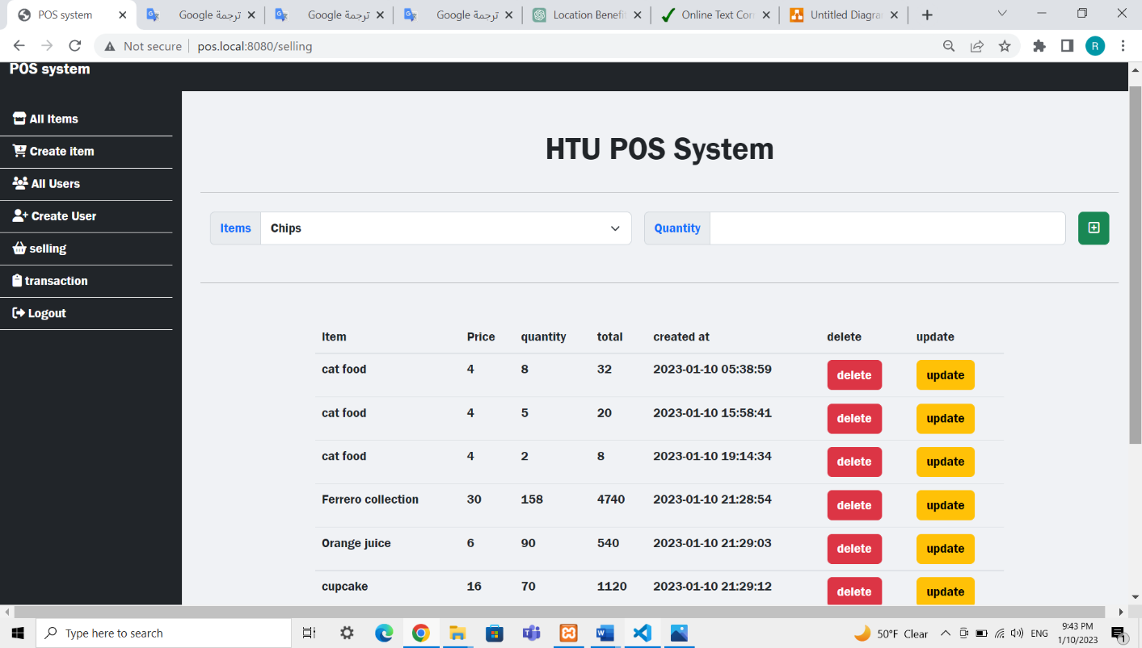

Figure [8]: selling dashboard

Figure (9) shows the dairy buy the logged in user buy the day remove the most recent transaction.

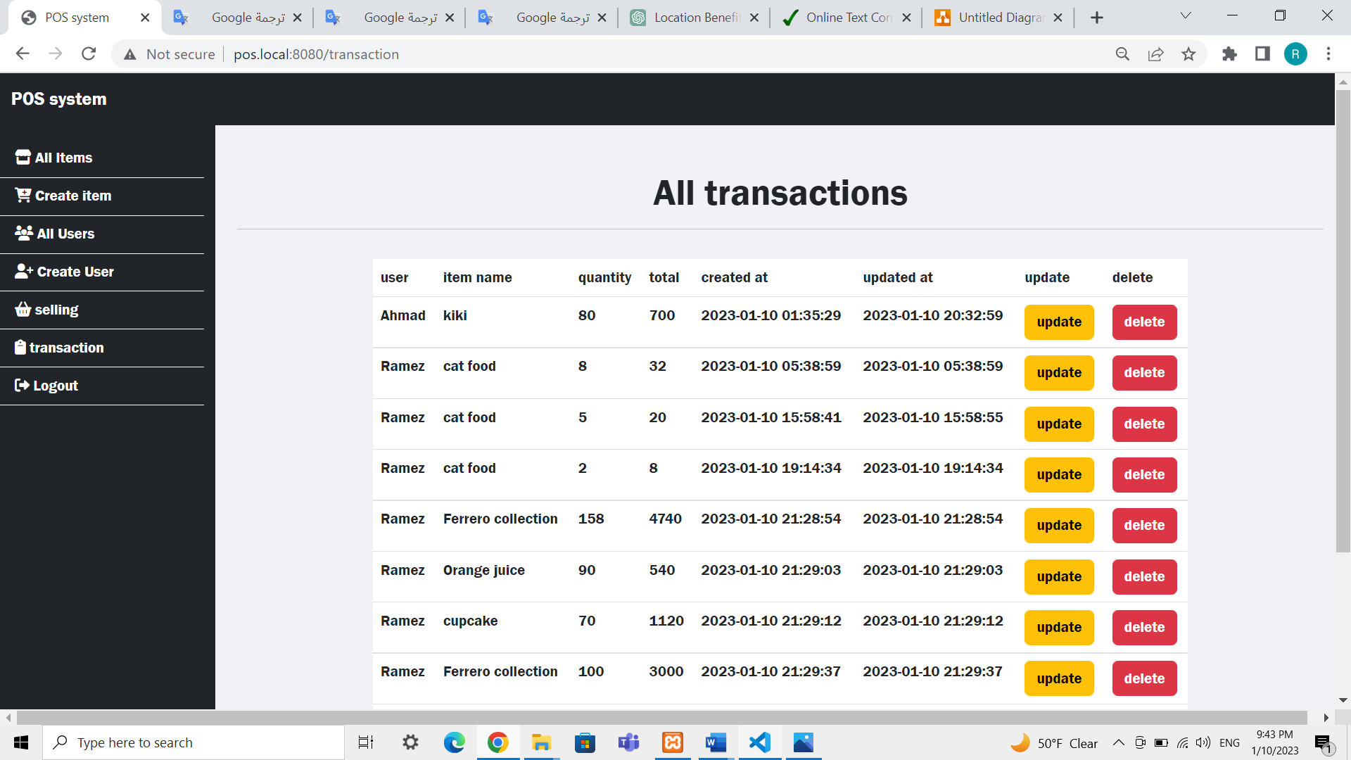

Figure [9]: list of transactions