Input – Website Design

Home Page

1. Left side –top corner – Logo & Name (font to be changed from Hindi type to Arial Black or any other font)
2. Below the Logo & Name, the horizontal menu,

* Home About Expertise Accolades Gallery Service Offered

(As I will be handling this consultancy alone, “us” & “our” can be avoided for about& location )

* As Contact details will appear on all pages, it is not included in the menu. is it OK?

1. Then the natural sceneries , few photos forwarded through email, or similar good photos of good quality can be put below the horizontal menu

Small write up provided ( refer excel sheet) on “Objective of this Consultancy” can be superimposed on the natural scenery photo, ensuring readability as different colours in the photo may affect readability

1. Below the photo

* Left side, the website map ( vertical menu) can be given ( not maps)
* Right side, Contact Details
* In between the menu and Contact Details , the Services Offered in Brief

1. Pl note corrections in

Copyright © Shree Enviro Services. All Rights Reserved.

Design by www.shreeenviro.com

1. Pl see the xcel file for other pages

Each page can have different natural scenery photo on which the“Objective of this Consultancy” can be super imposed as this will appear on all pages

1. Is it possible to

* To show all details of each page in the screen and avoid scrolling
* If the letters become too small to read or not readable easily, then scrolling can be used
* Howe he website pages will be shown in mobile screen

1. Background of the page can be light colour or light colour texture, instead of white
2. **Photos for Gallery**

National Award for Excellence in Water Management -2012

(from CII)

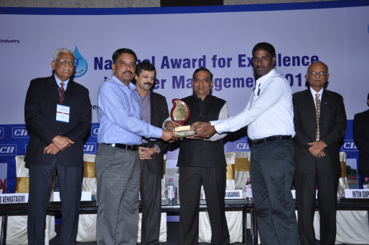

Golden Peacock Finalist Award for Environmental Management -2007

(from Institute of Directors)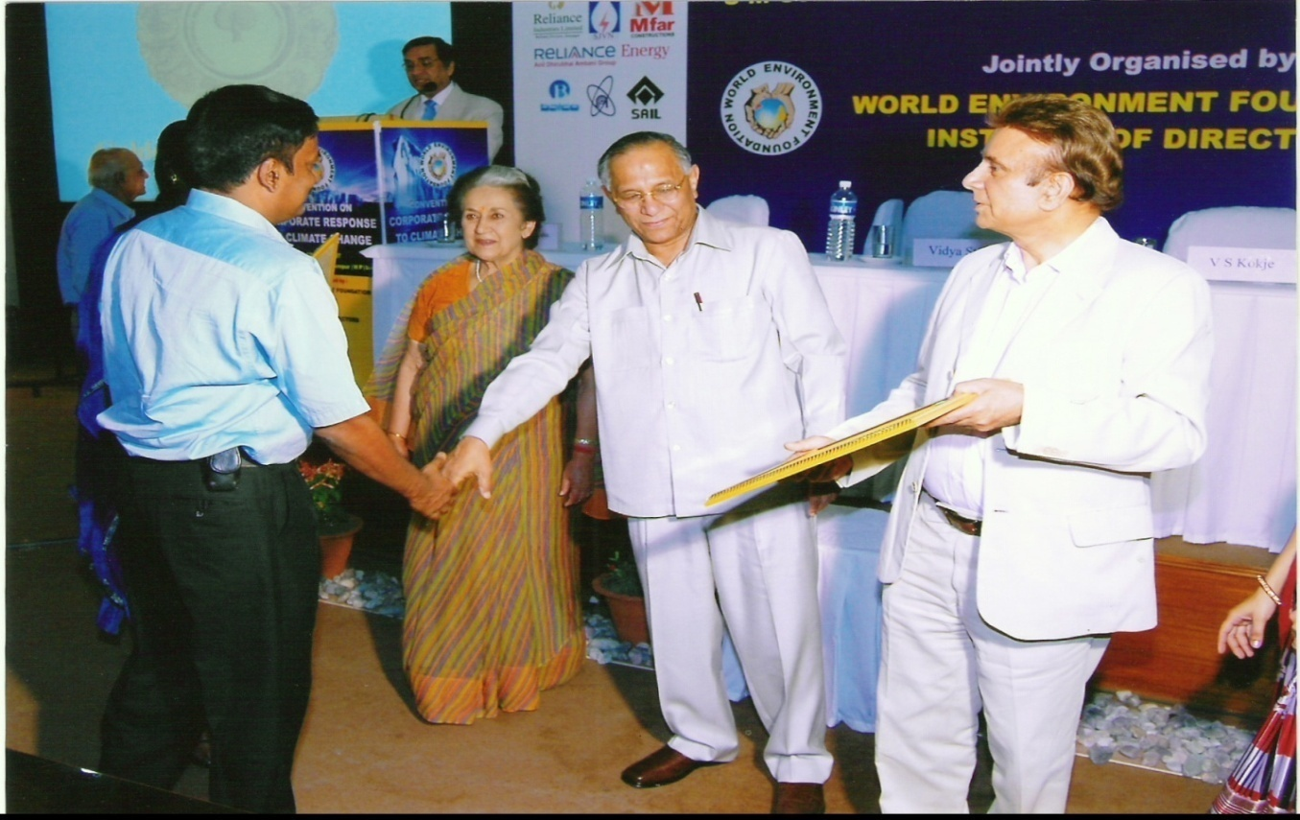

Golden Peacock Finalist Award for Excellence in Corporate Governance– 2006

(from Institute of Directors)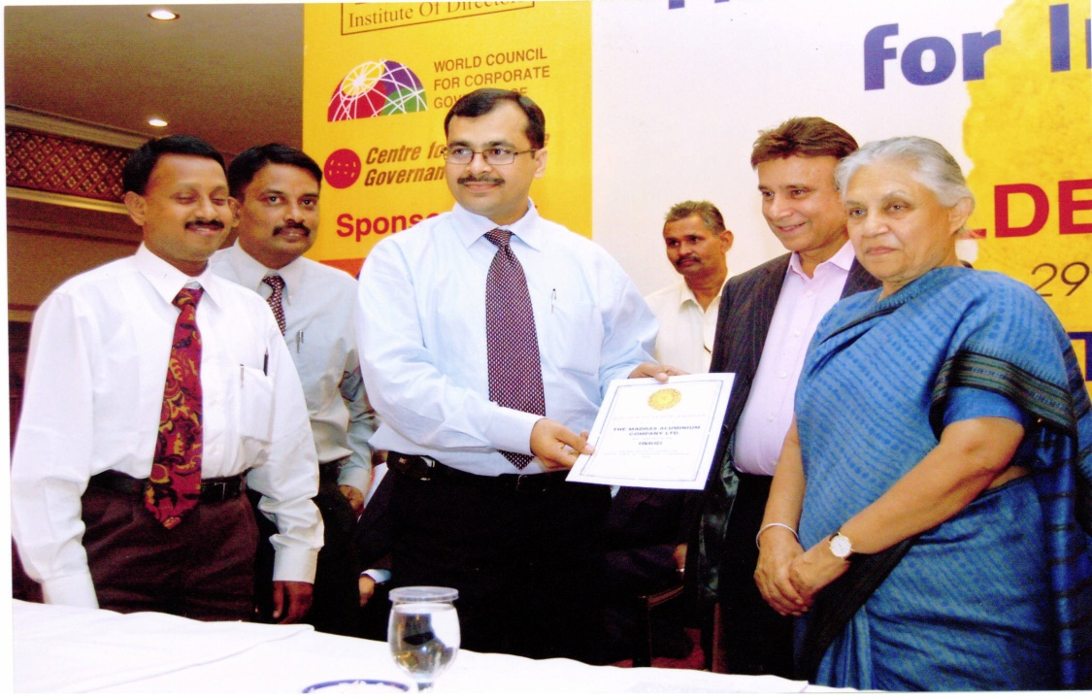

Golden Peacock Innovation Award - 2006

(from Institute of Directors)

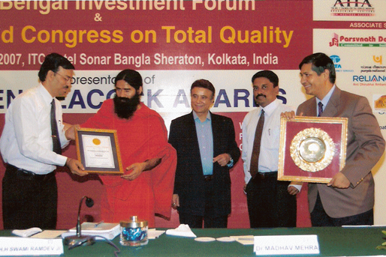

Leadership and Excellence Award for SHE Management –2006

(from CII)

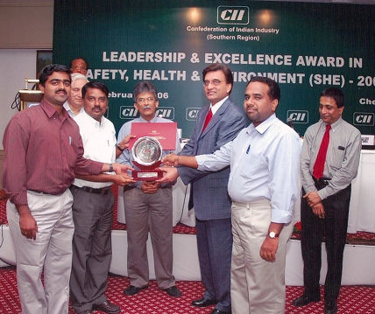

Sustainability Award-2006

(from CII)

