Link of Data source: <https://www.kaggle.com/code/fkfk14/fifa-world-cup-2022>

**DATA VISUALISTAIONS**

**VISUALIZATION 1 : No of Goals done by both team every day in FIFA .**

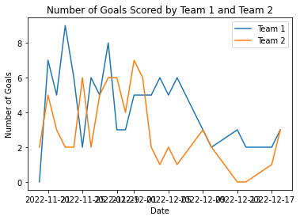

**Line plot information:**

Matplotlib is a potent Python data visualisation package. A line plot, one of the most widely employed forms of plots, is used to show the relationship between two continuous-scale variables.

A graph with data points linked by lines is called a line plot. The independent variable, which is often time or another continuous variable, is represented by the x-axis, while the dependent variable is represented by the y-axis. How the dependent variable varies over time or along the continuous variable is depicted by the line connecting the data points.

Line plots may be produced in Python by utilising the matplotlib.pyplot package. By providing the x and y coordinates of the data, the plot() method may be used to construct a line plot.

**VISUALIZATION 2 : Average possession percentage for team1 and team2**

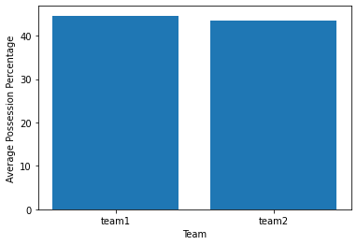

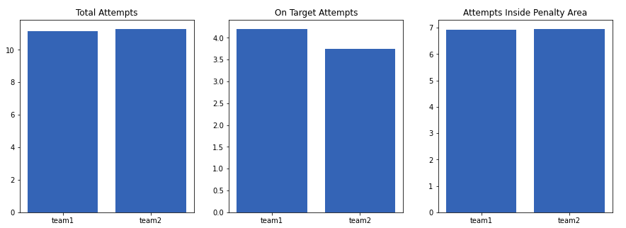

**A bar plot**

sometimes called a bar chart, is a form of graph that uses rectangular bars to display categorical data. The height or length of each bar, which corresponds to the value of the variable being measured, denotes a category or group.

Bar charts are frequently used to compare data from several groups or categories. A bar plot, for instance, can be used to compare the popularity of various movie genres, the number of individuals in various age groups, or the sales of various items.

You may build bar plots either vertically or horizontally. The most frequent type of bar chart has values on the y-axis and categories or groups mentioned on the x-axis. charting horizontal bars,

**VISUALIZATION 3 : Impact of possession in contest on number of goals scored**

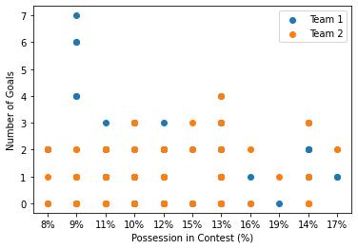

**A scatter graph:**

sometimes referred to as a scatter plot or scatter diagram, is a form of graph used in machine learning to show the connection between two variables. It shows the relationship or link between the variables visually.

Each point on the scatter graph corresponds to a pair of values for each of the two variables being examined. The values of the two variables define where each point is located. One variable is represented by the horizontal axis, and the other by the vertical axis.

While analysing data, a scatter graph may be used to spot patterns or trends such linear relationships, positive or negative correlations, or point clustering. It

**VISUALIZATION 4 :**

1. **What is the distribution of goals scored by team1 in FIFA 2022 dataset?**

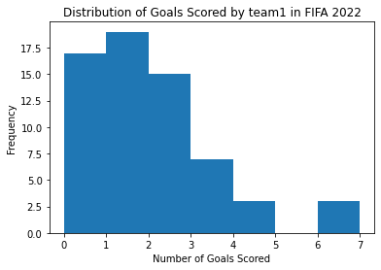

1. **What is the distribution of goals scored by team2 in FIFA 2022 dataset?**

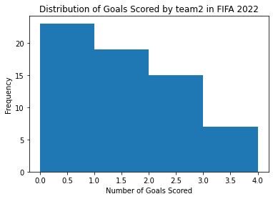

**About Histogram:**

A histogram is a graphical depiction of the distribution of a continuous variable used in machine learning. This particular style of bar graph shows the frequency distributions of various values or ranges of values for the variable under investigation.

The size of each bar in the histogram shows the frequency or proportion of observations that occur within a specific range of values. The histogram is made up of a series of contiguous rectangles or bars. The variable under study is split into equal intervals or bins on the horizontal axis, and the frequency or proportion of observations in each bin is shown on the vertical axis.

Understanding a distribution's shape, centre, and spread may be done with the use of histograms. They can highlight recurring patterns in the data, such the existence of several