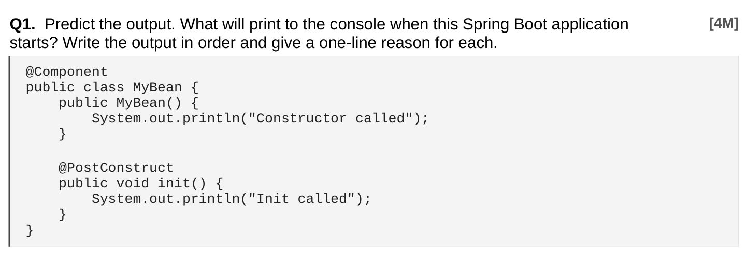
Ans:
Constructor called
Init called

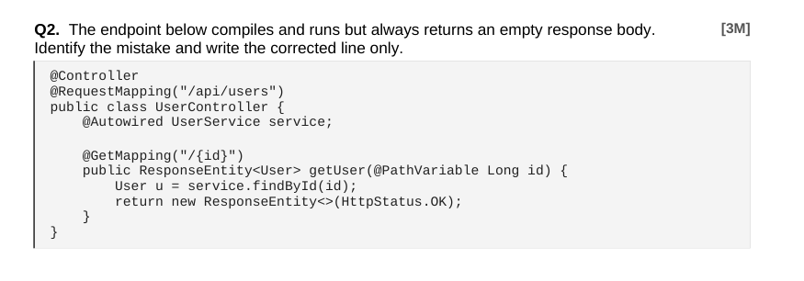
Ans:
Error: return new ResponseEntity<>(HttpStatus.OK);
Correct code: return new ResponseEntity<>(u, HttpStatus.OK);

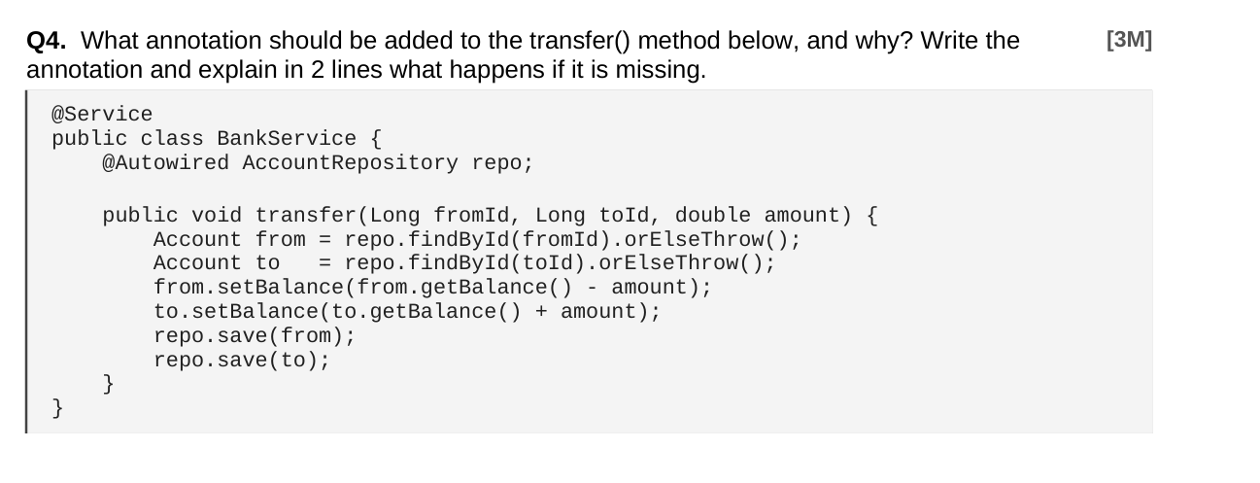
Ans: @Transactional Without it, partial updates may persist, leaving inconsistent balances.

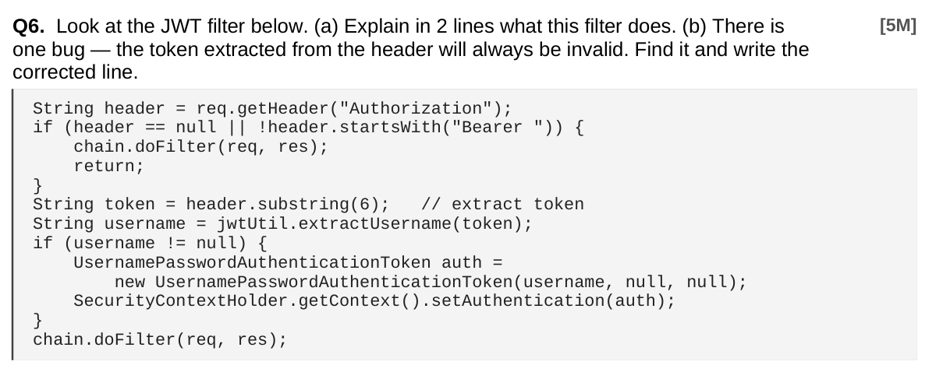
Ans:
(a) What the filter does
It intercepts incoming HTTP requests, checks for a Bearer token in the Authorization header, and extracts the username from the JWT.
If valid, it sets the authentication in the SecurityContextHolder so the user is treated as logged in.

(b) Bug in token extraction
The line
String token = header.substring(6);
is wrong because "Bearer " is 7 characters long, not 6. This causes the token to start with a space and be invalid.
Corrected line:
String token = header.substring(7);

Requirement: Find all Product entities where price < givenValue and category = givenString using @Query with named parameters.
Answer:
@Query("SELECT p FROM Product p WHERE p.price < :price AND p.category = :category")
List<Product> findByPriceAndCategory(@Param("price") double price,
@Param("category") String category);

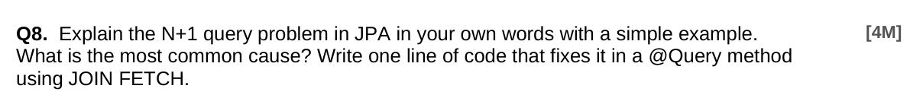

When you load a list of objects, and for each one JPA runs another query to get related data. So instead of 1 query, you get N+1 queries.
Example: You fetch all orders, then for each order JPA runs a query to get its items.
Cause: Lazy loading of relationships.
Fix: @Query("SELECT o FROM Order o JOIN FETCH o.items")

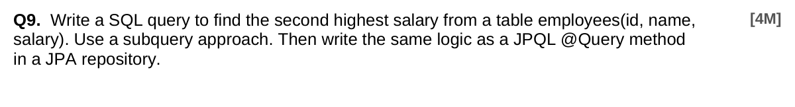

Ans:
SQL (subquery):
SELECT MAX(salary)
FROM employees
WHERE salary < (SELECT MAX(salary) FROM employees);

JPQL @Query:
@Query("SELECT MAX(e.salary) FROM Employee e WHERE e.salary < (SELECT MAX(e2.salary) FROM Employee e2)")
Double findSecondHighestSalary();

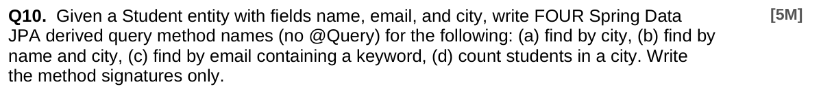

Ans:
List<Student> findByCity(String city);
List<Student> findByNameAndCity(String name, String city);
List<Student> findByEmailContaining(String keyword);
long countByCity(String city);

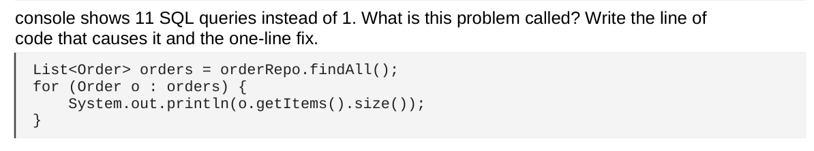
Ans:
This is the Problem name N+1 query problem.
Error line: System.out.println(o.getItems().size());
This triggers a new query for each order because of lazy loading.
Fix (one line): @Query("SELECT o FROM Order o JOIN FETCH o.items")

Ans:
application.yml
spring:
application:
name: product-service
eureka:
client:
service-url:
defaultZone: http://localhost:8761/eureka
Main class annotation:
@EnableEurekaClient
@SpringBootApplication
public class ProductServiceApplication { //code }

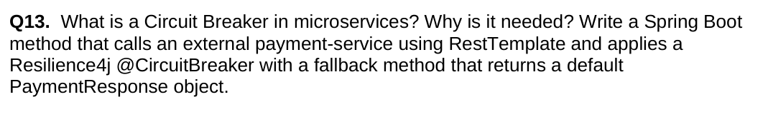Meaning: A circuit breaker stops calls to a failing service to avoid repeated errors.
Need: Protects microservices from cascading failures and keeps system stable.
Spring Boot method with Resilience4j:
@CircuitBreaker(name = "paymentService", fallbackMethod = "fallback")
public PaymentResponse callPayment() {
return restTemplate.getForObject("http://payment-service/pay", PaymentResponse.class);
}

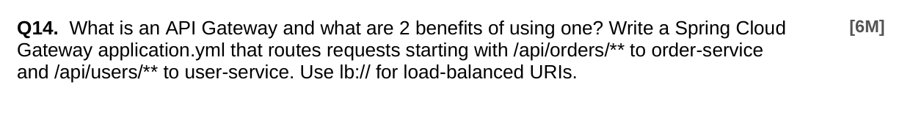
Ans:

Meaning: API Gateway is a single entry point for all client requests to microservices.
Benefits:
- Centralized routing and load balancing.
- Security (authentication, rate limiting).

yaml
spring:
cloud:
gateway:
routes:
- id: order-service
uri: lb://order-service
predicates:
- Path=/api/orders/**
- id: user-service
uri: lb://user-service
predicates:
- Path=/api/users/**

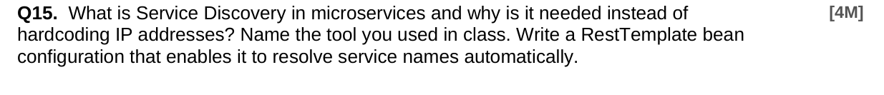
Ans:
Service Discovery lets microservices find each other by name instead of hardcoding IPs.
Need because IPs change, so discovery makes communication dynamic and reliable.
Tool used in class: Eureka.

RestTemplate bean config:
@Bean
@LoadBalanced
public RestTemplate restTemplate() {
return new RestTemplate();
}
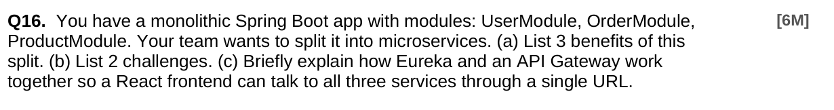
Ans:
(a) 3 Benefits:
- Each service can scale independently.
- Easier to deploy and update small parts.
- Fault isolation (one service crash doesn’t kill all).
(b) 2 Challenges:
- More complex communication between services.
- Harder debugging and monitoring.
(c) Eureka & API Gateway:
- Eureka keeps track of service names and locations.
- API Gateway uses Eureka to route requests.
- React frontend calls one URL (gateway), which forwards to User, Order, Product services automatically.

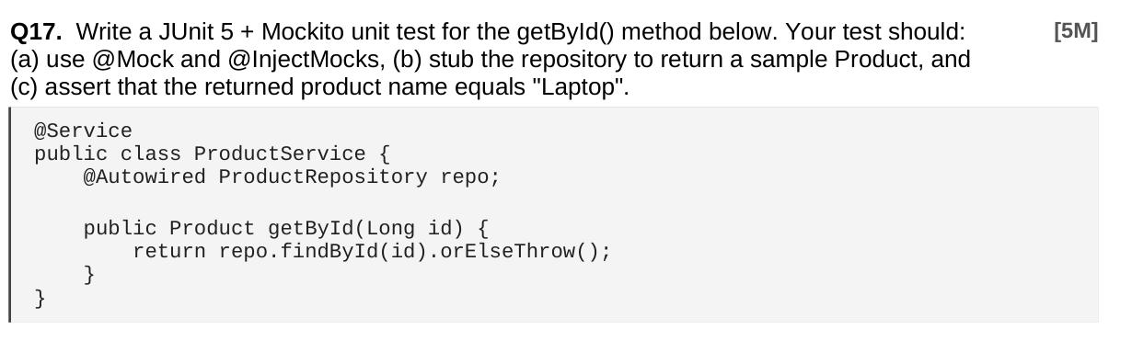
@ExtendWith(MockitoExtension.class)
class ProductServiceTest {
@Mock
ProductRepository repo;

@InjectMocks
ProductService service;

@Test
void testGetById() {
Product p = new Product(1L, "Laptop");
when(repo.findById(1L)).thenReturn(Optional.of(p));
Product result = service.getById(1L);
assertEquals("Laptop", result.getName());
}
}
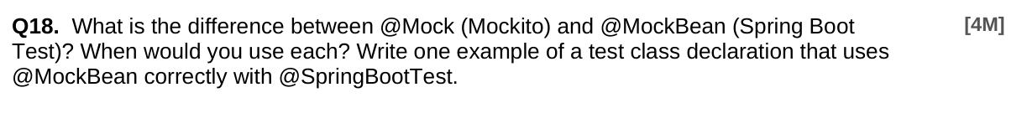

Ans:
@Mock (Mockito): Creates a plain mock object, not managed by Spring.
@MockBean (Spring Boot Test): Replaces a bean in the Spring context with a mock.
When to use:
- Use @Mock in unit tests with @ExtendWith(MockitoExtension.class).
- Use @MockBean in integration tests with @SpringBootTest to mock Spring beans.
Example:
@SpringBootTest
class ProductServiceTest {
@MockBean
ProductRepository repo;

@Autowired
ProductService service;
}

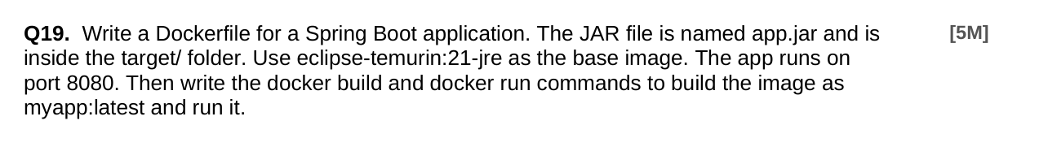

Ans:
Dockerfile:
FROM eclipse-temurin:21-jre
COPY target/app.jar app.jar
EXPOSE 8080
ENTRYPOINT ["java","-jar","/app.jar"]

Build command:
docker build -t myapp:latest .

Run command:
docker run -p 8080:8080 myapp:latest

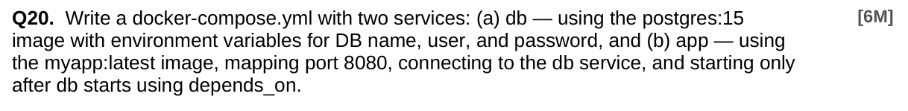
Ans:
version: "3.9"
services:
db:
image: postgres:15
environment:
POSTGRES_DB: mydb
POSTGRES_USER: myuser
POSTGRES_PASSWORD: mypass

app:
image: myapp:latest
ports:
- "8080:8080"
depends_on:
- db

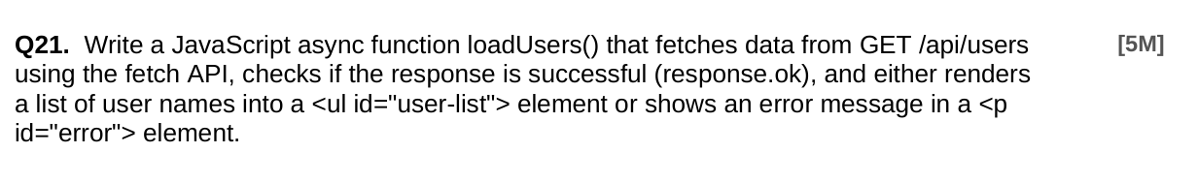
Ans:
async function loadUsers() {
try {
const response = await fetch("/api/users");
if (response.ok) {
const users = await response.json();
const list = document.getElementById("user-list");
list.innerHTML = users.map(u => `<li>${u.name}</li>`).join("");
} else {
document.getElementById("error").textContent = "Failed to load users";
}
} catch (e) {
document.getElementById("error").textContent = "Error: " + e.message;
}
}

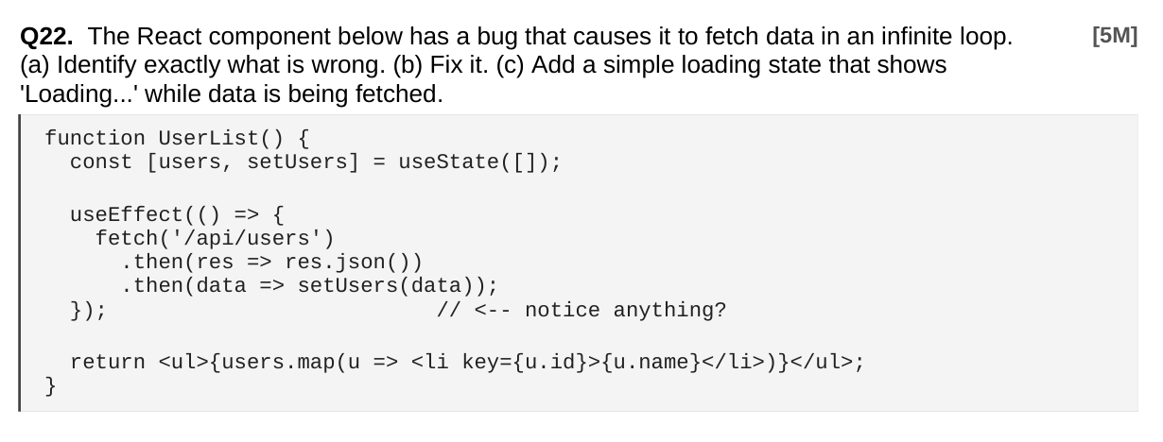
Ans:
(a) Problem: Missing dependency array in useEffect which causes infinite loop.
(b) Fix: Add empty array [] so it runs only once.
(c) With loading state like this

useEffect(() => {
fetch('/api/users')
.then(res => res.json())
.then(data => {
setUsers(data);
setLoading(false);
});
}, []); // fixed

