REPORT

First lab

Rami Alshalabi

**QUESTIONS FOR THE PROTECTION OF LABORATORY WORK No. 1**

1. What standard types are used in C++? How much memory is reserved for them?

Standard types in C++ include int, float, double, char, bool, etc.

The memory reserved for these types can vary based on the system architecture. For example, on a typical 32-bit system, an int may reserve 4 bytes.

1. Which program elements include the following:

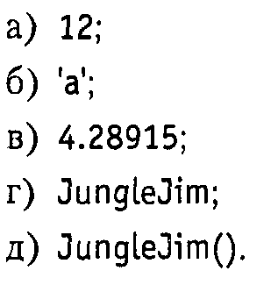

a. This is a literal constant of type int.

b. This is a character literal of type char.

c. This is a floating-point literal

d. identifier, representing a variable

e. This is a function call to a function

1. What is a function? What is the role of functions in C++?

A function is a named block of code that performs a specific task.

Functions help in organizing code, promoting code reusability, and improving readability.

1. Write the syntax of the function.

return_type function_name(parameters) {

// function body

}

1. Describe ways to use functions in programs with and without function declarations.

* Functions can be used by declaring them before they are called (function declaration) or defining them before or after the point of use.
* Declaration informs the compiler about the function's signature.

1. Explain the mechanisms for passing arguments by value and by reference to a function.

Explain the results of the programs.

1)

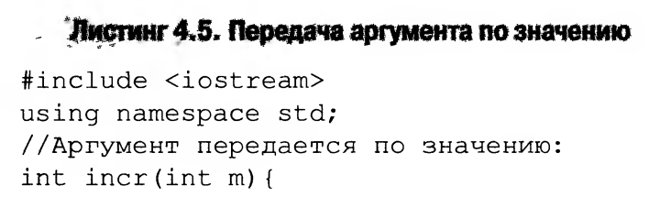

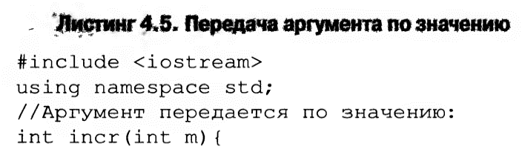

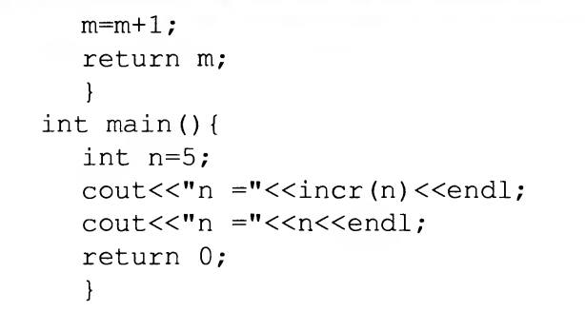

2))

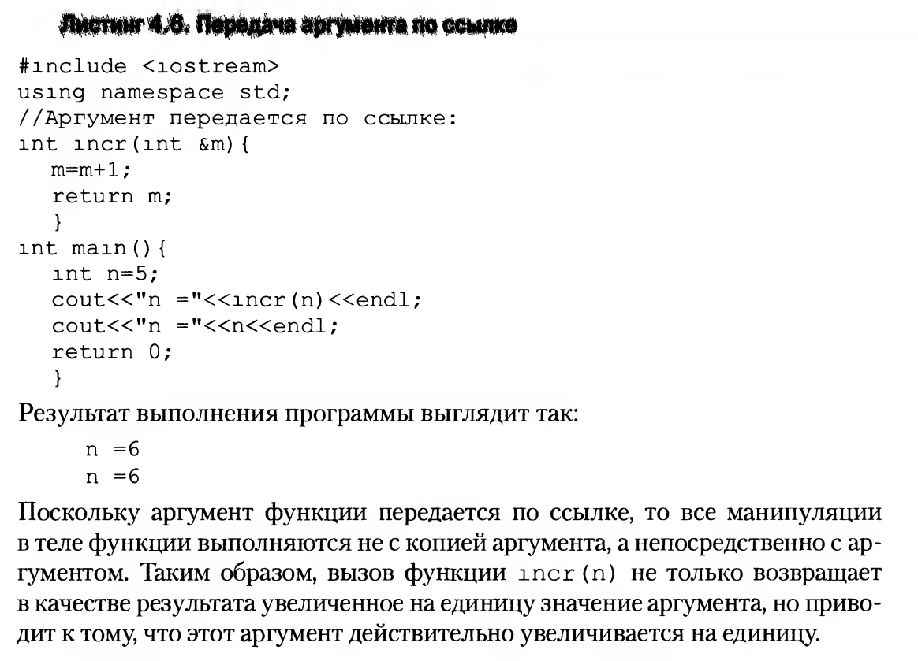



1. By Value: Copies the value of the argument. Changes inside the function do not affect the original.
2. By Reference: Passes the memory address of the argument. Changes inside the function affect the original.
3. What are the types of arguments that can be passed to function parameters?

Arguments can be passed by value, by reference, by pointer, or through constant references.

1. What are default arguments?

Explain the result of the program:

,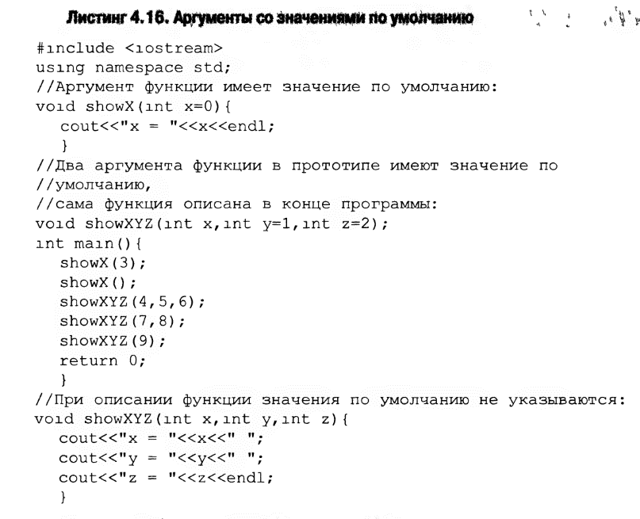

Default arguments are values assigned to parameters, allowing the function to be called without specifying values for those parameters.

Explanation:

showX is a function with a default argument. It prints the value of x.

showXYZ is declared with default arguments for y and z and defined later in the program. It prints the values of x, y, and z.

Results:

showX(3): Prints "x = 3".

showX(): Prints "x = 0" (default value).

showXYZ(4, 5, 6): Prints "x = 4 y = 5 z = 6".

showXYZ(7, 8): Prints "x = 7 y = 8 z = 2" (default value for z).

showXYZ(9): Prints "x = 9 y = 1 z = 2" (default values for y and z).

1. What is function overloading?

Function overloading is the ability to define multiple functions with the same name but different parameters.

1. What is the difference between a structure ( struct ) and an array?

* An array is a collection of elements of the same type, accessed by index.
* A structure (struct) is a user-defined data type that groups different types of data under a single name.