Captures

VERY IMPORTANT:I haven’t worked on design that much, I’m about to , but the functionalities are working and I’m like at 90% (or more)done.
This is the landing page(the first page)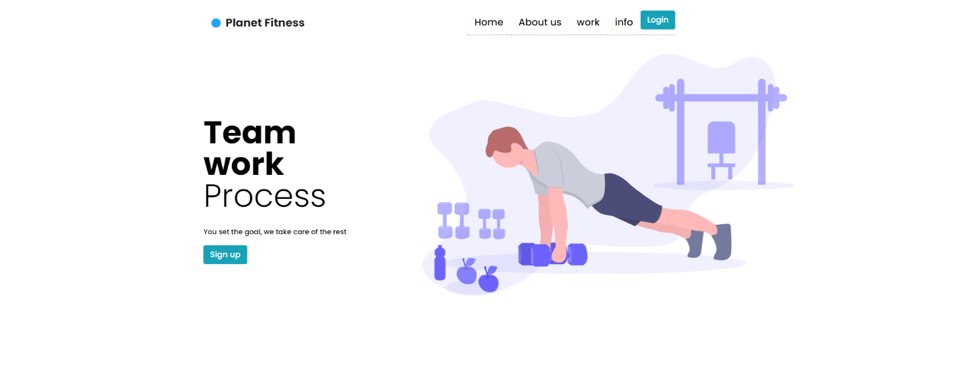

This is the login interface

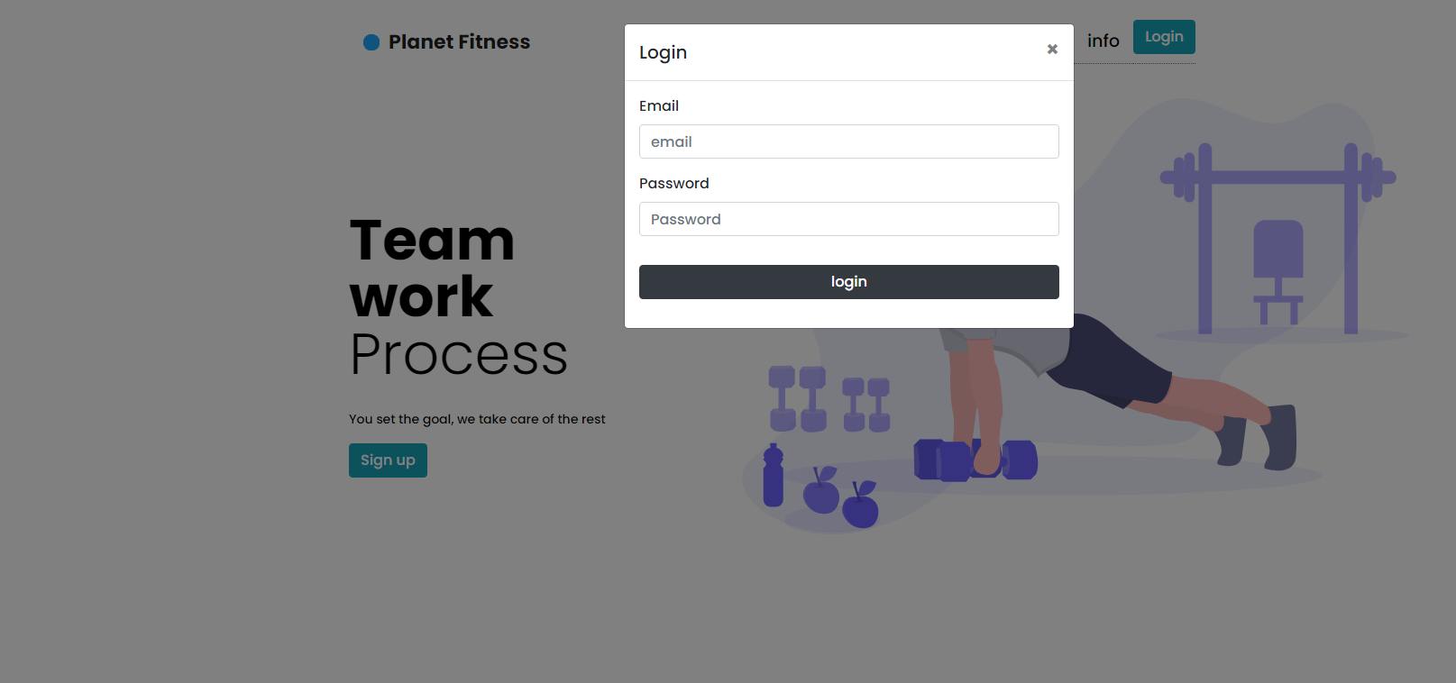

This is the register interface
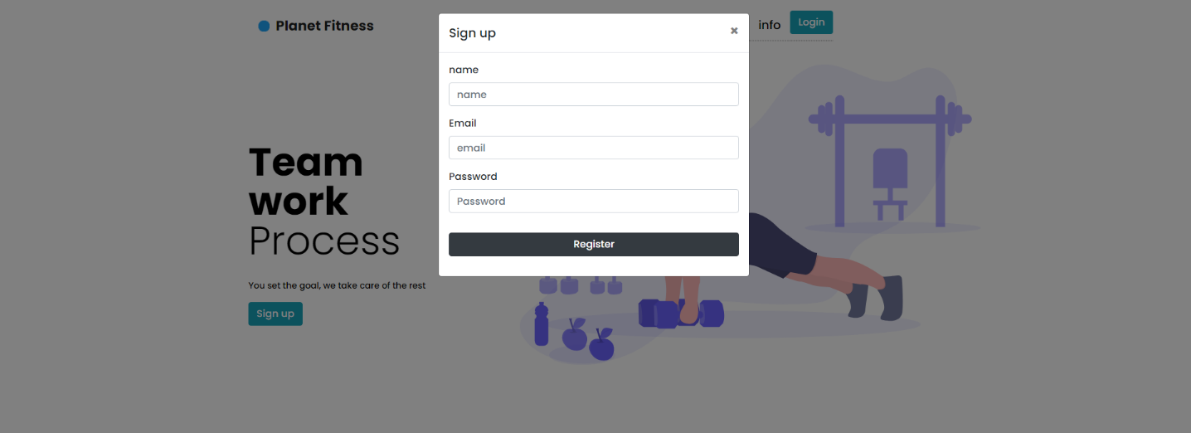

This is the create workout interface, this is the interface where an admin can create
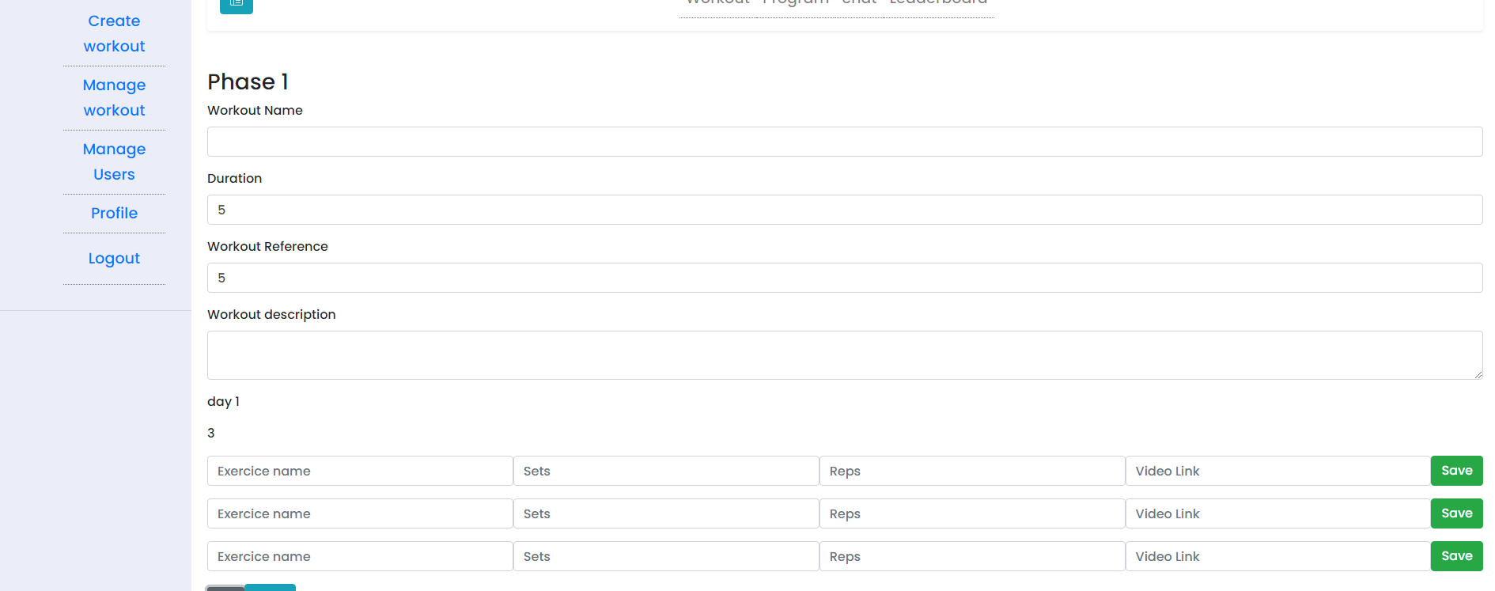
For each day you can put as many workout as you want,and they appear on the day they’re mean to appear
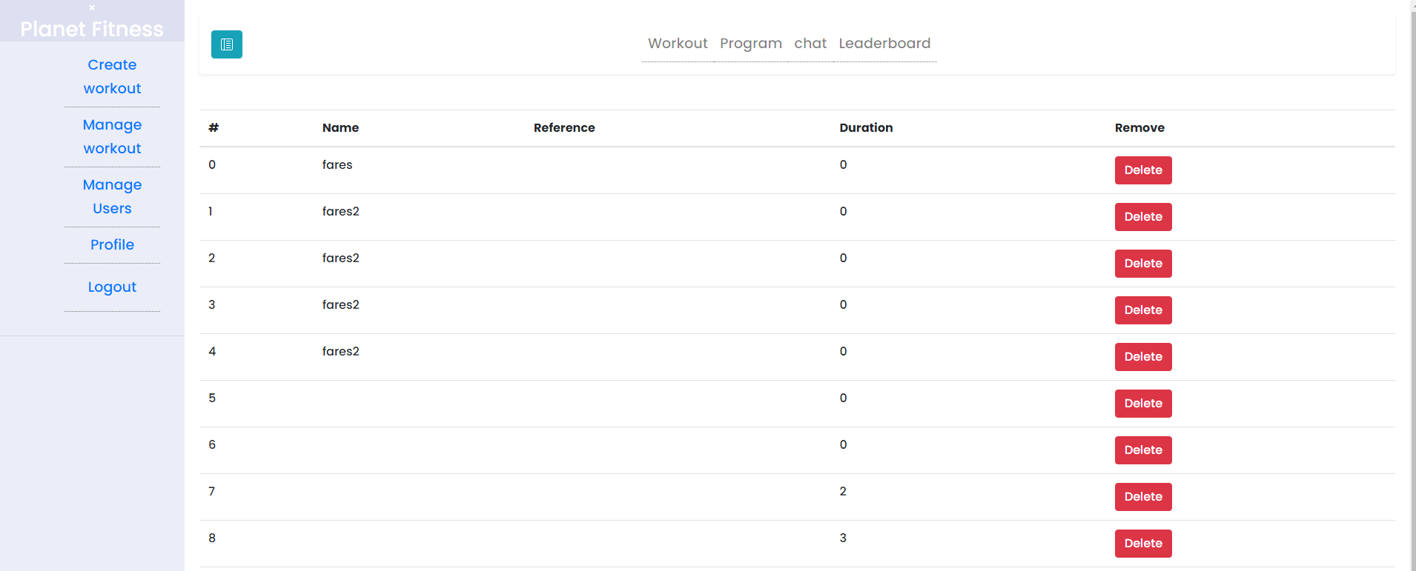
This is the manage workout interface, basically you can delete a workout or just see the list of the workout

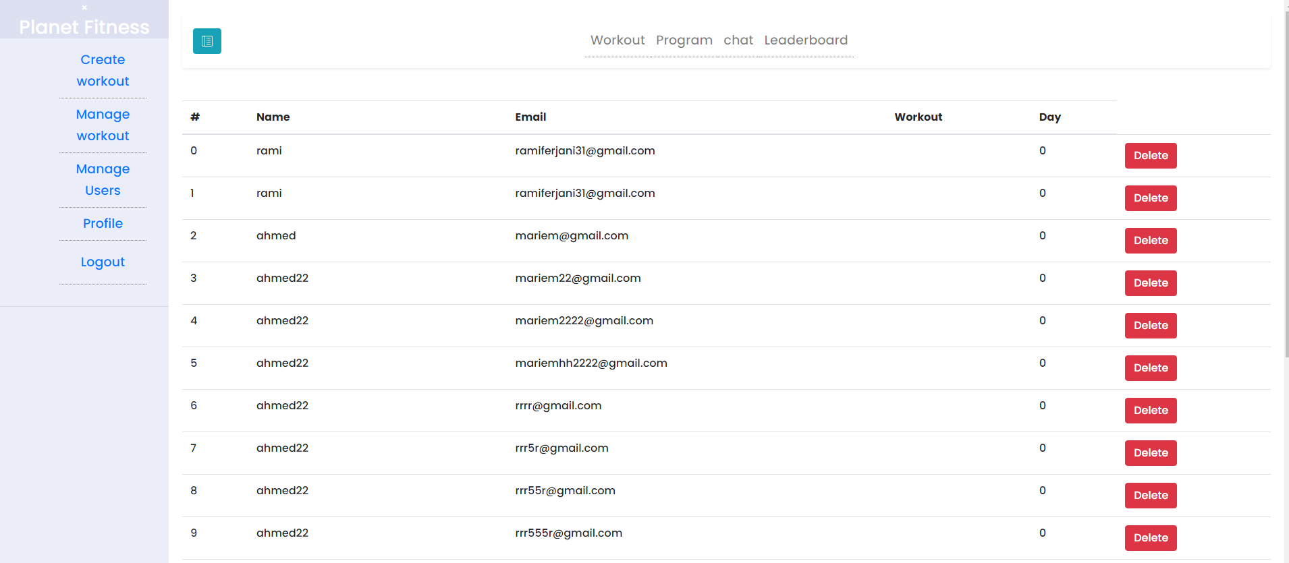
This is the manage user interface

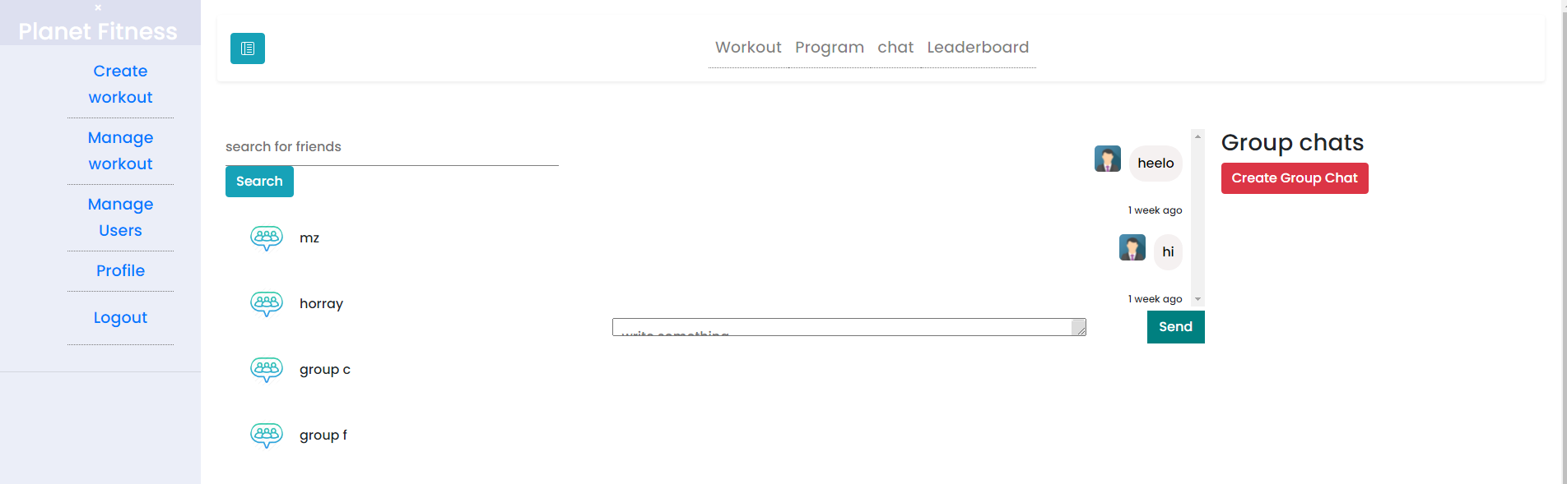

This is the chat interface

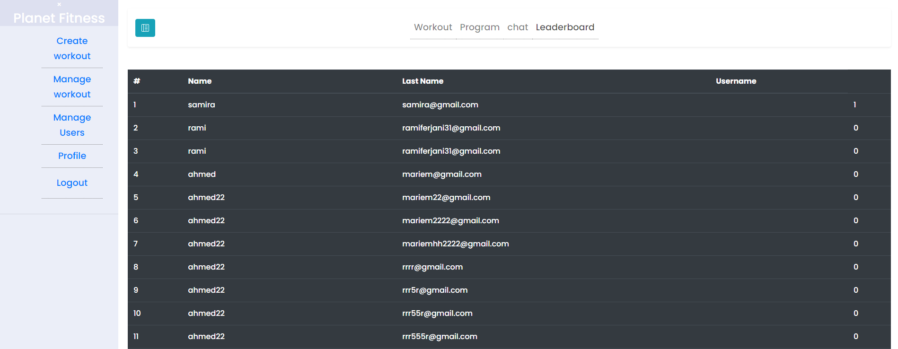

This is the leaderboard

This is the program interface, the user here chooses his condition , and based on his choice he gets a specific workout, that means for each combination there’s a workout, and theres like 63 combination or more
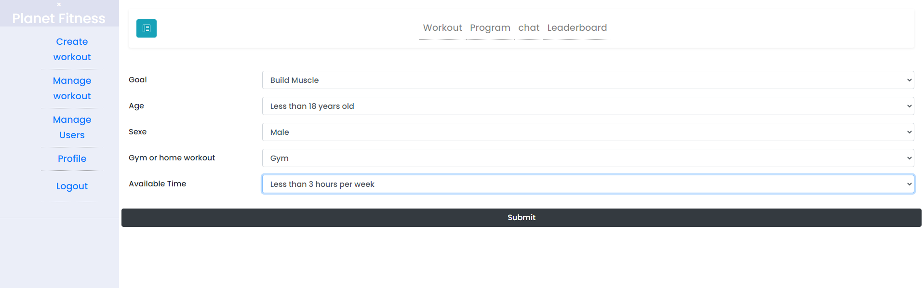

the workout interface is where the user finds his workout .the design isn’t ready but the functionalities are working

This is the create group chat interface
