Solar radiation unit conversions

1 BTU = 251.9958 Calorie
1 BTU = 1055.056 Joule
1 BTU = 1055.056 Watt-sec

1 Langley = 1 Cal/cm²
1 Cal = 4.1868 Joules
1 Watt = 1 Joule/sec
1 Watt-sec = 1 Joule
1 Watt/m² = 0.085985 Lang/hour (see Conversion Sequence 1)
1 Lang/hour = 11.6300 Watt/m² (see Conversion Sequence 1)

1 Langley = 41868 Joules/m² (see Conversion Sequence 2)
1 Langley = 41868 Watt-sec/m² (see Conversion Sequence 2)

1 Watt/cm² = 3170 BTU/ft²-hour (see Conversion Sequence 3)
1 Watt/m² = 0.3170 BTU/ft²-hour (see Conversion Sequence 3)

1 Langley/day = 0.484583 Watt/m² (see Conversion Sequence 4)
1 Langley/day = 0.153613 BTU/ft²-hour (see Conversion Sequence 4)
1 Langley/day = 0.041868 MJ/m²-day (see Conversion Sequence 4)
1 Watt = 3.41216 BTU/hour (see Conversion Sequence 5)

Conversion sequence 1:

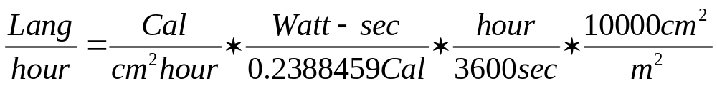

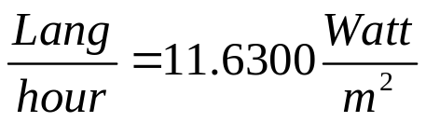 or 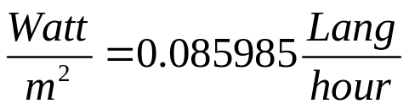

Conversion Sequence 2:

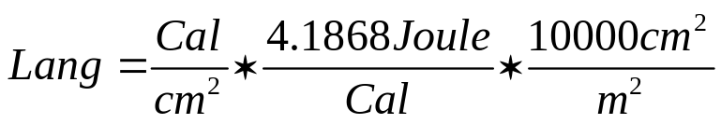

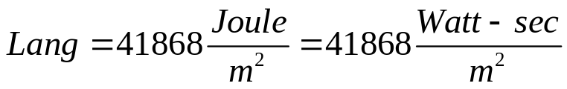

Conversion Sequence 3:

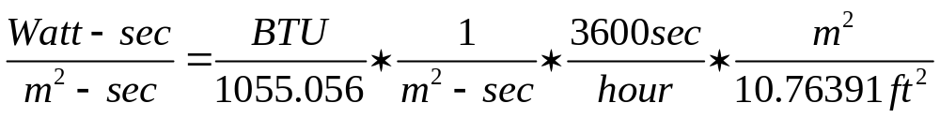

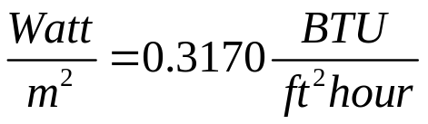

Conversion Sequence 4:

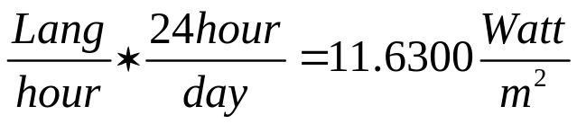 (from Conversion Sequence 1)

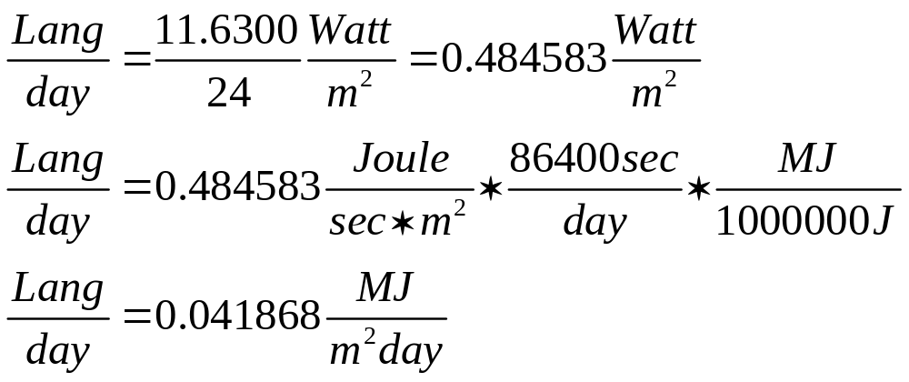
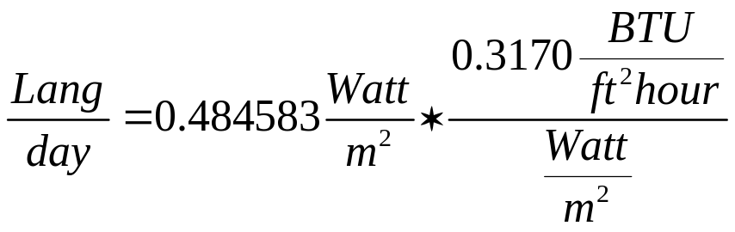
(from Conversion Sequence 3)

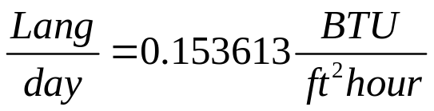

Conversion Sequence 5:

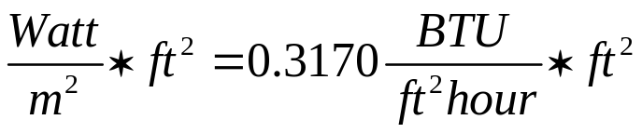 (from Conversion Sequence 3)
