

Universidad Carlos III

User Interfaces 2017-18

Case study  
Course 2017-18

Maryna Kotok –

Richard Lopez –

Ramiro Pinto – 100346042

Daniel Martin – 100346096

1. **Introduction**

This practice consists on the design, implementation and analysis of a video stream web page. To do so, we will create a prototype with some online tools, implement it writing code and analyzing the heuristic and the patterns used, and all will be reported in this document.

This document is organized into several parts. The first one is an introduction, which explains the practice and the organization of the document. The second one specifies the main goal of the system, providing a full description of the web page and the functionalities that the web page has. In the third part, which is the analysis and evaluation part, the end users are described with the illustration of three personas, and the heuristics and patterns of similar websites in which ours is based on are explained. The fourth part is where the design and the main goal of the two previous prototypes are shown, where the fifth one specifies the reasons of the design of the new prototype, as well as the Nielsen’s heuristics and Van Duyne patterns that have been applied. In the sixth part, the technology used to implement the webpage is explained, and in the seventh part, the whole implementation process is described. Finally, a final conclusion and personal opinion is given in the eighth part.

1. **Main Goal of the system**
   1. **Description**

The webpage implemented is a video streaming web page. Therefore, the main goal of the system is to provide to the end users an online service in which they can watch series and movies, most of them oriented to kids, so that all the family sit together to watch a film or a movie whenever they want. Also, the end users will have the possibility to create playlists, in which they can store their favorite episodes and movies, and share them with other users.

* 1. **Functionalities**

1. **Analysis and evaluation**
   1. **End users description**

As the case study webpage is very similar to the second prototype one, we can use the same personas explained in the third exercise to understand the needs and motivations of the final users.

* **Persona 1: Dave**

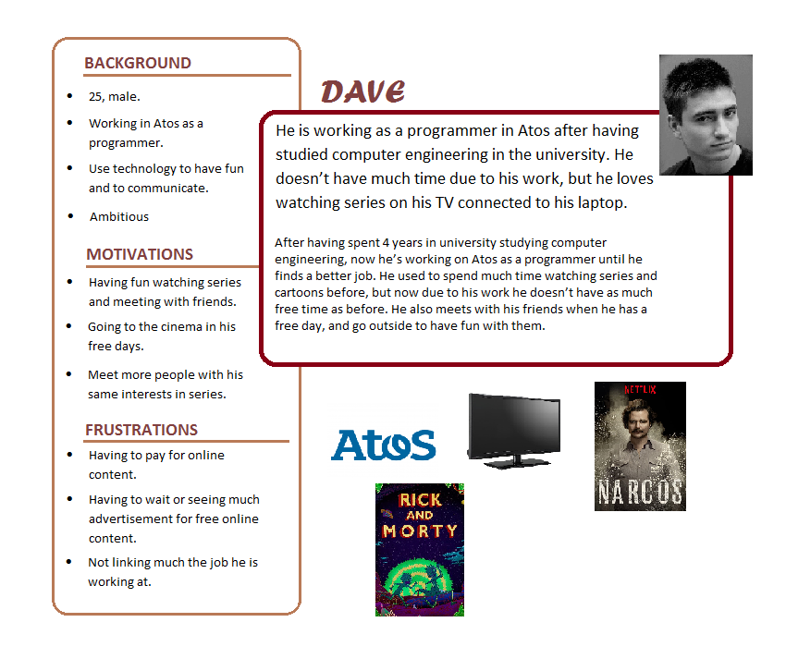

* **Persona 2: Sarah**

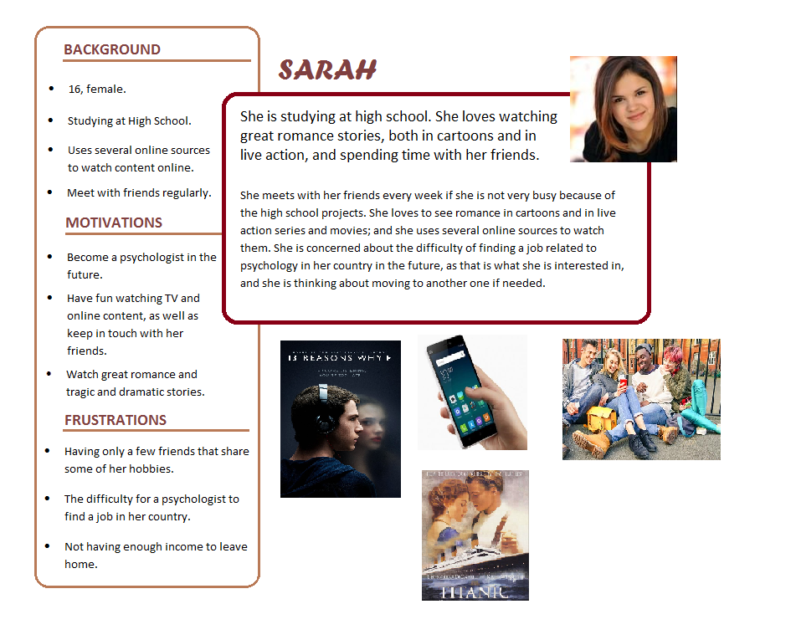

* **Persona 3: Lucas**

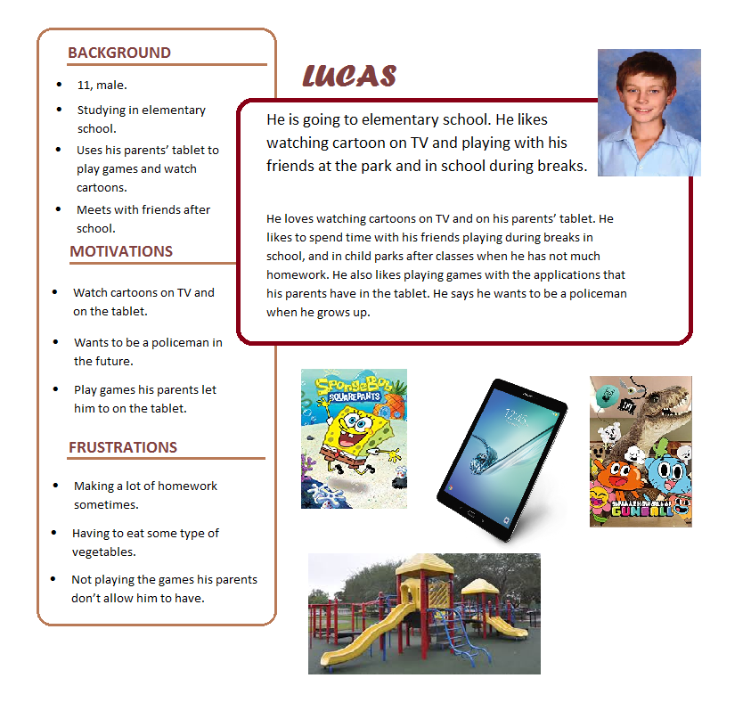

* 1. **Analysis and evaluation of similar webpages**

1. **Previous prototypes**
   1. **Prototype 1**
      1. **Main goal**

The first prototype, which was “Tubevision”, had the following main goal, which was explained in the third exercise:

“*Tubevision*, our video content platform, is a multimedia website for a diverse audience of users. Designed as an easy-to-use website, it features the ability to browse for content by category and to search for content through the use of a search box. Users to the website must subscribe in order to access the video content on the website, which spans from user-uploaded videos to TV streaming content to movies/films. In addition, *Tubevision* is accessible via a mobile device or a traditional desktop computer.

The webpage is monetized through two forms: 1) premium subscriptions and 2) pre-content video ads. Premium subscriptions are paid versions of subscription accounts which enables special features not available to non-premium subscribers, such as unlimited offline video downloads, unlimited movies, speech interface, and video advertisement-free content. Instead of invasive display ads on the side panel, non-premium users are shown short video ads spanning several seconds before their selected video content plays.”

* + 1. **Design**
  1. **Prototype 2**
     1. **Main goal**

The second prototype, which was “ScoobyMovie”, had a much more similar main goal to this final website. It was also a video streaming website for children, where they can watch films and series oriented to them, and create playlists to save their favorite videos and share them with other people through social media. They can also leave comments and likes on the videos. The most notable difference between this website and “ScoobyMovie” is the design, which is totally different.

* + 1. **Design**

1. **New prototype**
   1. **Design Reasons**
   2. **Nielsen’s Heuristics**
   3. **Van Duyne Patterns**
2. **Used technology**

For implementing the web page, we have decided to use php code, which is pretty similar to html code, in the sense that html code behaves the same way in php files. Also, we have used css for specifying the design of the webpage (colors, font, size, etc), and javaScript to implement the scripts used for the web pages. Additionally, to check the functionality of the php pages, we have used XAMMP, which is an application that provides a local server to your computer, so that the functionalities can be checked. To properly use this server, we have used a little bit of sql to create tables to store necessary information, such as the users, the comments, playlists and videos, and the information each of them has, like the likes and dislikes each video has, and the nickname and password of each user.

1. **Implementation Process**
2. **Conclusion and Personal Opinion**