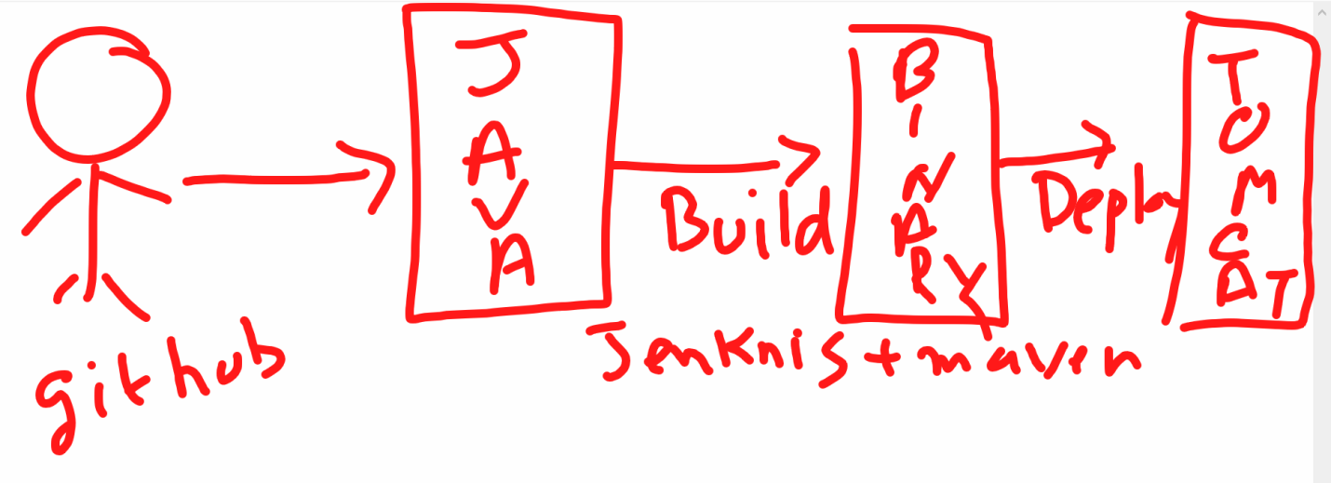

1. <https://github.com/vikas99341/my-morning-app>

* <https://maven.apache.org/guides/getting-started/maven-in-five-minutes.html>
* Yum install maven -y
* mvn --version
* mvn archetype:generate -DgroupId=com.mycompany.app -DartifactId=my-app -DarchetypeArtifactId=maven-archetype-quickstart -DarchetypeVersion=1.4 -DinteractiveMode=false
* yum install tree -y
* 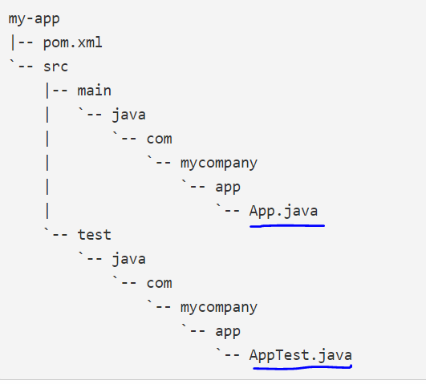
* 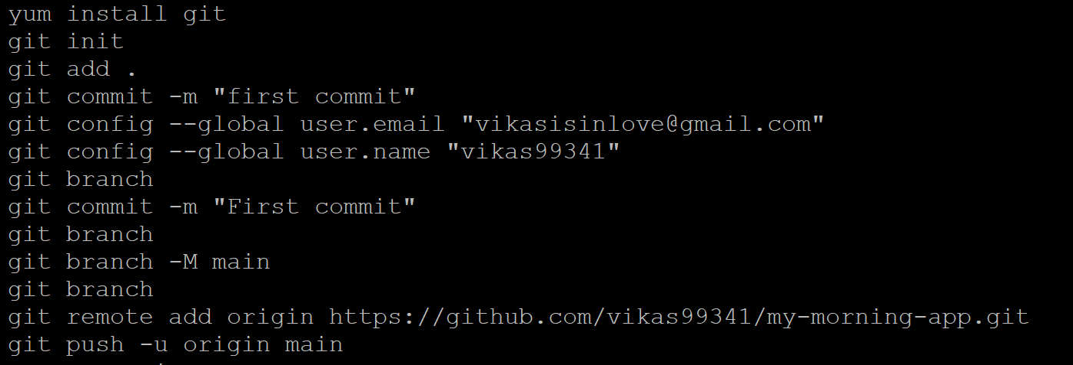

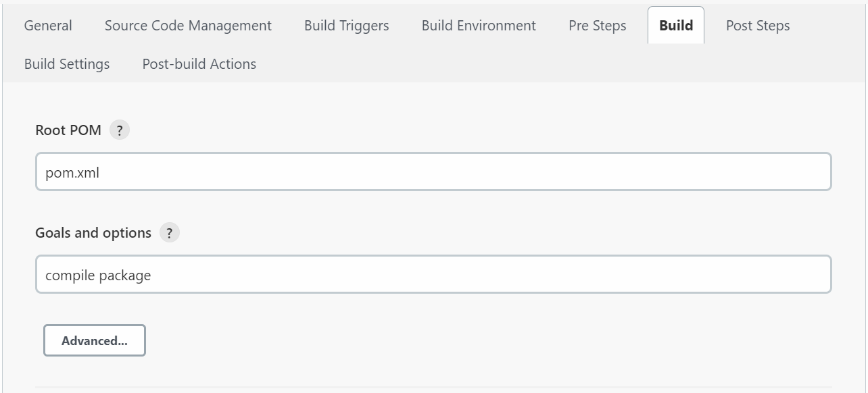

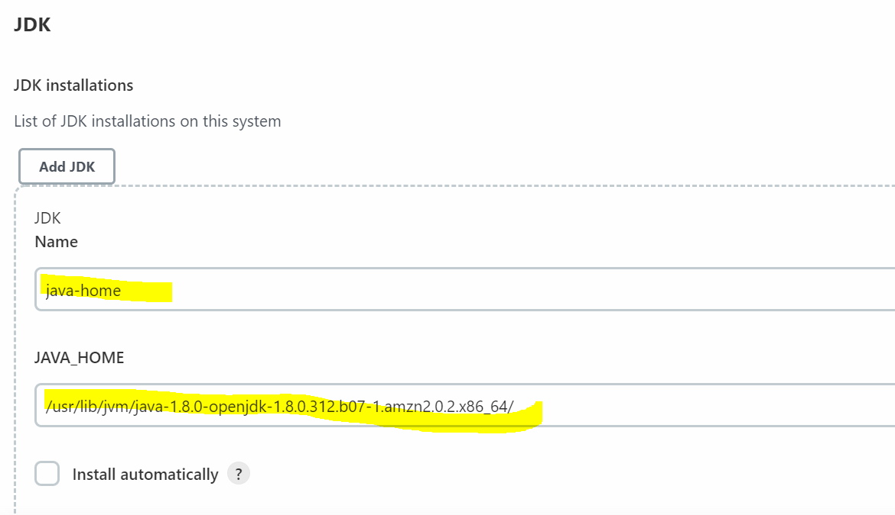

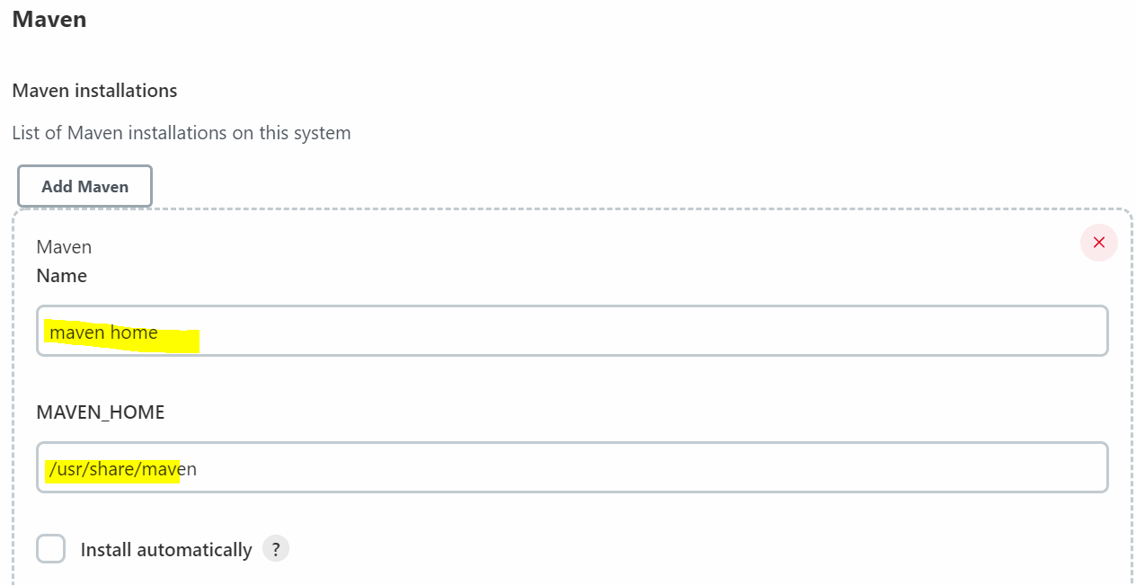

* 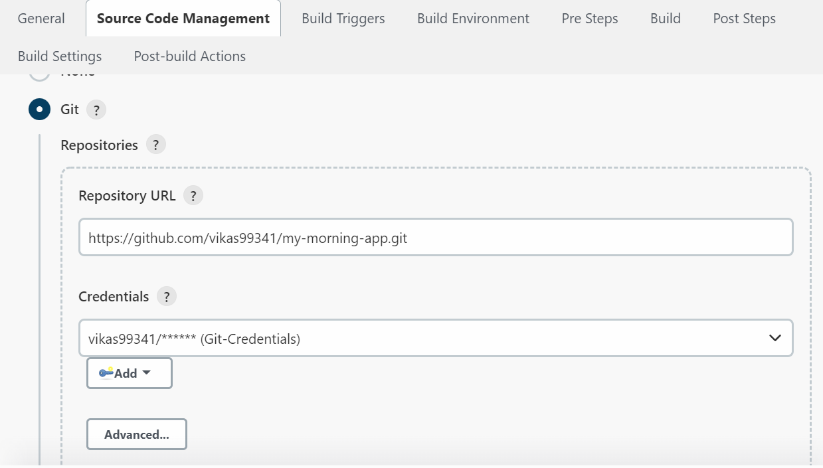
* 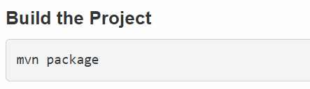
* 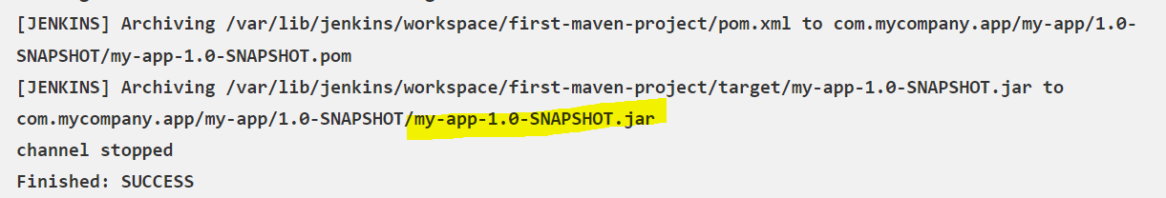
* 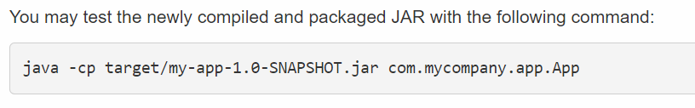
* 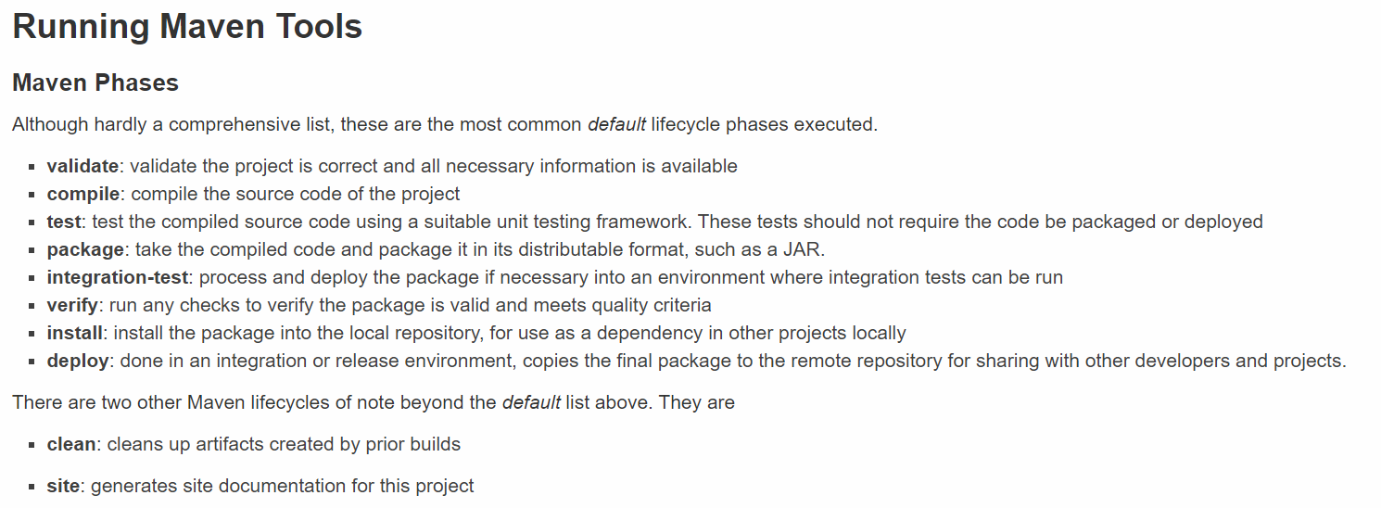
* Tomcat - <https://tomcat.apache.org/>
* <https://tomcat.apache.org/download-90.cgi>
* Right click on highlighted one tar.gz and copy as link address
* 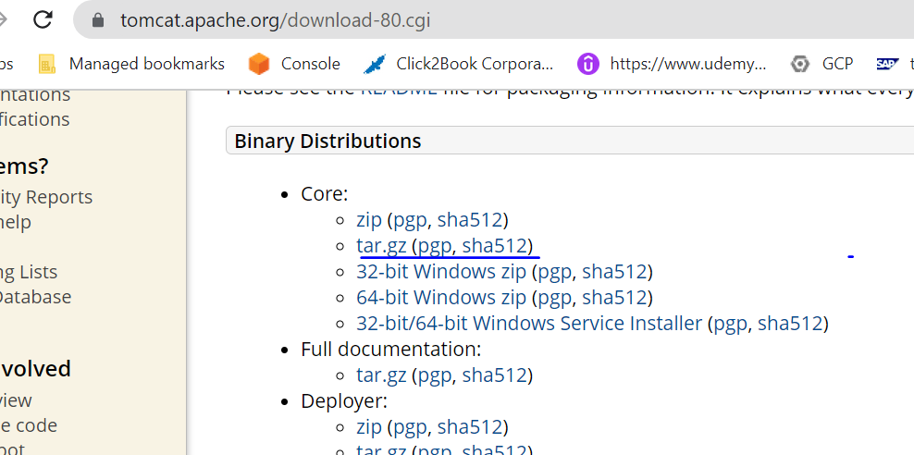
* Launch a EC2 Instance and install tomcat on that.
* amazon-linux-extras install java-openjdk11
* yum install java-1.8* -y
* java -version
* cd /opt
* wget <https://dlcdn.apache.org/tomcat/tomcat-9/v9.0.59/bin/apache-tomcat-9.0.59.tar.gz>
* unzip in using below command
* tar -xvzf apache-tomcat-9.0.59.tar.gz
* rename it using below command
* mv apache-tomcat-9.0.59 tomcat
* remove the tomcat tar file after unzip it
* rm -rf apache-tomcat-9.0.59.tar.gz
* cd tomcat/
* ls –ltr
* if we want to start tomcat server go to bin folder and run the ./startup.sh file
* cd bin/
* ./startup.sh

**How do I know which port Tomcat is running?**

where 8080 is the Tomcat port specified in conf/server. Xml

Now go to browser and copy the ec2 server public ipv4 add suffix :port

https:// 43.205.192.163:8080

* If your seeing the site can’t be reached
* Then go to security group🡪 inboud rules and add new rule for 8080 using customer tcp

default username: admin and pwd: admin

* 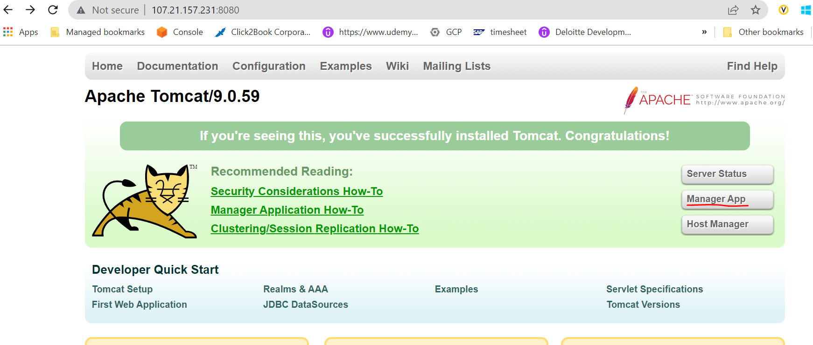

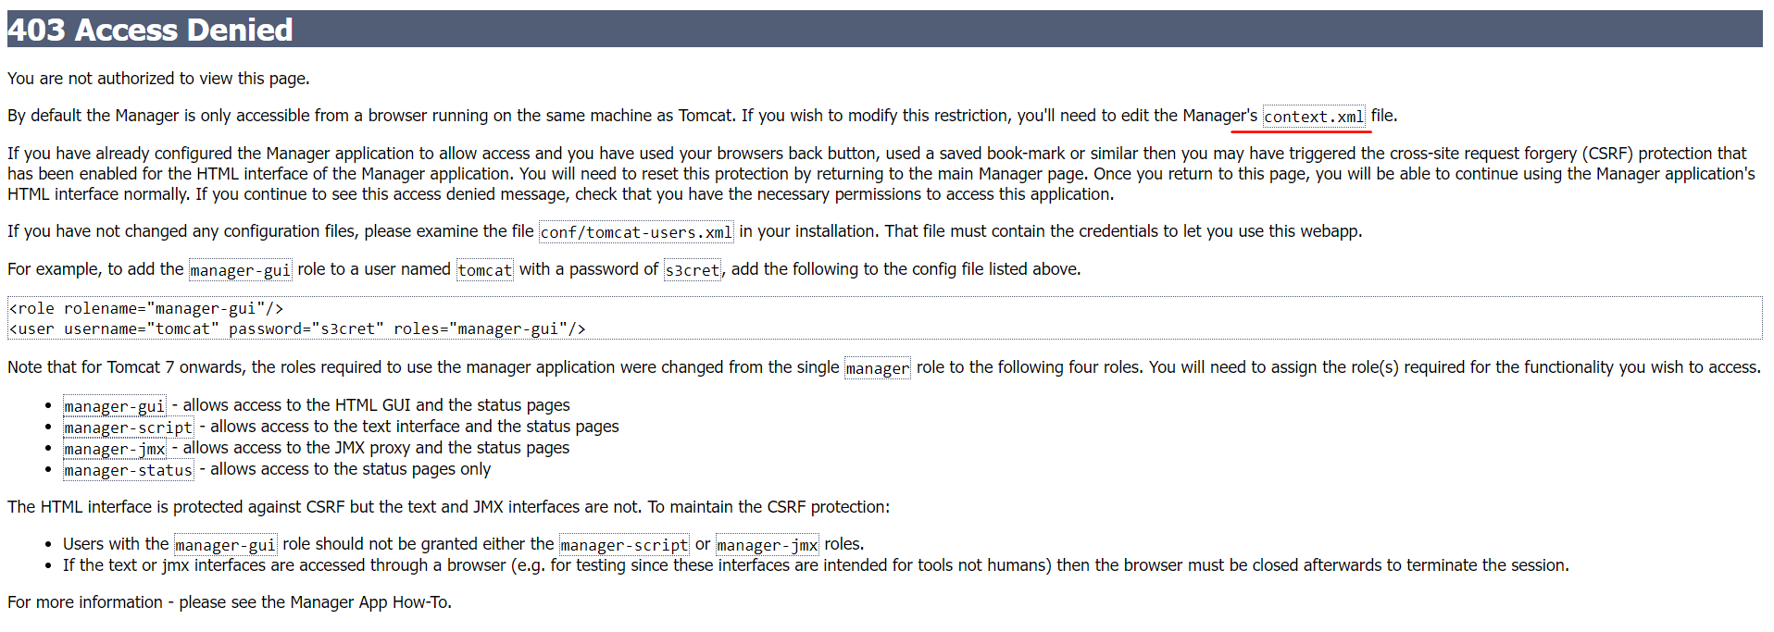

If you’re seeing above error after clicking on any Manager App anywhere then click issue the following command and do the necessary below changes in the below files.

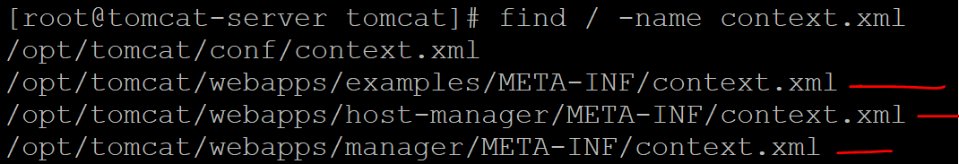

nano /opt/tomcat/webapps/examples/META-INF/context.xml

nano /opt/tomcat/webapps/host-manager/META-INF/context.xml

nano /opt/tomcat/webapps/manager/META-INF/context.xml

#do the comment below section in the above three files

* 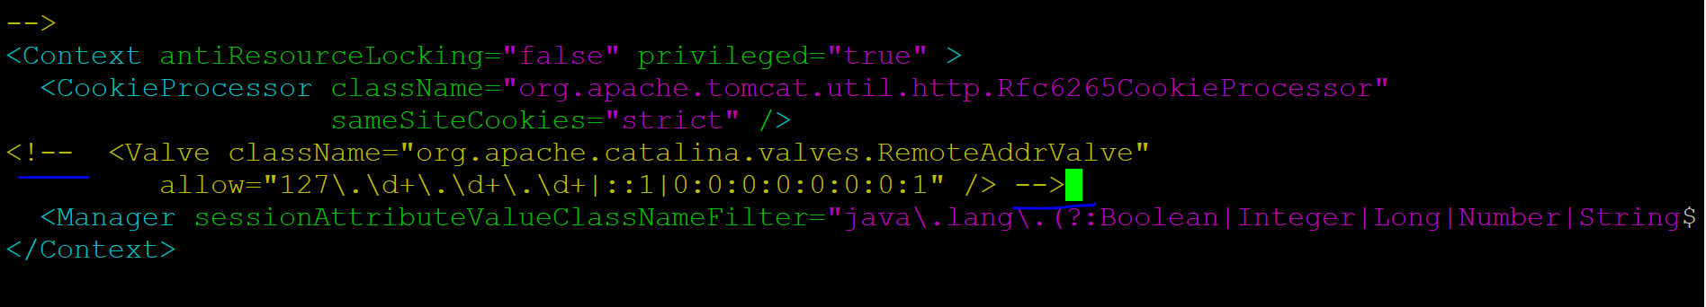
* 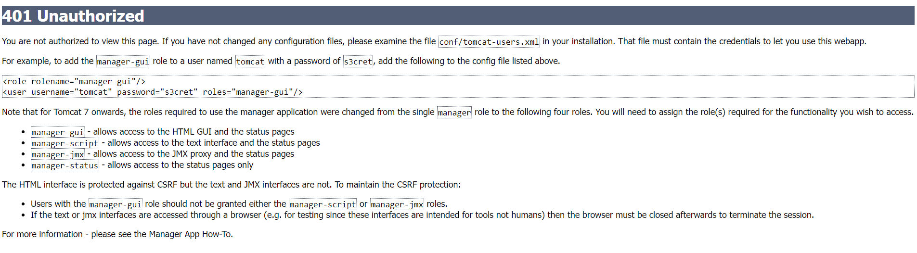
* Now go to conf/tomcat-users.xml 🡪 go all the way to down and add below content

<role rolename="manager-gui"/>

<role rolename="manager-script"/>

<role rolename="manager-jmx"/>

<role rolename="manager-status"/>

<user username="admin" password="admin" roles="manager-gui,manager-script,manager-jmx,manager-status"/>

* <user username="tomcat" password="pass123" roles="manager-gui"/>

Java Web Project

<https://maven.apache.org/archetypes/maven-archetype-webapp/>

1. mvn archetype:generate -DgroupId=com.sample.webproject -DartifactId=tomcat-demo -DarchetypeArtifactId=maven-archetype-webapp -DinteractiveMode=false
2. 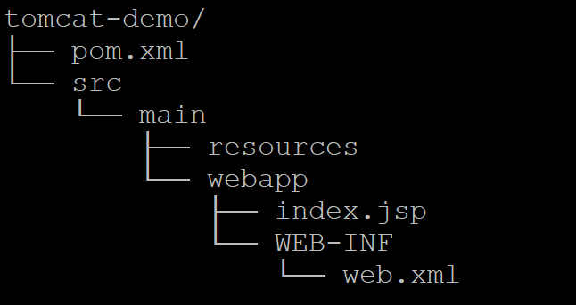
3. 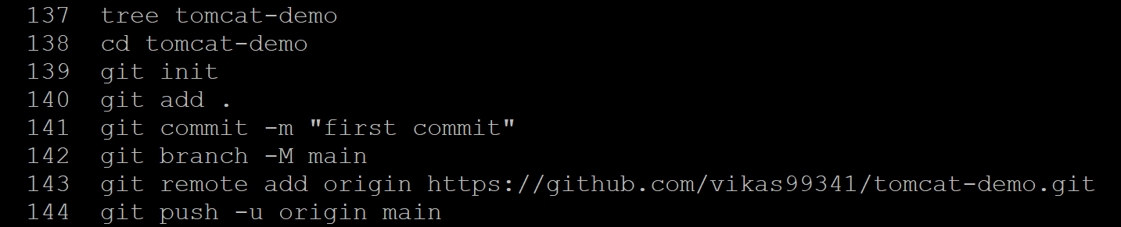

Step1: login into Jenkins 🡪 Dashboard 🡪 Manage Jenkins -🡪 Plugin Manager 🡪 search for “Deploy to Container Plugin” and install it.

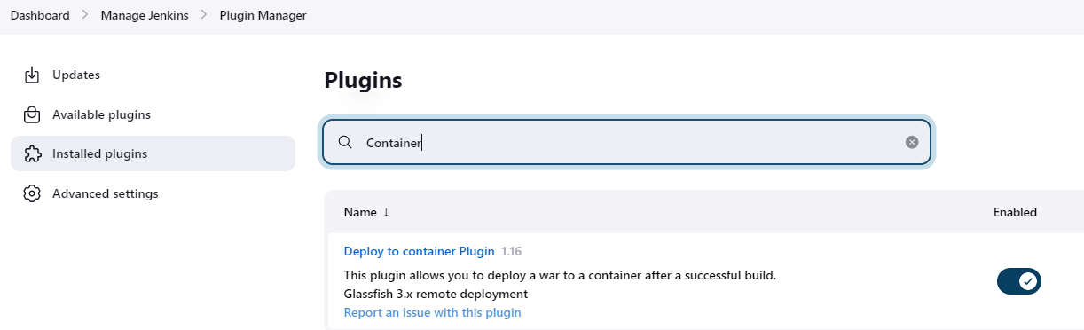

Step2: Now create an Jenkins job name: tomcat-web-app

Dashboard 🡪New Item -🡪 Name : tomcat-web-app

Select : Maven

Click **OK**

Step3: Go back to dashboard 🡪 click tomcat-web-app job name 🡪configure 🡪

Description : Any

Step4:Check Github project

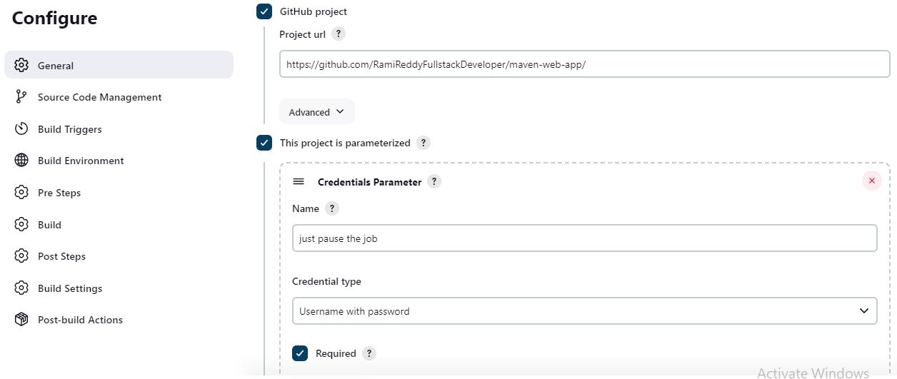

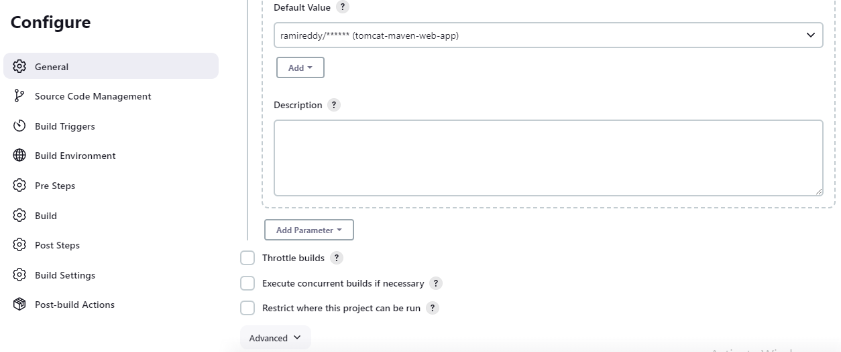

Step4: Source code management Section under configure only

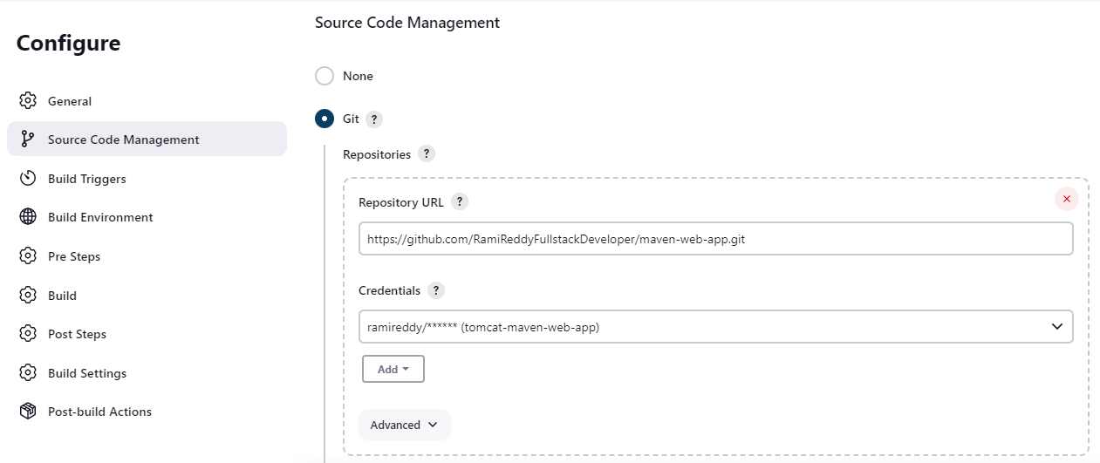

Now here specify which branch we want to pick from git and build purpose.

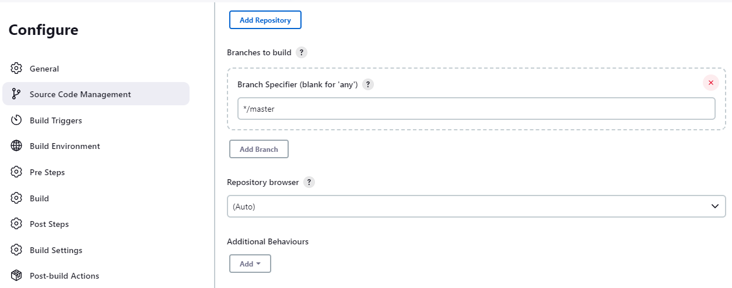

Note: Next Build Trigger and Build Environment section for now leave it as is.

We will talk about that later about use cases. Now lets come to Build section

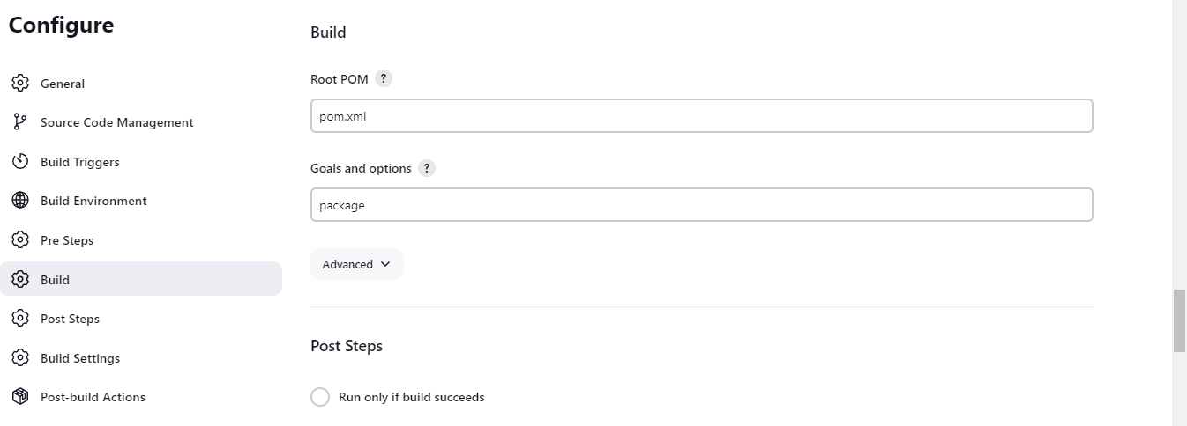

Step5: Build settings section.

Note: Go to ec2-server 🡪 Security group 🡪 inbound rule section 🡪 and enable

port number 25 for sending email, to check whether email came or not for this go to

https://www.mailinator.com/v4/public/inboxes.jsp?msgid=ramj-1681654501-114593268&to=ramj

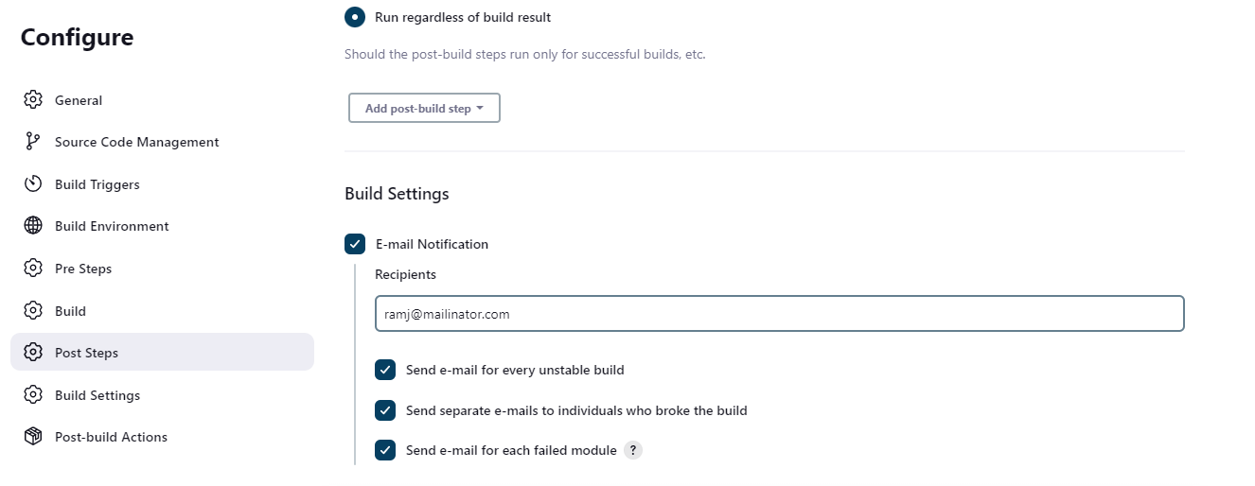

Step6: Post Build Section

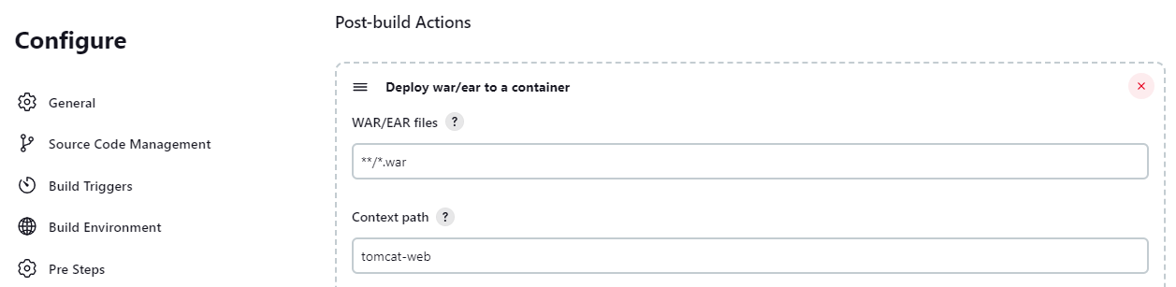

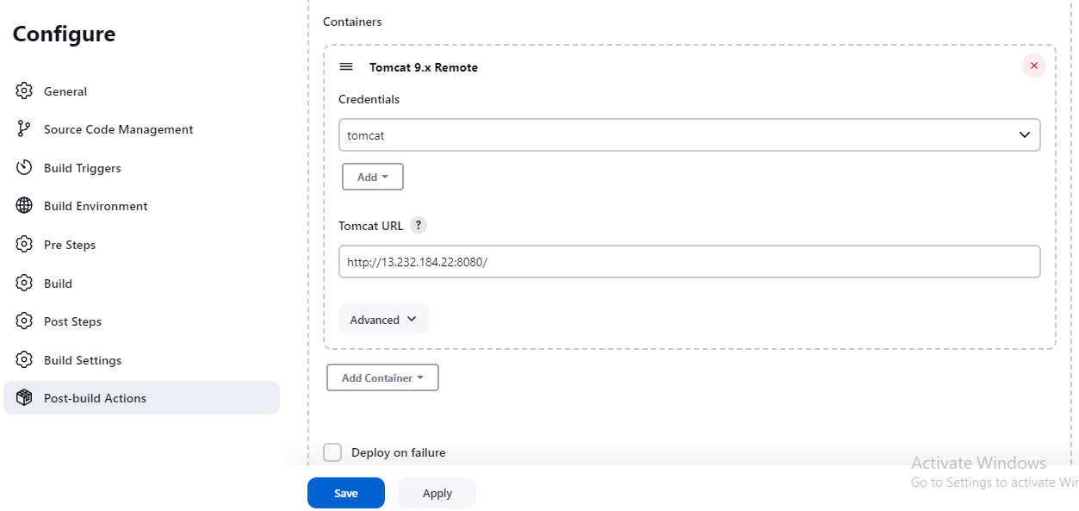

**Step7**: Now click apply and Save button

**Step8**: Now go back to Dashboard 🡪 click on the tomcat-web-job Jenkins job name 🡪

Build with parameter.

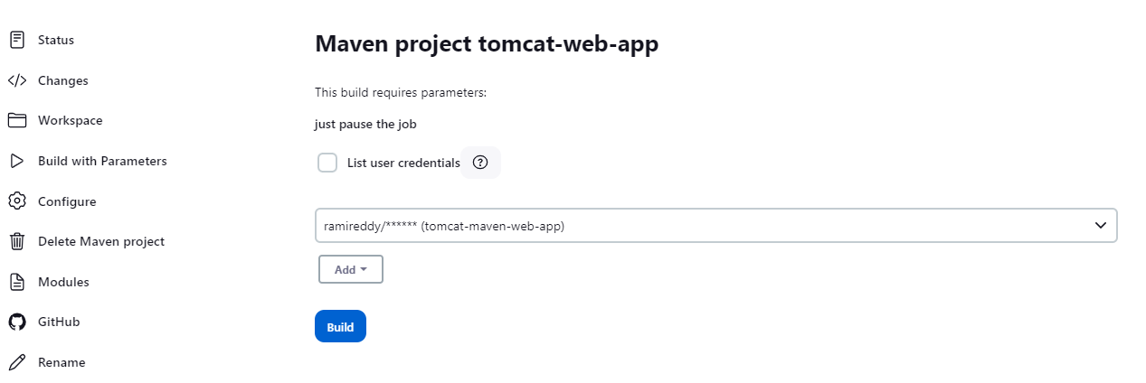

Step8: Click build it will trigger the build

Step9: to see the console output go to the below build history section-🡪 click build number 🡪 console output.

Step10: now we can verify whether we receive an email or not by visiting the below url. https://www.mailinator.com/v4/public/inboxes.jsp?msgid=ramj-1681654501-114593268&to=ramj

Step11: Done.

https://github.com/RamiReddyFullstackDeveloper/maven-web-app

Pipeline Job:

1. Bring tomcat(Pem key) and Jenkins server(ppk) up.
2. 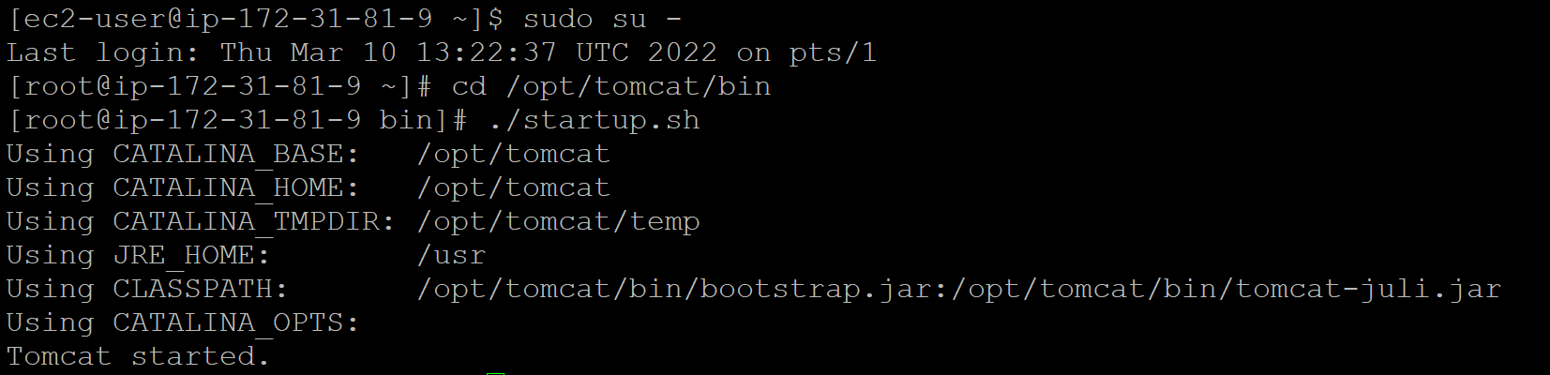
3. Jenkins machine : visudo 🡺 esc + i => esc :wq!
4. If we don’t know this where to find, pls refer Jenkins note.txt file in github
5. 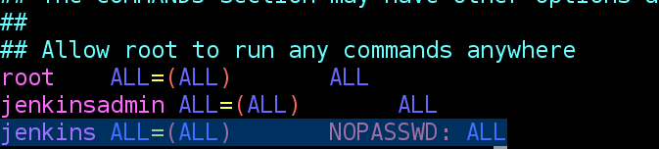
6. Change the tomcat root user to ec2-user using below command
7. On tomcat Machine: chown -R ec2-user:ec2-user /opt/tomcat/webapps

https://github.com/vikas99341/tomcat-demo.git

**Note**: Once build is successful, go to browser and paste the below url and you will see the output.

<http://13.232.184.22:8080/tomcat-web/>

**output**: Hello world //this is coming from our java project index.jsp.