## create tables

-- Drop tables  
  
drop table books;  
drop table authors;  
drop table publishers;  
drop table countries;  
drop table book_author;  
drop table book_publisher;  
drop table publisher_country;  
  
drop sequence book_seq, author_seq, pub_seq, country_seq;  
  
-- create sequences  
create sequence book_seq start with 1;  
create sequence author_seq start with 1;  
create sequence pub_seq start with 1;  
create sequence country_seq start with 1;  
  
-- create tables  
create table books (  
 book_id int primary key,  
 title varchar2(100),  
 isbn varchar2(30),  
 year_pub int  
);  
  
create table authors (  
 author_id int primary key,  
 authorName varchar2(100)  
);  
  
create table books_author (  
 book_id int,  
 author_id int,  
 foreign key (book_id) references book(book_id),  
 foreign key (author_id) references authors(author_id)  
);  
  
create table publishers (  
 pub_id int primary key,  
 pubName varchar2(100)  
);  
  
create table countries (  
 country_id int primary key,  
 country_name varchar2(100)  
);  
  
create table book_publisher (  
 pub_id int references publishers(pub_id),  
 book_id int references books(book_id)  
);  
  
create table publisher_country (  
 pub_id int references publishers(pub_id),  
 country_id int references countries(country_id)  
);

## insert tables

-- Insert values into books  
INSERT INTO books (title, isbn, year_pub) VALUES ('Catch-22', '978-1-4516-2665-0', 1961);  
INSERT INTO books (title, isbn, year_pub) VALUES ('The Martian', '978-0-553-41802-6', 2011);  
INSERT INTO books (title, isbn, year_pub) VALUES ('Grit', '978-1-5011-1110-5', 2016);  
INSERT INTO books (title, isbn, year_pub) VALUES ('Jupiters Circle', '978-1-63215-707-2', 2016);  
  
-- Insert values into countries  
INSERT INTO countries (country_name) VALUES ('US');  
INSERT INTO countries (country_name) VALUES ('CAN');  
INSERT INTO countries (country_name) VALUES ('UK');  
INSERT INTO countries (country_name) VALUES ('AUS');  
  
-- Insert values into publishers  
INSERT INTO publishers (pubName) VALUES ('Schuster');  
INSERT INTO publishers (pubName) VALUES ('Broadway Books');  
INSERT INTO publishers (pubName) VALUES ('Image Comics');  
  
-- Insert values into authors  
INSERT INTO authors (authorName) VALUES ('Andy Weir');  
INSERT INTO authors (authorName) VALUES ('Joseph Heller');  
INSERT INTO authors (authorName) VALUES ('Mark Millar');  
INSERT INTO authors (authorName) VALUES ('Angela Duckworth');  
  
-- Insert values into books_author  
INSERT INTO books_author (book_id, author_id) VALUES (1, 2);  
INSERT INTO books_author (book_id, author_id) VALUES (2, 1);  
INSERT INTO books_author (book_id, author_id) VALUES (3, 4);  
INSERT INTO books_author (book_id, author_id) VALUES (4, 3);  
  
-- Insert values into book_publisher  
INSERT INTO book_publisher (book_id, pub_id) VALUES (1, 1);  
INSERT INTO book_publisher (book_id, pub_id) VALUES (2, 2);  
INSERT INTO book_publisher (book_id, pub_id) VALUES (3, 1);  
INSERT INTO book_publisher (book_id, pub_id) VALUES (4, 3);  
  
-- Insert values into publisher_country  
INSERT INTO publisher_country (pub_id, country_id) VALUES (1, 1);  
INSERT INTO publisher_country (pub_id, country_id) VALUES (2, 1);  
INSERT INTO publisher_country (pub_id, country_id) VALUES (3, 1);  
  
-- Check data in books  
SELECT * FROM books;  
  
-- Check data in authors  
SELECT * FROM authors;  
  
-- Check data in books_author  
SELECT * FROM books_author;  
  
-- Check data in publishers  
SELECT * FROM publishers;  
  
-- Check data in book_publisher  
SELECT * FROM book_publisher;  
  
-- Check data in countries  
SELECT * FROM countries;  
  
-- Check data in publisher_country  
SELECT * FROM publisher_country;

### Books Table

| BOOK_ID | TITLE | ISBN | YEAR_PUB |
| --- | --- | --- | --- |
| 1 | Catch-22 | 978-1-4516-2665-0 | 1961 |
| 2 | The Martian | 978-0-553-41802-6 | 2011 |
| 3 | Grit | 978-1-5011-1110-5 | 2016 |
| 4 | Jupiters Circle | 978-1-63215-707-2 | 2016 |

### Authors Table

| AUTHOR_ID | AUTHORNAME |
| --- | --- |
| 1 | Andy Weir |
| 2 | Joseph Heller |
| 3 | Mark Millar |
| 4 | Angela Duckworth |

### Books_Author Table

| BOOK_ID | AUTHOR_ID |
| --- | --- |
| 1 | 2 |
| 2 | 1 |
| 3 | 4 |
| 4 | 3 |

### Publishers Table

| PUB_ID | PUBNAME |
| --- | --- |
| 1 | Schuster |
| 2 | Broadway Books |
| 3 | Image Comics |

### Book_Publisher Table

| PUB_ID | BOOK_ID |
| --- | --- |
| 1 | 1 |
| 2 | 2 |
| 1 | 3 |
| 3 | 4 |

### Countries Table

| COUNTRY_ID | COUNTRY_NAME |
| --- | --- |
| 1 | US |
| 2 | CAN |
| 3 | UK |
| 4 | AUS |

### Publisher_Country Table

| PUB_ID | COUNTRY_ID |
| --- | --- |
| 1 | 1 |
| 2 | 1 |
| 3 | 1 |

## Full schema

-- use JOIN to create produce table ou-- use JOIN to create produce table outputs  
select bk.title, auth.authorName, bk.isbn, bk.year_pub, pub.pubName --origin.country_name  
from books bk  
join books_author bkA on bk.book_id = bkA.book_id  
join authors auth on bkA.author_id = auth.author_id  
join book_publisher bpub on bk.book_id = bpub.book_id  
join publishers pub on bpub.pub_id = pub.pub_id

#### Join output

|  |  |  |  |  |  |
| --- | --- | --- | --- | --- | --- |
| BOOK_TITLE | BOOK_ISBN | BOOK_YEAR_PUB | AUTHOR_NAME | PUBLISHER_NAME | PUBLISHER_COUNTRY |
| Grit Catch-22 The Martian Jupiters Circle | 978-1-5011-1110-5 978-1-4516-2665-0 978-0-553-41802-6 978-1-63215-707-2 | 2016 1961 2011 2016 | Angela Duckworth Joseph Heller Andy Weir Mark Millar | Schuster Schuster Broadway Books Image Comics | US US US US |

## ER Diagram

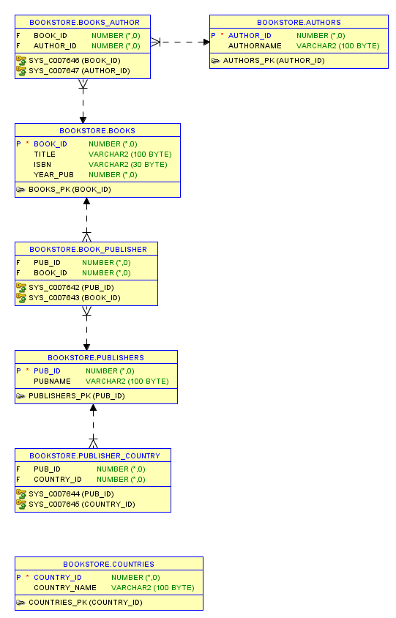

Books Relationship Diagram