1. SELECT *FROM EMP

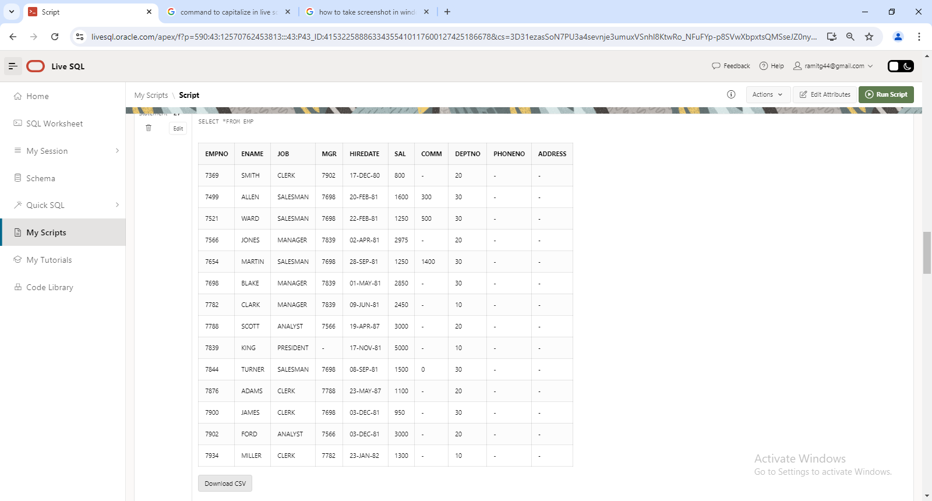

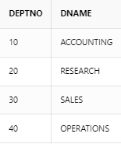

2. SELECT DEPTNO, DNAME FROM DEPT

3. SELECT EMPNO, ENAME, DEPTNO FROM EMP WHERE DEPTNO=20

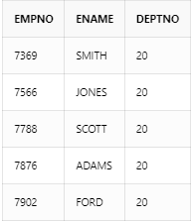

4. SELECT *FROM EMP ORDER BY DEPTNO DESC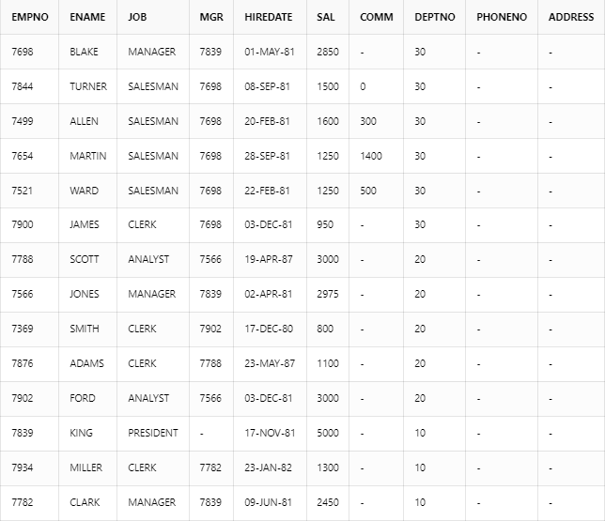

5. SELECT UNIQUE JOB FROM EMP

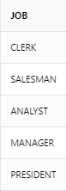

6. SELECT ENAME,12*SAL+NVL(COMM,0) AS ANNUAL_SALARY, DEPTNO FROM EMP WHERE JOB='CLERK' AND DEPTNO=20

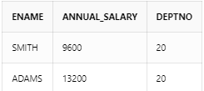

7. SELECT ENAME, HIREDATE FROM EMP WHERE ENAME LIKE 'S%' OR ENAME LIKE '_C%'

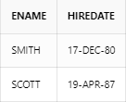

8. SELECT ENAME, HIREDATE, SAL FROM EMP WHERE JOB <> 'MANAGER'

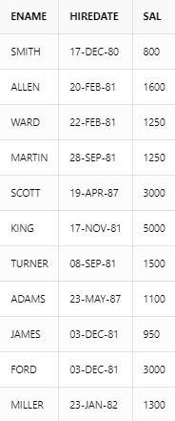

9. SELECT UPPER(ENAME) AS ENAME, LENGTH(ENAME) AS LENGTH FROM EMP

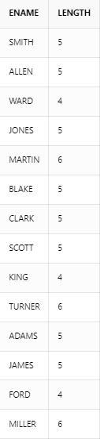

10.SELECT ENAME FROM EMP WHERE SAL>=4000 AND SAL<=6000

