ASSIGNMENT 2:

1. SELECT ENAME, MGR, TO_CHAR (HIREDATE,'DDSPTH MONTH YYYY')

AS DATE_HIRED FROM EMP

WHERE JOB = 'CLERK' OR DEPTNO = 20

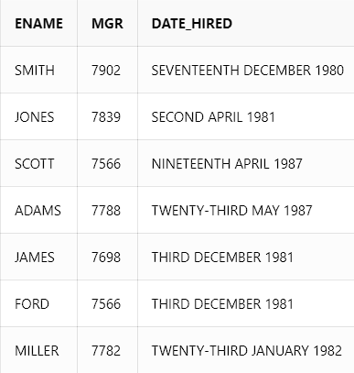

1. SELECT ENAME, SAL AS OLD_SAL, (1.25*SAL) AS NEW_SAL FROM EMP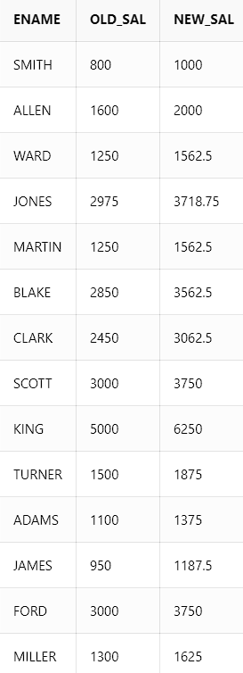
2. SELECT RPAD(ENAME,10), LPAD(SAL,10) FROM EMP

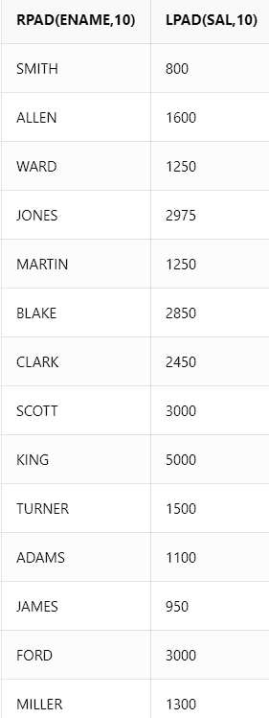

1. SELECT CONCAT(CONCAT(INITCAP(ENAME),'('),CONCAT(INITCAP(JOB),')')) AS "ROLE OF THE EMPLOYEE" FROM EMP

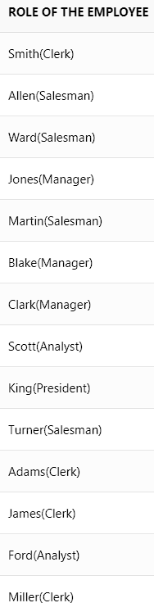

1. SELECT *FROM EMP WHERE JOB='CLERK'

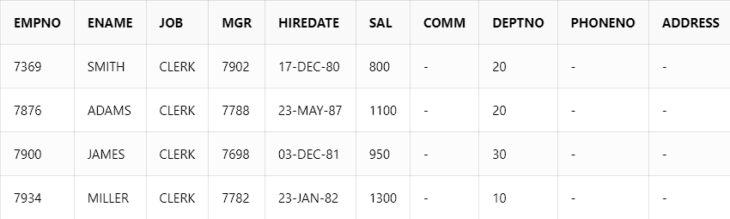

1. SELECT ENAME, HIREDATE AS HIRE_DATE,

(HIREDATE+365) AS SALARY_REVIEW_DATE

FROM EMP ORDER BY SALARY_REVIEW_DATE ASC

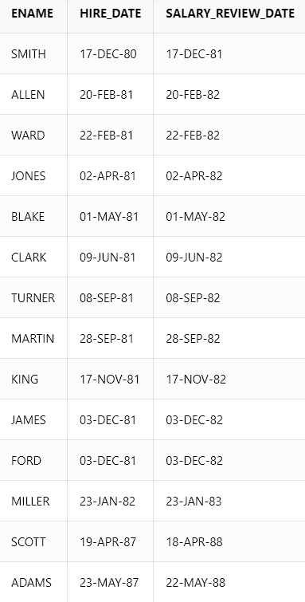

1. SELECT * FROM EMP

WHERE SAL IN (SELECT MAX(SAL) FROM EMP GROUP BY JOB)

ORDER BY SAL DESC

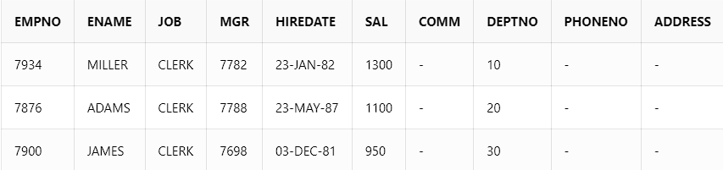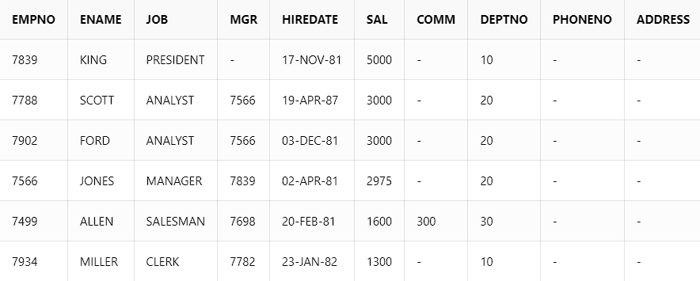

1. SELECT * FROM EMP E

WHERE HIREDATE IN (SELECT MAX(HIREDATE) FROM EMP WHERE E.DEPTNO = DEPTNO)

ORDER BY DEPTNO

1. SELECT D.DNAME, COUNT(E.EMPNO)

FROM EMP E, DEPT D WHERE E.DEPTNO = D.DEPTNO

GROUP BY D.DEPTNO, D.DNAME

ORDER BY D.DEPTNO

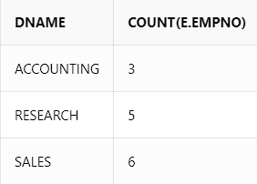

1. SELECT E.EMPNO, E.ENAME, E.SAL, S.GRADE

FROM EMP E, SALGRADE S WHERE E.SAL IN(SELECT MAX(SAL)

FROM EMP GROUP BY DEPTNO) AND E.SAL BETWEEN S.LOSAL AND S.HISAL

ORDER BY E.DEPTNO

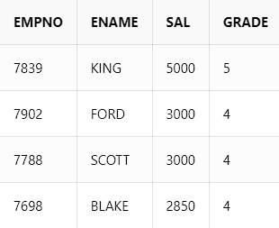

1. SELECT TO_CHAR (HIREDATE, 'YYYY') AS YEAR,

COUNT(EMPNO) AS NO_OF_EMPLOYEES

FROM EMP GROUP BY TO_CHAR (HIREDATE, 'YYYY') HAVING COUNT(EMPNO)= (SELECT MAX(COUNT(EMPNO)) FROM EMP

GROUP BY TO_CHAR (HIREDATE, 'YYYY'))

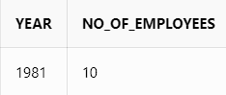

1. SELECT EMPNO, ENAME, JOB, MGR, HIREDATE,

SAL, COMM, DEPTNO, PHONENO, ADDRESS

FROM(SELECT EMPNO, ENAME,JOB, MGR, HIREDATE,

SAL, COMM, DEPTNO, PHONENO, ADDRESS, ROWNUM RN

FROM EMP)

WHERE MOD(RN,2)=1

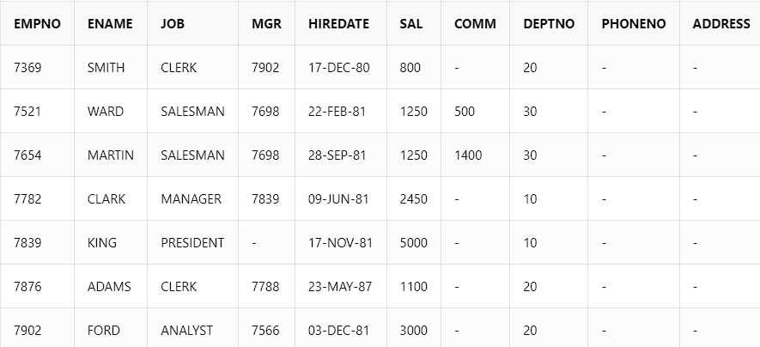

1. SELECT EMPNO, ENAME, SAL+NVL(COMM,0) AS TOTAL_SALARY FROM EMP

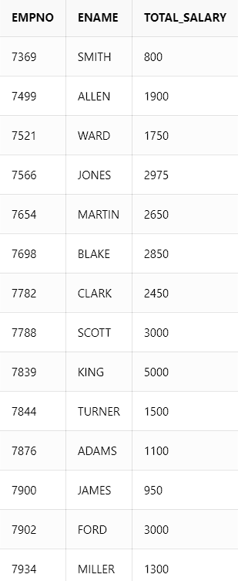

14. SELECT DISTINCT D.DNAME AS DEPARTMENT,

E.JOB AS AVAILABLE_JOBS FROM EMP E,

DEPT D WHERE D.DEPTNO = E.DEPTNO

ORDER BY DNAME

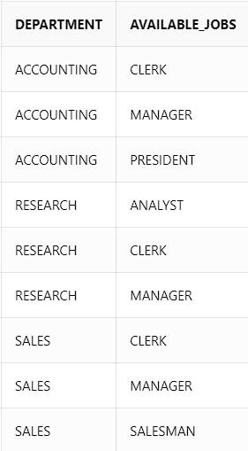

15. SELECT DISTINCT D.DNAME AS DEPARTMENT,

E.* FROM EMP E, DEPT D

WHERE D.DEPTNO = E.DEPTNO

