PROJECT REPORT

ON

SMART PLACEMENT CELL

Submitted By

ANANDHAKRISHNAN M (CEC17CS011)

ISSAC PAUL THOMAS (CEC17CS027)

RAHUL HARI (CEC17CS045)

VISHNU VISWAMBHARAN (CEC17CS065)

under the esteemed guidance of

Mrs. JUDY ANN JOY

Assistant Professor

Department Of Computer Engineering



JULY 2021

DEPARTMENT OF COMPUTER ENGINEERING

COLLEGE OF ENGINEERING, PALLIPPURAM P O, CHERTHALA,

ALAPPUZHA PIN: 688541,

PHONE: 0478 2553416, FAX: 0478 2552714

http://www.cectl.ac.in

A PROJECT REPORT ON

SMART PLACEMENT CELL

Submitted By

ANANDHAKRISHNAN M (CEC17CS011)

ISSAC PAUL THOMAS (CEC17CS027)

RAHUL HARI (CEC17CS045)

VISHNU VISWAMBHARAN (CEC17CS065)

under the esteemed guidance of

Mrs. JUDY ANN JOY

In partial fulfillment of the requirements for the award of the degree

of

Bachelor of Technology

in

Computer Science and Engineering

of

APJ Abdul Kalam Technological University



JULY 2021

DEPARTMENT OF COMPUTER ENGINEERING

COLLEGE OF ENGINEERING, PALLIPPURAM P O, CHERTHALA,

ALAPPUZHA PIN: 688541,

PHONE: 0478 2553416, FAX: 0478 2552714

http://www.cectl.ac.in

DEPARTMENT OF COMPUTER ENGINEERING

COLLEGE OF ENGINEERING CHERTHALA

ALAPPUZHA-688541



CERTIFICATE

This is to certify that, the project report titled SMART PLACEMENT CELL,is a bonafide record of the CS492 Project presented by ANANDHAKRISHNAN M (CEC17CS011), ISSAC PAUL THOMAS (CEC17CS027), RAHUL HARI (CEC17CS045), VISHNU VISWAMBHA-RAN (CEC17CS065) Eighth Semester B. Tech. Computer Science & Engineering students, under our guidance and supervision, in partial fulfillment of the requirements for the award of the degree, B. Tech. Computer Science & Engineering of APJ Abdul Kalam Technological University.

Guide Co-ordinator HoD

|  |  |  |
| --- | --- | --- |
| Mrs. Judy Ann John | Mr. Muhammed Ilyas | Dr. Priya S |
| Assistant Professor | Assistant Professor | Professor |
| Dept Of Computer Engg | Dept Of Computer Engg | Dept Of Computer Engg |

ACKNOWLEDGEMENT

This work would not have been possible without the support of many people. First and the foremost, we give thanks to Almighty God who gave us the inner strength, resource and ability to complete our project successfully.

We would like to thank Dr. Mini M G, our Principal, who has provided with the best facilities and atmosphere for the project completion and presentation.We would also like to thank our HoD Dr. Priya S (Professor, Department Of Computer Engineering), our project coordinator Mr. Muhammed Ilyas H (Assistant Professor, Department Of Computer Engineering), and our guide Mrs. Judy Ann Joy (Assistant Professor, Department Of Computer Engineering) for the help extended and also for the encouragement and support given to us while doing the project.

We would like to thank my dear friends for extending their cooperation and encouragement throughout the project work, without which we would never have completed the project this well. Thank you all for your love and also for being very understanding.

iv

ABSTRACT

The management of Training and Placement is supported by paper-based systems, databases, spreadsheets, and e-mail communications. Training and Placement is a crucial part of any edu-cational institution in which most of the work till now is being done manually. The aim of this project is the Automation of Training and Placement unit of the college. The project will include minimum manual work and maximum optimization, abstraction, and security .

This web application mainly focuses on helping students as well as the administrative au-thority to carry out each and every activity in the placement cell. This application can be accessed throughout the institution with respective logins provided. This system can be used as an efficient tool for the Training and placement officers (TPO) of the college to manage the student informa-tion and also pass the information regarding the placement activities. After login Students should be able to fill the registration form. This system could also be used as a central repository that con-trols/possesses the entire data of student academic details. This will also help in the fast execution of placement related activities.

Keywords: Optimization, Abstraction, Security, Placement Cell.

i

Contents

|  |  |  |  |  |
| --- | --- | --- | --- | --- |
| 1 | INTRODUCTION | | | 1 |
| 2 | PROBLEM STATEMENT | | | 3 |
|  | 2.1 | Problem Statement . . . . . . . . . . . . . . . . . . . . . . . . . . . . . . . . . | | 3 |
|  | 2.2 | Objective . . . . . . . . . . . . . . . . . . . . . . . . . . . . . . . . . . . . . . | | 3 |
| 3 | LITERATURE SURVEY | | | 4 |
|  | 3.1 | CASESTUDY1.................................. | | 4 |
|  | 3.2 | CASESTUDY2 .................................. | | 5 |
|  | 3.3 | CASESTUDY3 .................................. | | 5 |
|  | 3.4 | CASESTUDY4 .................................. | | 6 |
|  | 3.5 | CASESTUDY5 .................................. | | 7 |
|  | 3.6 | Case Study Analysis . . . . . . . . . . . . . . . . . . . . . . . . . . . . . . . . | | 8 |
| 4 | PROPOSED SYSTEM | | | 9 |
|  | 4.1 | Solution . . . . . . . . . . . . . . . . . . . . . . . . . . . . . . . . . . . . . . . | | 9 |
|  | 4.2 | Feasibility Study . . . . . . . . . . . . . . . . . . . . . . . . . . . . . . . . . . | | 9 |
|  |  | 4.2.1 | Technical Feasibility . . . . . . . . . . . . . . . . . . . . . . . . . . . . | 10 |
|  |  | 4.2.2 | Social Feasibility . . . . . . . . . . . . . . . . . . . . . . . . . . . . . . | 10 |
|  |  | 4.2.3 | Schedule Feasibility . . . . . . . . . . . . . . . . . . . . . . . . . . . . | 10 |
|  |  | 4.2.4 | Operational Feasibility . . . . . . . . . . . . . . . . . . . . . . . . . . . | 10 |
|  |  | 4.2.5 | Economic Feasibility . . . . . . . . . . . . . . . . . . . . . . . . . . . . | 11 |

ii

|  |  |  |  |  |
| --- | --- | --- | --- | --- |
| 5 | SOFTWARE REQUIREMENT SPECIFICATION | | | 12 |
|  | 5.1 | Overall Description . . . . . . . . . . . . . . . . . . . . . . . . . . . . . . . . . | | 12 |
|  |  | 5.1.1 | Product Perspective . . . . . . . . . . . . . . . . . . . . . . . . . . . . . | 12 |
|  |  | 5.1.2 | Product Functions . . . . . . . . . . . . . . . . . . . . . . . . . . . . . | 12 |
|  | 5.2 | User Classes and Characteristics . . . . . . . . . . . . . . . . . . . . . . . . . . | | 13 |
|  |  | 5.2.1 | Operating Environment . . . . . . . . . . . . . . . . . . . . . . . . . . . | 13 |
|  |  | 5.2.2 | Design and Implementation Constraints . . . . . . . . . . . . . . . . . . | 13 |
|  |  | 5.2.3 | Assumptions and Dependencies . . . . . . . . . . . . . . . . . . . . . . | 13 |
|  | 5.3 | External Interface Requirements . . . . . . . . . . . . . . . . . . . . . . . . . . | | 14 |
|  |  | 5.3.1 | User Interfaces . . . . . . . . . . . . . . . . . . . . . . . . . . . . . . . | 14 |
|  |  | 5.3.2 | Hardware Interfaces . . . . . . . . . . . . . . . . . . . . . . . . . . . . | 14 |
|  |  | 5.3.3 | Software Interfaces . . . . . . . . . . . . . . . . . . . . . . . . . . . . . | 14 |
|  |  | 5.3.4 | Communications Interfaces . . . . . . . . . . . . . . . . . . . . . . . . | 14 |
|  | 5.4 | System Features . . . . . . . . . . . . . . . . . . . . . . . . . . . . . . . . . . . | | 15 |
|  |  | 5.4.1 | Student User Module . . . . . . . . . . . . . . . . . . . . . . . . . . . . | 15 |
|  |  | 5.4.2 | Admin User Module . . . . . . . . . . . . . . . . . . . . . . . . . . . . | 15 |
|  |  | 5.4.3 | Execom User Module . . . . . . . . . . . . . . . . . . . . . . . . . . . | 16 |
|  | 5.5 | Other Nonfunctional Requirements . . . . . . . . . . . . . . . . . . . . . . . . . | | 17 |
|  |  | 5.5.1 | Security Requirements . . . . . . . . . . . . . . . . . . . . . . . . . . . | 17 |
|  |  | 5.5.2 | Software Quality Attributes . . . . . . . . . . . . . . . . . . . . . . . . | 17 |
| 6 | SYSTEM DESIGNS | | | 18 |
|  | 6.1 | Design . . . . . . . . . . . . . . . . . . . . . . . . . . . . . . . . . . . . . . . . | | 18 |
|  | 6.2 | ARCHITECTUREDIAGRAM........................... | | 19 |
|  | 6.3 | MODULES..................................... | | 20 |
|  |  | 6.3.1 | LOGIN................................... | 20 |
|  |  | 6.3.2 | Edit Student Profile . . . . . . . . . . . . . . . . . . . . . . . . . . . . . | 21 |
|  |  | 6.3.3 | View Placement Details . . . . . . . . . . . . . . . . . . . . . . . . . . | 22 |
|  |  | 6.3.4 | Register for drive . . . . . . . . . . . . . . . . . . . . . . . . . . . . . . | 23 |
|  |  | 6.3.5 | Send Message in Chat Forum . . . . . . . . . . . . . . . . . . . . . . . | 24 |

iii

|  |  |  |  |
| --- | --- | --- | --- |
|  | 6.3.6 | Update Password . . . . . . . . . . . . . . . . . . . . . . . . . . . . . . | 24 |
|  | 6.3.7 | Send emails to students . . . . . . . . . . . . . . . . . . . . . . . . . . . | 25 |
|  | 6.3.8 | Upload Bill Details . . . . . . . . . . . . . . . . . . . . . . . . . . . . . | 26 |
|  | 6.3.9 | Create Student Accounts . . . . . . . . . . . . . . . . . . . . . . . . . . | 27 |
|  | 6.3.10 | Upload Placement Drive Details . . . . . . . . . . . . . . . . . . . . . . | 28 |
| 6.4 | USE-CASEDIAGRAM .............................. | | 29 |
| 6.5 | SEQUENCEDIAGRAM.............................. | | 32 |
| 6.6 | Data Flow Diagram . . . . . . . . . . . . . . . . . . . . . . . . . . . . . . . . . | | 34 |
|  | 6.6.1 | Level 0 . . . . . . . . . . . . . . . . . . . . . . . . . . . . . . . . . . . | 35 |
|  | 6.6.2 | Level 1(Admin) . . . . . . . . . . . . . . . . . . . . . . . . . . . . . . . | 36 |
|  | 6.6.3 | Level 2 (Admin) . . . . . . . . . . . . . . . . . . . . . . . . . . . . . . | 37 |
|  | 6.6.4 | Level 3(Admin) . . . . . . . . . . . . . . . . . . . . . . . . . . . . . . . | 38 |
|  | 6.6.5 | Level 1(Student) . . . . . . . . . . . . . . . . . . . . . . . . . . . . . . | 41 |
|  | 6.6.6 | Level 2(Student) . . . . . . . . . . . . . . . . . . . . . . . . . . . . . . | 42 |
|  | 6.6.7 | Level 3(Student) . . . . . . . . . . . . . . . . . . . . . . . . . . . . . . | 43 |
|  | 6.6.8 | Level 1(Execom) . . . . . . . . . . . . . . . . . . . . . . . . . . . . . . | 45 |
|  | 6.6.9 | Level 2(Execom) . . . . . . . . . . . . . . . . . . . . . . . . . . . . . . | 45 |
|  | 6.6.10 | Level 3(Execom) . . . . . . . . . . . . . . . . . . . . . . . . . . . . . . | 46 |
| 7 SOFTWARE AND HARDWARE REQUIREMENT | | | 48 |
| 7.1 | Software Requirements . . . . . . . . . . . . . . . . . . . . . . . . . . . . . . . | | 48 |
| 7.2 | Hardware Requirements . . . . . . . . . . . . . . . . . . . . . . . . . . . . . . | | 48 |
|  | 7.2.1 | Computer . . . . . . . . . . . . . . . . . . . . . . . . . . . . . . . . . . | 48 |
|  | 7.2.2 | Smartphone . . . . . . . . . . . . . . . . . . . . . . . . . . . . . . . . . | 48 |
| 8 IMPLEMENTATION | | | 49 |
| 8.1 | Coding Environment Used . . . . . . . . . . . . . . . . . . . . . . . . . . . . . | | 49 |
| 8.2 | Login Module . . . . . . . . . . . . . . . . . . . . . . . . . . . . . . . . . . . . | | 50 |
|  | 8.2.1 | Admin Panel . . . . . . . . . . . . . . . . . . . . . . . . . . . . . . . . | 50 |
|  | 8.2.2 | Execom Panel . . . . . . . . . . . . . . . . . . . . . . . . . . . . . . . . | 50 |
|  | 8.2.3 | Student Panel . . . . . . . . . . . . . . . . . . . . . . . . . . . . . . . . | 50 |

iv

|  |  |  |  |
| --- | --- | --- | --- |
| 8.3 | Create Student Module . . . . . . . . . . . . . . . . . . . . . . . . . . . . . . . | | 50 |
|  | 8.3.1 | Admin Panel . . . . . . . . . . . . . . . . . . . . . . . . . . . . . . . . | 50 |
| 8.4 | Update Password . . . . . . . . . . . . . . . . . . . . . . . . . . . . . . . . . . | | 51 |
|  | 8.4.1 | Admin Panel . . . . . . . . . . . . . . . . . . . . . . . . . . . . . . . . | 51 |
|  | 8.4.2 | Execom Panel . . . . . . . . . . . . . . . . . . . . . . . . . . . . . . . . | 51 |
|  | 8.4.3 | Student Panel . . . . . . . . . . . . . . . . . . . . . . . . . . . . . . . . | 51 |
| 8.5 | Student Details . . . . . . . . . . . . . . . . . . . . . . . . . . . . . . . . . . . | | 51 |
|  | 8.5.1 | Admin Panel . . . . . . . . . . . . . . . . . . . . . . . . . . . . . . . . | 51 |
| 8.6 | Download Placement Details . . . . . . . . . . . . . . . . . . . . . . . . . . . . | | 51 |
|  | 8.6.1 | Admin Panel . . . . . . . . . . . . . . . . . . . . . . . . . . . . . . . . | 52 |
| 8.7 | Drive Management . . . . . . . . . . . . . . . . . . . . . . . . . . . . . . . . . | | 52 |
|  | 8.7.1 | Admin Panel . . . . . . . . . . . . . . . . . . . . . . . . . . . . . . . . | 52 |
|  | 8.7.2 | Student Panel . . . . . . . . . . . . . . . . . . . . . . . . . . . . . . . . | 52 |
| 8.8 | Send Mail Module . . . . . . . . . . . . . . . . . . . . . . . . . . . . . . . . . | | 52 |
|  | 8.8.1 | Admin Panel . . . . . . . . . . . . . . . . . . . . . . . . . . . . . . . . | 52 |
|  | 8.8.2 | Execom Panel . . . . . . . . . . . . . . . . . . . . . . . . . . . . . . . . | 53 |
| 8.9 | Forum . . . . . . . . . . . . . . . . . . . . . . . . . . . . . . . . . . . . . . . . | | 53 |
|  | 8.9.1 | Admin Panel . . . . . . . . . . . . . . . . . . . . . . . . . . . . . . . . | 53 |
|  | 8.9.2 | Execom Panel . . . . . . . . . . . . . . . . . . . . . . . . . . . . . . . . | 53 |
|  | 8.9.3 | Student Panel . . . . . . . . . . . . . . . . . . . . . . . . . . . . . . . . | 54 |
| 8.10 | Bill Management . . . . . . . . . . . . . . . . . . . . . . . . . . . . . . . . . . | | 54 |
|  | 8.10.1 | Admin Panel . . . . . . . . . . . . . . . . . . . . . . . . . . . . . . . . | 54 |
|  | 8.10.2 | Execom Panel . . . . . . . . . . . . . . . . . . . . . . . . . . . . . . . . | 54 |
| 8.11 Alumni Management . . . . . . . . . . . . . . . . . . . . . . . . . . . . . . . . | | | 54 |
|  | 8.11.1 | Admin Panel . . . . . . . . . . . . . . . . . . . . . . . . . . . . . . . . | 54 |
| 8.12 | Profile . . . . . . . . . . . . . . . . . . . . . . . . . . . . . . . . . . . . . . . . | | 55 |
|  | 8.12.1 | Student Panel . . . . . . . . . . . . . . . . . . . . . . . . . . . . . . . . | 55 |
| 8.13 | Logout . . . . . . . . . . . . . . . . . . . . . . . . . . . . . . . . . . . . . . . . | | 55 |
|  | 8.13.1 | Admin Panel . . . . . . . . . . . . . . . . . . . . . . . . . . . . . . . . | 55 |
|  | 8.13.2 | Execom Panel . . . . . . . . . . . . . . . . . . . . . . . . . . . . . . . . | 55 |

v

|  |  |  |  |
| --- | --- | --- | --- |
|  |  | 8.13.3 Student Panel . . . . . . . . . . . . . . . . . . . . . . . . . . . . . . . . | 55 |
| 9 | RESULT & ANALYSIS | | 61 |
|  | 9.1 | Screenshots . . . . . . . . . . . . . . . . . . . . . . . . . . . . . . . . . . . . . | 61 |
|  | 9.2 | Test Cases . . . . . . . . . . . . . . . . . . . . . . . . . . . . . . . . . . . . . . | 71 |
| 10 | CONCLUSION & FUTURE SCOPE | | 73 |
|  | REFERENCES | | 74 |

vi

List of Figures

|  |  |  |
| --- | --- | --- |
| 3.1 | Case Study Analysis . . . . . . . . . . . . . . . . . . . . . . . . . . . . . . . . | 8 |
| 6.1 | Architectural diagram . . . . . . . . . . . . . . . . . . . . . . . . . . . . . . . . | 19 |
| 6.2 | Use Case diagram . . . . . . . . . . . . . . . . . . . . . . . . . . . . . . . . . . | 31 |
| 6.3 | Student Sequence diagram . . . . . . . . . . . . . . . . . . . . . . . . . . . . . | 32 |
| 6.4 | Admin Sequence diagram . . . . . . . . . . . . . . . . . . . . . . . . . . . . . . | 33 |
| 6.5 | Execom Sequence diagram . . . . . . . . . . . . . . . . . . . . . . . . . . . . . | 34 |
| 6.6 | Level 0 DFD of Smart Placement Cell 0 . . . . . . . . . . . . . . . . . . . . . . | 35 |
| 6.7 | Level 1 DFD of Admin 0.1 . . . . . . . . . . . . . . . . . . . . . . . . . . . . . | 36 |
| 6.8 | Level 2 DFD of Admin 0.2 . . . . . . . . . . . . . . . . . . . . . . . . . . . . . | 37 |
| 6.9 | Level 3 DFD of Admin 0.2.1 . . . . . . . . . . . . . . . . . . . . . . . . . . . . | 38 |
| 6.10 | Level 3 DFD of Admin 0.2.2 . . . . . . . . . . . . . . . . . . . . . . . . . . . . | 38 |
| 6.11 | Level 3 DFD of Admin 0.2.3 . . . . . . . . . . . . . . . . . . . . . . . . . . . . | 39 |
| 6.12 | Level 3 DFD of Admin 0.2.4 . . . . . . . . . . . . . . . . . . . . . . . . . . . . | 39 |
| 6.13 | Level 3 DFD of Admin 0.2.5 . . . . . . . . . . . . . . . . . . . . . . . . . . . . | 40 |
| 6.14 | Level3 DFD of Admin 0.2.6 . . . . . . . . . . . . . . . . . . . . . . . . . . . . | 40 |
| 6.15 | Level 3 DFD of Admin 0.2.7 . . . . . . . . . . . . . . . . . . . . . . . . . . . . | 41 |
| 6.16 | Level 1 DFD of Student 0.1 . . . . . . . . . . . . . . . . . . . . . . . . . . . . | 41 |
| 6.17 | Level 2 DFD of Student 0.2 . . . . . . . . . . . . . . . . . . . . . . . . . . . . . | 42 |
| 6.18 | Level 3 DFD of Student 0.2.1 . . . . . . . . . . . . . . . . . . . . . . . . . . . . | 43 |
| 6.19 | Level 3 DFD of Student 0.2.2 . . . . . . . . . . . . . . . . . . . . . . . . . . . . | 43 |
| 6.20 | Level 3 DFD of Student 0.2.3 . . . . . . . . . . . . . . . . . . . . . . . . . . . . | 44 |
| 6.21 | Level 3 DFD of Student 0.2.4 . . . . . . . . . . . . . . . . . . . . . . . . . . . . | 44 |

vii

|  |  |  |
| --- | --- | --- |
| 6.22 | Level 1 DFD of Execom 0.1 . . . . . . . . . . . . . . . . . . . . . . . . . . . . | 45 |
| 6.23 | Level 2 DFD of Execom 0.2 . . . . . . . . . . . . . . . . . . . . . . . . . . . . | 45 |
| 6.24 | Level 3 DFD of Execom 0.2.1 . . . . . . . . . . . . . . . . . . . . . . . . . . . | 46 |
| 6.25 | Level 3 DFD of Execom 0.2.2 . . . . . . . . . . . . . . . . . . . . . . . . . . . | 46 |
| 6.26 | Level 3 DFD of Execom 0.2.3 . . . . . . . . . . . . . . . . . . . . . . . . . . . | 47 |
| 6.27 | Level 3 DFD of Execom 0.2.4 . . . . . . . . . . . . . . . . . . . . . . . . . . . | 47 |
| 8.1 | Implementation of server.js file . . . . . . . . . . . . . . . . . . . . . . . . . . . | 56 |
| 8.2 | Create student code . . . . . . . . . . . . . . . . . . . . . . . . . . . . . . . . . | 57 |
| 8.3 | Create student code . . . . . . . . . . . . . . . . . . . . . . . . . . . . . . . . . | 58 |
| 8.4 | Create student code . . . . . . . . . . . . . . . . . . . . . . . . . . . . . . . . . | 59 |
| 8.5 | Create student code . . . . . . . . . . . . . . . . . . . . . . . . . . . . . . . . . | 60 |
| 9.1 | Admin Login Page . . . . . . . . . . . . . . . . . . . . . . . . . . . . . . . . . | 61 |
| 9.2 | Admin Home Page . . . . . . . . . . . . . . . . . . . . . . . . . . . . . . . . . | 62 |
| 9.3 | Admin can send email . . . . . . . . . . . . . . . . . . . . . . . . . . . . . . . | 62 |
| 9.4 | Admin Forum . . . . . . . . . . . . . . . . . . . . . . . . . . . . . . . . . . . . | 63 |
| 9.5 | Admin can add drive details . . . . . . . . . . . . . . . . . . . . . . . . . . . . | 63 |
| 9.6 | Admin can add bills . . . . . . . . . . . . . . . . . . . . . . . . . . . . . . . . . | 64 |
| 9.7 | Alumni management . . . . . . . . . . . . . . . . . . . . . . . . . . . . . . . . | 64 |
| 9.8 | Bill Management by Execom . . . . . . . . . . . . . . . . . . . . . . . . . . . . | 65 |
| 9.9 | Drive Mangement by Execom . . . . . . . . . . . . . . . . . . . . . . . . . . . | 65 |
| 9.10 | Execom Forum . . . . . . . . . . . . . . . . . . . . . . . . . . . . . . . . . . . | 66 |
| 9.11 | Send Mail By Execom . . . . . . . . . . . . . . . . . . . . . . . . . . . . . . . | 66 |
| 9.12 | Update execom password . . . . . . . . . . . . . . . . . . . . . . . . . . . . . . | 67 |
| 9.13 | Student/Execom Login . . . . . . . . . . . . . . . . . . . . . . . . . . . . . . . | 67 |
| 9.14 | Student register for drive . . . . . . . . . . . . . . . . . . . . . . . . . . . . . . | 68 |
| 9.15 | Student Profile . . . . . . . . . . . . . . . . . . . . . . . . . . . . . . . . . . . | 68 |
| 9.16 | Student Forum . . . . . . . . . . . . . . . . . . . . . . . . . . . . . . . . . . . | 69 |
| 9.17 | Update student password . . . . . . . . . . . . . . . . . . . . . . . . . . . . . . | 69 |
| 9.18 | Student logout . . . . . . . . . . . . . . . . . . . . . . . . . . . . . . . . . . . . | 70 |

viii

|  |  |  |
| --- | --- | --- |
| 9.19 | Admin Test cases . . . . . . . . . . . . . . . . . . . . . . . . . . . . . . . . . . | 71 |
| 9.20 | Execom Test Cases . . . . . . . . . . . . . . . . . . . . . . . . . . . . . . . . . | 71 |
| 9.21 | Student Test Cases . . . . . . . . . . . . . . . . . . . . . . . . . . . . . . . . . | 72 |

ix

Chapter 1

INTRODUCTION

A web application or "web app" is a software program that runs on a web server. Unlike traditional desktop applications, which are launched by your operating system, web apps must be accessed through a web browser. Web apps have several advantages over desktop applications. Since they run inside web browsers, developers do not need to develop web apps for multiple platforms. A web application is any application that uses a web browser as a client. The application can be as simple as a message board or a guest sign-in book on a website, or as complex as a word processor or a spreadsheet. The Benefits of a Web Application is relieves the developer of the responsibility of building a client for a specific type of computer or a specific operating system.

The project is developed on the basis of Placement Cell being presently used in the college for storing and retrieving the information of students and companies who are registered in Place-ment Cell. The SPC System provides the facility of maintaining the details of the students. It also provides a requested list of candidates to recruit the students based on given query. Administrator logging in may also search any information put up by the students. This project will aid colleges to practice full IT deployment. This will also help in fast access procedures in placement related ac-tivities.The current placement system has very tedious and takes more time for processing because most of the works are done manually. In Various colleges, training and placement officers have to manage the students profile and documents of students for their training and placement manually. Placement Officer has to collect the information of various companies who want to recruit students and notify students time to time about them.

Now a days Placement Officer has to arrange profiles of students according to various streams and notify them according to company requirements. If any modifications or updates

1

College of Engineering, Cherthala CHAPTER 1. INTRODUCTION

are required in the profile of any student, it has to search and to be done it manually.

The objective of this SPC automates the process of college placement activities by provid-ing the online application. This application will eliminate most of the manual activities of the current placement system. Helps the Jobseekers to know about the job vacancy and other Com-pany requirements enable the placement officer to make filtering of profiles based on companys requirement maintain the students information and curriculum vitae.

Department of Computer Engineering 2

Chapter 2

PROBLEM STATEMENT

2.1 Problem Statement

The placement cell works are tedious and time-consuming. In the current scenario, all these works are done manually. There is no platform to co-ordinate the placement activities effectively.

2.2 Objective

The objective is to make a web app to work out the predefined function according to the user’s demand.

* It reduces the human effort and time spent after these tasks.
* Whereas some tasks are done routinely, the same process needs to be replicated all along.
* The placement officer or authorized ones have to update, delete, manage these data.
* These tasks demand a huge amount of time and human effort. This process becomes difficult as the number of users increases.
* The security of user data is also uncertain here.
* As the registration processes are done as a whole, there exists a fear of ineligible students getting the same opportunity.

3

Chapter 3

LITERATURE SURVEY

3.1 CASE STUDY 1

A STUDY AND ANALYSIS OF TRAINING AND PLACEMENT CELLS IN ENGINEER-ING COLLEGES- Shamala S. Angadi, Gomatesh M. Ravanavar[1]

Training and Placement Cell (TPC) is an integral part of any institution. The entire world was suffering from global recession in the recent years. Almost the whole nation was affected by global recession. In such difficult situation it is very important for every institution to have best training and placement cell for their institution so that they train the students in all the aspect to make them fit to take up challenges in the real life. The functioning of different training and placement cells in the different technical institutions have been studied and analyzed. Certain best practices adopted by few TPCs were listed out. The study was descriptive and data was collected through survey method by using set of structured questionnaire from Training and Placement Officers (TPOs) and the final year students.

* This study was conducted in 36 engineering colleges in Mysore region under VTU, Kar-nataka.
* It indicates the various functions and the corresponding result by TPC in the institution.

Based on the data was collected from the 33 private technical institutions from Mysore region under VTU, Karnataka for both TPOs and students to understand the present working status of the TPCs. About 90% of the TPOs agree that management is aware about the importance of

4

College of Engineering, Cherthala CHAPTER 3. LITERATURE SURVEY

TPC they have an organized and planned placement process. About 85% of the TPOs agree that placement has effect on college admissions is high About 75% of the TPOs agree that high priority is given by the college management to the TPC activities. About 50% of the students agree that the TPC has, complete database of all present students,vision and mission statements are well defined and displayed. About 40% of the students say that their TPC does not have their own software to preserve and update students database.

3.2 CASE STUDY 2

Web Based Placement Management System - Anjali.V , Jeyalakshmi.PR[2]

The project is aimed at developing an application for the “WEB BASED PLACEMENT MANAGEMENT SYSTEM” of the college. The system is an application that can be accessed and effectively used throughout the organization with proper login enabled. This system can be used as an application for the Placement Officers in the college to manage the student information with regard to placement. Student logging should be able to upload their personal and educational information in the form of a resume. The key feature of this project is that it is one time registration enabled. Our project provides the facility of maintaining the details of the students. It reduces the manual work and consumes less paper work to reduce the time. This project is developed with PHP for frontend and MY SQL for backend.

The placement cell calls the companies to select their students for jobs via the campus inter-view. The placement cell allows the companies to view the student resumes in selective manner. They can filter the students profile as per their requirement. The job details of the placed students will be provided by the administrator.

3.3 CASE STUDY 3

Database Management System - Azhar Susanto, Meiryani[3]

A database is a system used to manage data on a computer system. There are several database work systems that have their own laws and ways of working. Data are arranged in various levels.

Department of Computer Engineering 5

College of Engineering, Cherthala CHAPTER 3. LITERATURE SURVEY

In computer data are classified in a hierarchy. A higher level consists of one or more data at a lower level. Example: a folder has several sub folders, some subfolders have several files. Management of database management requires a tool / tool to be able to manage it, so that database management can continue to be managed and continue to improve its performance. With the existence of an information system, an organization will strive to be more competitive and efficient, which in turn adds value to obtaining, changing and distributing information with the aim of increasing decision making, increasing organizational performance in achieving its organizational goals. An effective Information System provides accurate, timely and relevant information to users so that it can be used for decision making. In making decisions, both in daily operations, as well as in strategic planning into the future. The decision-making process must be based on timely and appropriate data and information so that the decisions taken are on target. Information is obtained from data processing, and data processing is carried out by information systems with the support of information technology.

Function of DBMS

* Maintaining Data Integrity maximize data consistency
* Data Security
* Enables Access to Multiple Users
* Data Dictionary
* Transaction Management
* Provides an interface for communication

3.4 CASE STUDY 4

Developing a frontend application using ReactJS and Redux- Khuat, Tung[4]

The result of this project was a web-based application that the company can use as a Content Management System. The system acts as a centralized control panel and enables the user to

Department of Computer Engineering 6

College of Engineering, Cherthala CHAPTER 3. LITERATURE SURVEY

manage company product’s data. The main method of development applied in this project was Agile methodology as it is suitable for the changing requirements of the project and for the nature of a start-up company. The Agile is an incremental model, consisting of many iterations. However, this thesis structure follows the traditional Software Development Life Cycle stages to provide an overview of the entire development process

React or React.js, is an open-source JavaScript library for building user interfaces.It is used for handling view layer. React uses Jsx syntax. It is maintained by Facebook, Instagram and a community of developers and corporations.

Advantages of React.JS

virtual DOM

* Whenever any changes are to be made, they are made to the Virtual DOM and later it is compared with the original DOM. The final changes are then updated to the real DOM.

Components

* Components are one of the important features of Vue.js that helps create custom elements, which can be reused in HTML.

Developer toolset

• React has a lot plugins and libraries to use.

3.5 CASE STUDY 5

Node.js Challenges in Implementation- Hezbullah Shah & Tariq Rahim Soomro[5]

Node.js gave rise to the Full Stack Developers who are now able to manage server and client side by their own. Node.js is fast and reliable for heavy files and heavy network load applications due to its event driven, non-blocking, and asynchronous approaches, where developers can also maintain a complete projects in single pages (SPA) and can use for IOT. The result of study con-cludes from a survey and from literature review the implementation areas and challenges of the Node.js. Lastly will provide suggestion on how to improve to overcome the challenges.

Department of Computer Engineering 7

College of Engineering, Cherthala CHAPTER 3. LITERATURE SURVEY

Advantages

* NPM (Node package manager), Node’s package ecosystem, is the largest and the fastest growing software registry in the world
* High Performance
* Single Programming Language for both front end and back end.

Disadvantages

* Node.js falls short at executing heavy CPU-based computing
* Frequent changes

3.6 Case Study Analysis

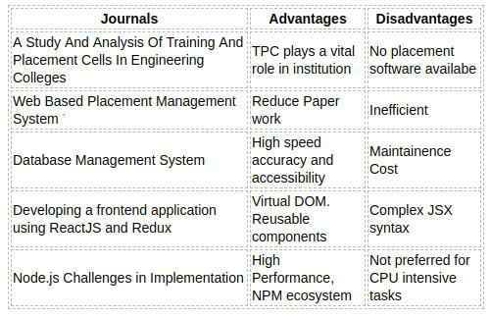

Fig. 3.1: Case Study Analysis

Department of Computer Engineering 8

Chapter 4

PROPOSED SYSTEM

4.1 Solution

The aim is to develop a web application with advanced features. The main purpose is to automate the routine tasks so that the time consumed is reduced. The main functions are as follows:

* Student’s information is maintained in the database so that the data will be organized and, can be accessed from anywhere.
* Gives more security to data, ensures data accuracy.
* Reduces paper work and save a lot of time.
* Since the registration for the recruitment process is not shared as a whole, only eligible students get a chance. Hence a need for second filtering can be avoided.
* Since the data is stored in a database, the chance of data duplication is probably less.
* The system will be cost effective.

4.2 Feasibility Study

The main objective of this study is to determine whether the proposed system is feasible or not. Mainly there are three types of feasibility study to which the proposed system is subjected as described below:

Five key considerations are involved in this feasibility

9

College of Engineering, Cherthala CHAPTER 4. PROPOSED SYSTEM

* Technical Feasibility
* Social Feasibility
* Schedule Feasibility
* Operational Feasibility
* Economic Feasibility

The proposed system must be evaluated from a technical viewpoint first, and if technically feasible, their impact on the organization must be assessed. If compatible, the operational system can be devised. Then those must be tested for economic feasibility.

4.2.1 Technical Feasibility

The technologies required for the development is identified. Since, both the hardware and software requirements are satisfied, it is technically feasible.

4.2.2 Social Feasibility

The proposed project will be socially feasible. The social feasibility determines whether the project would be accepted by the people. This assumption would in general examine the probability that the project would have to be accepted by the group of people that are directly affected by the proposed system

4.2.3 Schedule Feasibility

The primary analysis depicts that the project can be completed by the schedule. Thus the project is feasible.

4.2.4 Operational Feasibility

The proposed project is beneficial because it helps in making faster and reliable decisions. So, users will be encouraged to use it, and it is expected to serve the user’s need, which means helping the user in making decisions.

Department of Computer Engineering 10

College of Engineering, Cherthala CHAPTER 4. PROPOSED SYSTEM

4.2.5 Economic Feasibility

The system will be developed at reasonable cost with the available hardware, software and manpower. So, its benefits overweigh the cost. So, it is economically feasible.

Department of Computer Engineering 11

Chapter 5

SOFTWARE REQUIREMENT SPECIFICATION

5.1 Overall Description

The purpose of this document is to present a detailed description of Smart Placement Cell. It will explain the purpose and features of the system, the interfaces of the system, what the system will do, the constraints under which it must operate and how the system will react to external stimuli. It aims at digitizing the activities of Placement Cell. It provides a space to display a student’s profile. An efficient system for alumni data management. Admins can manage the student database.

5.1.1 Product Perspective

This project aims to develop a web app to manage the placement cell activities within the College. It allows the admins to store, update and manage the student database. It allows the student to get updated with their training and placement activities.

5.1.2 Product Functions

This project has many functions. They are listed below:

* Student Database Storage and Management: All the student data can stored in well orga-nized manner. Admin has the privilege to manage student database.
* Email Management: Admin can Send emails to students based on the criteria provided by the company.

12

College of Engineering, Cherthala CHAPTER 5. SOFTWARE REQUIREMENT SPECIFICATION

* Forum : Students can submit their queries in the forum and admins can respond to these queries.
* Treasury Management : Admins can keep track of the account details by storing the bills in image format.
* Alumni management: Admins can manage alumni data and send emails to them.

5.2 User Classes and Characteristics

* Students who can update their profile, avail their services and interact with Placement Cell
* Placement Cell executives such as TPO and executive committee members can sort and man-age student databases and send mass emails. They can interact with students and respond to queries

5.2.1 Operating Environment

* Computer with any web browser.
* Smartphone with any Web browser.

5.2.2 Design and Implementation Constraints

* Frontend is developed using React.JS and SASS.
* Backend is developed using Express.Js Framework.
* MongoDB database is used.

5.2.3 Assumptions and Dependencies

* Computer or Smartphone with any browser.
* A good internet connection.

Department of Computer Engineering 13

College of Engineering, Cherthala CHAPTER 5. SOFTWARE REQUIREMENT SPECIFICATION

5.3 External Interface Requirements

5.3.1 User Interfaces

The user interface is in such a way that it can be easily understood by the students and TPC officials. It is made possible by implementing the modular concept in which each module deal with its own functionalities.

UI will me mainly styled using SASS which is a stylesheet language that’s compiled to CSS. It allows you to use variables, nested rules, mixins, functions, and more, all with a fully CSS-compatible syntax. Sass helps keep large stylesheets well-organized and makes it easy to share design within and across projects.

Opening of the application takes the user to landing page.From there the user can login as an administrator or as a student and they will be logged into to the respective dashboard.

5.3.2 Hardware Interfaces

Basic Requirement: The primary requirement is a smartphone or a computer. The smart phone or the computer must have a stable internet connection to enable the smooth working of the application.

5.3.3 Software Interfaces

The web app opened in a browser is connected to MongoDB database. The data to be stored includes information about students and alumni.

5.3.4 Communications Interfaces

An MongoDB server is used for storing the data. The web app communicates with Mon-goDB server using API.

Department of Computer Engineering 14

College of Engineering, Cherthala CHAPTER 5. SOFTWARE REQUIREMENT SPECIFICATION

5.4 System Features

5.4.1 Student User Module

Description and Priority

A student can manage his/her details in the profile and also receive valuable information about placement activities.

Stimulus/Response Sequences

Students can login into their profile with respective email and password. The User ID and password will be validated. After successful validation, the user gains access to his/her profile. After login student can update his/her profile details.As a response student will get a message saying his/her profile is updated. Student can also ask questions in TPC forum, and this question will be posted in the forum.

Functional Requirements

* User login - the user is able to log into the web application.
* Profile Updation - the user is able to update his/her profile.
* Forum - user is able to write their queries.
* Drive Registration - the user is able to register/unregister the available drive

5.4.2 Admin User Module

Description and Priority

An admin can login to the respective profile and manage the student database. Admin can also send emails to student based on the certain criteria. It acts as a super user to the system

Department of Computer Engineering 15

College of Engineering, Cherthala CHAPTER 5. SOFTWARE REQUIREMENT SPECIFICATION

Stimulus/Response Sequences

Admin tries to login into their profile with respective email and password. The User ID and password is validated. After successful validation, the user gains access to his/her profile. Admin can send mass emails to students based on the company requirements and these emails will be received by students. Admin can view and respond to the questions posted by students in the forum and the response will be posted in the forum.

Functional Requirements

* User login - the user is able to log into the web application.
* Database Management - the user is able to manage the student and alumni database.
* Forum - user is able to provide response to queries.
* Bill Management - The web app must have a feature to store official bills of the placement cell.
* Drive management - the user is to add or remove the various placement opportunities
* Update Execom & student password - the user is able to update the student and execom details
* View Student Details- the user can view the updated student profile
* View Placement details - The user can view the placement details of each batch

5.4.3 Execom User Module

Description and Priority

An execom can login to the respective profile and manage the student database. Admin can also send emails to student based on the certain criteria.

Department of Computer Engineering 16

College of Engineering, Cherthala CHAPTER 5. SOFTWARE REQUIREMENT SPECIFICATION

Stimulus/Response Sequences

Execom tries to login into their profile with respective email and password. The User ID and password is validated. After successful validation, the user gains access to his/her profile. Admin can send mass emails to students based on the company requirements and these emails will be received by students. Admin can view and respond to the questions posted by students in the forum and the response will be posted in the forum.

Functional Requirements

* User login - the user is able to log into the web application.
* Forum - user is able to provide response to queries.
* Bill Management - The web app must have a feature to store official bills of the placement cell.
* - Update Execom password - the user is able to update the execom details.

5.5 Other Nonfunctional Requirements

Performance Requirements

This web application requires a decent web browser preferably Google Chrome or Mozilla Firefox.

5.5.1 Security Requirements

Since these apps store the information in the remote server, data won’t be lost if the client crashes. Also the app will be regularly updated for fixing bugs and adding new features. In case of problems the user can contact the app support team for any help.

5.5.2 Software Quality Attributes

Smart Placement Cell System provides a simple and easy to use UI. Users can access the web application from anywhere and anytime using a web browser.

Department of Computer Engineering 17

Chapter 6

SYSTEM DESIGNS

6.1 Design

Design of the system includes mainly two steps:

* System Design
* Detailed Design

In System design a structural framework for the entire system is created. It is done in such a way that related part come under particular groups. Thus after the system design, a network of different groups is obtained. It is the high-level strategy for solving the problem and building a solution. It includes the decision about the organization of the system into subsystems, the allocation of subsystems to hardware and software components, and major conceptual and policy decisions that form the framework for the detailed design.

In detailed design, each group is studied in detail and the internal operations are decided. Based on this, the data structures and the programming language to be used are decided. Apart from detailed design, the system design can be grouped into physical design and structural design. The physical design maps out the details of the physical system and plans the system implementation and specifies the hardware and software requirements.

Structured design is an attempt to minimize the complexity and make a problem manageable by subdividing into smaller segments, which is called modularization or decomposition. In this way structuring minimizes intuitive reasoning and promotes maintainable provable of systems.The structured design partitions a program into small, independent modules. They are arranged in a

18

College of Engineering, Cherthala CHAPTER 6. SYSTEM DESIGNS

hierarchy that approximates a model of the business are and is organized in a top-down manner. Logical design proceeds in a top-down manner. General features, such as reports and inputs are identified first. Then each is studied individually and in more detail. Hence the structured design is an attempt to minimize the complexity and make a problem.

6.2 ARCHITECTURE DIAGRAM

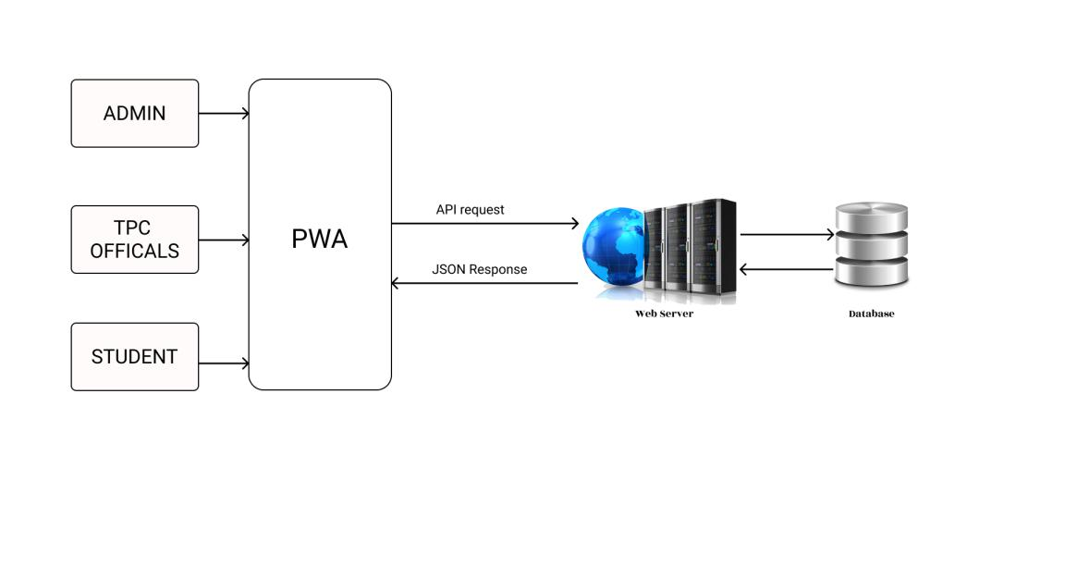

Fig. 6.1: Architectural diagram

Main components of System Architecture are :

* Static CDN : A content delivery network (CDN) refers to a geographically distributed group of servers which work together to provide fast delivery of Internet content. The Static CDN gives hydarted React.js and static styles to client as per request from the client. Static CDN used is ”Netlify”.
* Client : Client-side rendering. Uses API for dynamic data. Client request for static pages or styles, which is stored in the static CDN. API requests are made to the server and gets JSON data(JavaScript Object Notation) in return from the server. For front-end java script library, React.js is used

Department of Computer Engineering 19

College of Engineering, Cherthala CHAPTER 6. SYSTEM DESIGNS

* Server : Hosted in any of the cloud providers like AWS, Azure, etc. Searches for contents requested by the client, in the database, which is MongoDB, and returns data to client. Node.js is used for back-end.
* Database(MongoDB) : Hosted in Mongo Atlas. Provides data to the server as per the requests.

6.3 MODULES

6.3.1 LOGIN

Client side

Input : Username & Password

Output : Success message

1. start
2. Takes username & password from the user.
3. Send this data to the server using API Request (JSON).
4. If an error occurred, display the error.
5. If success, display the success message.
6. Stop

Server Side

Input : JSON Request (username & password)

Output : Success message

1. Start
2. Extract username password from JSON Request.
3. Validate the user data.

Department of Computer Engineering 20

College of Engineering, Cherthala CHAPTER 6. SYSTEM DESIGNS

1. If user does not exist, send back 404 not found error.
2. If a user exists, check if the password matches.
   1. If yes, send back 200 response.
   2. If no, send back 400 Bad request.
3. If any other error occurred, respond back with a 500 Internal server error.
4. Stop

6.3.2 Edit Student Profile

Client side

Input : Student data

Output : Success message

1. start
2. Takes data from the Students.
3. Send this data to the server using API Request (JSON).
4. If an error occurred, display the error.
5. If success, display the success message.
6. Stop

Server Side

Input : JSON Request (student data)

Output : Success message

1. Start
2. Extract student data from JSON Request.

Department of Computer Engineering 21

College of Engineering, Cherthala CHAPTER 6. SYSTEM DESIGNS

1. Validate the user data.
   1. If valid, Update Student values in database and 201 success message.
   2. If no, send back 400 Bad request.

.

4. Stop

6.3.3 View Placement Details

Client side

Input : student id

Output : Placement details

1. start
2. Send student data to server using API Request (JSON).
3. If an error occurred, display the error.
4. If success, display the drive details obtained in the API response.
5. Stop

Server Side

Input : JSON Request (student id)

Output : JSON data(placement Details )

1. Start
2. Extract student data from JSON Request.
3. Retrieve student details from database.
4. Retrieve Valid Drive details if any using student details.

Department of Computer Engineering 22

College of Engineering, Cherthala CHAPTER 6. SYSTEM DESIGNS

* 1. If any drive available, send drive details as JSON response .
  2. If no, send back 400 Bad request.

1. Stop

6.3.4 Register for drive

Client side

Input : student id

Output : Success message

1. start
2. Send student data to server using API Request (JSON).
3. If an error occurred, display the error.
4. If success, display Success message.
5. Stop

Server Side

Input : JSON Request (student id)

Output : Success Message

1. Start
2. Extract student id from JSON Request.
3. Update Student as Registered for drive in database.
4. If an error occurred respond back with a 500 Internal server error.
5. If success, send back 201 as response.
6. Stop

Department of Computer Engineering 23

College of Engineering, Cherthala CHAPTER 6. SYSTEM DESIGNS

6.3.5 Send Message in Chat Forum

Client side

Input : id & Message

Output : Success message

1. start
2. Send data to server using API Request (JSON).
3. If an error occurred, display the error.
4. If success, display Success message.
5. Stop

Server Side

Input : JSON Request ( id & Message)

Output : Success Message

1. Start
2. Extract id & message from JSON Request.
3. Save id and message in database.
4. If an error occurred respond back with a 500 Internal server error.
5. If success, send back 201 as response.
6. Stop

6.3.6 Update Password

Client side

Input : id, old password & new password

Output : Success message

Department of Computer Engineering 24

College of Engineering, Cherthala CHAPTER 6. SYSTEM DESIGNS

1. start
2. Send data to server using API Request (JSON).
3. If an error occurred, display the error.
4. If success, display Success message.
5. Stop

Server Side

Input : JSON Request (id, old password & new password)

Output : Success Message

1. Start
2. Extract id, old password & new password from JSON Request.
3. Retrieve old password from database using id
4. compare both old passwords.
   1. if same, update password in database and respond with 201 success message
   2. if not, send back 400 Bad request.
5. Stop

6.3.7 Send emails to students

Client side

Input : criteria & message

Output : Success message

1. start
2. Send data to server using API Request (JSON).

Department of Computer Engineering 25

College of Engineering, Cherthala CHAPTER 6. SYSTEM DESIGNS

1. If an error occurred, display the error.
2. If success, display Success message.
3. Stop

Server Side

Input : JSON Request (criteria & message)

Output : Success Message

1. Start
2. Retrieve student list using given criteria.
3. Send Emails to students using student list and message
4. Stop

6.3.8 Upload Bill Details

Client side

Input : date, amount & description

Output : Success message

1. start
2. Send this data to the server using API Request (JSON).
3. If an error occurred, display the error.
4. If success, display the success message.
5. Stop

Department of Computer Engineering 26

College of Engineering, Cherthala CHAPTER 6. SYSTEM DESIGNS

Server Side

Input : JSON Request (date, amount & description)

Output : Success message

1. Start
2. Extract date, amount & description from JSON Request.
3. Validate the user data.
   1. If valid, Insert Bill details in database and 201 success message.
   2. If no, send back 400 Bad request.
4. Stop

6.3.9 Create Student Accounts

Client side

Input : csv file with register numbers of student

Output : Success message

1. start
2. Extract data from csv file
3. Send this data to the server using API Request (JSON).
4. If an error occurred, display the error.
5. If success, display the success message.
6. Stop

Department of Computer Engineering 27

College of Engineering, Cherthala CHAPTER 6. SYSTEM DESIGNS

Server Side

Input : JSON Request (Registration number)

Output : Success message

1. Start
2. Extract registration numbers from JSON Request.
3. Validate each registration.
4. for each valid registration number.
   1. If valid, insert registration number to database.
   2. If no, send back 400 Bad request.
5. Stop

6.3.10 Upload Placement Drive Details

Client side

Input : company name, position, salary & description

Output : Success message

1. start
2. Send this data to the server using API Request (JSON).
3. If an error occurred, display the error.
4. If success, display the success message.
5. Stop

Department of Computer Engineering 28

College of Engineering, Cherthala CHAPTER 6. SYSTEM DESIGNS

Server Side

Input : JSON Request ( company name, position, salary & description)

Output : Success message

1. Start
2. Extract company name, position, salary & description from JSON Request
3. Validate the user data
   1. If valid, Insert Placement details in database and 201 success message.
   2. If no, send back 400 Bad request
4. Stop

6.4 USE-CASE DIAGRAM

Use case diagrams model the functionality of a system using actors and use cases. Use cases are a set of actions, services, and functions that the system needs to perform. The below mentioned use case diagram has three actors :

* Admin
* Student
* Execom

Here the Admin can:

* Login
* Admin can view& update student profile
* Admin can respond to the queries
* Admin can manage alumni data

Department of Computer Engineering 29

College of Engineering, Cherthala CHAPTER 6. SYSTEM DESIGNS

* Admin can send e-mail
* Admin can update execom password
* Admin can provide various placement drives
* Admin can have bill management

Here the Student can:

* Login
* Student can view& update their profile
* Student can view Chat in forum
* Student can view& register for drive

Here the Execom can:

* Login
* Execom can view& update student profile
* Execom can respond to the queries
* Execom can send e-mail
* Execom can update password
* Execom can have bill management

Department of Computer Engineering 30

College of Engineering, Cherthala CHAPTER 6. SYSTEM DESIGNS

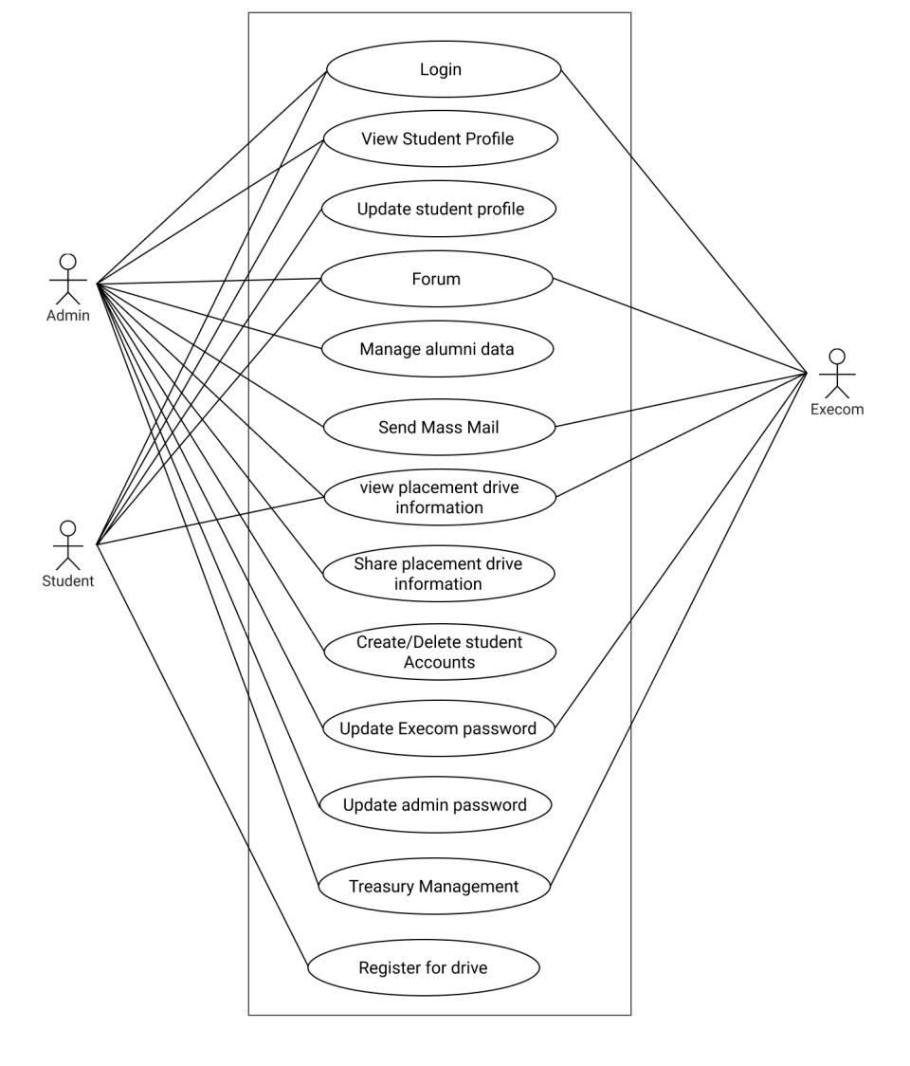

Fig. 6.2: Use Case diagram

Department of Computer Engineering 31

College of Engineering, Cherthala CHAPTER 6. SYSTEM DESIGNS

6.5 SEQUENCE DIAGRAM

A Sequence diagram simply depicts interaction between objects in a sequential order i.e. the order in which these operations take place.

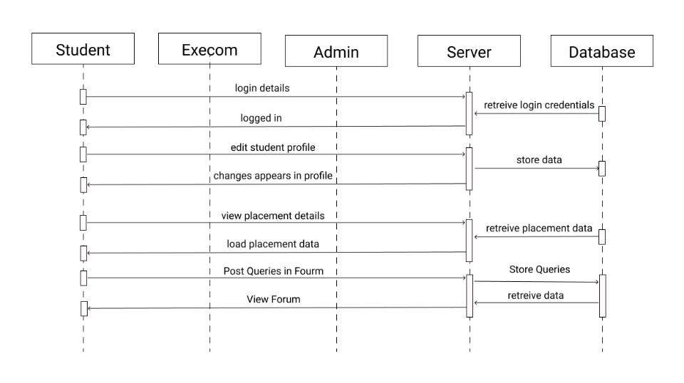

Fig. 6.3: Student Sequence diagram

Department of Computer Engineering 32

College of Engineering, Cherthala CHAPTER 6. SYSTEM DESIGNS

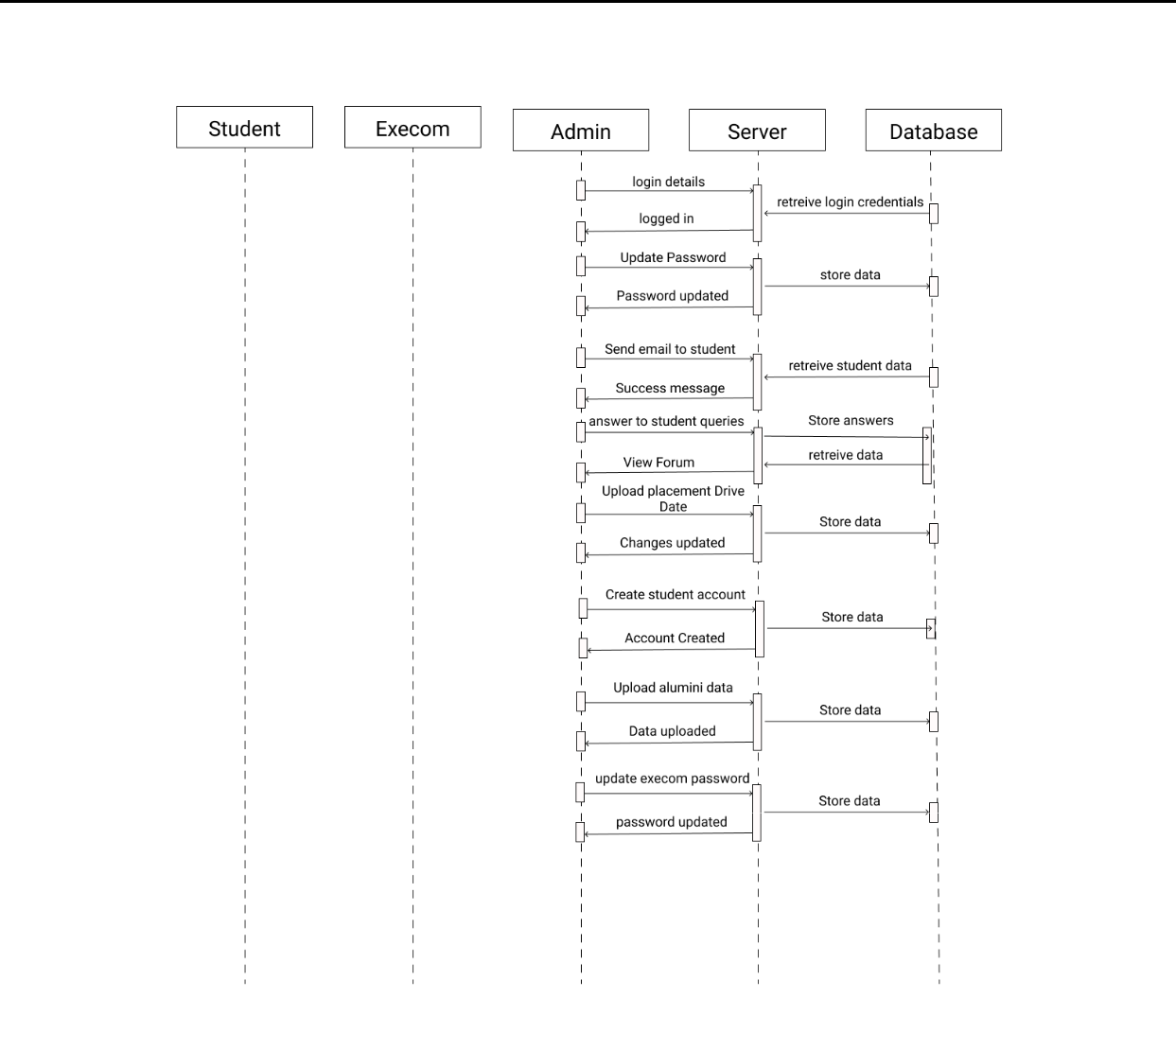

Fig. 6.4: Admin Sequence diagram

The ER or (Entity Relational Model) is a high-level conceptual data model diagram. Entity-Relation model is based on the notion of real-world entities and the relationship between them.

Department of Computer Engineering 33

College of Engineering, Cherthala CHAPTER 6. SYSTEM DESIGNS

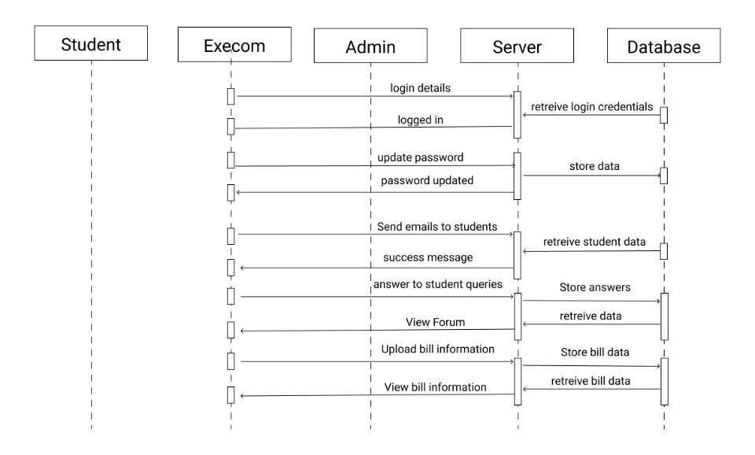

Fig. 6.5: Execom Sequence diagram

6.6 Data Flow Diagram

The data flow diagram (DFD) is used for classifying system requirements to major transfor-

mation that will become programs in system design. This is starting point of the design phase that

functionally decomposes the required specifications down to the lower level of details

Bubbles: Represent the data transformations.

Lines: Represent the logic flow of data.

Data can trigger events and can be processed to useful information. Systems analysis recognizes the central goal of data in organizations.

Description

* Process: Describes how each input data is converted to output data
* Data Store: Describes the repositories of data in a system.
* Data Flow: Describes the data flowing between process, Data stores and entities.
* Source: An external entity causing the origin of data

Department of Computer Engineering 34

College of Engineering, Cherthala CHAPTER 6. SYSTEM DESIGNS

• Sink: An external entity, which consumes the data

6.6.1 Level 0

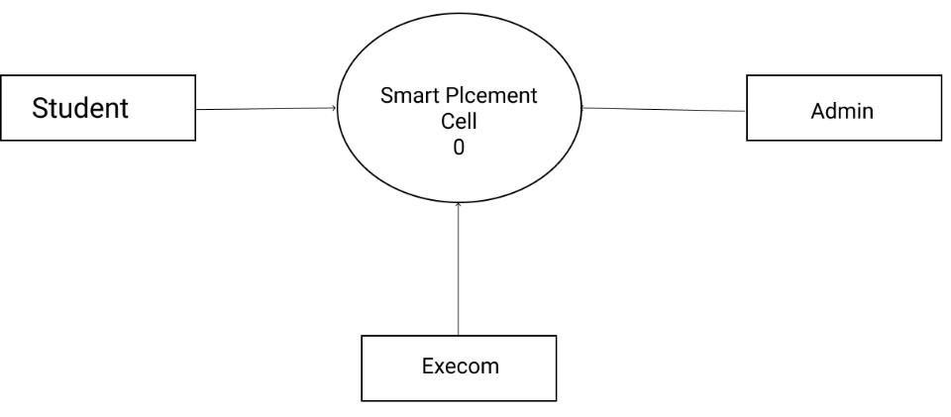

Fig. 6.6: Level 0 DFD of Smart Placement Cell 0

Department of Computer Engineering 35

College of Engineering, Cherthala CHAPTER 6. SYSTEM DESIGNS

6.6.2 Level 1(Admin)

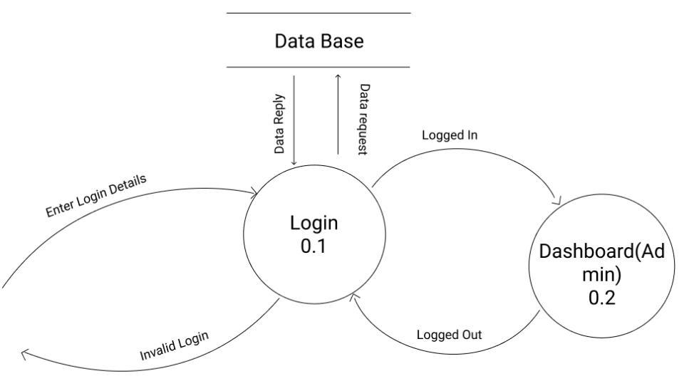

Fig. 6.7: Level 1 DFD of Admin 0.1

Department of Computer Engineering 36

College of Engineering, Cherthala CHAPTER 6. SYSTEM DESIGNS

6.6.3 Level 2 (Admin)

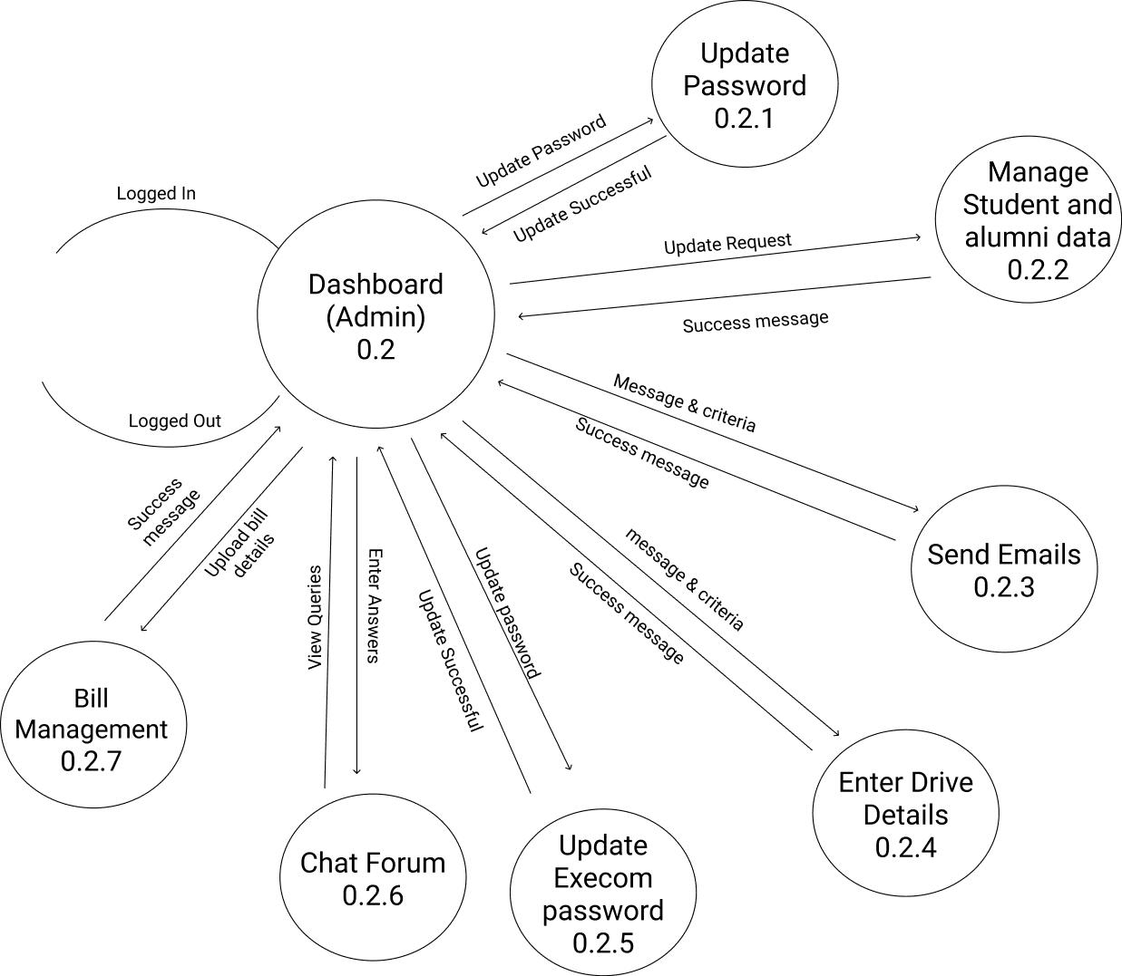

Fig. 6.8: Level 2 DFD of Admin 0.2

Department of Computer Engineering 37

College of Engineering, Cherthala CHAPTER 6. SYSTEM DESIGNS

6.6.4 Level 3(Admin)

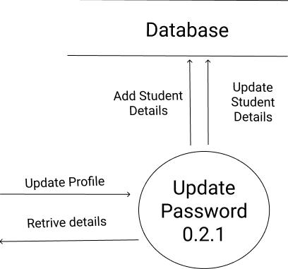

Fig. 6.9: Level 3 DFD of Admin 0.2.1

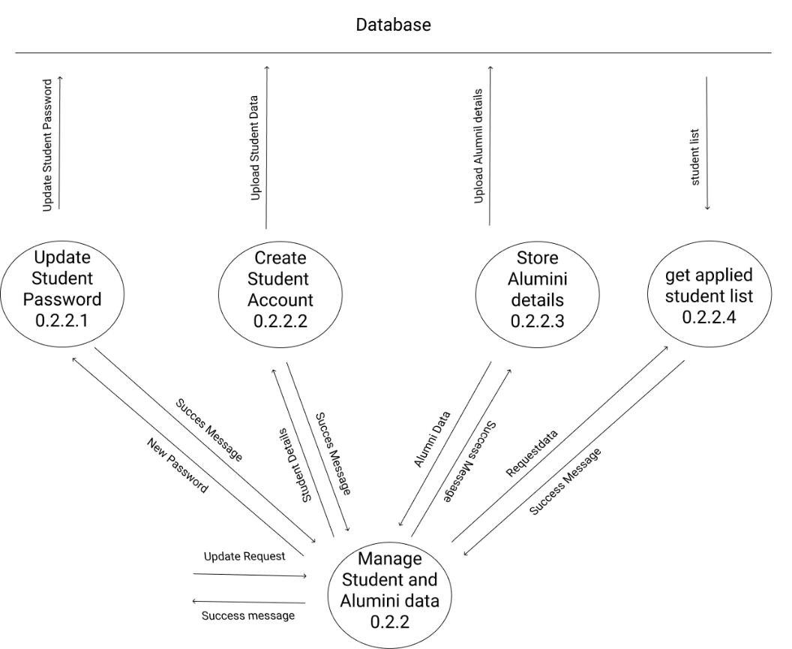

Fig. 6.10: Level 3 DFD of Admin 0.2.2

Department of Computer Engineering 38

College of Engineering, Cherthala CHAPTER 6. SYSTEM DESIGNS

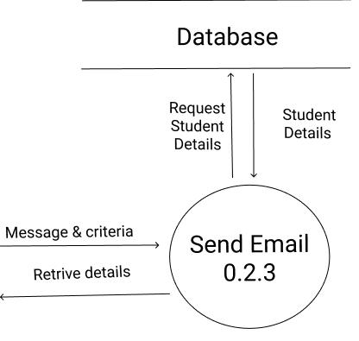

Fig. 6.11: Level 3 DFD of Admin 0.2.3

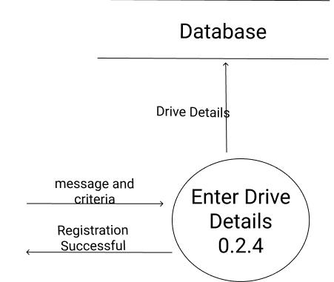

Fig. 6.12: Level 3 DFD of Admin 0.2.4

Department of Computer Engineering 39

College of Engineering, Cherthala CHAPTER 6. SYSTEM DESIGNS

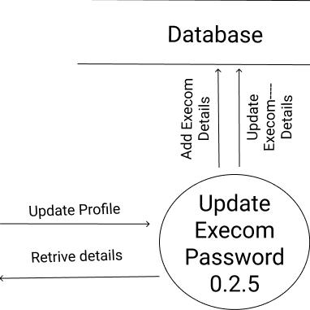

Fig. 6.13: Level 3 DFD of Admin 0.2.5

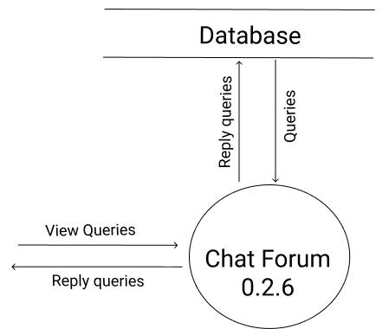

Fig. 6.14: Level3 DFD of Admin 0.2.6

Department of Computer Engineering 40

College of Engineering, Cherthala CHAPTER 6. SYSTEM DESIGNS

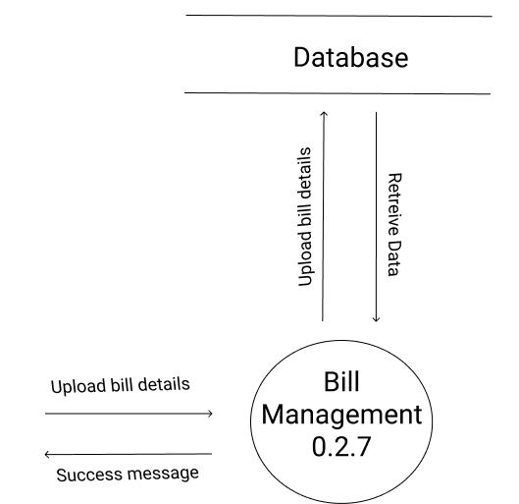

Fig. 6.15: Level 3 DFD of Admin 0.2.7

6.6.5 Level 1(Student)

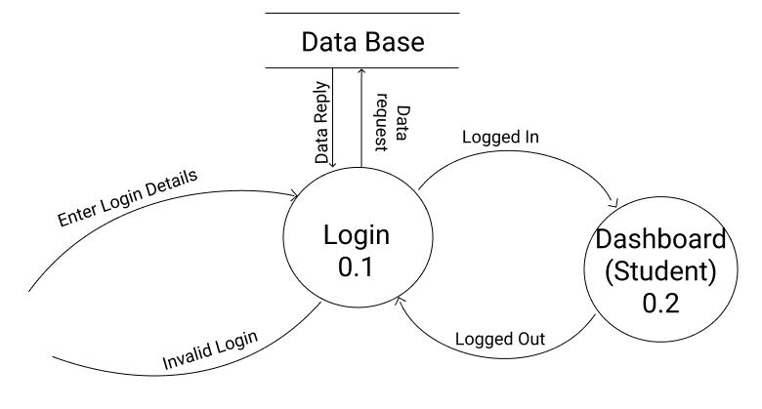

Fig. 6.16: Level 1 DFD of Student 0.1

Department of Computer Engineering 41

College of Engineering, Cherthala CHAPTER 6. SYSTEM DESIGNS

6.6.6 Level 2(Student)

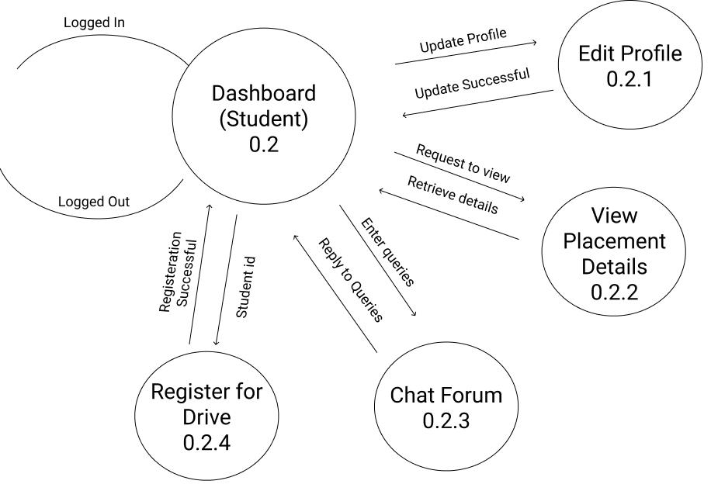

Fig. 6.17: Level 2 DFD of Student 0.2

Department of Computer Engineering 42

College of Engineering, Cherthala CHAPTER 6. SYSTEM DESIGNS

6.6.7 Level 3(Student)

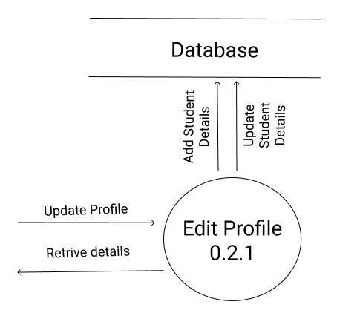

Fig. 6.18: Level 3 DFD of Student 0.2.1

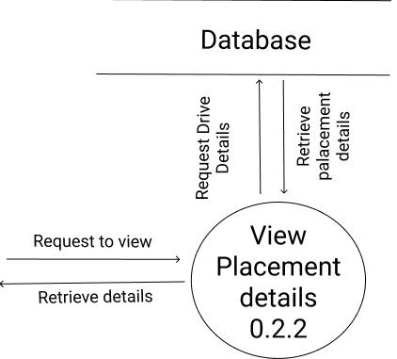

Fig. 6.19: Level 3 DFD of Student 0.2.2

Department of Computer Engineering 43

College of Engineering, Cherthala CHAPTER 6. SYSTEM DESIGNS

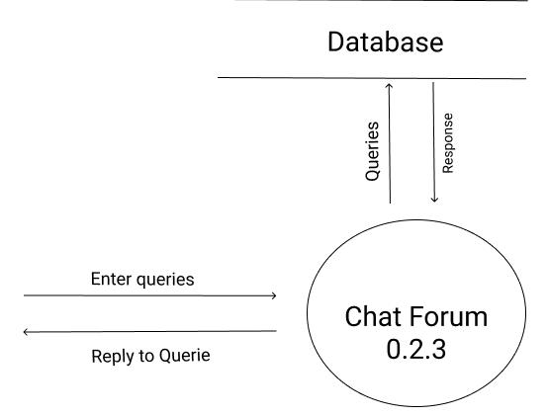

Fig. 6.20: Level 3 DFD of Student 0.2.3

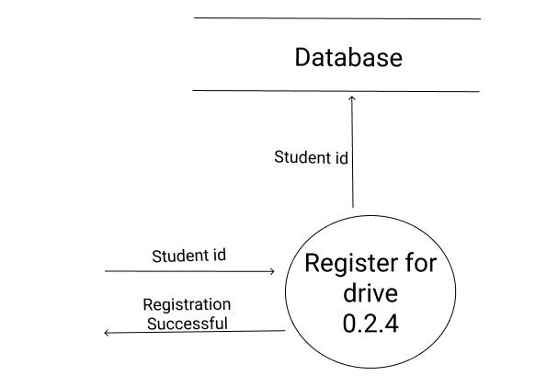

Fig. 6.21: Level 3 DFD of Student 0.2.4

Department of Computer Engineering 44

College of Engineering, Cherthala CHAPTER 6. SYSTEM DESIGNS

6.6.8 Level 1(Execom)

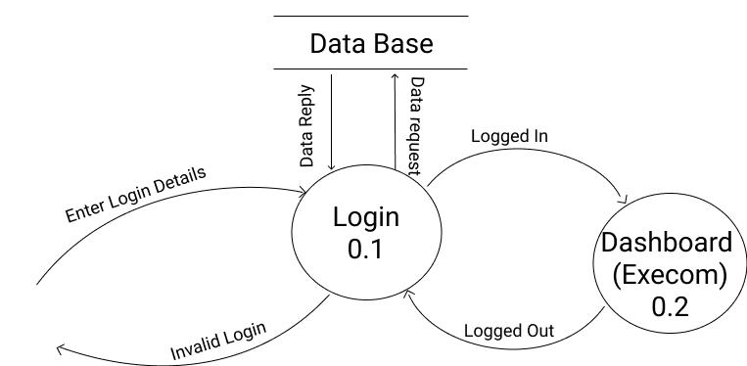

Fig. 6.22: Level 1 DFD of Execom 0.1

6.6.9 Level 2(Execom)

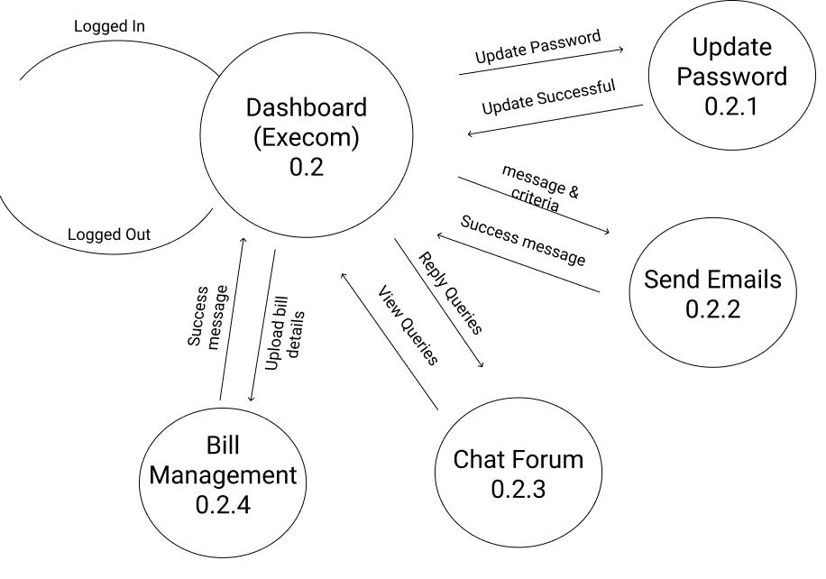

Fig. 6.23: Level 2 DFD of Execom 0.2

Department of Computer Engineering 45

College of Engineering, Cherthala CHAPTER 6. SYSTEM DESIGNS

6.6.10 Level 3(Execom)

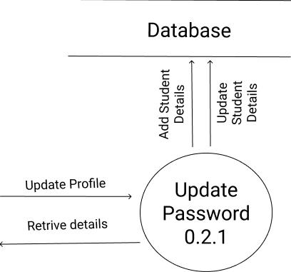

Fig. 6.24: Level 3 DFD of Execom 0.2.1

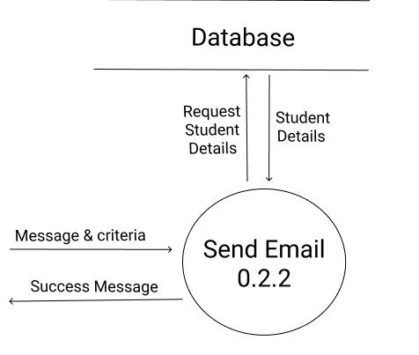

Fig. 6.25: Level 3 DFD of Execom 0.2.2

Department of Computer Engineering 46

College of Engineering, Cherthala CHAPTER 6. SYSTEM DESIGNS

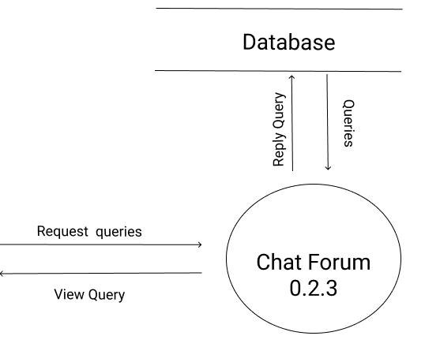

Fig. 6.26: Level 3 DFD of Execom 0.2.3

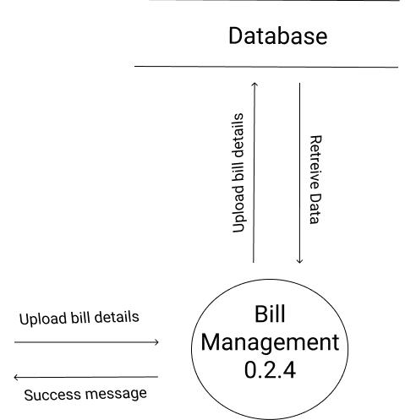

Fig. 6.27: Level 3 DFD of Execom 0.2.4

Department of Computer Engineering 47

Chapter 7

SOFTWARE AND HARDWARE REQUIREMENT

7.1 Software Requirements

* Frontend : ReactJs, Sass
* Server : NodeJS, Express
* Database : Mongo DB
* Web Browser : Chrome or Firefox preferred.

7.2 Hardware Requirements

7.2.1 Computer

* Processor : Pentium 4
* Main memory : Minimum : 2GB

7.2.2 Smartphone

• RAM : 2GB

48

Chapter 8

IMPLEMENTATION

An important aspect of system and analyst’s job is to make sure that the new design im-plemented to establish standards. Implementation involves all these activities that take place to convert from the old system to new. A proper implementation is essential to provide reliable sys-tem to meet the requirements of a new computerized system will improve the efficiency of the entire system and reduce the labours involved.

8.1 Coding Environment Used

Visual Studio Code is a source-code editor developed by Microsoft for Windows, Linux and macOS. It includes support for debugging, embedded Git control, syntax highlighting, intelligent code completion, snippets, and code refactoring. It comes with built-in support for JavaScript, TypeScript and Node.js and has a rich ecosystem of extensions for other languages (such as C++, C, Java, Python, PHP, Go) and runtimes (such as .NET and Unity). It is also customizable, so users can change the editor’s theme, keyboard shortcuts, and preferences. The source code is free and open source and released under the permissive MIT License. The compiled binaries are freeware and free for private or commercial use.

49

College of Engineering, Cherthala CHAPTER 8. IMPLEMENTATION

8.2 Login Module

This allows the user to login into the application. Only a valid user has the permission to use the different facilities provided by the application.

8.2.1 Admin Panel

The Login in page contains text field’s to enter Password of the Admin, also a Login button to login.It stores the password in hashed form and stored as cookies so that the user can directly login when the window is closed without logging out.

8.2.2 Execom Panel

The Login in page contains text field’s to enter Designation and Password of the Execom member, also a Login button to login.It stores the password in hashed form and stored as cookies so that the user can directly login when the window is closed without logging out.

8.2.3 Student Panel

The Login in page contains text field’s to enter Email and Password, generally the password is set as students registration number of the Student, also a Login button to login.It stores the password in hashed form and stored as cookies so that the user can directly login when the window is closed without logging out.

8.3 Create Student Module

This allow users to create the student profile.

8.3.1 Admin Panel

The Page contains text fields to enter student name,email, register number,branch, passing out year and a button to add students to database.The user can also create the students by uploading the .csv file.

Department of Computer Engineering 50

College of Engineering, Cherthala CHAPTER 8. IMPLEMENTATION

8.4 Update Password

This allows the user to update the password in the application.

8.4.1 Admin Panel

The Update password page contains 2 sections i.e for update student and execom password consist of text field’s to enter old,new and confirm Password of the Student or Execom, also a Update button to update.

8.4.2 Execom Panel

The Update password page contains text field’s to enter old,new and confirm Password of the Execom, also a Update button to update.

8.4.3 Student Panel

The Update password page contains text field’s to enter old,new and confirm Password of the Student, also a Update button to update.

8.5 Student Details

List of students in a tabular view.

8.5.1 Admin Panel

The Admin can view the basic details of students of current batch. It will be listed as a table. A ’More Info’ button will be provided for viewing additional details and a ’delete’ button to delete that student from database.

8.6 Download Placement Details

Downloads the placement details of a batch.

Department of Computer Engineering 51

College of Engineering, Cherthala CHAPTER 8. IMPLEMENTATION

8.6.1 Admin Panel

The Admin can download the Placement details of a batch in .csv format. A text field is provided to input the batch number that the admin needs.

8.7 Drive Management

This module helps the user to add or delete drives details which can be viewed by students to register.

8.7.1 Admin Panel

The drive management page consist of a add on button to add new drives .On clicking the add on button a pop up screen is projected to which enables the user to add various details regarding the organisation and the eligibility criteria mentioned by them. Once the Drives are added the admin user have the privilege to delete the drives so as student user can view the currently available drives.

8.7.2 Student Panel

The students are able to view and register for the available drives that matches to their pro-file.It provides 2 button. On clicking the view buttons enables the student o view the organisation details and eligibility criteria. On clicking the Register/Unregister button student can register to drive and successfully registration message is toasted. If the student clicks that button again, it is unregistered.

8.8 Send Mail Module

This module is used to send mass mails to students based on certain criteria.

8.8.1 Admin Panel

The admin is able to send mass emails to students. Emails are sent based on criteria such as B.Tech CGPA, Higher secondary pass percentage, No: of backlogs etc..An additional space is

Department of Computer Engineering 52

College of Engineering, Cherthala CHAPTER 8. IMPLEMENTATION

provided for the admin to add the custom message content i.e. Details regarding the Drive or other information. Once the send mail button on the bottom is clicked, students who meet the specified requirements are filtered out and emails will be sent tho them. Thus the chance for ineligible students to register can be stopped.

8.8.2 Execom Panel

The Execom is able to send mass emails to students. Emails are sent based on criteria such as B.Tech CGPA, Higher secondary pass percentage, No: of backlogs etc..An additional space is provided for the admin to add the custom message content i.e. Details regarding the Drive or other information. Once the send mail button on the bottom is clicked, students who meet the specified requirements are filtered out and emails will be sent tho them. Thus the chance for ineligible students to register can be stopped.

8.9 Forum

Forum refers to a public space where the students can enquire and admins and execom members can respond to their queries. All the queries and their replies will be displayed here. Most recent query will be shown first.

8.9.1 Admin Panel

The Admin is able to send reply to queries from the student panel. After each query, an answer button is seen. Clicking on the button will direct Admin to a text field to enter input for the reply. It has a submit button to send the reply for the queries asked from student panel. Admin can delete queries form the forum thus it wont be showcased in the forum again.

8.9.2 Execom Panel

The Execom is able to send reply to queries from the student panel. After each query, an answer button is seen. Clicking on the button will direct Execom to a text field to enter input for the reply. It has a submit button to send the reply for the queries asked from student panel. Execom can delete queries form the forum thus it wont be showcased in the forum again.

Department of Computer Engineering 53

College of Engineering, Cherthala CHAPTER 8. IMPLEMENTATION

8.9.3 Student Panel

Students can ask drive related queries here. The student has a text field to enter the query.

Admin or Execom will reply to that queries.

8.10 Bill Management

This unit is to create and manage the bills for proper treasury management.

8.10.1 Admin Panel

The Admin is able to view, create and delete bills. A ’+’ icon will be provided on the bottom-right of the window to add a new bill. This A new window popups, where you can enter the Bill name, bill date and bill amount and a short description. After filling the given fields, click ’Add Bill’ button. This will save the bill and it will be previewed in the Bill window as a card. To delete any bills, click on the ’bin’ button on the top-right of the card.

8.10.2 Execom Panel

The Execom is able to view, create and delete bills. A ’+’ icon will be provided on the bottom-right of the window to add a new bill. This A new window popups, where you can enter the Bill name, bill date and bill amount and a short description. After filling the given fields, click ’Add Bill’ button. This will save the bill and it will be previewed in the Bill window as a card. To delete any bills, click on the ’bin’ button on the top-right of the card.

8.11 Alumni Management

This option allows to convert a batch data to alumni and to download the alumni details.

8.11.1 Admin Panel

The Admin is allowed to convert the student data of a specific year to alumni data. Alumni data will be filtered off from student data. Admin is also able to download the alumni details thus converted till date. It will be downloaded in CSV format.

Department of Computer Engineering 54

8.12 Profile

This unit is to update the student profile.

8.12.1 Student Panel

Here, the students will be able to upload his/her personal details like name, gender, DOB and educational details like B.Tech CGPA, No: of backlogs etc and contact details and guardian details. If the student wants to edit it afterwards, an edit profile button is provided below. In addition to that, a space for uploading placement details is also provided which included Placed Company and CTC. These can also be updated as needed.

8.13 Logout

A Logout button is seen on the end of the dashboard.This allows the user to logout back to the login page.

8.13.1 Admin Panel

As the Admin clicks the logout button, a confirmation window popups. After clicking Lo-gout, the admin rerouted to student/execom login page even though Admin panel is in separate route.

8.13.2 Execom Panel

As the Execom clicks the logout button, a confirmation window popups. After clicking Logout, the execom is directed to the login page.

8.13.3 Student Panel

As the Student clicks the log out button, a confirmation window popups. After clicking Logout, the student is directed to the login page.

55

College of Engineering, Cherthala CHAPTER 8. IMPLEMENTATION

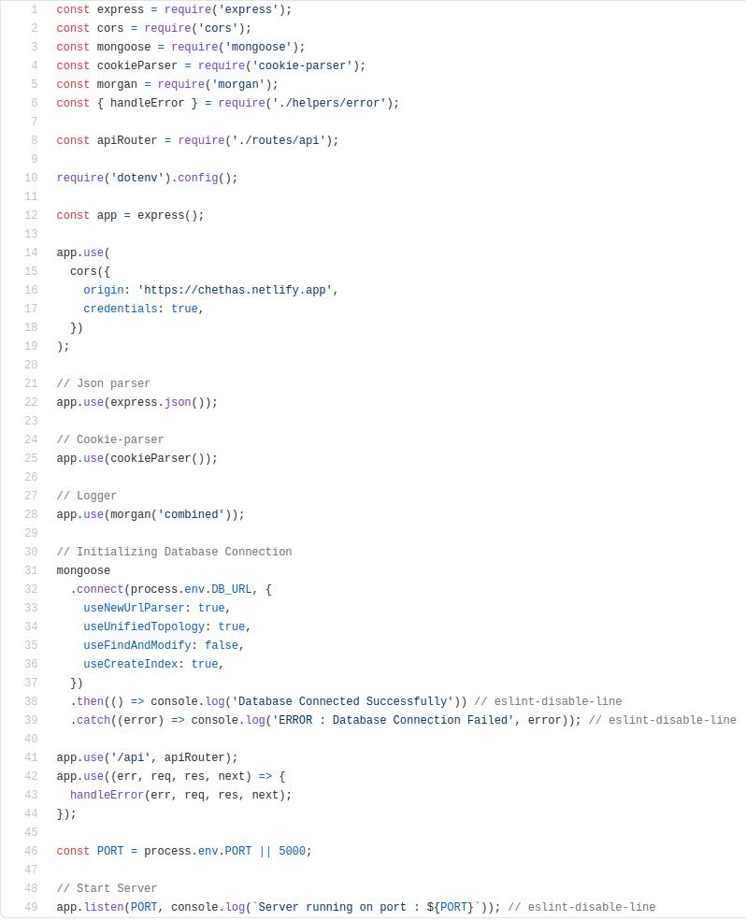

Fig. 8.1: Implementation of server.js file

Department of Computer Engineering 56

College of Engineering, Cherthala CHAPTER 8. IMPLEMENTATION

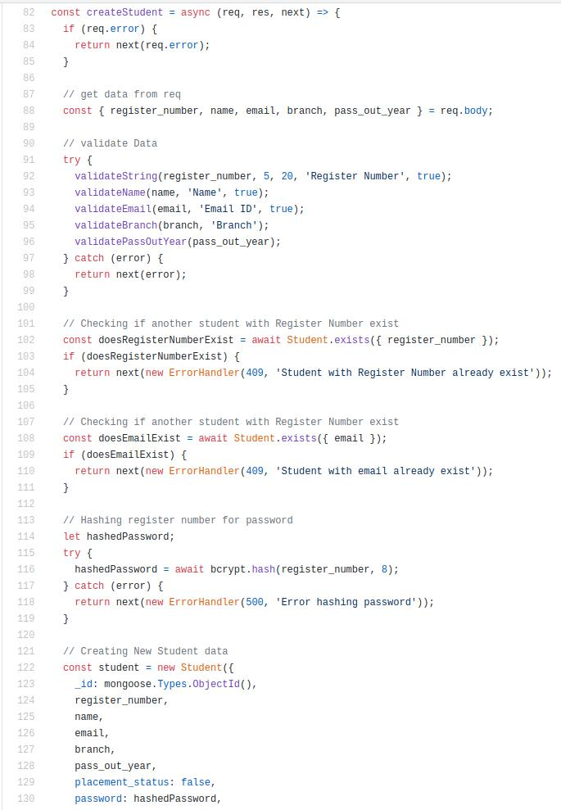

Fig. 8.2: Create student code

Department of Computer Engineering 57

College of Engineering, Cherthala CHAPTER 8. IMPLEMENTATION

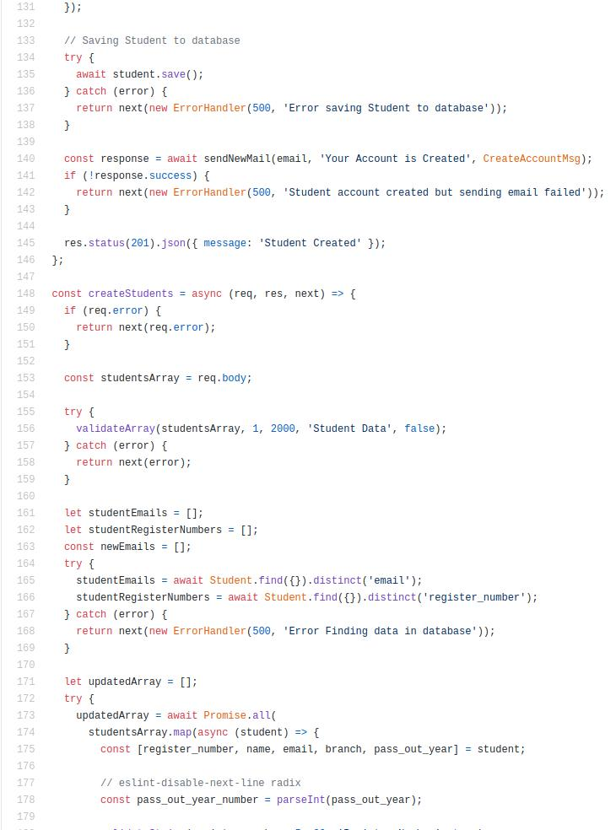

Fig. 8.3: Create student code

Department of Computer Engineering 58

College of Engineering, Cherthala CHAPTER 8. IMPLEMENTATION

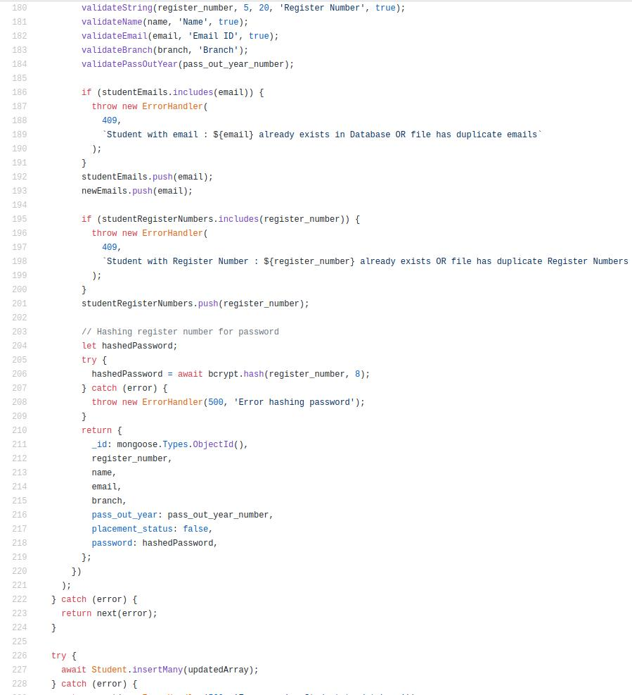

Fig. 8.4: Create student code

Department of Computer Engineering 59

College of Engineering, Cherthala CHAPTER 8. IMPLEMENTATION

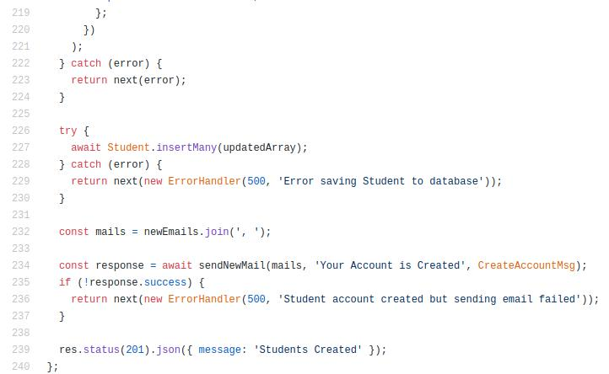

Fig. 8.5: Create student code

Department of Computer Engineering 60

College of Engineering, Cherthala CHAPTER 8. IMPLEMENTATION

Chapter 9

RESULT & ANALYSIS

9.1 Screenshots

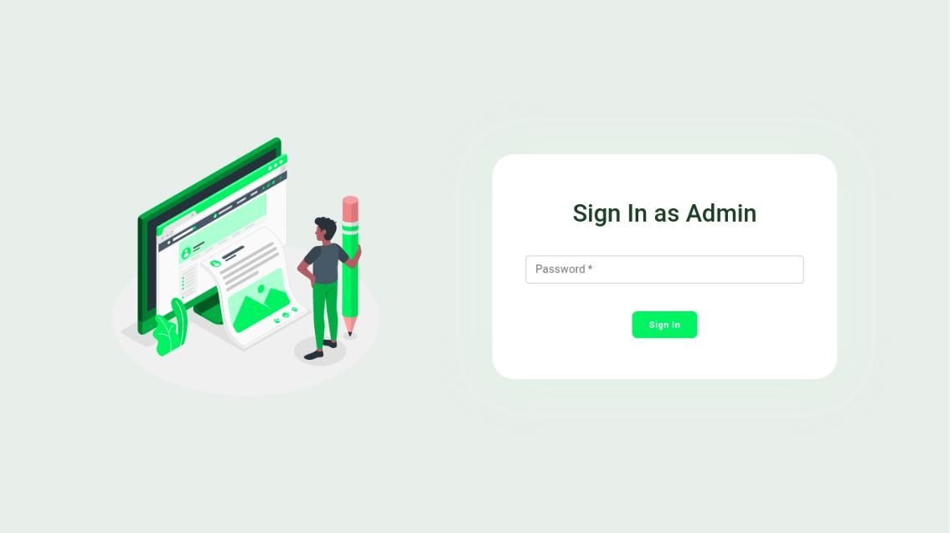

Fig. 9.1: Admin Login Page

Department of Computer Engineering 61

College of Engineering, Cherthala CHAPTER 8. IMPLEMENTATION

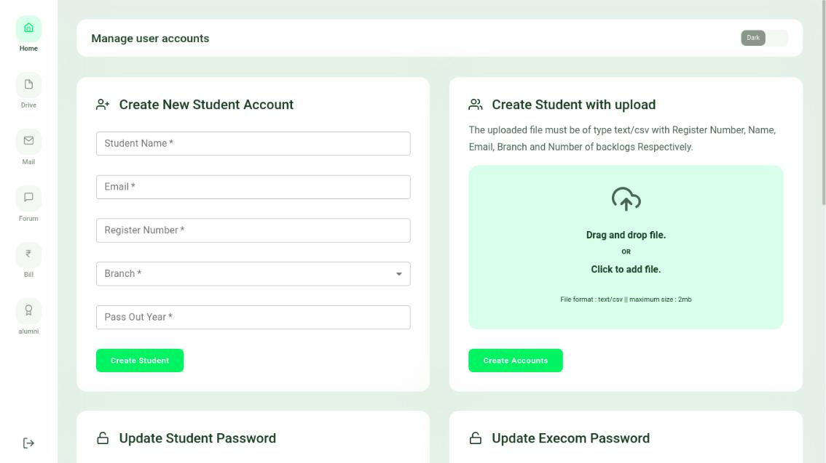

Fig. 9.2: Admin Home Page

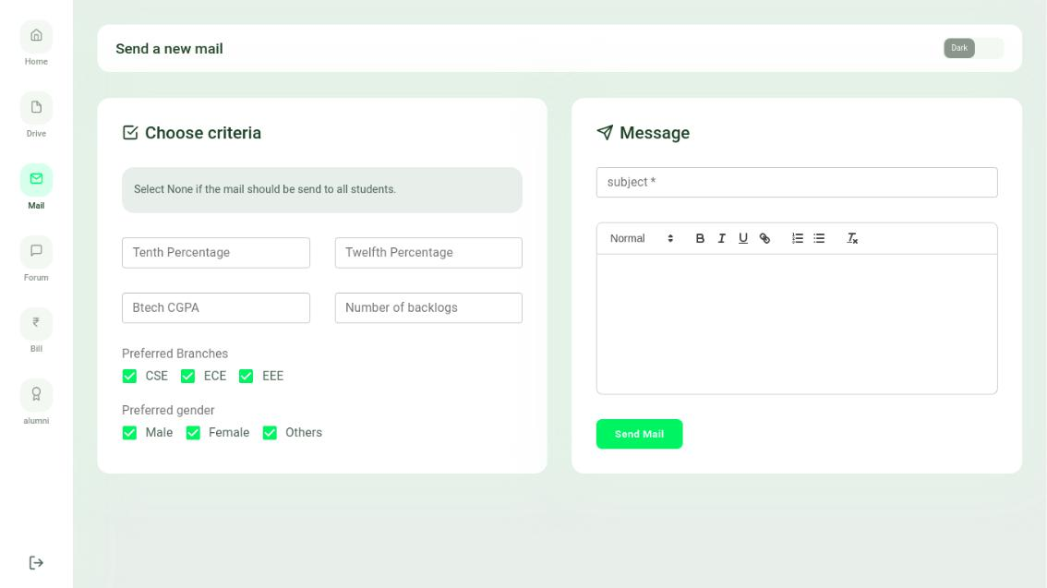

Fig. 9.3: Admin can send email

Department of Computer Engineering 62

College of Engineering, Cherthala CHAPTER 8. IMPLEMENTATION

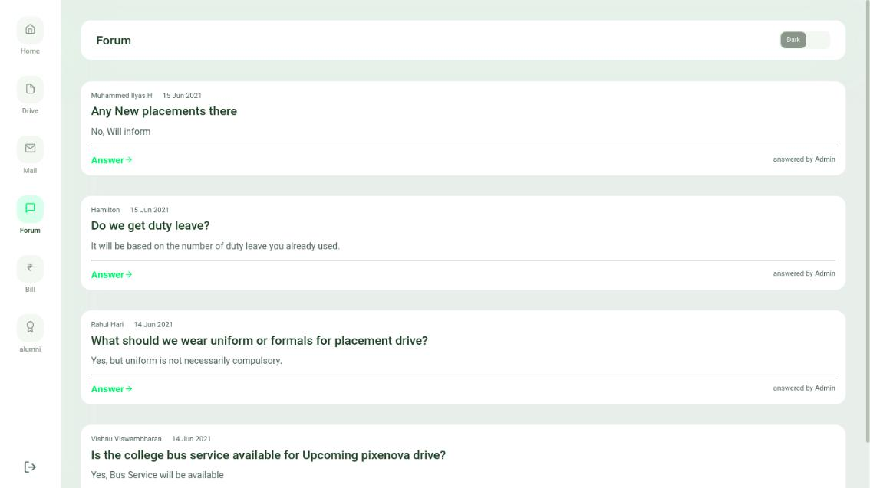

Fig. 9.4: Admin Forum

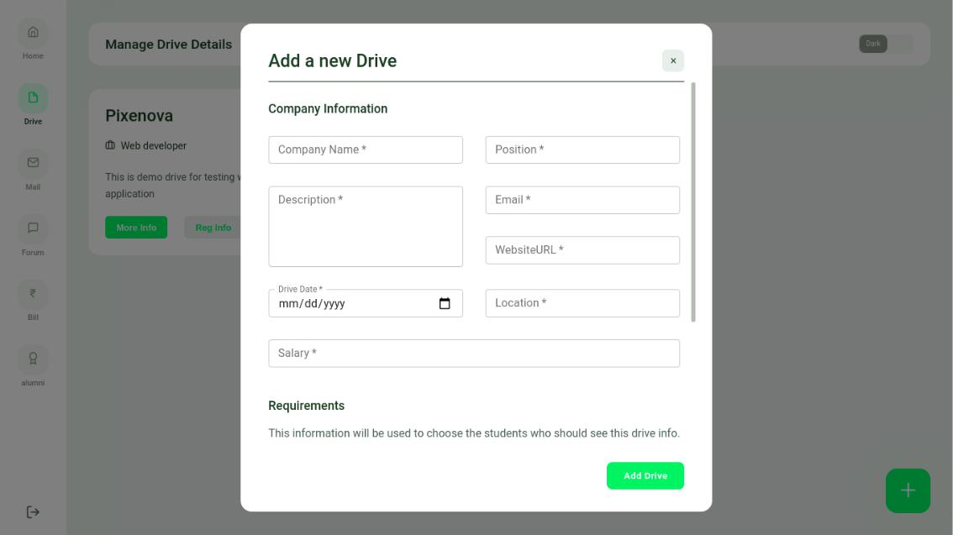

Fig. 9.5: Admin can add drive details

Department of Computer Engineering 63

College of Engineering, Cherthala CHAPTER 8. IMPLEMENTATION

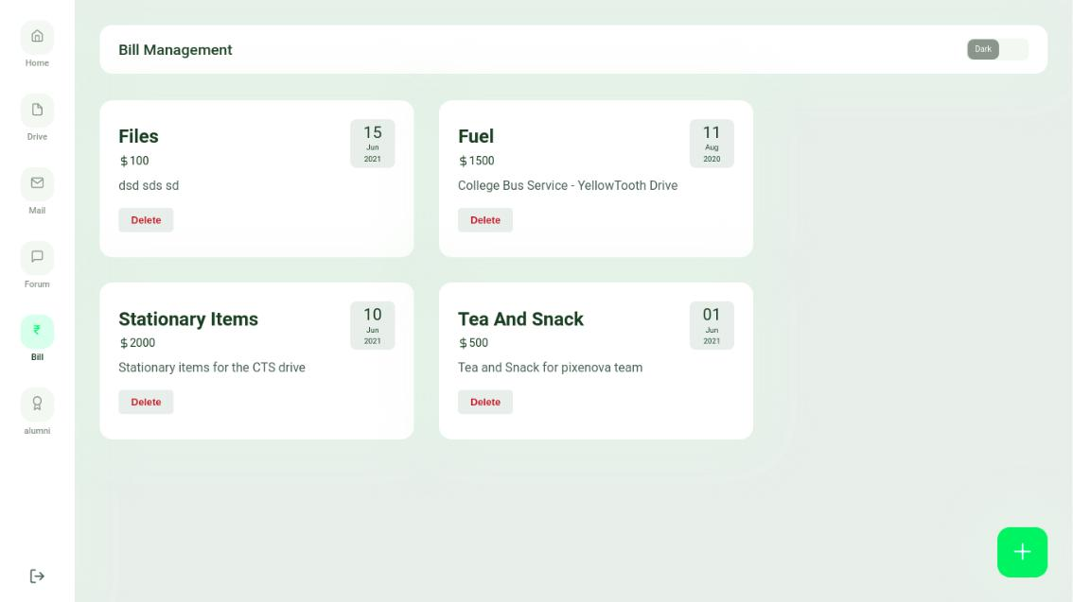

Fig. 9.6: Admin can add bills

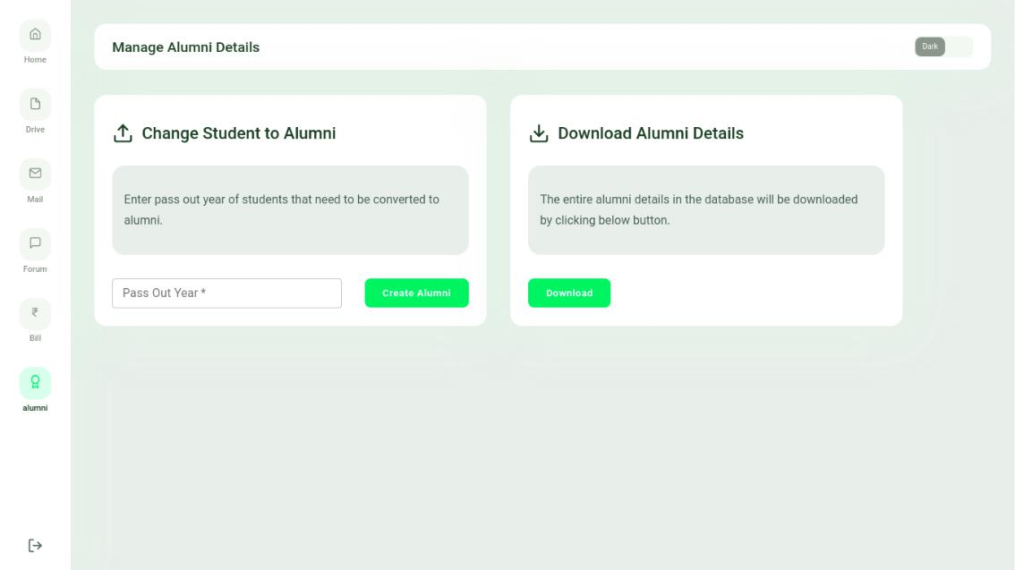

Fig. 9.7: Alumni management

Department of Computer Engineering 64

College of Engineering, Cherthala CHAPTER 8. IMPLEMENTATION

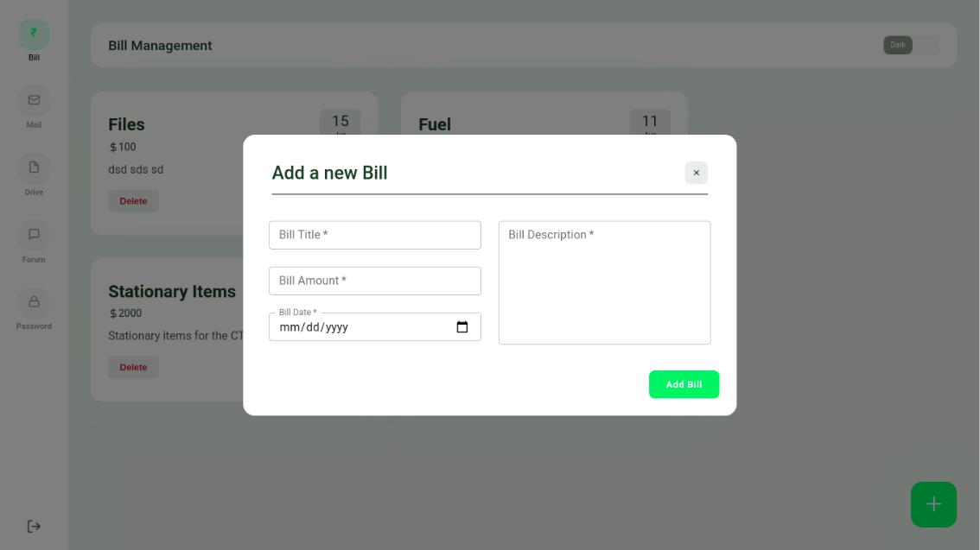

Fig. 9.8: Bill Management by Execom

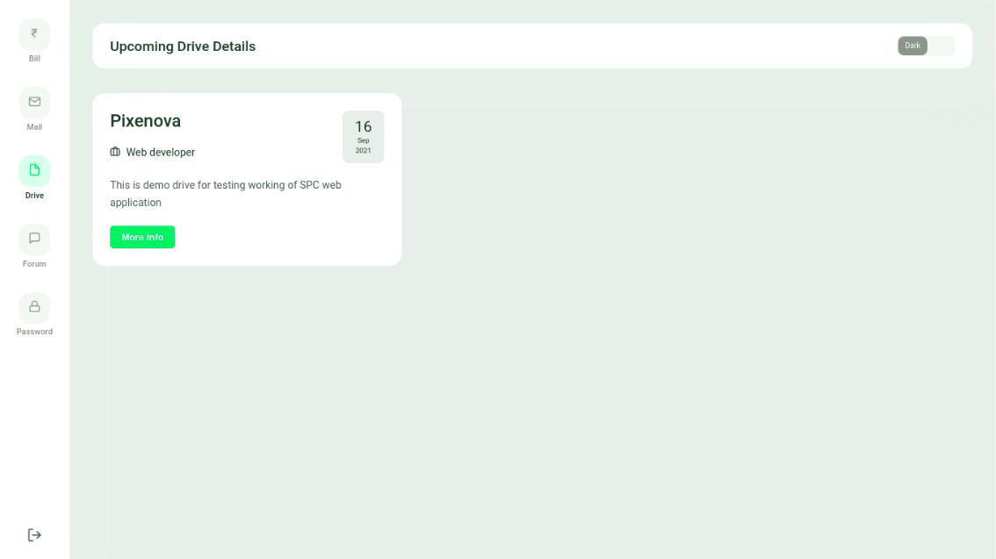

Fig. 9.9: Drive Mangement by Execom

Department of Computer Engineering 65

College of Engineering, Cherthala CHAPTER 8. IMPLEMENTATION

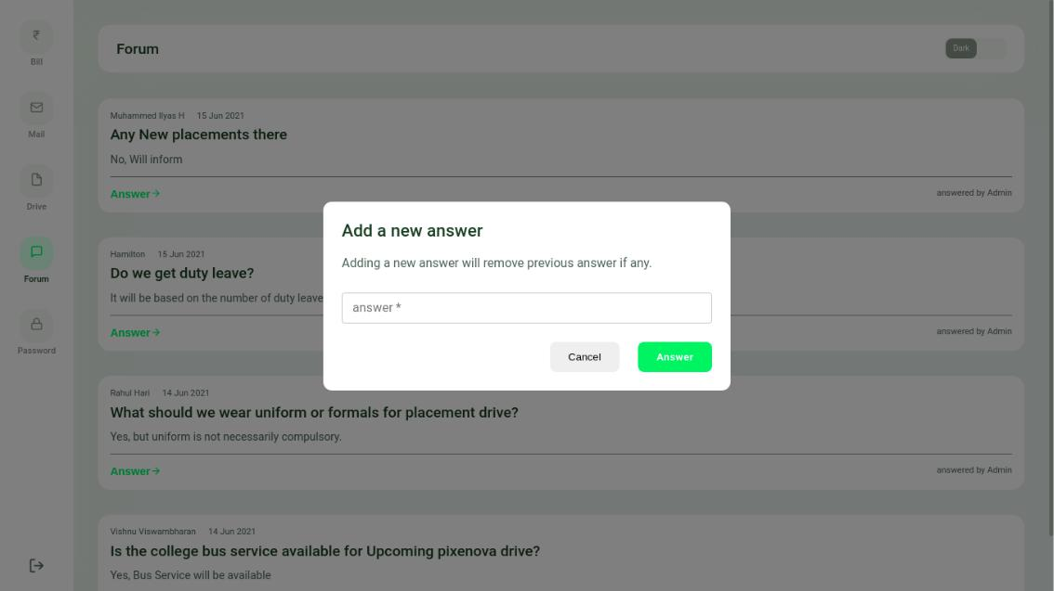

Fig. 9.10: Execom Forum

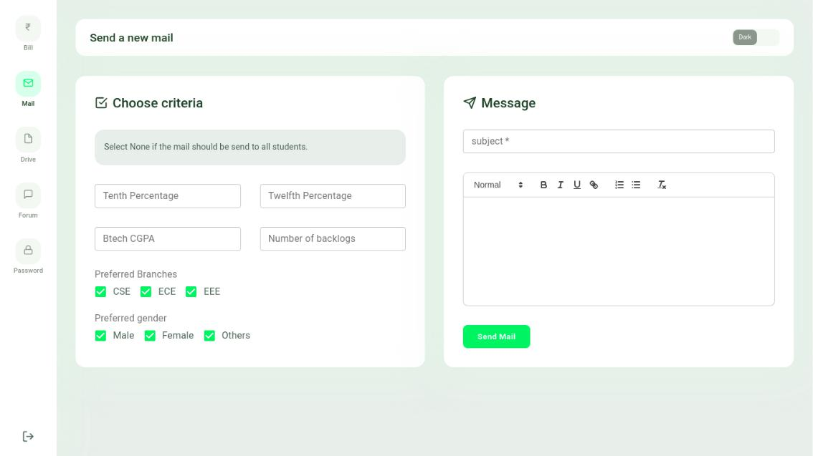

Fig. 9.11: Send Mail By Execom

Department of Computer Engineering 66

College of Engineering, Cherthala CHAPTER 8. IMPLEMENTATION

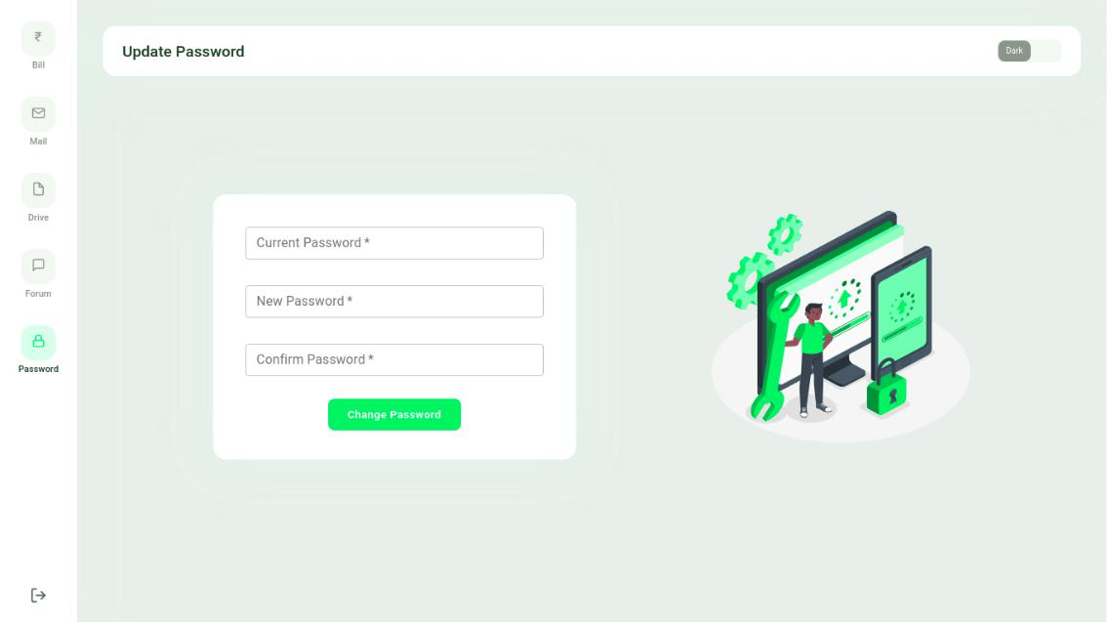

Fig. 9.12: Update execom password

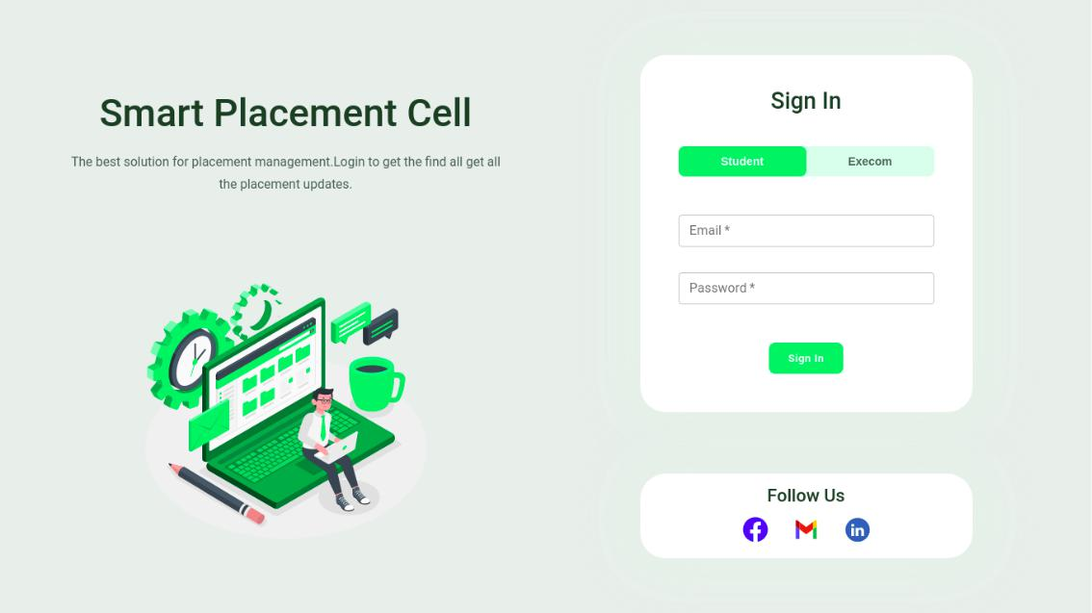

Fig. 9.13: Student/Execom Login

Department of Computer Engineering 67

College of Engineering, Cherthala CHAPTER 8. IMPLEMENTATION

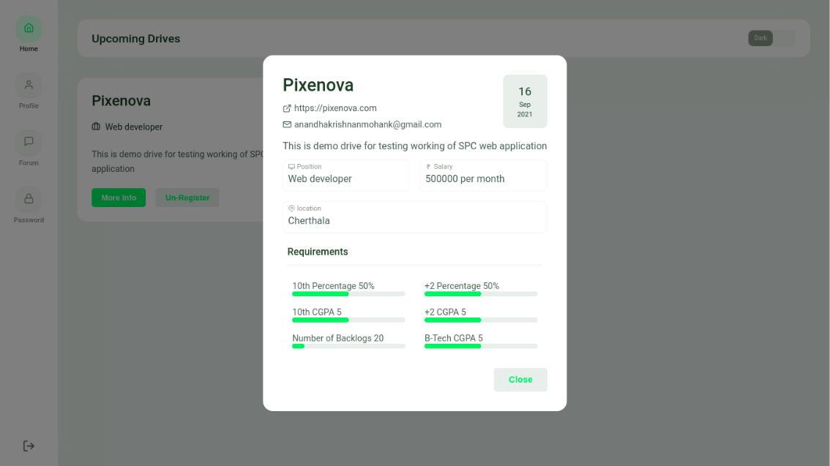

Fig. 9.14: Student register for drive

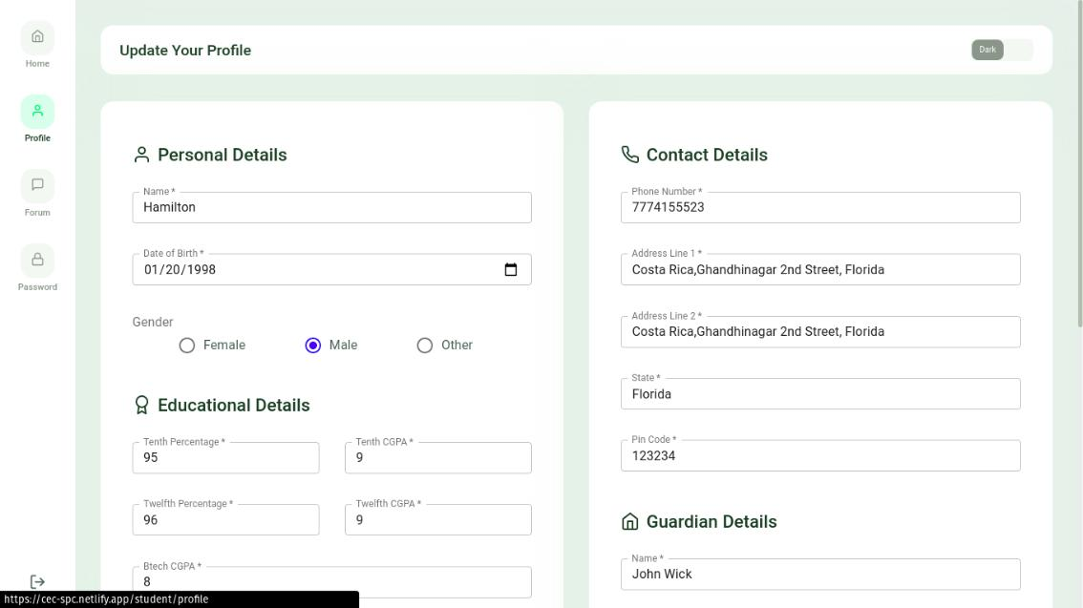

Fig. 9.15: Student Profile

Department of Computer Engineering 68

College of Engineering, Cherthala CHAPTER 8. IMPLEMENTATION

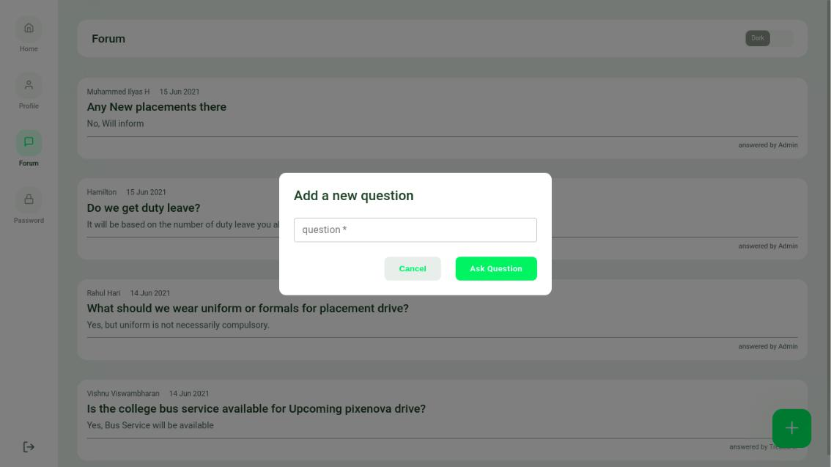

Fig. 9.16: Student Forum

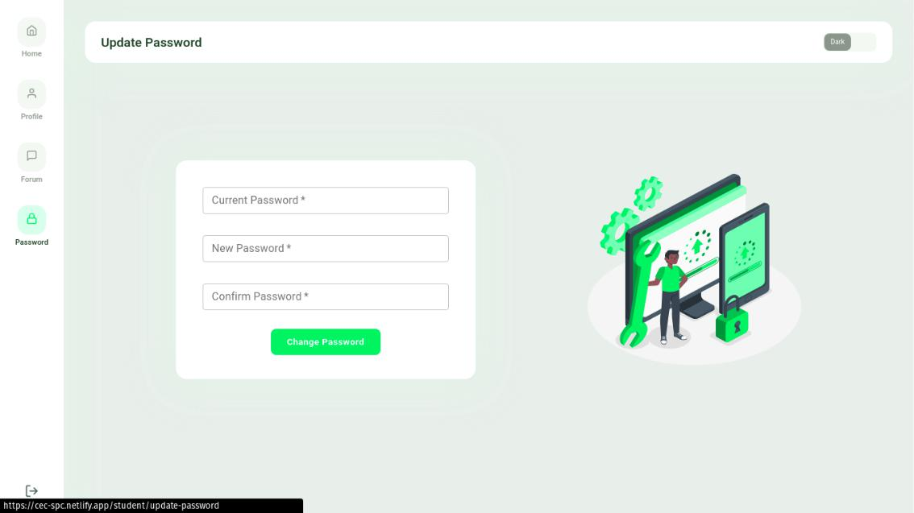

Fig. 9.17: Update student password

Department of Computer Engineering 69

College of Engineering, Cherthala CHAPTER 8. IMPLEMENTATION

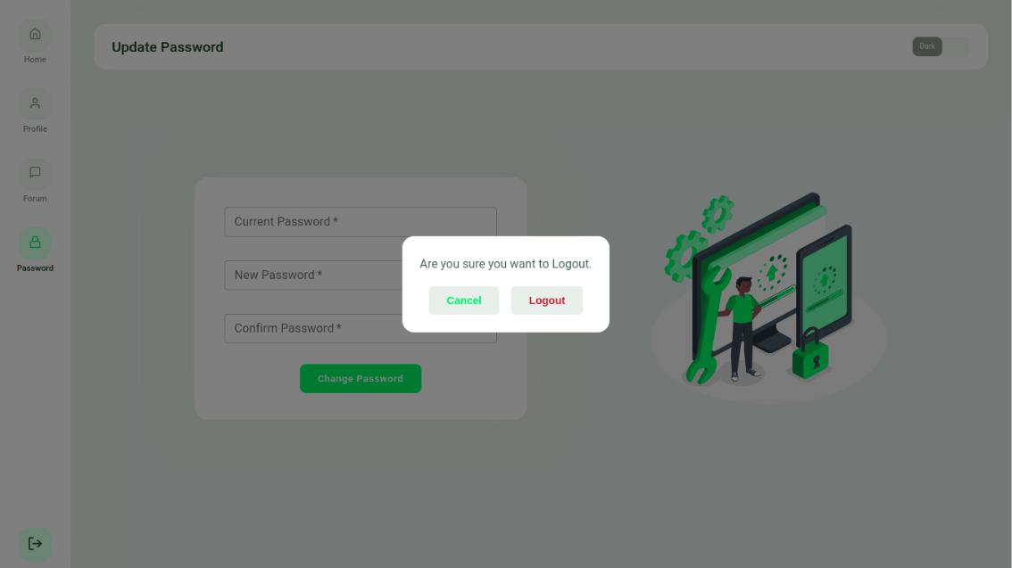

Fig. 9.18: Student logout

Department of Computer Engineering 70

College of Engineering, Cherthala CHAPTER 8. IMPLEMENTATION

9.2 Test Cases

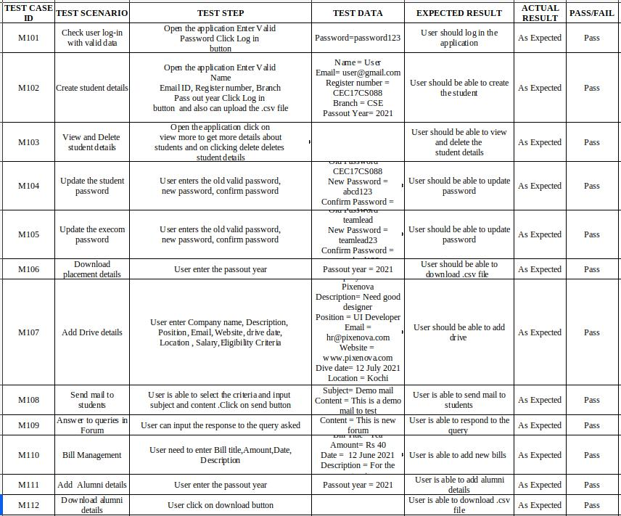

Fig. 9.19: Admin Test cases

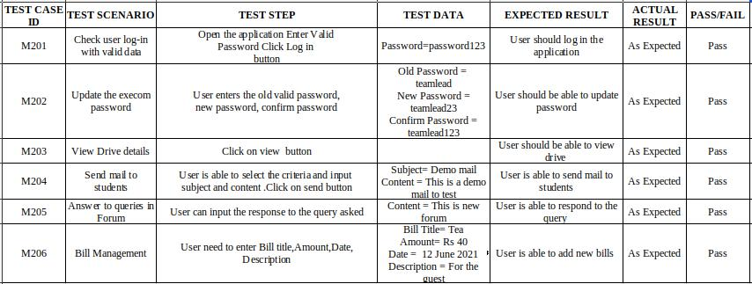

Fig. 9.20: Execom Test Cases

Department of Computer Engineering 71

College of Engineering, Cherthala CHAPTER 8. IMPLEMENTATION

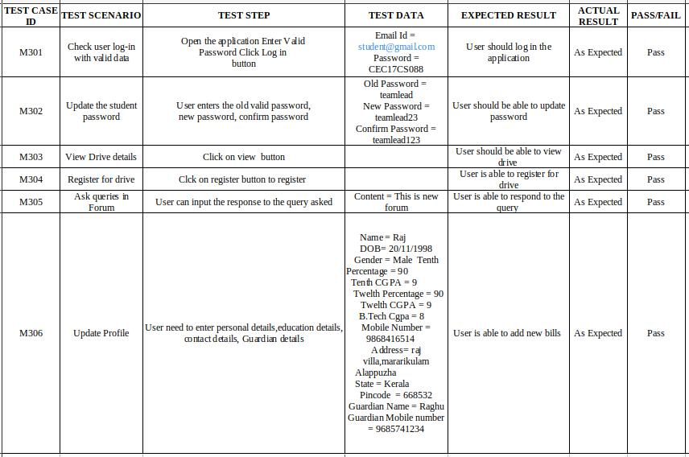

Fig. 9.21: Student Test Cases

Department of Computer Engineering 72

Chapter 10

CONCLUSION & FUTURE SCOPE

The development of this project has many new areas of investigation.This project has wide scope to implement it at any University/Institution. Future Scope of this project are as follows:

* Dynamic statistical representation of data for tracking progress.
* Add payment methods to collect training fees.
* Publish university notifications.
* Integration of Training system such as to conduct aptitude test.
* Integration of SMS system to notify students.

A Placement Cell has many functions and processes that demands a lot of time and human effort. So the aim is to build a modern progressive web application to reduce manual labour in TPC. React.JS will be used to build the front end. Node.js and express will be used to build the back end. Admin, Student and Execom members will be the three users. Users will be given their own accounts to carryout their activities. The student will be able to take part in placement activities by logging into their portal, whereas the Admin or Execom can organize these drives according to their criterion.

73

REFERENCES

1. Shamala S. Angadi, Gomatesh M. Ravanava: A STUDY AND ANALYSIS OF TRAIN-ING AND PLACEMENT CELLS IN ENGI-NEERING COLLEGES- 2018, 65, 461–482, doi:10.1177/0022429417742124
2. Anjali.V , Jeyalakshmi.PR: Web Based Placement Management System, International Jour-nal of Computer Science and Information Technologies, Vol. 7 (2) , 2016, 760-763
3. Azhar Susanto, Meiryani: Database Management System, INTERNATIONAL JOURNAL OF SCIENTIFIC TECHNOLOGY RESEARCH VOLUME 8, ISSUE 06, JUNE 2019 ISSN 2277-8616
4. Khuat, Tun:Developing a frontend application using ReactJS and Redux , Laurea University of Applied Sciences ,2018
5. Hezbullah Shah Tariq Rahim Soomro: Node.js Challenges in Implementation,2018 ,54,654-451
6. Mr.Rohit A.Dhole, Web Based Automation Of Training And Placement Cell, International Journal of Scientific Engineering Research, Volume 7, Issue 2, February-2016 ISSN 2229-5518
7. Shailendra Vidhate,Ajaz Ahmed, Amit Kolhe, Mukul Tilak, Shefali Kolge, Shailendra Vid-hate1,Ajaz Ahmed2, Amit Kolhe3, Mukul Tilak4, Shefali Kolge, International Research Journal of Engineering and Technology, ISSN: 2395 -0056 Volume: 03 Issue: 03 | Mar-2016

74

College of Engineering, Cherthala REFERENCES

1. Bhumi Godiwala, Yash Doshi, Bhavya Vora, Anuja Odhekar, TRAINING AND PLACE-MENT CELL ANDROID APPLICATION, Proceedings of the 3rd International Conference on Advances in Science Technology (ICAST) 2020, Issue: 03 April, 2020
2. Roger S. Pressman,Software Engineering, McGraw-Hill Higher Education,ISBN 0073655783, Issue:2000
3. Sliberschatz A., H. F. Korth and S. Sudarshan, Database System Concepts, 6/e, McGraw Hill, 2011
4. "Creatrix Campus"[Online] Available :"https://www.creatrixcampus.com/placement-management-software, 2021

Department of Computer Engineering 75