Triggers

1. This trigger handles logging, when a movie gets deleted from table Movie, it moves that into

Table Deleted_Movie

SET SQL_SAFE_UPDATES = 0;

delimiter //

create trigger Movie_Remove

before delete on Movie

for each row

begin

insert into Deleted_Movie values (old.ID, old.Title, old.Genre, old.`Description`, old.Director, old.Actors, old.`Year`, old.`Runtime (Minutes)`, old.Rating, old.Votes, old.`Revenue (Millions)`, old.Metascore);

end //

delimiter ;

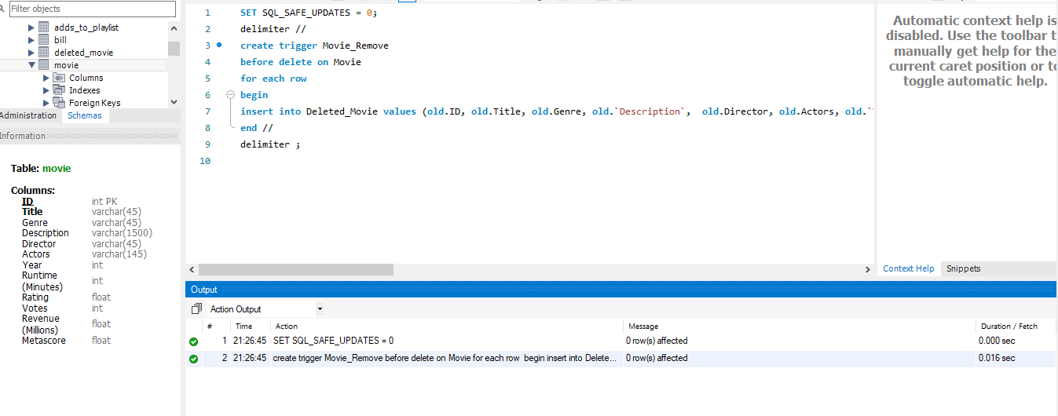

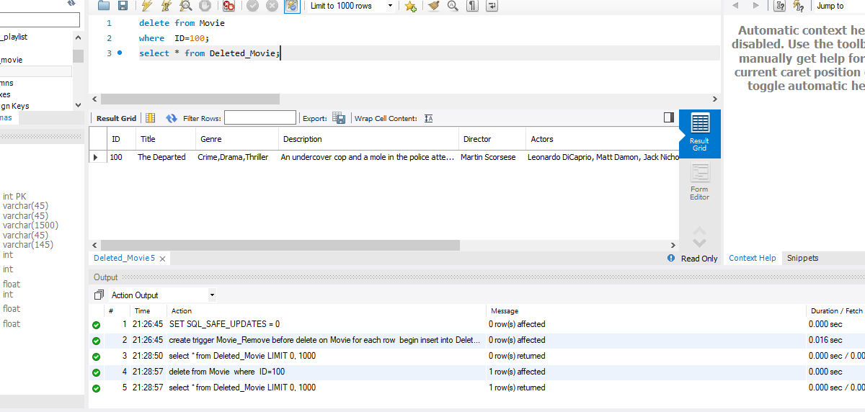

2.

delimiter //

create trigger Card_Handler

before delete on User

for each row

begin

delimiter;

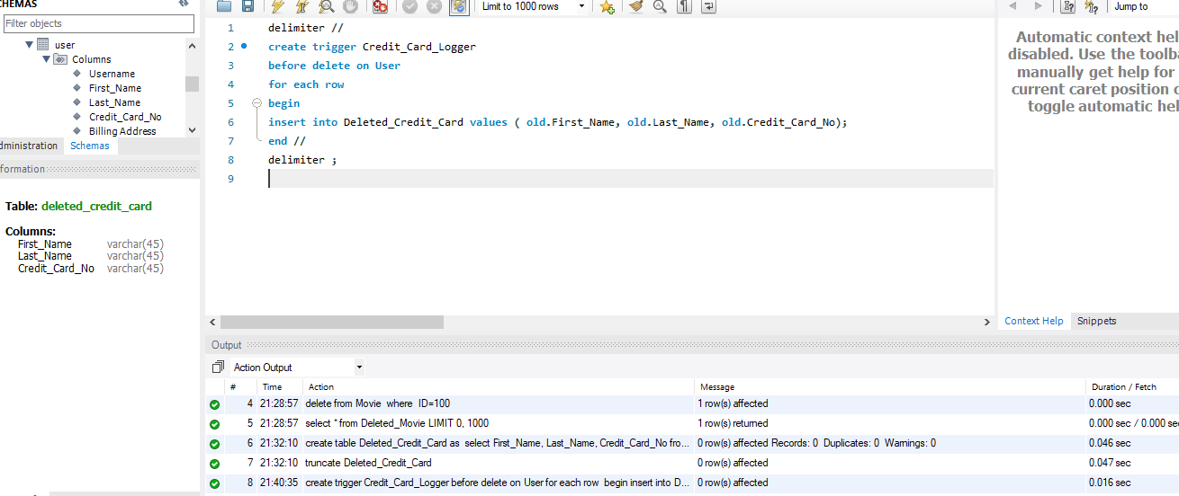

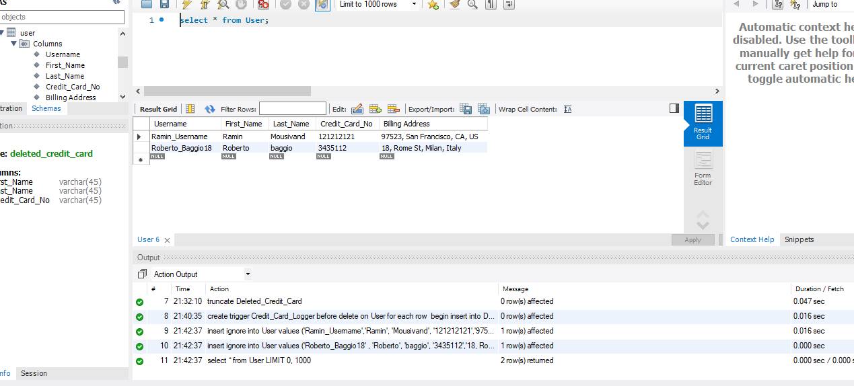

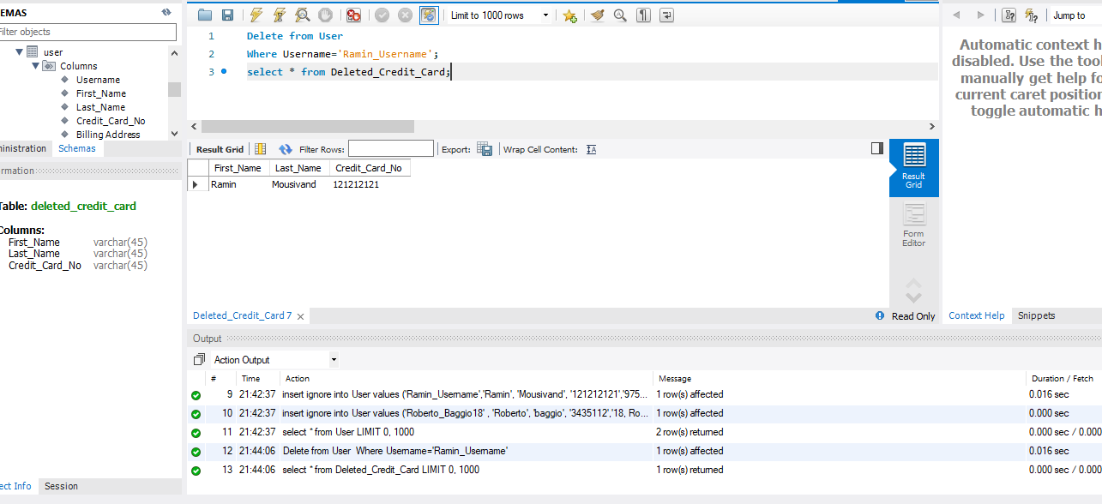

1. This query creates account number 1 after the user sign up (insert)

delimiter //

create trigger Account_Creation

after insert on User

for each row

begin

Insert into Account values (1, new.First_Name, new.Username);

end //

delimiter ;

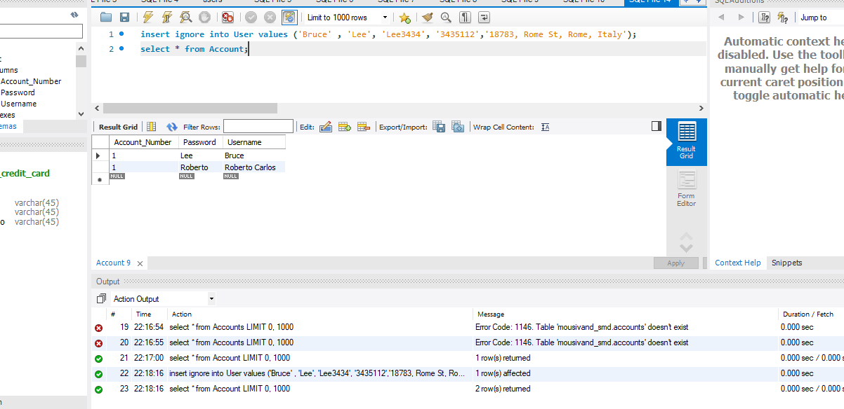

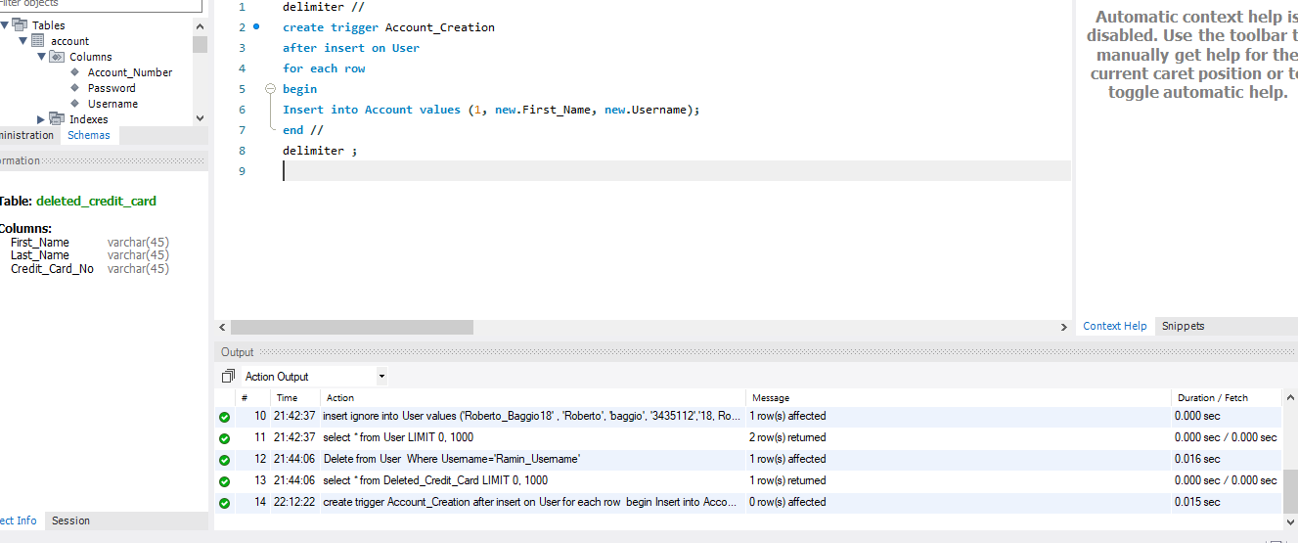

delimiter //

create trigger Username_Update

after update on User

for each row

begin

update Account

set Username= old.Username

where Username= new.Username;

end //

delimiter;

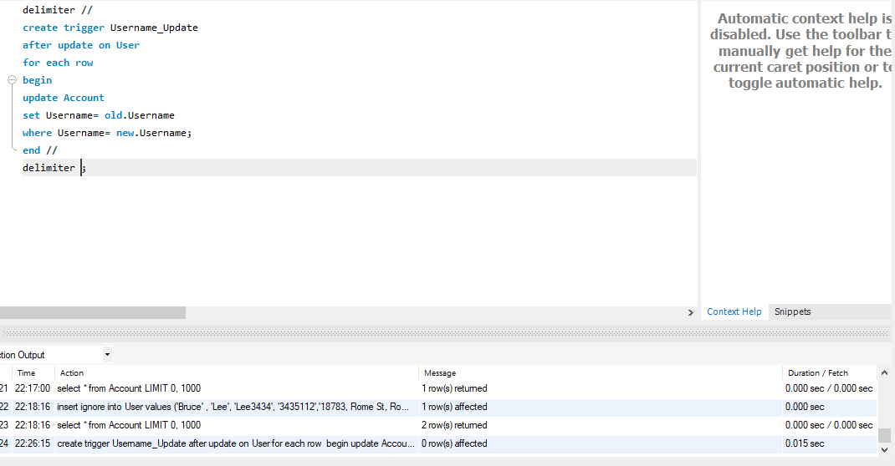

5.

This trigger removes watch history for a deleted account

delimiter //

create trigger Clear_Watch_History

after delete on Account

for each row

begin

delete from Watches

where Username= old.Username And Account_Number= old.Account_Number;

end //

delimiter ;

