

CMPE277

Ramin Mousivand – 012499474 – Lab 1

**With Dr. Rayes permission, this project is done using the React-Native framework. Therefore, Android Studio is set up and used only as an android emulator. Visual Studio is used as the IDE.**

**Framework**

React-native is a javascript library that is coded in javascript, but compiled into both android and ios applications. It runs over nodejs which is a C++ environment for javascript.

**Code Structure**

Regarding the structure of the code, index.js is the main file that will take “App.js” javascript file to do the abstract processing on by the framework. App.js is the main component of the project which may include smaller reusable components. In this application, the smallest reusable components are page headers and footers. They are used in bigger components that are the application pages. App.js file has these pages and takes care of the navigation through the pages and being passed to index.js as the biggest application component.

**External Libraries**

The libraries used in this project are native-base version 2.15.2 for easier and more beautiful UI. The other library installed manually other than default node modules for the project, is react-navigation version 2.11.2. This library gives the ability to include multiple pages one the app.

**APK Generation Process**

After finishing the project, the following steps were taken to generate the apk file [1].

1. At the root of the project this command should be used

react-native bundle --platform android --dev false --entry-file index.js --bundle-output android/app/src/main/assets/index.android.bundle --assets-dest android/app/src/main/res

2. cd android

3. Using the following command at android directory of the project.

./gradlew assembleDebug

4. The file will be available at yourProject/android/app/build/outputs/apk/debug/app-debug.apk

# 

# 

# 

# 

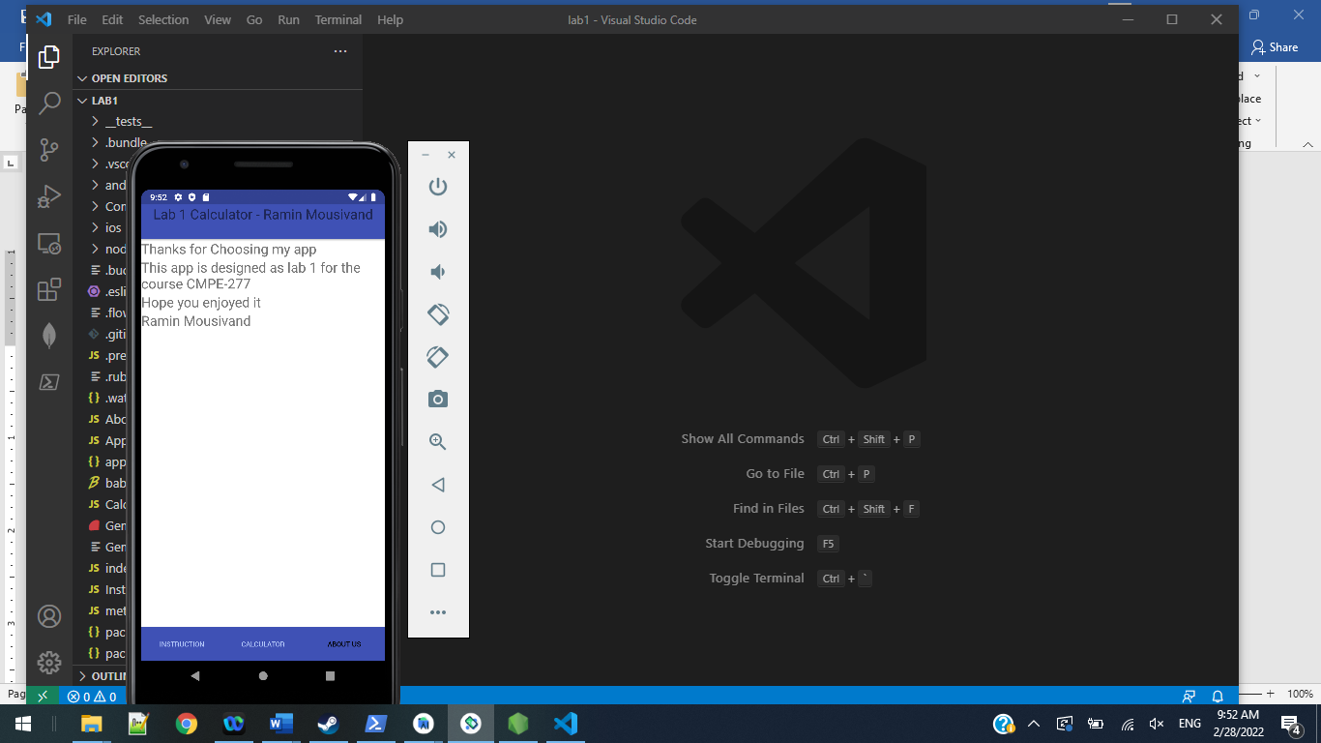

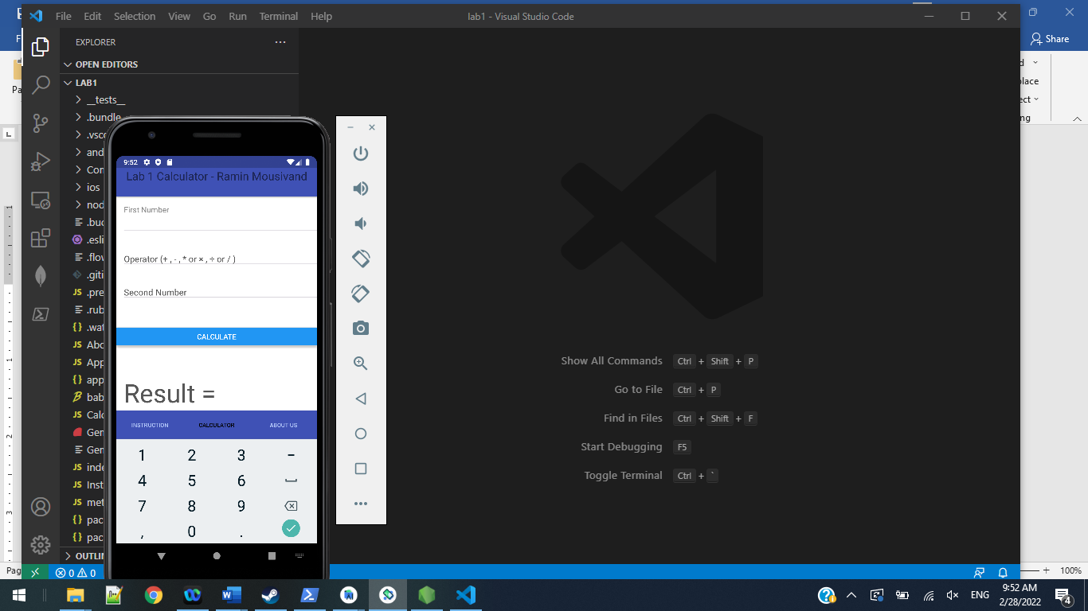

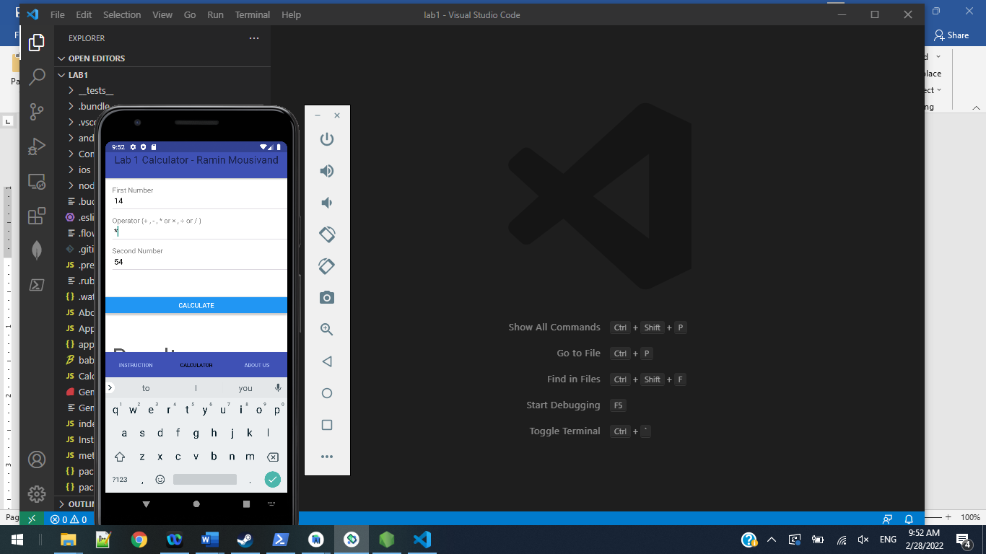

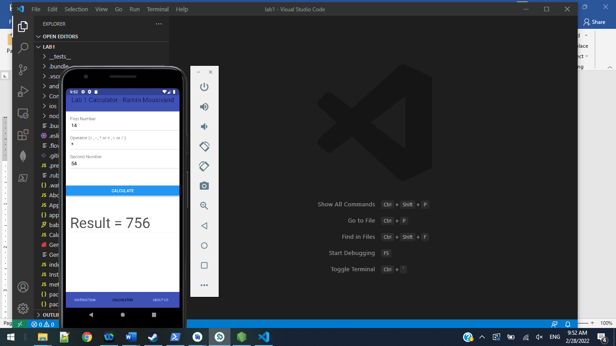

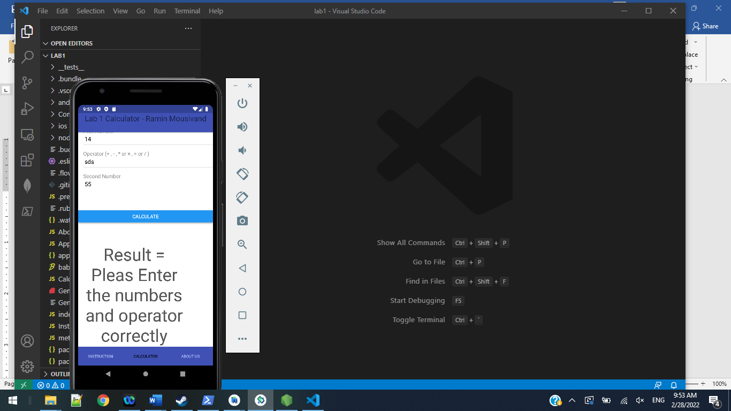

**Maven vs Gradle Question**

These two have many differences such as languages they support, configuration (DSL vs XML), java compilation (necessary for Maven), usability, performance and focus. Gradle is widely used because of its high performance, fast build time and support for web and mobile application development.

(Since the language, tools and frameworks used for this lab are different, Dr. Rayes accepted the questions for this lab don’t apply on my case and my grade be based on the app, screenshots, apk and source code, Also the apk was tested on a real phone too.)

**References**

1. <https://medium.com/geekculture/react-native-generate-apk-debug-and-release-apk-4e9981a2ea51>
2. <https://www.geeksforgeeks.org/difference-between-gradle-and-maven>