Assignment #5. JavaScript Basics (DOM Manipulation & Events)

Student: Write your full name

Group: Write your group

Objective:

The goal of this assignment is to introduce the fundamentals of JavaScript, focusing on working with the Document Object Model (DOM) and event handling. By the end, students will be able to write scripts that manipulate HTML elements, respond to user interactions, and make web pages more dynamic.

Rules for Submission:
- The assignment must be completed individually. If you have the same paperwork with other students, you will have 0 to this work.
- The assignment must be submitted by the deadline which is specified in the moodle.astanait.edu.kz. Works submitted after the deadline will not be accepted! To receive a grade, you must submit by deadline and defend your work at practice lesson time. If you do not defend your assignment, your grade will be 0
- Your project must be published using GitHub Pages or Netlify.
- Submit the GitHub repository link containing your completed assignment. Include a README.md file with a brief description and instructions. Create a navigation bar (navbar) that links to the different tasks/parts of the assignment across separate pages.

Part 1. Introduction to JavaScript

Task 0. First Script
- Create an HTML page and include a JavaScript file.
- Use console.log() to print your name and group.
- Write a script that shows an alert message: “Hello, JavaScript World!”.

Task 1. Variables & Operators
- Declare variables of different data types (string, number, boolean).
- Perform arithmetic operations and display the results in the console.
- Concatenate strings and print them in the console.

Part 2. DOM Manipulation

Task 2. Changing Content
- Create a paragraph and a button.
- When the button is clicked, change the paragraph text to something new.

Task 3. Changing Styles
- Create a <div> container.
- Add a button that, when clicked, changes the background color of the block.
- Add another button that changes the font size of the text inside the block.

Task 4. Creating & Removing Elements
- Create a button “Add Item” that adds a new <li> item to a list.
- Create another button “Remove Item” that removes the last item from the list.

Part 3. Events

Task 5. Mouse Events
- Create a box that changes color when the mouse is over it (mouseover).
- Restore the original color when the mouse leaves (mouseout).

Task 6. Keyboard Events
- Create an input field.
- Display the current value of the input in real time (use keyup event).

Task 7. Calculator
- Create a basic calculator that performs addition, subtraction, multiplication, and division.

Part 4. Mini Project — Interactive To-Do List

Task 8. Build a To-Do App
- Create a text input and an “Add Task” button.
- When a task is added, display it in a list with a “Delete” button next to it.
- Add functionality to mark tasks as completed (strike-through effect).
- Store tasks temporarily in an array (no need for database/local storage).

Example:

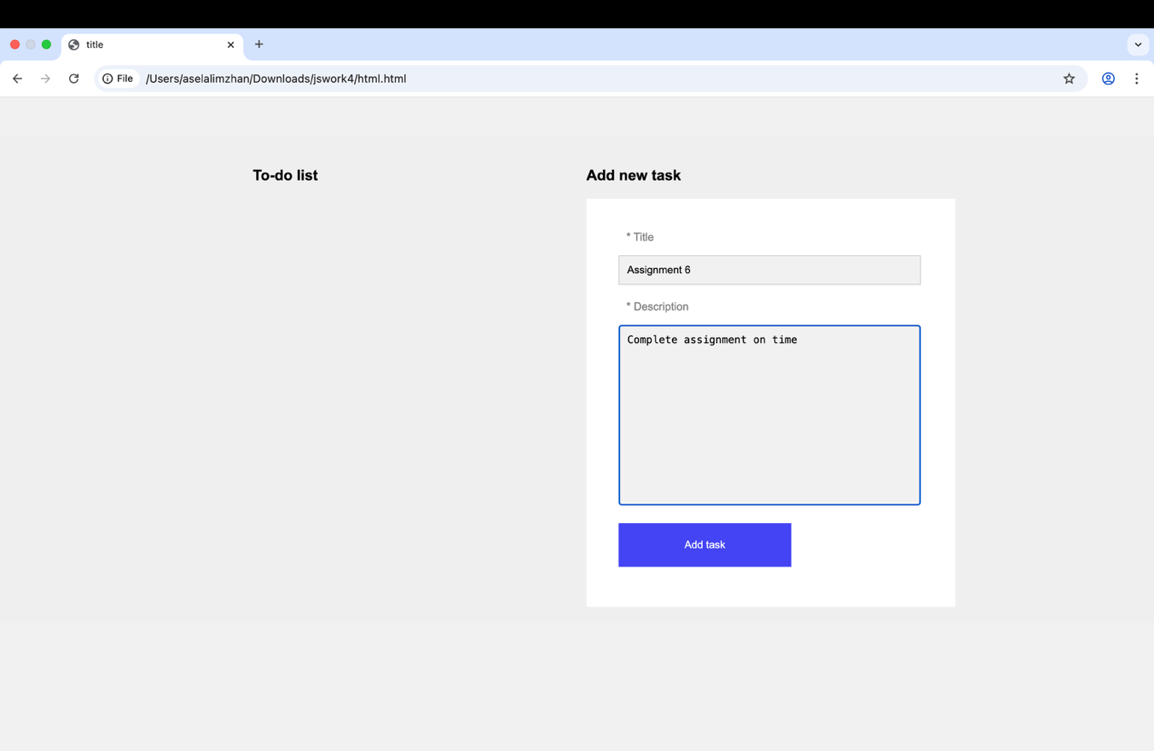

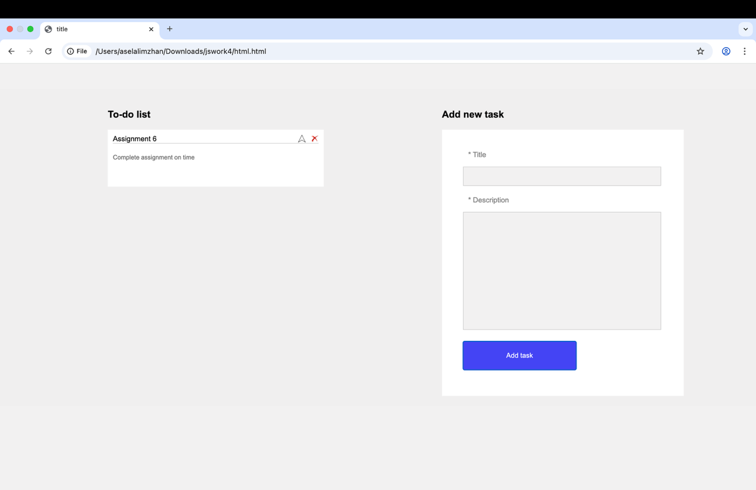

Evaluation Criteria (100%):
# | Task | Description | Points
1 | Practice | working HTML/CSS/Script files, a published website link. | 20
2 | Assignment Defense | Individual oral defense of the assignment. The student must explain their HTML/CSS/Script code, demonstrate the completed webpages, and answer the instructor’s questions. | 30
3 | Live Coding | In-class coding challenge where the student creates or modifies a simple webpage using HTML and CSS and Script. | 50

Resources:
- Abitova G.A. Web technologies Front-End Development. Part 1 (2022);
- https://www.youtube.com/playlist?list=PLPT6CF0r4E3qOlnNkS3UXcTe7I_V8kviI
- https://www.youtube.com/playlist?list=PLPT6CF0r4E3oeXhlV0N3ol5mdoOlkdH9y
- https://developer.mozilla.org/enUS/docs/Web/JavaScript/Guide
- https://www.w3schools.com/js/
- https://javascript.info/dom-nodes

**Questions will be based on the provided resources

Good luck!

