3 Methodology
3.1 Data and study design
The analysis is based on data collected from an experiment involving 1,527 employees distributed across 25 offices in 16 Italian cities over two consecutive years (2023–2024). Two questionnaires were administered before and after the introduction of a gamification-based mobility platform, allowing the construction of a panel dataset, capturing changes in commuting behavior over time.
The gamification application enabled employees to report their commuting trips by selecting among the following transport modes and their combinations: car, bus, motorcycle, walking, bike, train, and tram. For sustainable trips, points were assigned based on internal business rules and travelled distance. These points could subsequently be redeemed for rewards within the platform. The application also included a carpooling feature, allowing users to coordinate shared trips.
Apart from the abovementioned performance-based mechanisms, the platform incorporated other gamification elements aimed at promoting user engagement and encouraging sustainable mobility behavior. Social elements were introduced via leaderboards, enabling users to compare their performance with that of others, fostering competition and social comparison. Furthermore, the platform provided feedback on environmental impact by informing users about the emissions associated with their travel choices, thereby increasing awareness of the consequences of individual mobility decisions.
The questionnaires collected information on commuting behavior, individual characteristics, work-related conditions, and accessibility factors. In addition, the application derived supplementary variables such as travel time, travel distance, and the degree of urbanization of home and workplace locations using open-source data from ISTAT (see Table X for the list of variables).
Question Category | Question
Commuting behavior | Chosen Mode  Number of usual stops during a trip  Need to accompany other people (Elderly, children etc)  Available modes of transportation
Individual Characteristics | Age group  Home qaddress  Office address  Family unit  Gender
Work-related | Number of working days per month  Working time arrangement
Accessibility conditions | Distance to the closest PT stop from home
Perceptions and prioritoies | Reasons for choosing the current mode  Satisfaction with the current mode

Based on the geographical location of employees’ homes and offices, each location was classified according to its degree of urbanization into one of three categories: non-urban, peri-urban, and urban (see Fig. X). These categories are used as proxies to capture differences in accessibility to mobility alternatives, particularly public transport and shared mobility services.
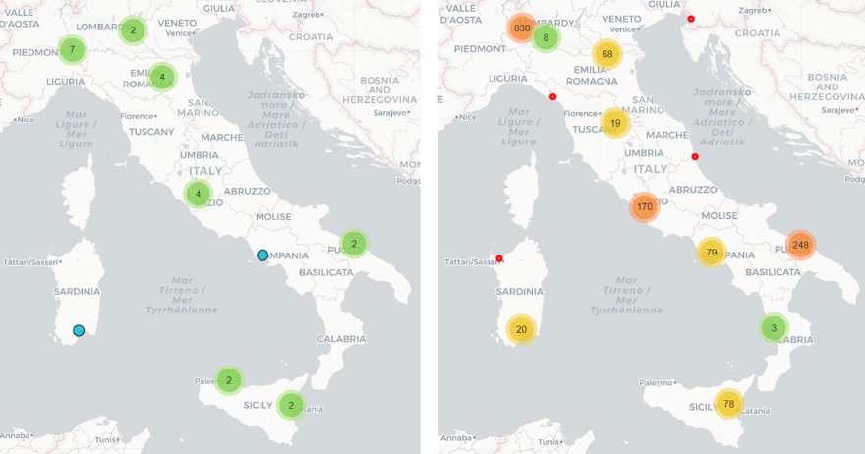
Fig. Geographical spread of the Employees’ Home - Offices
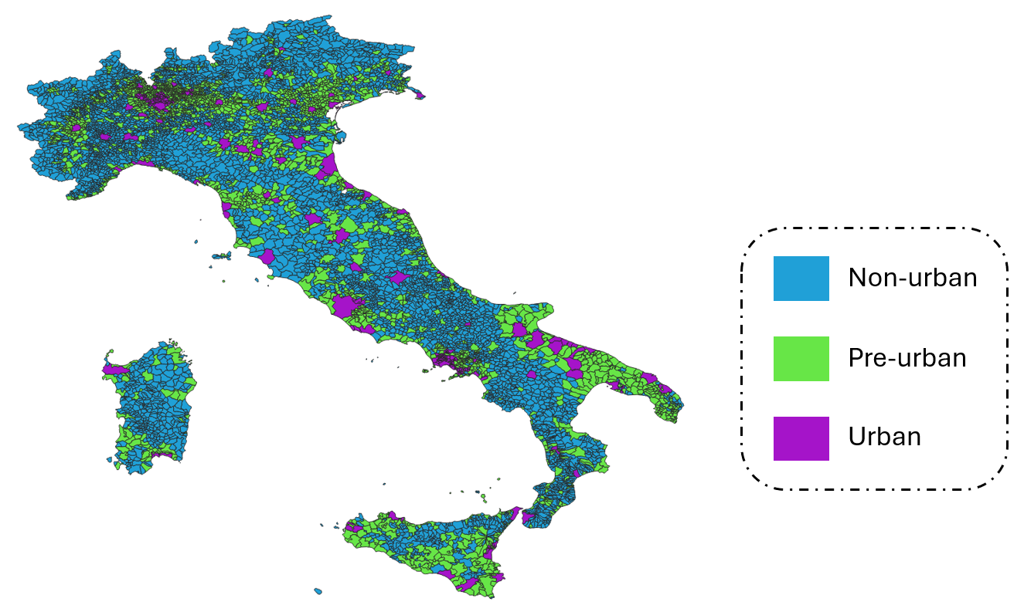
Fig. Degree of Urbanization
Across the two survey waves, approximately 15% of employees (230 individuals) changed their primary commuting mode. Car usage remained the dominant mode, increasing slightly from 57.11% in 2023 to 58.55% in 2024, while public transport usage increased marginally from 21.68% to 22.59% (see Fig. X).
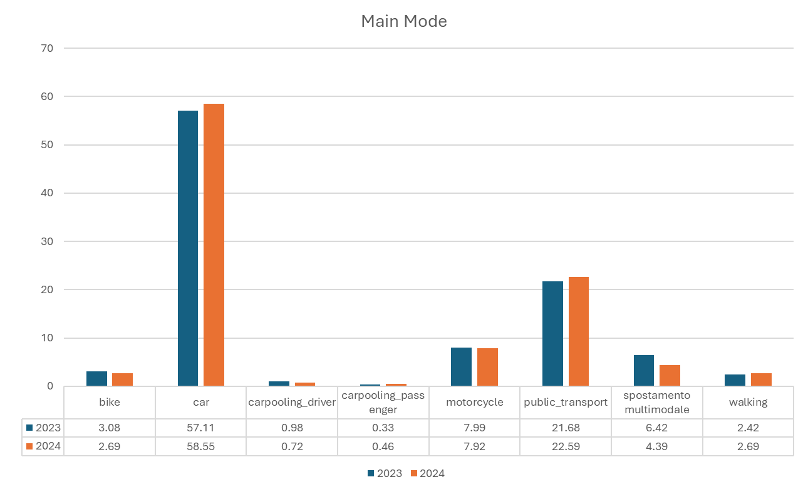
Fig – Modal split comparison
3.2 Commuter Segmentation
To account for heterogeneity in commuting behavior and contextual conditions, a segmentation approach was adopted. Clustering was performed using the K-Prototypes algorithm, which is suitable for datasets containing both numerical and categorical variables.
The clustering procedure was based on pre-choice variables only, excluding the observed commuting mode, in order to avoid circularity in the analysis. The set of variables included all attributes belonging to the categories of commuting behavior, individual characteristics, work-related factors, and accessibility conditions, as previously defined in Table 1. These variables capture key dimensions influencing commuting decisions, such as travel distance, office attendance, spatial context, household constraints, and availability of alternative transport options.
The K-Prototypes algorithm was applied iteratively for different values of $k$, and the resulting cluster configurations were evaluated based on both cost reduction and interpretability. As shown in Fig. X, a substantial decrease in clustering cost is observed when moving from two to three clusters (−15.0%), while additional clusters yield progressively smaller improvements. Beyond $k=3$, marginal cost reductions become limited (below 7%), and the resulting clusters are less interpretable in behavioral and contextual terms.
On this basis, a three-cluster solution was selected as the most appropriate compromise between statistical performance and interpretability.

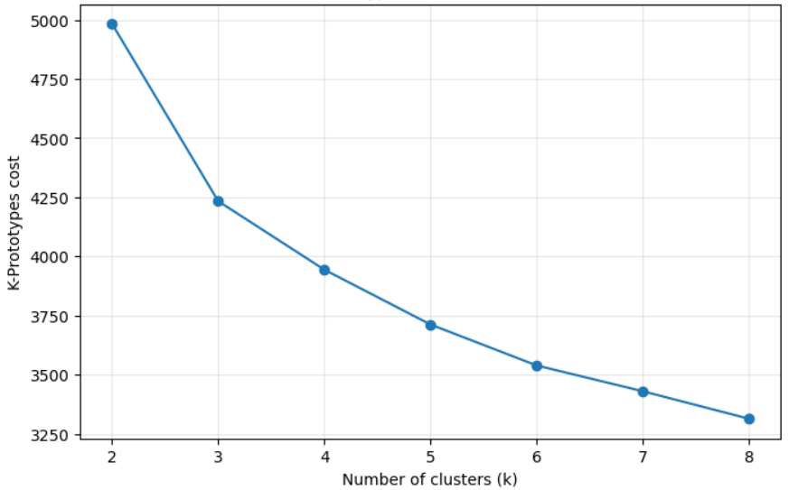
Fig. K-Prototype cost for K from 2 to 8
Cluser 1 - Accessibility-driven commuters
This cluster includes 721 employees and is characterized by relatively favorable mobility conditions. Individuals in this group typically live close to their workplace, with an average commuting distance of approximately 8 km, and exhibit a relatively high frequency of office attendance (around 10 days per month). Commuting patterns are predominantly urban-to-urban (approximately 88%), and household-related constraints, such as accompanying other individuals, are limited. Almost 52.4% of the individuals in this cluster use car as their primary mode.
In addition, this group benefits from a higher availability of alternative transport options, including cycling and public transport, which increases the range of feasible commuting choices. Overall, this cluster represents commuters with relatively high accessibility and lower structural constraints.
Cluster 2 – Constraint-driven commuters
The second cluster comprises 632 employees and is characterized by more complex and constrained mobility conditions. Individuals in this group travel significantly longer distances, with an average commuting distance of approximately 49 km, and show slightly lower office attendance (around 8.5 days per month).
Commuting patterns are more heterogeneous, often involving mixed urban and peri-urban environments. This cluster is also associated with higher levels of private vehicle ownership and a stronger reliance on cars, with approximately 61% of individuals using the car as their primary mode. In addition, the cluster exhibits a marked gender imbalance, with male employees accounting for approximately 70% of the population. Household constraints are more pronounced, with a higher incidence of accompanying other individuals during trips. The availability of alternative transport options, such as cycling, is more limited compared to other groups.
Overall, this cluster represents commuters whose travel behavior is largely shaped by structural constraints, including distance, spatial context, and household responsibilities.
Cluster 3 – Remote/Hybrid workers
The third cluster includes 173 employees and is characterized by low commuting frequency and more flexible work arrangements. Individuals in this group travel on average 1.7 days per month, reflecting a strong presence of remote or hybrid working patterns. The average commuting distance is intermediate (approximately 33 km), and trips often involve more complex structures, including multiple stops and higher levels of accompaniment.
Despite relatively flexible travel patterns, commuting episodes in this group are less frequent, reducing overall exposure to daily mobility decisions. While a share of these individuals resides in urban contexts, the combination of trip complexity and lower commuting frequency distinguishes this cluster from the others. Approximately 62% of individuals in this cluster use the car as their primary mode.
3.3 Mode shift patterns across clusters
Mode shift patterns were analyzed across the three identified commuter clusters to examine how behavioral changes differ under varying mobility conditions.
As shown in Fig. X, the magnitude and direction of these changes vary across clusters. In Cluster 1 (accessibility-driven commuters), 96 individuals changed mode, representing the highest absolute number of changes. Among these, 24 shifted from private motorized modes to more sustainable alternatives, while a larger share (39 individuals) shifted in the opposite direction, primarily toward car use.
In Cluster 2 (constraint-driven commuters), 109 individuals changed mode. Similar to Cluster 1, shifts are observed in both directions, with 25 individuals moving toward sustainable modes and 34 shifting toward private motorized modes. Despite the higher number of changes, the overall modal distribution in this group remains strongly dominated by car use.
Cluster 3 (low-exposure commuters) exhibits a lower number of changes (25 individuals), reflecting reduced commuting frequency. In this group, 8 individuals shifted from private motorized modes to sustainable alternatives, while 5 moved in the opposite direction.
Across all clusters, mode shifts are not consistently directed toward more sustainable transport options, with a notable share of employees shifting toward private motorized modes, even in contexts where alternative options are available.
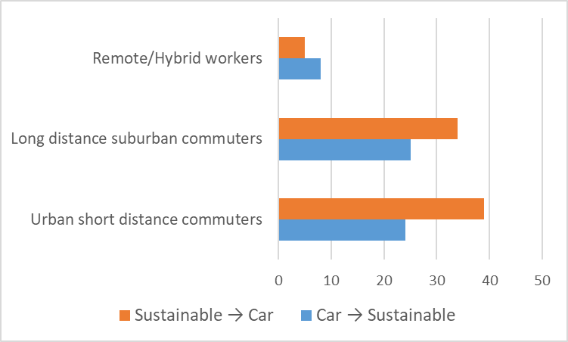
Fig. Mode shifts by cluster

3.4 Application engagement
Additional insights into behavioral patterns are obtained from self-reported responses regarding both the use of the gamification platform and the motivations underlying mode choice.
A subset of employees reported not using the gamification application despite being aware of its existence. The main reasons for non-use are summarized in Fig. X. The most frequently cited barriers relate to structural and contextual factors, including long commuting distances (12%), insufficient public transport services (11%) and the need for stronger incentives (10%).

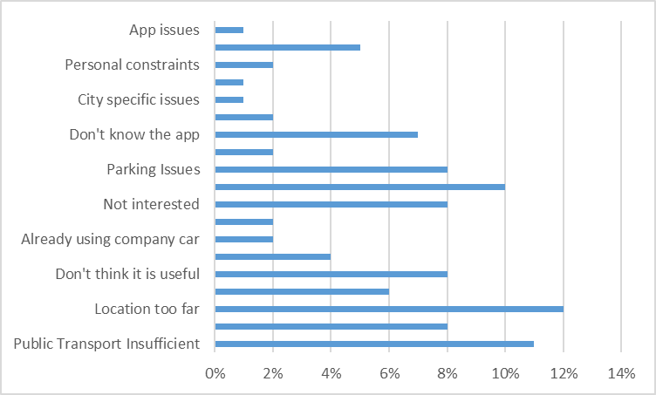
Fig. Reasons for not using the gamification app

