Euro Working Group on Transportation Annual Meeting 2026 - EWGT2026
Evaluating the impact of gamification-based mobility interventions: evidence from heterogeneous commuter populations
, Guido Gentileª
ªSapienza University of Rome, Via Eudossiana 18, Rome 00184, Italy
Abstract
Transport Demand Management (TDM) policies increasingly rely on digital and gamification-based interventions to promote sustainable commuting behaviors. This study evaluates the impact of a gamification-based mobility platform implemented within a company involving 1,527 employees across 25 offices in 16 Italian cities. Using panel data collected through two surveys conducted before and after the intervention, the analysis examines changes in commuting behavior and explores how these changes vary across different accessibility contexts and individual characteristics. The results show that, despite the introduction of incentive-based mobility services, the aggregate modal split remained largely unchanged. However, approximately 15% of employees modified their commuting mode, with changes concentrated among individuals operating in more favorable accessibility conditions. These findings suggest that behavioral responses to gamification interventions are not uniform and are influenced by a combination of contextual factors and individual characteristics.
© 2027 The Authors. Published by ELSEVIER B.V.
This is an open access article under the CC BY-NC-ND license (https://creativecommons.org/licenses/by-nc-nd/4.0)
Peer-review under responsibility of the scientific committee of the Euro Working Group on Transportation Annual Meeting 2026 - EWGT2026
Keywords: TDM, Gamification, Transportation Policies
- Introduction
Transport Demand Management (TDM) refers to a set of policies and incentives designed to influence travel behaviour and reduce reliance on private cars. Rather than expanding infrastructure, TDM aims to improve the efficiency of existing transport systems by encouraging travellers to adopt more sustainable mobility options. With the rapid development of smartphone technologies, transportation authorities and organizations increasingly implement digital platforms and mobile applications that provide incentives for travellers to modify their travel behaviour, for example by shifting from single-occupancy vehicles (SOV) to public transport, cycling, or carpooling. Organizations are often considered suitable environments for implementing such strategies because they provide a clearly defined group of employees and centralized administrative structures that facilitate the implementation and evaluation of mobility programs (Riggs 2015). Evidence from the Federal Highway Administration also suggests that TDM measures can achieve significant impacts at relatively low cost when they are targeted to appropriate groups of travellers.

However, the effectiveness of TDM initiatives largely depends on understanding the heterogeneity of travellers. Many mobility programs are implemented without clearly identifying the specific groups they aim to influence, which may limit their effectiveness. Previous studies therefore highlight the importance of audience segmentation in designing behaviour change policies. For example, Pan et al. (2024) develop traveller personas based on trip characteristics, demographic attributes, and lifestyle factors, allowing policymakers to distinguish between individuals who are unlikely to change their travel behaviour and those more likely to shift toward sustainable alternatives such as public transport, micromobility, or carpooling. Various analytical approaches have been used for this purpose, including clustering techniques and latent class analysis.

Among the emerging tools used to support behaviour change in transportation is gamification, which refers to the use of game design elements in non-game contexts to increase user engagement and motivation. Gamification systems typically incorporate elements such as goals or challenges, points, rewards, and leaderboards to encourage individuals to adopt desired behaviours. In the transportation sector, gamification has been applied through mobile applications that promote sustainable mobility choices, improve eco-driving behaviour, and encourage cycling or walking. Wang et al. 2022 report that the most frequently used gamification elements in transportation applications are goals or challenges and point systems, often combined with rewards and social interaction features to increase user engagement. Existing studies suggest that such systems can lead to behavioural changes such as increased use of sustainable transport modes, safer driving practices, and reductions in energy consumption and carbon emissions (Andersson et al. 2018; Wang et al. 2022).

Despite these promising results, the long-term effectiveness of gamification in transportation remains uncertain. Several studies indicate that behavioural interventions based on incentives or gamified nudges may increase awareness and short-term engagement but do not necessarily lead to sustained changes in travel behaviour (Rosenfield et al. 2020). The effectiveness of these interventions may also depend strongly on contextual factors, such as the availability of alternative transport modes and the level of car dependency. For instance, research by Cellina et al. 2019 shows that behavioural change interventions can produce stronger impacts in contexts with higher car dependency, while limited effects may be observed where mobility patterns are already optimized or where viable alternatives are lacking. These findings highlight the importance of considering traveller segmentation and contextual characteristics when designing behavioural interventions.

Against this background, this study examines the role of gamification in influencing commuting behaviour within a workplace context. By analysing survey data collected from employees before and after the implementation of a gamified mobility system, this research investigates whether such interventions contribute to behavioural change and explores how traveller characteristics and contextual factors may influence their effectiveness.
- Methodology
The study focuses on an experiment conducted on 1,527 employees of a company distributed across 25 offices in 16 different cities in Italy over two consecutive years, 2023 and 2024. The spatial distribution of employees across offices and residential locations creates substantial heterogeneity in accessibility conditions. While some offices are located in metropolitan areas with well-developed public transportation systems, others are situated in smaller cities or suburban areas where access to public transport and shared mobility services is more limited. Similarly, employees’ residential locations vary significantly in terms of distance to the workplace and accessibility to sustainable transport modes. Differences in commuting distance and travel time therefore represent important constraints affecting the feasibility of adopting alternative modes such as cycling or public transportation.

In the first year (2023), a comprehensive questionnaire was designed to capture employees’ socio-economic characteristics, mobility habits, commuting patterns, and attitudes toward alternative transport modes. The survey collected information on variables such as commuting distance and travel time, access to public transportation, parking conditions at the workplace, and employees’ willingness to adopt alternative mobility options.

Responses to the first questionnaire indicated that the most frequently used commuting modes were the private car (57.11%) and public transportation (21.68%), highlighting a strong dependence on private vehicles among employees (Figure 1).

Given the high level of car usage, the company introduced a gamification-based mobility platform aimed at encouraging more sustainable commuting behaviors. The platform included several initiatives: (1) a carpooling application allowing employees to share commuting trips with colleagues and receive points for participation; (2) an activity-based application through which employees could earn points by commuting using sustainable modes such as bus, metro, bicycle, or walking; (3) integration with shared mobility services such as scooters and shared bicycles; and (4) a service enabling the purchase of public transportation tickets. Employees could accumulate points through these activities and redeem them for rewards.

After the first questionnaire, the mobility services were introduced to employees. A second questionnaire was then administered, largely replicating the first survey in order to assess potential changes in commuting behavior and attitudes after the introduction of the services. The two surveys therefore create a panel dataset that allows the observation of potential behavioral changes over time.

The results of the second questionnaire showed that the modal split did not change significantly (See Fig. 1). Car usage slightly increased from 57.11% to 58.55%, while public transportation usage experienced a modest increase of approximately 1.05%.

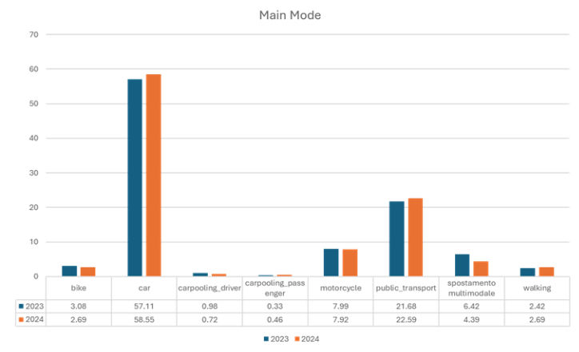
Fig. 1. Mode distribution in 2023 and 2024

A closer inspection of individual-level changes reveals that approximately 230 employees (around 15% of the sample) changed their commuting mode between the two survey waves. When examining these shifts in relation to the degree of urbanization of employees’ residential and office locations, most changes occurred among employees whose home and workplace were both located in urban areas. In these contexts, employees have greater access to public transportation and shared mobility services, which increases the feasibility of switching between modes. Conversely, employees located in peri-urban or non-urban contexts exhibited fewer mode changes, likely reflecting stronger structural constraints related to accessibility and commuting distance.
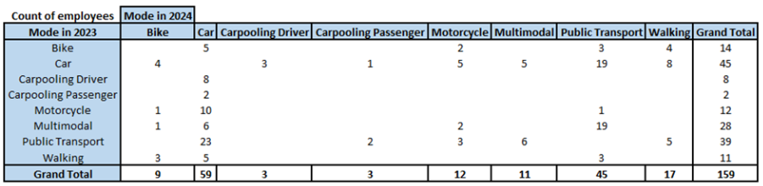
Fig. 2. Mode changes for employees with Urban–Urban home and office locations

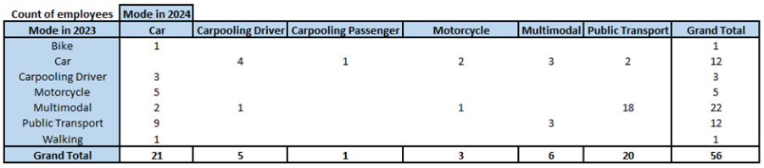
Fig. 3. Mode changes for employees with Peri-Urban–Urban home and office locations

In the second questionnaire (2024), employees who did not use the mobility services were also asked to indicate the reasons for not adopting the application. Among employees whose primary commuting mode was car or motorcycle, the most frequently cited reasons included the lack of viable alternatives, long commuting distances, and limited accessibility to public transportation (see Fig. 4)
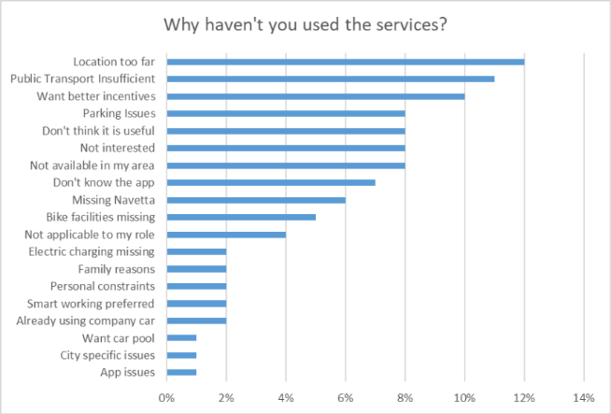
Fig. 4. Motivations behind not-using the gamficiation service

To better understand the heterogeneous responses to the mobility intervention, the analysis focuses on identifying patterns of modal change at the individual level. Particular attention is given to structural factors that influence accessibility to alternative transport modes. Among these factors, the degree of urbanization of both the residential and office locations is used as an indicator of the availability of public transportation and shared mobility services.

The analysis compares commuting modes reported in the two survey waves in order to identify employees who changed their primary commuting mode after the introduction of the gamification-based mobility platform. Mode shifts are then examined across different accessibility contexts defined by the degree of urbanization of the employees’ home and workplace locations.

In addition to spatial accessibility conditions, the dataset includes several individual-level characteristics such as socio-economic attributes, commuting distance, and attitudes toward alternative transport modes. These variables provide a basis for exploring the heterogeneous constraints that influence employees’ mobility decisions.
- Results and Conclusions
The analysis indicates that the introduction of the gamification-based mobility services did not produce substantial changes in the aggregate modal split of the employee population. Car usage remained dominant, and the overall distribution of commuting modes remained relatively stable between the two survey waves.

However, examining individual-level changes reveals that approximately 15% of employees modified their commuting mode during the study period. These changes were not evenly distributed across the population but were strongly associated with accessibility conditions.

Employees whose home and workplace were both located in urban areas exhibited the highest number of mode changes. In these contexts, employees generally have greater access to public transportation networks and shared mobility services, which increases the feasibility of experimenting with alternative commuting options. In contrast, employees located in peri-urban or non-urban areas showed fewer mode changes and often remained dependent on private car use.

Survey responses from employees who did not use the mobility services further highlight the importance of structural constraints. Many respondents indicated that limited transport alternatives, long commuting distances, and inadequate public transportation accessibility prevented them from adopting more sustainable commuting modes.

These findings suggest that behavioral interventions such as gamification platforms may influence commuting behavior primarily among employees who already have access to viable transport alternatives.

The results of this study indicate that behavioral interventions aimed at promoting sustainable commuting—such as gamification platforms and incentive-based mobility services—may have limited impact when applied uniformly to heterogeneous commuter populations. While some employees demonstrated a willingness to experiment with alternative commuting modes, particularly in urban contexts with greater accessibility to transport alternatives, many others remained constrained by structural factors such as commuting distance and limited public transportation availability.

The findings highlight the importance of considering both spatial accessibility and individual characteristics when designing mobility policies. Uniform interventions may not adequately address the diverse constraints faced by different groups of commuters.

Future research will therefore focus on identifying meaningful segments of employees based on their accessibility conditions, socio-economic characteristics, and commuting patterns. Such segmentation can support the development of more targeted mobility strategies and help determine which types of interventions are most effective for different groups of commuters and over different time horizons.
References
Riggs, W., 2015. Testing personalized outreach as an effective TDM measure. Transportation Research Part A: Policy and Practice. 78, 178-186.
Pan, M., Ryan, A., 2015. Segmenting the target audience for transportation demand management programs: An investigation between mode shift and individual characteristics. International Journal of Sustainable Transportation. 18, 62-83. 62–83. https://doi.org/10.1080/15568318.2023.2201941.
Wang, W., Gan, H., Wang, X. et al, 2022. Initiatives and challenges in using gamification in transportation: a systematic mapping. Eur. Transp. Res. Rev. 14, 4. https://doi.org/10.1186/s12544-022-00567-w
Rosenfield, A., Attanucci, J., Zhao, J., 2020. A Randomized Controlled Trial in Travel Demand Management. Transportation 47, 1907–1932. https://doi.org/10.1007/s11116-019-10023-9 .
Andersson, A., Hiselius, L. W., Adell, E., 2018. Promoting sustainable travel behaviour through the use of smartphone applications: A review and development of a conceptual model. Travel Behaviour and Society 11, 52-61. https://doi.org/10.1016/j.tbs.2017.12.008 .
Cellina, F., Bucher, D., Mangili, F., Veiga Simão, J., Rudel, R., & Raubal, M., 2019). A Large Scale, App-Based Behaviour Change Experiment Persuading Sustainable Mobility Patterns: Methods, Results and Lessons Learnt. Sustainability, 11(9), 2674. https://doi.org/10.3390/su11092674 .

* Corresponding author. Tel.: +39-347-139-9267 E-mail address: ramin.bohlouli@uniroma1.it

