Euro Working Group on Transportation Annual Meeting 2026 - EWGT2026
Evaluating the impact of gamification-based mobility interventions: evidence from heterogeneous commuter populations
Ramin Bohlouli^{a,}, Marzieh Afsariª, Lory Michelle Bresciani Miristiceª, Guido Gentileª
ªSapienza University of Rome, Via Eudossiana 18, Rome 00184, Italy
Abstract
Transport Demand Management (TDM) policies increasingly rely on digital and gamification-based interventions to promote sustainable commuting behaviors. This study evaluates the impact of a gamification-based mobility platform implemented within a company involving 1,527 employees across 25 offices in 16 Italian cities. Using panel data collected through two surveys conducted before and after the intervention, the analysis examines changes in commuting behavior and explores how these changes vary across different accessibility contexts and individual characteristics. The results show that, despite the introduction of incentive-based mobility services, the aggregate modal split remained largely unchanged. However, approximately 15% of employees modified their commuting mode, with changes varying significantly across different segments of the population. A clustering analysis using K-Prototype based on pre-choice variables identifies distinct commuter groups characterized by different accessibility conditions, mobility constraints, and behavioral patterns. While some employees show limited responsiveness to the intervention, others remain strongly constrained by structural factors such as commuting distance and limited transport options. Across all identified segments, mode shifts are not systematically directed toward more sustainable alternatives, with a considerable share of employees shifting toward private car use. These findings suggest that gamification-based TDM policies alone may have limited effectiveness in generating long-term behavioral change when applied uniformly across heterogeneous populations. The results highlight the importance of segmentation and context-specific policy design, where interventions are tailored to the characteristics and constraints of different commuter groups.
© 2027 The Authors. Published by ELSEVIER B.V.
This is an open access article under the CC BY-NC-ND license (https://creativecommons.org/licenses/by-nc-nd/4.0)
Peer-review under responsibility of the scientific committee of the Euro Working Group on Transportation Annual Meeting 2026 - EWGT2026
Keywords: TDM, Gamification, Transportation Policies
- Introduction
Transport Demand Management (TDM) refers to a set of policies and incentives designed to influence travel behaviour and reduce reliance on private cars by encouraging the adoption of more sustainable transport modes. With the rapid development of smartphone technologies, transportation authorities and organizations increasingly implement digital platforms and mobile applications that provide incentives for travellers to shift from single-occupancy vehicles to alternatives such as public transport, cycling, or carpooling. Organizations represent suitable environments for implementing such strategies, as they provide a clearly defined group of employees and centralized structures that facilitate the evaluation of mobility programs (Riggs, 2015). Evidence from the Federal Highway Administration further suggests that TDM measures can be effective when targeted to appropriate groups of travellers.
However, the effectiveness of TDM initiatives depends strongly on the heterogeneity of travellers. Many mobility programs are implemented without clearly identifying the groups they aim to influence, which may limit their impact. Previous studies highlight the importance of segmentation in designing behaviour change policies. For instance, Pan et al. (2024) develop traveller personas based on trip characteristics, demographic attributes, and lifestyle factors, enabling the identification of individuals more likely to shift toward sustainable transport modes.
Among the tools used to support behavioural change, gamification has gained increasing attention. By incorporating elements such as rewards, challenges, and feedback mechanisms, gamification-based applications aim to increase user engagement and promote sustainable mobility choices. While existing studies show that such interventions can improve awareness and encourage behavioural experimentation (Andersson et al., 2018; Wang et al., 2022), their effectiveness in producing sustained behavioural change remains uncertain. Recent evidence suggests that behavioural incentives may have limited impact when structural constraints, such as limited accessibility to alternative modes or high car dependency, are present (Rosenfield et al., 2020; Cellina et al., 2019).
Against this background, this study contributes by providing empirical evidence from a large-scale real-world experiment on how the effectiveness of gamification-based TDM interventions depends on accessibility conditions and commuter heterogeneity in a workplace context. Using panel data collected before and after the intervention and a segmentation-based approach, the analysis examines whether such policies lead to measurable changes in commuting behaviour and explores how these effects vary across different clusters of employees and contextual conditions.
- Methodology
The analysis is based on data collected from an experiment involving 1,527 employees distributed across 25 offices in 16 Italian cities over two consecutive years (2023–2024). Two questionnaires were administered before and after the introduction of a gamification-based mobility platform, allowing the construction of a panel dataset, capturing changes in commuting behavior over time.
The analysis first compares commuting modes between the two survey waves to identify employees who modified their primary commuting mode following the introduction of the intervention. Approximately 15% of employees (230 individuals) changed their commuting mode during the study period. To account for heterogeneity in behavioral responses, a segmentation-based approach is adopted. Clustering is performed using the K-Prototypes algorithm on pre-choice variables, capturing socio-demographic characteristics, accessibility conditions, commuting patterns, and mobility constraints.
Post-clustering analysis is then conducted to examine differences in modal choice and mode shifts across clusters (See Fig. 1), as well as to interpret behavioral responses in relation to structural conditions and perceived constraints.
Additional qualitative insights are derived from open-text responses provided by employees who did not use the gamification platform, with the most frequently cited barriers including lack of viable alternatives, long commuting distances, and limited accessibility to public transportation.

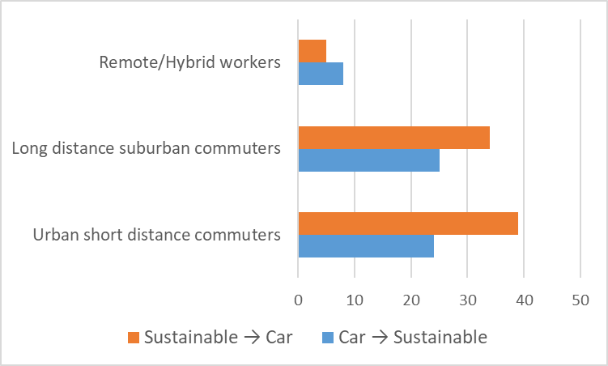

Fig. 1. Mode shifts by cluster (%)
- Results and Conclusions
The results indicate that the introduction of the gamification-based mobility platform did not lead to significant changes in the aggregate modal split. Car usage remained the dominant mode, increasing slightly from 57.11% in 2023 to 58.55% in 2024, while public transportation usage increased marginally from 21.68% to 22.59%.
Clustering analysis reveals three distinct commuter segments with different mobility conditions and behavioral patterns. The first group, urban short-distance commuters, is characterized by high accessibility to alternative modes and relatively flexible commuting conditions. Despite these favorable conditions, mode shifts within this group are not consistently directed toward sustainable alternatives, with a notable share of employees shifting from sustainable modes to private car use. The second group, long-distance suburban commuters, is characterized by strong car dependency, longer commuting distances, and greater household constraints. In this segment, structural limitations significantly restrict the feasibility of adopting alternative modes, resulting in limited responsiveness to the intervention. The third group, remote and hybrid workers, exhibits low commuting frequency and more flexible travel patterns. While this group shows moderate use of sustainable modes, their limited exposure to commuting reduces the overall impact of the intervention.
Across all clusters, the results show that mode shifts are not systematically oriented toward more sustainable modes. This is further supported by user satisfaction analysis, which indicates consistently high satisfaction levels among car users and lower satisfaction levels among public transport users, suggesting that the perceived utility of private car use remains high for a significant portion of the population. Overall, the findings provide strong evidence that gamification-based TDM policies may have limited effectiveness in generating long-term behavioral change when applied uniformly across heterogeneous commuter populations. The results highlight the importance of segmentation and context-specific policy design, where interventions are tailored to the accessibility conditions, constraints, and behavioral characteristics of different commuter groups. These findings also suggest that behavioral incentives alone may be insufficient in the absence of structural improvements and should be complemented by policies addressing accessibility and mobility infrastructure over different time horizons.
References
Riggs, W., 2015. Testing personalized outreach as an effective TDM measure. Transportation Research Part A: Policy and Practice. 78, 178-186.
Pan, M., Ryan, A., 2015. Segmenting the target audience for transportation demand management programs: An investigation between mode shift and individual characteristics. International Journal of Sustainable Transportation. 18, 62-83. 62–83. https://doi.org/10.1080/15568318.2023.2201941.
Wang, W., Gan, H., Wang, X. et al, 2022. Initiatives and challenges in using gamification in transportation: a systematic mapping. Eur. Transp. Res. Rev. 14, 4. https://doi.org/10.1186/s12544-022-00567-w
Rosenfield, A., Attanucci, J., Zhao, J., 2020. A Randomized Controlled Trial in Travel Demand Management. Transportation 47, 1907–1932. https://doi.org/10.1007/s11116-019-10023-9 .
Andersson, A., Hiselius, L. W., Adell, E., 2018. Promoting sustainable travel behaviour through the use of smartphone applications: A review and development of a conceptual model. Travel Behaviour and Society 11, 52-61. https://doi.org/10.1016/j.tbs.2017.12.008 .
Cellina, F., Bucher, D., Mangili, F., Veiga Simão, J., Rudel, R., & Raubal, M., 2019). A Large Scale, App-Based Behaviour Change Experiment Persuading Sustainable Mobility Patterns: Methods, Results and Lessons Learnt. Sustainability, 11(9), 2674. https://doi.org/10.3390/su11092674 .

* Corresponding author. Tel.: +39-347-139-9267 E-mail address: ramin.bohlouli@uniroma1.it

