ASSIGNMENT 1

RAMINDERPREET SINGH (5370169)

Code:

<!DOCTYPE html>

<html>

    <head>

        <title>Assignment1 solution</title>

    </head>

    <body>

        <h1>Raminderpreet singh</h1>

        <div>

            <p>I am raminderpreet singh student of <stong>Cst</stong> in matrix college</p>

            <p>I am living in <em>  montreal </em> from last 8 months</p>

        </div>

        <div>

            <img src="raminder.png" alt="image not available">

        </div>

        <a href="https://www.google.ca/">clickme!<a/>

    </body>

</html>

Screenshot 1.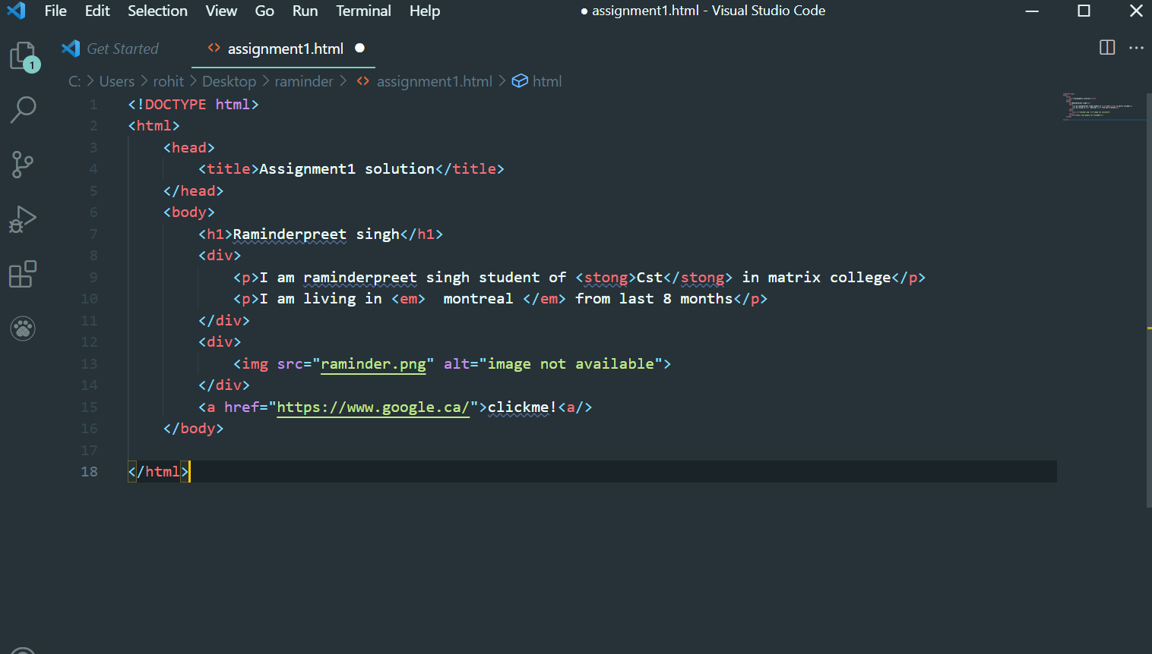

SCREENSHOT 2

