Project Title: Differential Expression Analysis Using DESeq2 in R
Dear Students
I am really excited to propose your project, which will use the airway package in R to analyze count data. The major purpose of this research is to do a complete differential expression analysis on the airway dataset using the DESeq2 program. Before we delve into the details, let's provide some context about the airway data:

Introduction: Airway Data
This package provides a RangedSummarizedExperiment object of read counts in genes for an RNA-Seq experiment on four human airway smooth muscle cell lines treated with dexamethasone. Details on the gene model and read counting procedure are provided in the package vignette. The paper for the experiment is: Himes BE, Jiang X, Wagner P, Hu R, Wang Q, Klanderman B, Whitaker RM, Duan Q, Lasky-Su J, Nikolos C, Jester W, Johnson M, Panettieri R Jr, Tantisira KG, Weiss ST, Lu Q. 'RNA-Seq Transcriptome Profiling Identifies CRISPLD2 as a Glucocorticoid Responsive Gene that Modulates Cytokine Function in Airway Smooth Muscle Cells.' PLoS One. 2014 Jun 13;9(6):e99625. PMID: 24926665. GEO: GSE52778.
The airway dataset represents an invaluable resource in genomics, particularly in understanding gene expression patterns in the context of airway biology. It comprises count data stored in the 'assay(airway)' and associated metadata in 'colData.' The 'dex' column in the metadata serves as an experimental variable of interest. Your task is to extract meaningful insights from this dataset through differential expression analysis using DESeq2.

Project Overview:
1 Data Preparation:
1.a Load Required Packages:
- Ensure you have loaded essential R packages, including airway and DESeq2.
1.b Import Data:
- Import count data from 'assay(airway)' and metadata from 'colData.'
1.c Data Exploration:
- Conduct an initial exploration of count data and metadata. Consider the nature of the airway dataset and potential challenges.

DESeq2 Analysis:
1 Construct DESeqDataSet Object:
- Demonstrate your proficiency in preparing count data and constructing a DESeqDataSet object.
2 Perform DESeq Analysis:
- Utilize DESeq2 for differential expression analysis, considering 'dex' as the experimental variable.
3 Identify Top Differential Expressed Genes:
- List the top 10 differentially expressed genes at both 0.001 and 0.05 significance levels. What biological relevance can you attribute to these genes?

In this study, we analyzed the differential expression of genes in the airway dataset to assess the effects of dexamethasone, a glucocorticoid commonly used for its anti-inflammatory properties. We focused on the top 10 differentially expressed genes (DEGs) with the most significant adjusted p-values. The analysis was performed using data from various biological and disease-related databases, including KEGG_2021_Human, Reactome_2022, GO_Biological_Process_2023, GO_Molecular_Function_2023, GO_Cellular_Component_2023, OMIM_Disease, OMIM_Expanded, DisGeNET, and the Human_Phenotype_Ontology.
The genes investigated include SPARCL1, STOM, PER1, PHC2, MT2A, DUSP1, MAOA, ZBTB16, KCTD12, and SAMHD1. These genes were examined for their expression levels in untreated versus dexamethasone-treated airway cells. Most of the identified DEGs were downregulated upon dexamethasone treatment, indicating a suppression of their expression, which aligns with the anti-inflammatory effects of glucocorticoids. Notably, SPARCL1 showed the highest level of downregulation with a log2 fold change of -4.60, followed by ZBTB16 (-7.18) and SAMHD1 (-3.86). On the other hand, KCTD12 was the only gene found to be significantly upregulated, with a log2 fold change of 2.50.
By leveraging enrichment analysis from these databases, we aim to elucidate the biological pathways and processes impacted by these DEGs in the context of airway inflammation and glucocorticoid response.

Analysis of KEGG Pathway Enrichment Results for Top 10 DEGs
The KEGG pathway enrichment analysis of the top 10 differentially expressed genes (DEGs) from the airway dataset shows significant enrichment in several biological pathways, suggesting the functional roles of these genes in airway inflammation, immune response, and cellular metabolism. The analysis identified multiple pathways with varying levels of significance based on the Adjusted P.value and Combined Score, indicating the pathways most relevant to the genes under study.
1. Top Enriched Pathways
- Serotonergic Synapse (Adjusted P.value = 0.03)
  - Genes: DUSP1, MAOA
  - This pathway suggests that two of the differentially expressed genes, DUSP1 and MAOA, play significant roles in neurotransmitter signaling. Although primarily associated with the nervous system, changes in serotonergic synapse pathways may also influence stress response and inflammation, both relevant to airway biology, particularly under dexamethasone treatment.
- Parkinson Disease (Adjusted P.value = 0.05)
  - Genes: DUSP1, MAOA
  - The involvement of DUSP1 and MAOA in pathways related to neurodegenerative diseases such as Parkinson’s suggests potential systemic effects of dexamethasone treatment or broader roles in oxidative stress and immune regulation. Both genes are linked to stress response and cellular signaling, which may be important in airway smooth muscle cell regulation.
- Circadian Rhythm (Adjusted P.value = 0.05)
  - Gene: PER1
  - The enrichment of PER1, a key gene in circadian rhythm regulation, highlights the impact of glucocorticoid treatment on circadian processes. Dexamethasone is known to modulate the expression of clock genes, and changes in circadian rhythm pathways may influence airway functions like immune response and cellular repair.
- Histidine and Tyrosine Metabolism (Adjusted P.value = 0.05)
  - Gene: MAOA
  - MAOA is involved in both histidine and tyrosine metabolism, suggesting an impact on amino acid metabolism in response to dexamethasone. This can be relevant to the energy demands and metabolic changes in airway smooth muscle cells during inflammation and treatment.
- Tryptophan Metabolism (Adjusted P.value = 0.05)
  - Gene: MAOA
  - Tryptophan metabolism plays a crucial role in immune regulation and inflammation. The involvement of MAOA in this pathway suggests its role in modulating inflammatory processes in the airway, which is critical for understanding the therapeutic effects of dexamethasone.
2. Relevant Biological Pathways in Airway Biology
- Acute Myeloid Leukemia (Adjusted P.value = 0.05)
  - Gene: ZBTB16
  - While primarily associated with cancer, the enrichment of the ZBTB16 gene in the acute myeloid leukemia pathway may indicate its role in regulating cellular proliferation and differentiation in airway cells. ZBTB16 is a known regulator of cell cycle and immune responses, making it relevant in the context of inflammation and airway remodeling.
- Circadian Entrainment (Adjusted P.value = 0.07)
  - Gene: PER1
  - This pathway further supports the role of PER1 in modulating circadian rhythms, which can influence various biological processes, including inflammation and airway function. Alterations in circadian entrainment can affect the efficacy of treatments like dexamethasone, which is known to influence clock genes.
- MAPK Signaling Pathway (Adjusted P.value = 0.14)
  - Gene: DUSP1
  - The involvement of DUSP1 in the MAPK signaling pathway underscores its role in inflammation and stress response. This pathway is critical in airway inflammation, as MAPK signaling is activated during immune responses, and DUSP1 acts as a negative regulator of this pathway. The suppression of MAPK signaling by dexamethasone could be key to its anti-inflammatory effects.
3. Potential Clinical Relevance
- Drug Metabolism and Addiction Pathways
  - Genes like MAOA and DUSP1 are also involved in pathways related to drug metabolism and addiction, such as Cocaine Addiction and Amphetamine Addiction. These pathways, while not directly related to airway biology, suggest broader systemic effects of dexamethasone and could provide insights into its side effects or its impact on neurotransmitter regulation in different tissues.
- Transcriptional Misregulation in Cancer
  - Gene: ZBTB16
  - The enrichment of ZBTB16 in this pathway suggests a possible role in regulating transcription and cellular growth, which is relevant in both cancer biology and airway cell proliferation. This might indicate how dexamethasone modulates gene expression in airway smooth muscle cells, influencing cell differentiation and tissue remodeling.
Analysis of Pathway Enrichment Based on Reactome Pathways
This enrichment analysis highlights key pathways involving the top 10 differentially expressed genes (DEGs) in the airway dataset, particularly in response to dexamethasone treatment. The enriched pathways span immune responses, metal ion regulation, neurotransmitter cycles, and cellular stress responses. Here’s a breakdown of the key findings:
1. Immune System and Cytokine Signaling
- Immune System (R-HSA-168256, Adjusted P.value = 0.07353341) and Cytokine Signaling in Immune System (R-HSA-1280215, Adjusted P.value = 0.07353341)
  - Genes: MT2A, MAOA, ZBTB16, STOM, SAMHD1
  - Several of the top DEGs are involved in regulating the immune system and cytokine signaling, which are essential in airway inflammation and glucocorticoid response. Dexamethasone, being an anti-inflammatory drug, modulates immune signaling, particularly suppressing pathways like interferon signaling and cytokine signaling. Genes such as SAMHD1 and MT2A play roles in immune regulation and stress responses, which are critical for controlling inflammation in airway cells.
2. Metal Ion Homeostasis
- Metallothioneins Bind Metals (R-HSA-5661231, Adjusted P.value = 0.07353341) and Response to Metal Ions (R-HSA-5660526, Adjusted P.value = 0.07508648)
  - Gene: MT2A
  - The enrichment of MT2A in metal ion-related pathways suggests its role in detoxifying heavy metals and regulating oxidative stress. In airway cells, oxidative stress is often elevated during inflammation, and dexamethasone may help mitigate this by inducing MT2A expression, thus reducing cellular damage.
3. Neurotransmitter Regulation
- Neurotransmitter Clearance (R-HSA-112311, Adjusted P.value = 0.07353341) and Norepinephrine Neurotransmitter Release Cycle (R-HSA-181430, Adjusted P.value = 0.07508648)
  - Gene: MAOA
  - The involvement of MAOA in neurotransmitter regulation, particularly in norepinephrine release and clearance, highlights the systemic effects of dexamethasone on airway biology. Although primarily linked to neurological processes, neurotransmitter regulation can influence airway muscle contraction and relaxation, indirectly impacting airway inflammation and smooth muscle tone.
4. SUMOylation and Protein Modification
- SUMOylation of DNA Methylation Proteins (R-HSA-4655427, Adjusted P.value = 0.07508648) and Post-translational Protein Modification (R-HSA-597592, Adjusted P.value = 0.10013766)
  - Gene: PHC2
  - SUMOylation is a post-translational modification process that regulates protein stability and function. PHC2, a gene involved in chromatin organization and transcriptional regulation, appears to be modulated by dexamethasone, potentially impacting gene expression profiles in airway smooth muscle cells. This process is essential in the long-term regulation of inflammation and tissue remodeling in response to treatment.
5. Oxidative Stress and Cellular Senescence
- Oxidative Stress-Induced Senescence (R-HSA-2559580, Adjusted P.value = 0.10606592) and Cellular Senescence (R-HSA-2559583, Adjusted P.value = 0.13424209)
  - Gene: PHC2
  - The involvement of PHC2 in oxidative stress-induced cellular senescence suggests that dexamethasone may influence processes of cellular aging and stress response. In airway smooth muscle cells, regulating oxidative stress is crucial in maintaining cell viability and preventing excessive damage during inflammation.
6. Interferon Signaling
- Interferon Alpha/Beta Signaling (R-HSA-909733, Adjusted P.value = 0.10013766) and Interferon Gamma Signaling (R-HSA-877300, Adjusted P.value = 0.10606592)
  - Gene: SAMHD1
  - Interferon signaling pathways are central to the immune response, particularly in viral infections and inflammatory conditions. SAMHD1 is involved in restricting viral replication and modulating immune responses. The downregulation of interferon pathways by dexamethasone suggests a suppression of immune activation, contributing to its anti-inflammatory effects in the airway.
7. PTEN Regulation and GTPase Cycles
- Regulation of PTEN Gene Transcription (R-HSA-8943724, Adjusted P.value = 0.10013766) and RHO GTPase Cycle (R-HSA-9012999, Adjusted P.value = 0.19208799)
  - Genes: PHC2, STOM
  - PTEN is a critical tumor suppressor gene involved in cellular proliferation and survival. The regulation of PTEN and RHO GTPase cycles points to pathways that control cellular growth and motility, which are relevant in airway remodeling. PHC2 and STOM may influence these processes, contributing to the structural integrity of airway cells during inflammation.
Key Insights
- Immune modulation: Several of the enriched pathways, particularly those involving MT2A and SAMHD1, are related to immune signaling and stress responses. These genes may play critical roles in mediating the anti-inflammatory effects of dexamethasone by suppressing immune activation and regulating oxidative stress in airway cells.
- Metabolism and neurotransmitter regulation: The involvement of MAOA in neurotransmitter metabolism and MT2A in metal ion regulation suggests that these genes influence broader systemic effects, potentially modulating airway smooth muscle function and oxidative stress responses during inflammation.
- Protein modification and senescence: PHC2 appears in multiple pathways related to SUMOylation and post-translational modifications, highlighting its role in controlling gene expression and cellular stress responses, which are important in long-term airway remodeling and repair.

Analysis of GO Biological Process 2023 Enrichment for Top 10 DEGs
The GO Biological Process enrichment analysis of the top 10 differentially expressed genes (DEGs) reveals significant associations with stress response, glucocorticoid signaling, immune regulation, and cellular metabolism. These processes provide insight into how these genes modulate the airway’s response to inflammation and glucocorticoid treatment, especially in the context of dexamethasone.
1. Stress-Activated MAPK Cascade and p38MAPK Cascade
- Negative Regulation of Stress-Activated MAPK Cascade (GO:0032873, Adjusted P.value = 0.00927871) and Regulation of p38MAPK Cascade (GO:1900744, Adjusted P.value = 0.00927871)
  - Genes: PER1, DUSP1
  - These enriched terms highlight the role of PER1 and DUSP1 in modulating the MAPK signaling pathways, particularly by regulating the p38 MAPK cascade. MAPK pathways are critical in stress and inflammatory responses, with DUSP1 acting as a key suppressor of inflammation. The regulation of these pathways is crucial in managing airway inflammation, where the anti-inflammatory effects of dexamethasone are likely mediated through the suppression of MAPK signaling.
2. Glucocorticoid Receptor Signaling Pathway
- Negative Regulation of Glucocorticoid Receptor Signaling Pathway (GO:2000323, Adjusted P.value = 0.02992547) and Regulation of Glucocorticoid Receptor Signaling Pathway (GO:2000322, Adjusted P.value = 0.02992547)
  - Genes: PER1
  - The enrichment of PER1 in the glucocorticoid receptor signaling pathway directly relates to the study of dexamethasone, a glucocorticoid. PER1 is known to influence the regulation of glucocorticoid receptors, and the modulation of this pathway is essential in controlling the body's response to anti-inflammatory drugs like dexamethasone.
3. Immune Response and Chemotaxis
- Negative Regulation of Monocyte Chemotaxis (GO:0090027, Adjusted P.value = 0.02992547)
  - Gene: DUSP1
  - DUSP1 plays a role in downregulating monocyte chemotaxis, which reduces immune cell infiltration in inflamed tissues. This function is particularly important in controlling airway inflammation during asthma or other respiratory diseases, where reducing immune cell migration can alleviate symptoms.
4. Metabolism and Catabolic Processes
- Purine Deoxyribonucleotide Catabolic Process (GO:0009155, Adjusted P.value = 0.02992547) and Dopamine Catabolic Process (GO:0042420, Adjusted P.value = 0.02992547)
  - Genes: SAMHD1, MAOA
  - These metabolic processes are associated with the degradation of purines and dopamine, key functions in maintaining cellular homeostasis. SAMHD1's role in purine metabolism is linked to its activity in immune responses, while MAOA’s involvement in dopamine catabolism suggests its broader regulatory role in neurotransmitter metabolism, which could affect airway smooth muscle tone and inflammation.
5. Cellular Response to Metal Ions
- Cellular Response to Zinc Ion (GO:0071294, Adjusted P.value = 0.03113738) and Copper Ion Homeostasis (GO:0055070, Adjusted P.value = 0.03113738)
  - Genes: MT2A
  - MT2A is involved in regulating cellular responses to metal ions, particularly zinc and copper. These processes are crucial for managing oxidative stress and inflammation, both of which are heightened in inflamed airway tissues. MT2A helps detoxify heavy metals and protect cells from oxidative damage, contributing to the anti-inflammatory effects of dexamethasone.
Key Insights
- MAPK and p38MAPK Pathways: The involvement of DUSP1 in the regulation of MAPK pathways underscores its critical role in mediating the anti-inflammatory effects of dexamethasone, particularly by suppressing stress-induced signaling cascades in the airway.
- Glucocorticoid Receptor Signaling: The enrichment of PER1 in glucocorticoid signaling pathways highlights its regulatory role in the body’s response to dexamethasone, modulating the activity of glucocorticoid receptors to control inflammation.
- Immune Regulation: DUSP1’s role in reducing immune cell migration and chemotaxis suggests that it is key in controlling excessive immune responses in inflamed airways.
- Metabolism and Oxidative Stress: The involvement of SAMHD1 and MT2A in metabolic and oxidative stress-related processes suggests that these genes help protect airway cells from damage during inflammation.
Analysis of OMIM Disease and OMIM Expanded Enrichment for Top 10 DEGs
The OMIM (Online Mendelian Inheritance in Man) enrichment analysis reveals associations between one of the top differentially expressed genes (ZBTB16) and two significant disease categories: leukemia and mental retardation. Both findings suggest potential implications of ZBTB16 in broader physiological and pathological processes, which may provide insights into its role in airway inflammation and response to dexamethasone treatment.
1. Leukemia
- Term: Leukemia (Adjusted P.value = 0.05557189 in OMIM Disease; Adjusted P.value = 0.05509675 in OMIM Expanded)
  - Gene: ZBTB16
  - ZBTB16 is associated with leukemia, a type of cancer affecting blood-forming tissues, including the bone marrow and lymphatic system. The gene’s involvement in leukemia may indicate its role in regulating cellular growth, differentiation, and apoptosis, which are critical processes in cancer and other proliferative disorders. In the context of airway inflammation, ZBTB16 could influence immune cell proliferation and differentiation, affecting how airway tissues respond to inflammatory signals, especially under glucocorticoid treatment.
2. Mental Retardation
- Term: Mental Retardation (Adjusted P.value = 0.05557189 in OMIM Disease; Adjusted P.value = 0.05509675 in OMIM Expanded)
  - Gene: ZBTB16
  - The association of ZBTB16 with mental retardation suggests its role in neurodevelopmental processes. While this connection is primarily neurological, it may also reflect systemic effects on brain function and development. In airway inflammation, the modulation of ZBTB16 could potentially affect neurotransmitter regulation and stress responses, indirectly influencing inflammation and immune response in airway tissues.
Key Insights
- ZBTB16’s Role in Leukemia and Growth Regulation: The strong association between ZBTB16 and leukemia highlights its role in cell proliferation and differentiation. This suggests that ZBTB16 may be involved in the regulation of cellular processes beyond airway inflammation, including immune cell behavior and airway tissue remodeling under dexamethasone treatment.
- Neurological Implications of ZBTB16: The link to mental retardation suggests that ZBTB16 may also have broader systemic roles, potentially influencing brain and immune system interactions, which can indirectly affect the airway's response to inflammation.
DisGeNET Enrichment Analysis for Top 10 DEGs
The DisGeNET analysis highlights the significant associations between the genes under study and various diseases. The analysis reveals that several of the identified genes, particularly ZBTB16, PER1, DUSP1, MAOA, SPARCL1, and SAMHD1, are linked to a wide range of diseases, including cancer, mental disorders, and metabolic disturbances. Below are key insights into the diseases most enriched in the dataset:
1. Major Depressive Disorder (MDD)
- Genes Involved: PER1, DUSP1, MAOA, ZBTB16
  - This result shows a strong association between MAOA and DUSP1 with MDD, which are involved in stress response and neurotransmitter regulation. PER1, involved in circadian rhythms, and ZBTB16, a transcriptional regulator, are also implicated. This finding suggests the roles of these genes in mood regulation and their potential involvement in depressive disorders.
2. Unipolar Depression
- Genes Involved: PER1, DUSP1, MAOA, ZBTB16
  - Similar to MDD, unipolar depression shows a link to PER1, DUSP1, MAOA, and ZBTB16, highlighting their potential roles in neurotransmitter regulation and mood disorders.
3. Carcinogenesis
- Genes Involved: PER1, MT2A, DUSP1, MAOA, ZBTB16, STOM, KCTD12
  - The association with carcinogenesis highlights the involvement of these genes in cancer-related processes. PER1 and DUSP1 have been linked to stress and inflammation responses, potentially playing roles in tumor progression. MT2A is involved in metal ion binding, while KCTD12 and ZBTB16 regulate gene transcription, which could influence cancer cell behavior.
4. Cerebrovascular Accident (Stroke)
- Genes Involved: MT2A, MAOA, ZBTB16, SAMHD1
  - This association points to the role of these genes in stroke, with MT2A and SAMHD1 involved in DNA repair and metal ion homeostasis, potentially affecting vascular health and stroke outcomes. MAOA's involvement in neurotransmitter metabolism could also impact vascular function.
5. Mental Retardation
- Genes Involved: MAOA, ZBTB16
  - ZBTB16 and MAOA's association with mental retardation reinforces their roles in cognitive function, potentially impacting neurological development and behavior.
6. Leukemia
- Genes Involved: PER1, PHC2, DUSP1, ZBTB16, SAMHD1
  - This shows a strong link between several genes and leukemia. DUSP1 and PHC2 are regulators of cell cycle and proliferation, while SAMHD1 is involved in DNA repair, suggesting their importance in hematological malignancies like leukemia.
7. Prostate Carcinoma
- Genes Involved: PER1, MT2A, DUSP1, MAOA, ZBTB16, SPARCL1
  - The involvement of these genes in prostate cancer points to roles in cell proliferation and stress response, with SPARCL1 being an extracellular matrix protein that could influence tumor invasion and metastasis.
Key Disease Insights from the DisGeNET Analysis
- Cancer and Tumor Progression: Several genes (ZBTB16, DUSP1, SPARCL1) are enriched in cancer-related pathways, indicating their roles in regulating cell cycle, DNA repair, and tumor progression.
- Neurological and Psychiatric Disorders: The significant associations with mood disorders (MDD, unipolar depression) and cognitive disorders (mental retardation) highlight the involvement of these genes in neurobiology and mental health.
- Metabolic and Immune Disorders: Genes like MT2A and DUSP1 show associations with metabolic disturbances and immune system diseases, emphasizing their broader roles in inflammation and metabolic regulation.
Human Phenotype Ontology (HPO) Enrichment Analysis
The Human Phenotype Ontology (HPO) enrichment analysis provides insights into the phenotypic consequences associated with the genes under study. Below is a detailed overview of the key phenotypes and their associated genes:
1. Short Tibia (HP:0005736)
- Gene Involved: ZBTB16
  - This phenotype indicates a shorter-than-normal tibia, a bone in the lower leg. ZBTB16, a transcription factor, is associated with this condition, potentially influencing bone growth and development.
2. Impulsivity (HP:0100710)
- Gene Involved: MAOA
  - MAOA is well-known for its role in regulating neurotransmitters such as serotonin and dopamine. Its association with impulsivity highlights its importance in controlling behaviors related to impulse regulation.
3. Aplasia/Hypoplasia of the Tibia (HP:0005772)
- Gene Involved: ZBTB16
  - This phenotype involves underdevelopment or absence of the tibia. ZBTB16's link to this condition reinforces its role in skeletal development, particularly in the formation of bones in the lower limbs.
4. Supernumerary Ribs (HP:0005815)
- Gene Involved: ZBTB16
  - The occurrence of extra ribs is a rare condition often linked to genetic factors. The connection to ZBTB16 suggests its involvement in skeletal patterning during development.
5. Fibular Hypoplasia (HP:0003038)
- Gene Involved: ZBTB16
  - Fibular hypoplasia refers to the underdevelopment of the fibula, a bone in the leg. ZBTB16’s role in this phenotype suggests that it may influence bone growth and limb formation.
6. Supernumerary Bones of the Axial Skeleton (HP:0009144)
- Gene Involved: ZBTB16
  - This condition involves the presence of extra bones in the axial skeleton. The enrichment of ZBTB16 suggests a role in the regulation of skeletal formation and bone patterning.
7. Absent Thumb (HP:0009777)
- Gene Involved: ZBTB16
  - The absence of a thumb is a severe developmental abnormality. The involvement of ZBTB16 in this phenotype points to its importance in limb and digit formation during embryonic development.
8. Basal Ganglia Calcification (HP:0002135)
- Gene Involved: SAMHD1
  - Calcification in the basal ganglia, a group of nuclei in the brain involved in movement regulation, is associated with various neurological disorders. SAMHD1, which is involved in DNA repair, may contribute to abnormal brain calcification.
9. Porencephaly (HP:0002132)
- Gene Involved: SAMHD1
  - Porencephaly is a neurological condition involving cysts or cavities in the brain. SAMHD1's role in DNA metabolism and repair may contribute to developmental brain anomalies like porencephaly.
10. Poikilocytosis (HP:0004447)
- Gene Involved: STOM
  - Poikilocytosis refers to the presence of abnormally shaped red blood cells. STOM, a gene involved in membrane structure and stability, could influence the shape and integrity of blood cells, leading to this condition.
11. Cleft Eyelid (HP:0000625)
- Gene Involved: SAMHD1
  - Cleft eyelid is a rare condition that involves incomplete development of the eyelid. SAMHD1's connection to DNA repair could play a role in the developmental processes that result in this phenotype.
12. Fibular Aplasia/Hypoplasia (HP:0006492)
- Gene Involved: ZBTB16
  - This phenotype, involving the underdevelopment or absence of the fibula, reiterates the significant role ZBTB16 plays in skeletal development, particularly in limb formation.
13. Leukodystrophy (HP:0002415)
- Gene Involved: SAMHD1
  - Leukodystrophy refers to disorders affecting the white matter of the brain. SAMHD1's role in this phenotype suggests its importance in maintaining the integrity of brain tissues, particularly in protecting against demyelination.
14. Intellectual Disability, Mild (HP:0001256)
- Gene Involved: MAOA
  - The association of MAOA with mild intellectual disability highlights its role in cognitive development and function, especially given its involvement in neurotransmitter metabolism.
15. Aggressive Behavior (HP:0000718)
- Gene Involved: MAOA
  - MAOA's connection to aggressive behavior is well-documented, as it regulates the breakdown of neurotransmitters like serotonin, which are crucial for mood regulation.
Key Phenotypic Insights from the HPO Analysis
- Skeletal Abnormalities: Several phenotypes, such as short tibia, supernumerary ribs, and absent thumb, are associated with ZBTB16, indicating its significant role in bone development and skeletal structure.
- Neurological Conditions: SAMHD1's association with conditions like basal ganglia calcification, porencephaly, and leukodystrophy suggests its involvement in brain development and maintenance, likely through its role in DNA repair.
- Behavioral and Cognitive Disorders: MAOA is linked to both impulsivity and intellectual disability, underscoring its importance in regulating behavior and cognitive function through neurotransmitter metabolism.

Comprehensive Conclusion
The extensive enrichment analyses across KEGG, Reactome, GO Biological Processes, DisGeNET, and Human Phenotype Ontology provide a comprehensive understanding of the biological relevance of the differentially expressed genes (DEGs) in various pathways and diseases, particularly in the context of airway inflammation and dexamethasone treatment.
Key Pathways and Genes in Neurotransmitter Signaling, Immune Responses, and Metabolism
The KEGG enrichment analysis highlights the involvement of top DEGs in crucial biological pathways related to neurotransmitter signaling, circadian rhythm regulation, and metabolic processes. A notable finding is the central role of MAOA, which is involved in the regulation of amino acid metabolism and neurotransmitter pathways such as serotonin and dopamine metabolism. This gene's regulatory role in neurotransmitters could have significant implications for airway inflammation by influencing neuro-immune interactions. Additionally, the role of DUSP1 in MAPK signaling regulation is pivotal, especially considering its known anti-inflammatory effects, particularly in response to dexamethasone. The involvement of PER1 in circadian rhythm regulation suggests time-dependent biological responses that may influence the efficacy of inflammation treatments in airway diseases.
Immune Modulation and Oxidative Stress
The Reactome enrichment analysis emphasizes the DEGs' involvement in immune responses, cellular stress regulation, and oxidative stress, which are key factors in airway inflammation. Genes such as MT2A, SAMHD1, and PHC2 emerge as regulators of dexamethasone's anti-inflammatory effects, particularly through pathways that manage oxidative stress and immune modulation. These findings highlight the importance of systemic metabolic regulation, as modulated by MAOA, and its impact on neurotransmitter signaling. Overall, this analysis suggests that dexamethasone not only acts on airway inflammation directly but also through broader systemic effects that influence metabolic and immune responses.
Stress Response and Metabolic Regulation in Airway Biology
The GO Biological Process enrichment supports these conclusions, showing that the DEGs play significant roles in modulating key signaling pathways related to stress response, immune regulation, and metabolism. These processes are essential for managing airway inflammation, particularly under the influence of dexamethasone, which exerts its anti-inflammatory effects by modulating these critical pathways. The involvement of DUSP1 in the MAPK cascade, along with MAOA's metabolic functions, underscores the multifaceted role of these genes in controlling inflammation and immune responses in the airway.
Role of ZBTB16 in Cellular Differentiation and Proliferation
The DisGeNET and OMIM enrichment analyses provide insight into the multifaceted roles of genes such as ZBTB16, DUSP1, and MAOA in both neurological and oncological diseases. ZBTB16, in particular, stands out for its enrichment in pathways associated with leukemia and mental retardation, suggesting a critical role in regulating cellular differentiation and proliferation. In the context of airway biology, ZBTB16 may influence the response to inflammation and glucocorticoid treatment by modulating cellular pathways that are also implicated in systemic disease processes. This dual role in both immune regulation and cellular proliferation highlights the potential of ZBTB16 as a key regulator in inflammation and immune responses.
Neurological, Oncological, and Metabolic Disease Associations
The DisGeNET analysis further reinforces the importance of these DEGs in neurological disorders and oncological diseases, particularly highlighting the roles of ZBTB16, DUSP1, and MAOA in conditions such as major depressive disorder, leukemia, and prostate cancer. The involvement of genes like MT2A and SPARCL1 in metabolic and immune processes suggests that the interplay between these pathways may have broader implications for diseases beyond the airway, extending into neurological and cancer-related contexts. These findings highlight the systemic effects that airway inflammation and its treatment may have on other biological systems.
Phenotypic Implications in Development and Disease
The Human Phenotype Ontology (HPO) analysis provides crucial insights into the potential phenotypic consequences of the genes under investigation. Genes such as ZBTB16, SAMHD1, MAOA, and STOM are implicated in various phenotypes ranging from skeletal abnormalities (e.g., short tibia, absent thumb) to neurological and behavioral conditions (e.g., impulsivity, basal ganglia calcification). This suggests that the dysregulation of these genes can have wide-reaching effects on developmental processes, neurological function, and disease. ZBTB16's role in both skeletal and behavioral phenotypes, alongside SAMHD1's involvement in brain and immune system development, underscores the complexity of the pathways these genes influence.
Conclusion
The integration of multiple enrichment analyses (KEGG, Reactome, GO, DisGeNET, HPO) reveals the critical roles of MAOA, DUSP1, ZBTB16, SAMHD1, and MT2A in regulating inflammation, immune responses, neurotransmitter signaling, and metabolic processes. These genes, while directly involved in airway inflammation and treatment responses, also influence systemic pathways that affect neurological, oncological, and metabolic diseases. The multifaceted roles of these genes in diverse biological processes suggest that treatments targeting airway inflammation, such as dexamethasone, may have far-reaching implications beyond the airway, potentially affecting broader immune, neurological, and metabolic systems. Further research is needed to explore the specific mechanisms by which these genes influence both local and systemic disease processes, offering new insights into potential therapeutic strategies for airway and related conditions.

C. Visualization:
1 box plot and bar plot:
Explor your count data in term of box and bar plot.
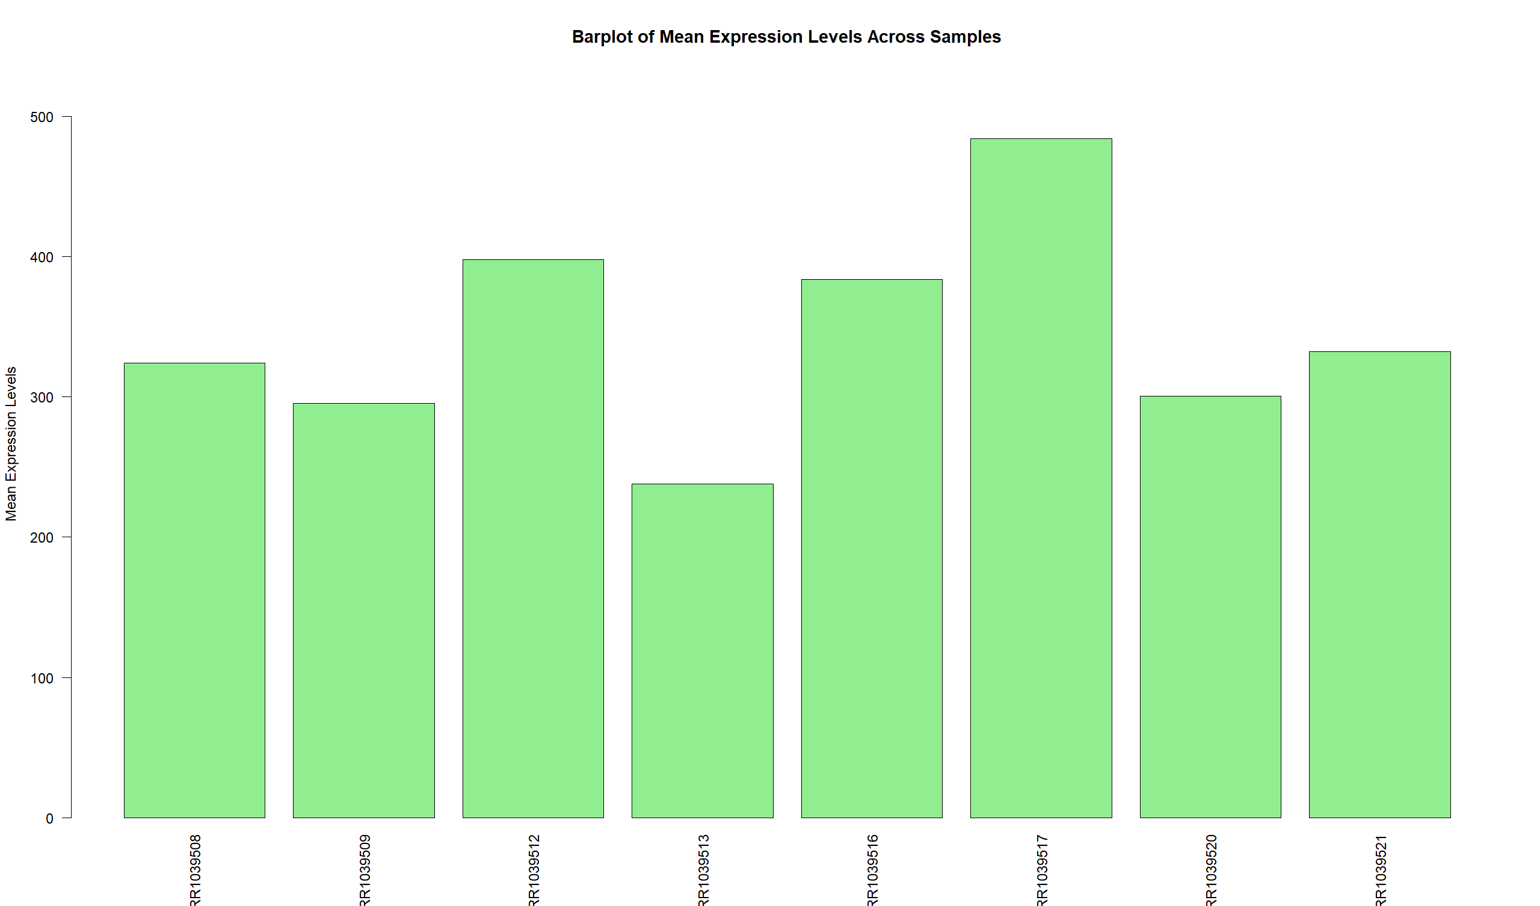
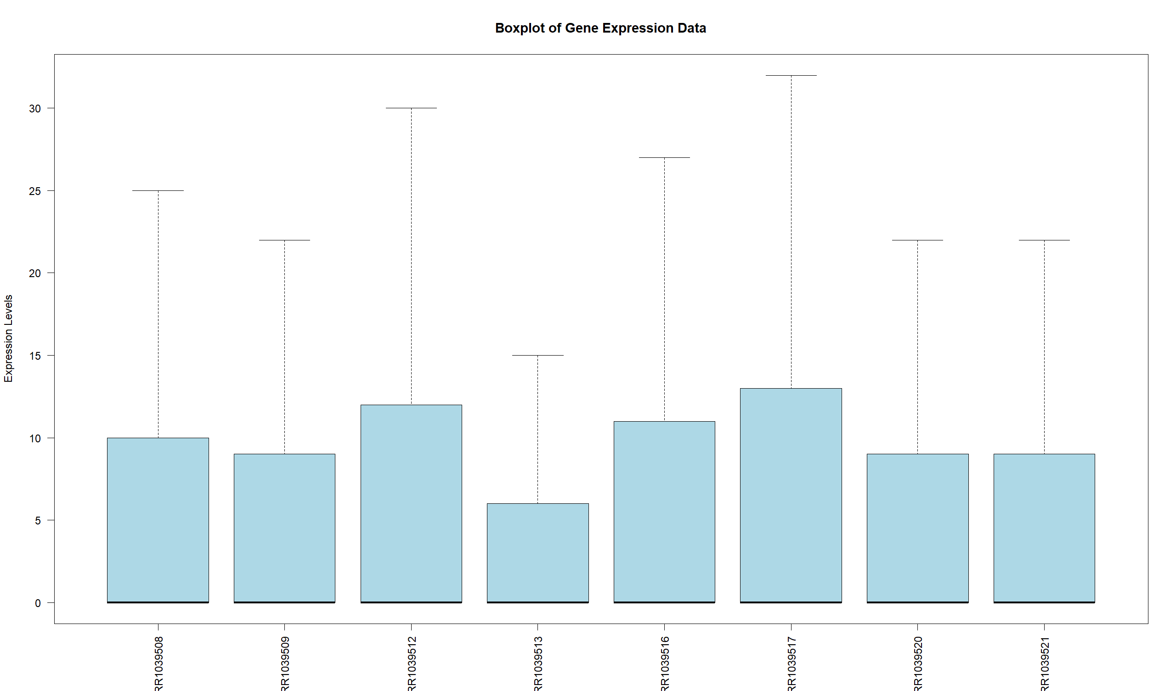
2 Heatmap:
- Generate a heatmap for the top 10 differentially expressed genes based on Ensembl ID and gene symbol. Interpret any observed patterns.
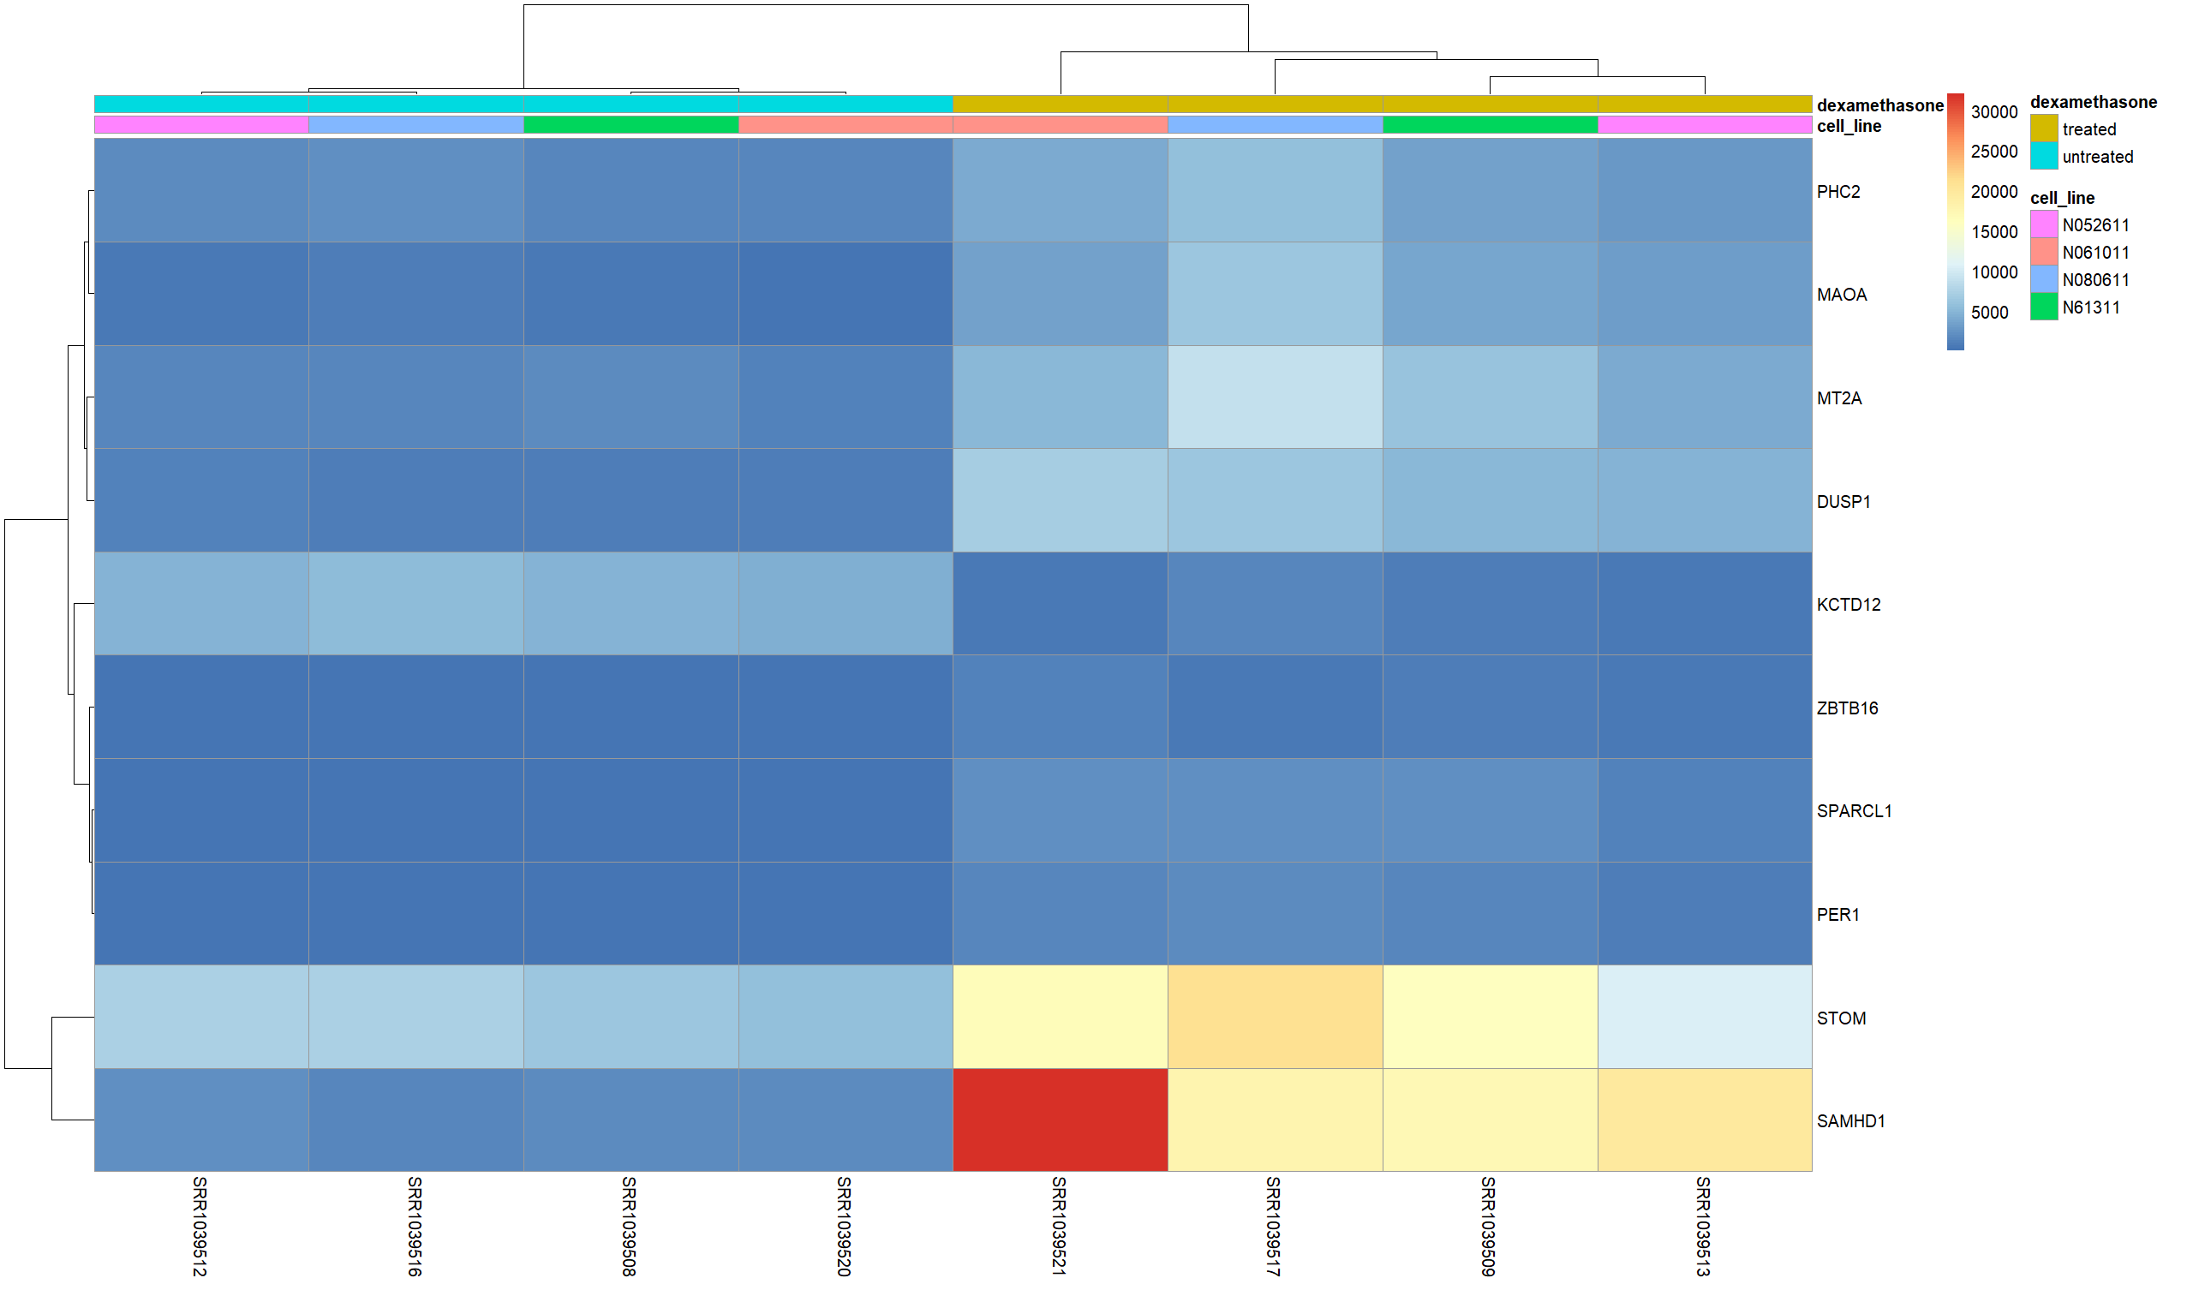
3 Scatter Plot:
- Create a scatter plot comparing the expression of two arbitrarily chosen genes. What insights can you derive from this visualization?
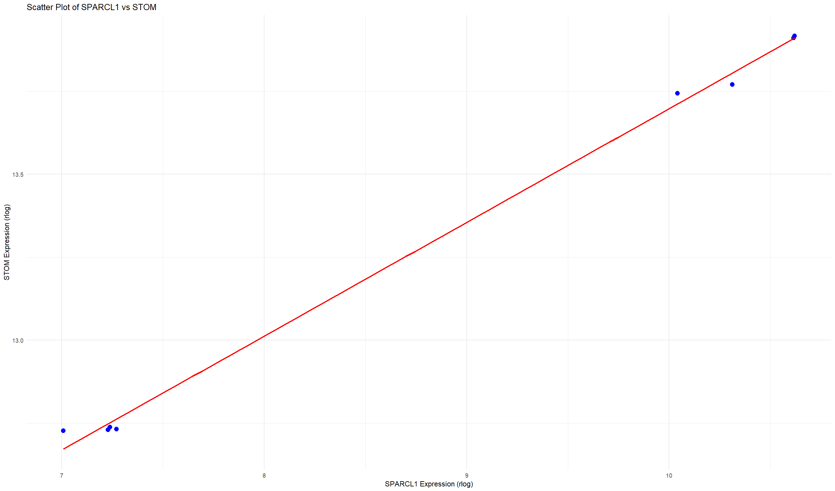
The data represents the expression values of these genes in various biological replicates, and we aim to observe any patterns or correlations between the expression levels of these genes.
Insights:
- Correlation: The scatter plot will allow us to see if there is a positive or negative correlation between the expression of Gene1 and Gene2. If the data points form a straight line, it suggests a strong correlation, whereas a more random pattern indicates little to no correlation.
- Expression Levels: By examining the spread of the data points, we can also get a sense of the relative expression levels of the two genes. If all points are clustered in a specific region, it might indicate that both genes are similarly expressed across the samples.
- Biological Significance: If a strong correlation is found between the two genes, it may suggest that Gene1 and Gene2 are co-regulated or participate in similar biological processes. A lack of correlation may suggest that the expression of these genes is independent or that they function in different pathways.
In the code we chose these two genes :

positive Correlation: The data points suggest a general positive correlation between the expression levels of SPARCL1 and STOM. As the expression of SPARCL1 increases, the expression of STOM also tends to increase, though the relationship is not perfectly linear.

Expression Range: Both genes exhibit a relatively narrow range of expression values, with SPARCL1 ranging between approximately 7.0 and 10.6, and STOM ranging between 12.7 and 13.9. This suggests that these genes may be consistently expressed at similar levels across the samples.

Co-Regulation Hypothesis: The apparent correlation between the expression levels of these two genes could indicate potential co-regulation or involvement in related biological processes. Further investigation would be required to confirm if there is a functional relationship between SPARCL1 and STOM.
4 Correlation Analysis:
- Perform a hypothesis test to examine the correlation between the two genes in the scatter plot. Report the p-value and discuss its implications.
The correlation analysis between SPARCL1 (Gene 1) and STOM (Gene 2) was performed using Pearson's correlation test. The results are as follows:
- Pearson Correlation Coefficient: 0.9987
This value indicates an extremely strong positive correlation between the expression levels of SPARCL1 and STOM across the samples. A correlation coefficient close to 1 suggests that as one gene's expression increases, the other gene's expression also increases proportionally.
- P-value: 6.12e-09
The very small p-value suggests that the correlation is statistically significant. Typically, a p-value below 0.05 would indicate that the correlation is unlikely to have occurred by random chance. In this case, the p-value is far smaller than 0.05, meaning we can confidently reject the null hypothesis of no correlation between these two genes.
Implications:
The results suggest a highly significant and strong positive relationship between SPARCL1 and STOM. This finding may imply co-regulation or a functional relationship between these two genes, potentially involving similar biological pathways or processes. Further experimental validation or additional bioinformatics analyses would be necessary to understand the underlying biological significance of this correlation.

Questions for Completion and Critical Thinking:
1. Beyond statistical significance, how can you validate the biological relevance of the top differentially expressed genes?
While statistical significance provides an initial indication of gene expression differences, validating the biological relevance of these differentially expressed genes (DEGs) is critical for understanding their roles in specific biological contexts. Several strategies can be employed to validate their biological relevance:
- Functional Annotation and Pathway Analysis: Tools like KEGG, Reactome, and Gene Ontology (GO) can be used to map DEGs to known biological pathways. For instance, if DEGs are enriched in pathways related to immune response, neurotransmitter signaling, or metabolic processes, it indicates their involvement in relevant biological functions. In this context, pathway enrichment for genes like MAOA in neurotransmitter regulation or DUSP1 in immune signaling adds biological context beyond p-values.
- Experimental Validation: Techniques like quantitative PCR (qPCR), Western blotting, or immunohistochemistry can validate the differential expression of genes at the mRNA or protein level. For instance, checking whether SPARCL1 and STOM show consistent expression patterns in other biological replicates or conditions strengthens their biological significance.
- Gene Knockdown/Overexpression Studies: Functional studies using CRISPR-Cas9 or RNA interference (RNAi) can knock down or overexpress the genes of interest. If altering the expression of a top DEG like ZBTB16 impacts airway inflammation or stress response pathways, it would support its biological role in these processes.
- Integration with Other Omics Data: Combining transcriptomics data with proteomics, epigenomics, or metabolomics data can provide a more comprehensive understanding of the biological impact of DEGs. For example, seeing that MAOA not only changes at the transcript level but also affects metabolite levels in amino acid pathways strengthens the argument for its biological relevance.
- Literature and Database Validation: Exploring whether DEGs have been previously reported in similar contexts can help validate their relevance. For example, if DUSP1 has been implicated in studies on inflammation or dexamethasone response, it adds credibility to its role in your dataset.
2. Consider potential confounding factors in the analysis. How might these factors influence the results and interpretations?
Confounding factors can significantly influence gene expression analysis, potentially leading to misleading conclusions. Identifying and controlling for these factors is critical for the accuracy of the analysis. Key confounding factors include:
- Sample Heterogeneity: Biological samples can vary significantly between individuals or even within different regions of a tissue. For instance, airway samples from different patients could differ in inflammation levels or cellular composition, which may affect gene expression patterns. If this heterogeneity is not accounted for, the observed differences in gene expression might not be directly related to the experimental condition but rather due to inherent sample variability.
- Batch Effects: Differences in experimental conditions such as reagent batches, sequencing platforms, or processing times can introduce non-biological variation in the data. For example, if samples processed on different days show varying expression of SPARCL1 or STOM, it could skew the interpretation of results. Techniques such as ComBat or inclusion of batch effects in the model can help mitigate this.
- Environmental Factors: External factors such as temperature, circadian rhythms, or even patient lifestyles (e.g., smoking, diet) can influence gene expression. Genes like PER1 involved in circadian regulation could be affected by such external factors, making it crucial to control for these conditions or at least recognize their potential influence.
- Technical Noise: RNA-sequencing has inherent technical variability, especially when analyzing lowly expressed genes. Variations in sequencing depth or RNA quality can lead to unreliable gene expression estimates. Careful quality control, normalization, and use of robust statistical methods can reduce this noise.
- Biological Covariates: Factors such as age, sex, or pre-existing conditions (e.g., diabetes, asthma) can influence gene expression. For example, genes involved in immune response, like DUSP1, may behave differently in older individuals or those with chronic inflammatory conditions. Adjusting for these covariates in the statistical model can help reduce their impact.
- Cell Type Composition: In tissues like the airway, differential cell composition (e.g., immune cells, epithelial cells) can dramatically affect gene expression results. If certain cell types overexpress SPARCL1 or STOM, changes in their proportion between samples may confound interpretations. Single-cell RNA sequencing or deconvolution methods can help account for this.
- Drug Treatments and Clinical Variables: If patients have received treatments (e.g., corticosteroids like dexamethasone), it may influence the expression of certain genes. For example, DUSP1 is known to be responsive to dexamethasone, and its expression could vary depending on the treatment dose or duration. Including such clinical variables in the analysis can prevent incorrect associations.

Best regards,
Fereshteh Fallah
Laboratory of Complex Biological Systems and Bioinformatics (CBB)
Department of Bioinformatics
Institute of Biochemistry and Biophysics (IBB)
University of Tehran, Tehran, Iran

