Cadmium Biosensor Conditions Screening
  - 13 October 2026

Aim of the Experiment
The objective of this experiment was to test conditions for the cadmium biosensor (piGEM004?) in S. cerevisiae. Different concentrations of calcium and cadmium were added to the buffer, and changes in fluorescence were recorded. The cells were expected to show increased fluorescence after sensing Cd²⁺, which causes an influx of Ca²⁺ into the cell. The calcium then binds to the reporter, causing its fluorescence to increase.
Relevant literature:
cadmium response - https://febs.onlinelibrary.wiley.com/doi/10.1016/j.febslet.2014.07.001
GCaMP - Fast and sensitive GCaMP calcium indicators for imaging neural populations
GCaMP in Candida albicans - https://journals.asm.org/doi/10.1128/mbio.01157-23?url_ver=Z39.88-2003&rfr_id=ori:rid:crossref.org&rfr_dat=cr_pub%20%200pubmed

Sample Preparation
Ruiqi brought the cells from INM and measured the OD immediately before transporting them.
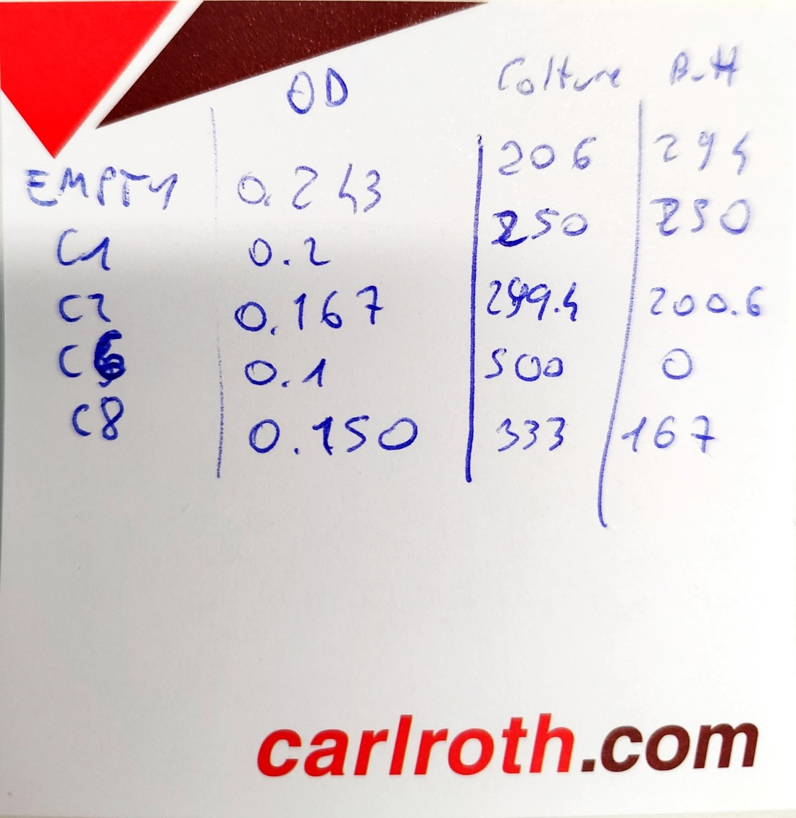

All cultures were diluted to the same OD (see the beautiful image above for the volume of buffer added to achieve OD normalization). (we can change this image into a table of course XD)
Ruiqi has the original data on OD.

500 uL of cells were centrifuged for 2 min at 4000 rpm to remove the media and were resuspended in the same volume of 60 mM PIPES buffer (pH 6.5). This was repeated three times.

100 uL of cells in buffer were added to the wells.

Experimental Setup
96-well black flat-bottom plate (Greiner?).
Stock solutions of CaCl₂ and CdCl₂ were prepared at concentrations of 100 mM and 1 mM.
Images were acquired using the Nikon Axiovert confocal microscope.

Conditions Tested and File Names

Filename | Sample | Ca²⁺ (mM) | Cd²⁺ (mM) | Time | Well/Field | Notes
C1_0mM-calcium_0mM_cadmium_B5_1.nd2 | C1 | 0 | 0 | t0 | B5 | Baseline control
C1_0mM-calcium_0mM-cadmium_B6_t0min_1001.nd2 | C1 | 0 | 0 | t0 | B6 | Baseline control
C1_1mM-calcium_0mM_cadmium_B5_t0_1001.nd2 | C1 | 1 | 0 | t0 | B5 | Calcium only
C1_1mM-calcium_0mM_cadmium_B5_t0_1.nd2 | C1 | 1 | 0 | t0 | B5 | Calcium only (replicate acquisition)
C1_1mM-calcium_0mM_cadmium_B5_t5min_1.nd2 | C1 | 1 | 0 | 5 min | B5 | Calcium only
C1_10mM-calcium_5mM-cadmium_B6_t5min_1001.nd2 | C1 | 10 | 5 | 5 min | B6 | High Ca + high Cd
C2_0mM-calcium_0mM_cadmium_C5_1.nd2 | C2 | 0 | 0 | t0 | C5 | Baseline control
C2_1mM-calcium_0mM_cadmium_C5_t0_1.nd2 | C2 | 1 | 0 | t0 | C5 | Calcium only
C2_1mM-calcium_0uM-cadmium_B6_t0min_1.nd2 | C2 | 1 | 0 | t0 | B6 | Calcium only
C2_10mM-calcium_500uM-cadmium_B5_t5min_1.nd2 | C2 | 10 | 0.5 | 5 min | B5 | High Ca + low Cd
C2_1mM-calcium_5mM-cadmium_B6_t5min_2.nd2 | C2 | 1 | 5 | 5 min | B6 | Low Ca + high Cd
C2_10mM-calcium_5mM-cadmium_B7_t5min_1001.nd2 | C2 | 10 | 5 | 5 min | B7 | High Ca + high Cd
C6_0mM-calcium_0mM_cadmium_D5_1.nd2 | C6 | 0 | 0 | t0 | D5 | Baseline control
C6_10mM-calcium_500uM-cadmium_D7_t5min_1001.nd2 | C6 | 10 | 0.5 | 5 min | D7 | High Ca + low Cd
C6_10mM-calcium_5mM-cadmium_D6_t5min_1001.nd2 | C6 | 10 | 5 | 5 min | D6 | High Ca + high Cd
C8_0mM-calcium_0mM_cadmium_E5_1.nd2 | C8 | 0 | 0 | t0 | E5 | Baseline control
C8_10mM-calcium_5mM-cadmium_E6_t5min_1001.nd2 | C8 | 10 | 5 | 5 min | E6 | High Ca + high Cd
Empty_0mM-calcium_0mM_cadmium_A5_1.nd2 | Empty | 0 | 0 | t0 | A5 | Negative control
Empty_0mM-calcium_0mM-cadmium_A6_t0min_1001.nd2 | Empty | 0 | 0 | t0 | A6 | Negative control
Empty_10mM-calcium_5mM-cadmium_A6_t5min_1001.nd2 | Empty | 10 | 5 | 5 min | A6 | Negative control with ions

Observations
A substantial number of colonies exhibited increased fluorescence. Quantification need to be done, but I am unfamiliar with that and Naresh will help out soon.

Response at 5 mM Cd²⁺
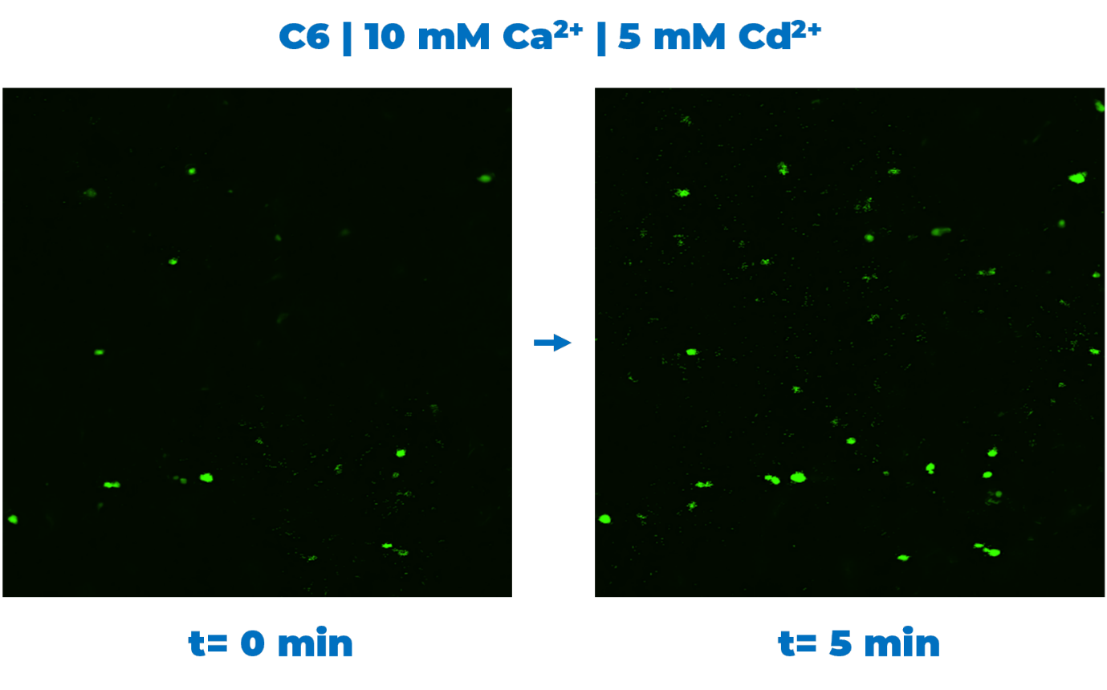This condition produced the strongest response, and multiple examples of sensor activation were observed. The Cd²⁺ concentration of 5 mM is high, but gave clear responses in around 2 minutes after addition to the well.

Response at 500 µM Cd²⁺
The 500 µM Cd²⁺ concentration was less effective. however, I was able to capture some cells flaring up in response to cadmium.
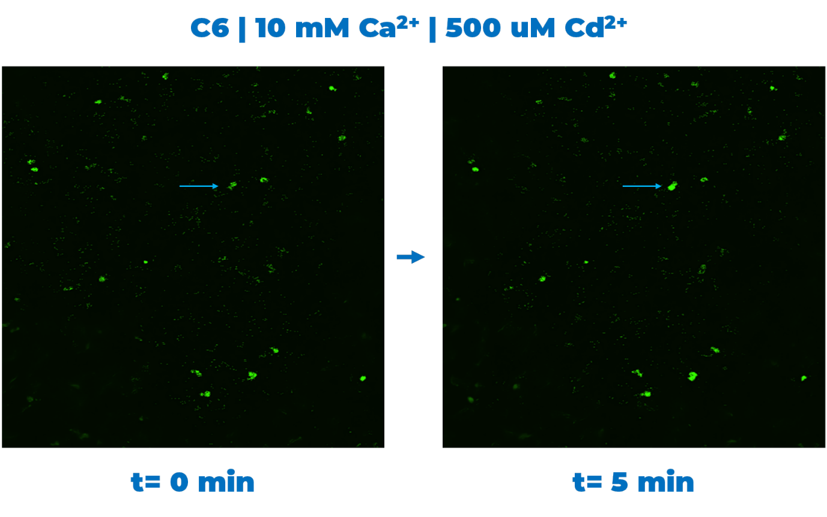

In the case shown, the fluorescence increase was not due to cells changing position and entering the focal plane (this is true for the other images above as well).

Effect of Calcium Concentration
Increased fluorescence was observed at both 1 mM and 10 mM Ca²⁺ concentrations, but did not seem to correlate with the amount of calcium added:

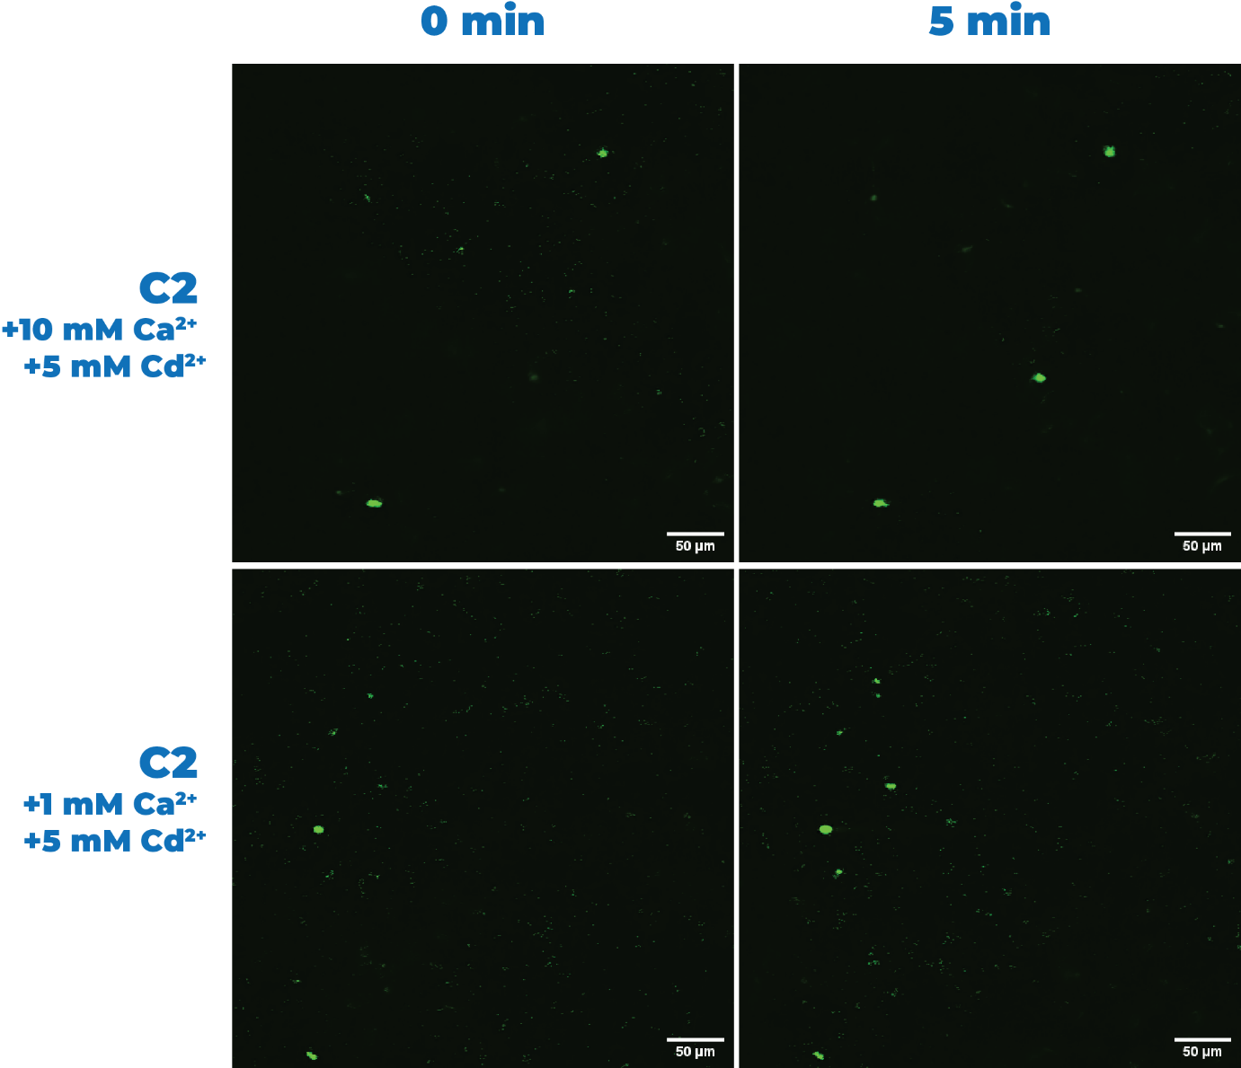

Empty-Vector Control
The empty vector control showed no detectable change in fluorescence over the course of the timelapse experiment. Faint autofluorescence was barely visible.

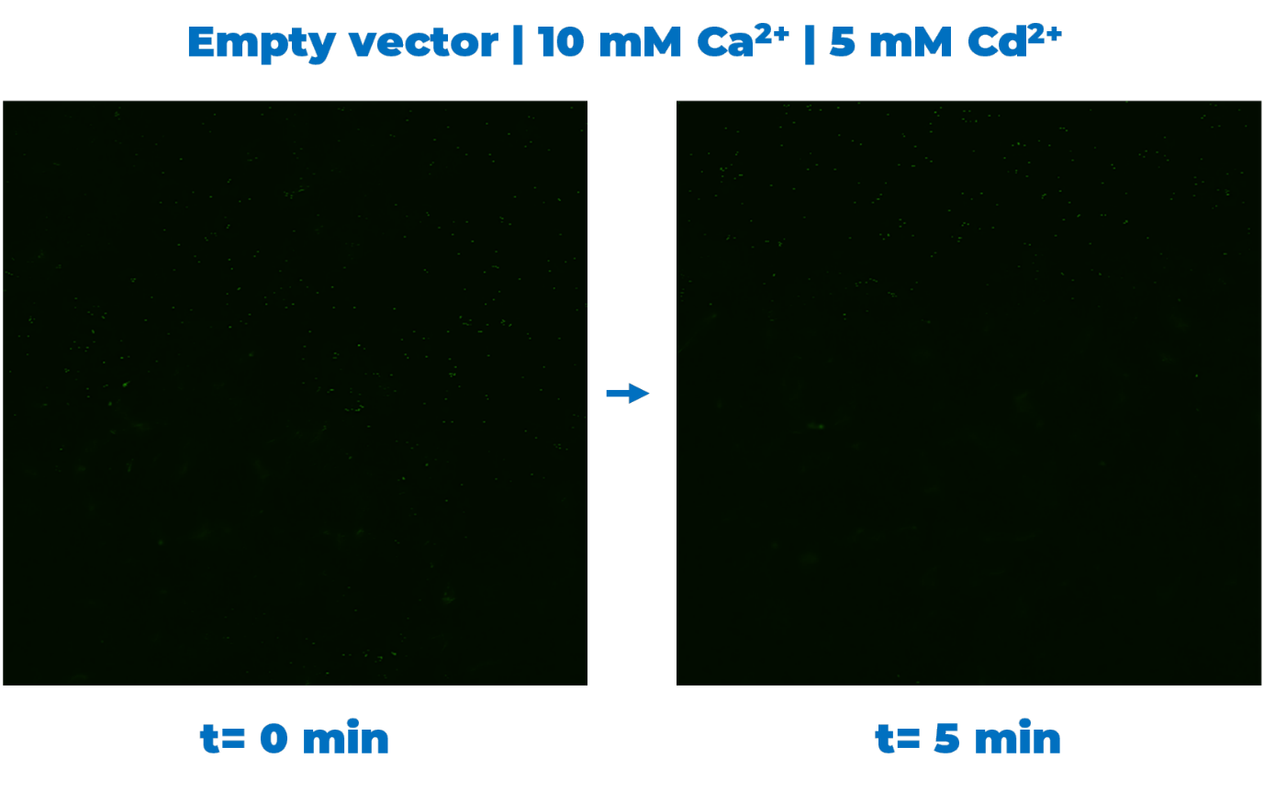

(The small green dots visible in the image are imaging noise.)

Fluorescence Quantification
Needs to be done! @Nareshyboy #mastrmicroscopist

Preliminary Conclusions
Cells carrying the cadmium biosensor exhibited increased fluorescence following exposure to Cd²⁺, with the strongest responses observed at 5 mM Cd²⁺. Fluorescence activation was observed at both 1 mM and 10 mM Ca²⁺ concentrations. In contrast, the empty-vector control showed no detectable increase in fluorescence over time. These observations suggested that the biosensor responded to cadmium exposure under multiple calcium concentrations and that 5 mM Cd²⁺ produced the most pronounced response among the conditions tested.

