- - According to the FastQC result the data requested are :
- Total reads Count : 942900
- Total poor sequences : 0
- %GC content : 46%
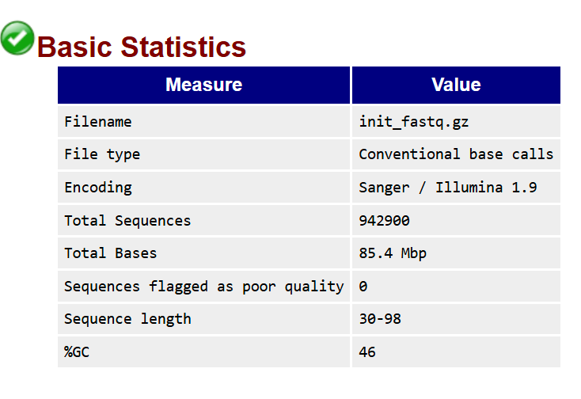
- – metaphylan for number and count of genus
n | Genus name | Genus NCBI Taxonomi id | Relative Abundance
1 | g__Blautia | 572511 | 35.90309
2 | g__Bifidobacterium | 1678 | 19.57633
3 | g__Mediterraneibacter | 2316020 | 5.13339
4 | g__Eisenbergiella | 1432051 | 4.88505
5 | g__Anaerostipes | 207244 | 4.53167
6 | g__Monoglobus | 2039302 | 3.95875
7 | g__Faecalibacillus | 2678885 | 3.30863
8 | g__Agathobaculum | 2048137 | 3.30063
9 | g__Akkermansia | 239934 | 3.16068
10 | g__Adlercreutzia | 447020 | 2.62956
11 | g__GGB3637 |  | 2.15673
12 | g__Faecalibacterium | 216851 | 1.99793
13 | g__Faecalimonas | 2005355 | 1.92734
14 | g__Evtepia | 2211178 | 0.98645
15 | g__Enterococcus | 1350 | 0.77524
16 | g__GGB3511 |  | 0.69193
17 | g__Tyzzerella | 1506577 | 0.6246
18 | g__Sellimonas | 1769710 | 0.52792
19 | g__GGB3677 |  | 0.48435
20 | g__Lactonifactor | 420345 | 0.37393
21 | g__Anaeromassilibacillus | 1924093 | 0.36089
22 | g__Lachnoclostridium | 1506553 | 0.34119
23 | g__GGB9739 |  | 0.32393
24 | g__Parabacteroides | 375288 | 0.32201
25 | g__Longicatena | 1918536 | 0.3098
26 | g__Eggerthella | 84111 | 0.28182
27 | g__Ruthenibacterium | 1905344 | 0.15215
28 | g__Flavonifractor | 946234 | 0.14285
29 | g__Rikenella | 28138 | 0.1381
30 | g__Gordonibacter | 644652 | 0.13165
31 | g__Ruminococcus | 1263 | 0.13151
32 | g__Alistipes | 239759 | 0.11607
33 | g__GGB3534 |  | 0.08315
34 | g__GGB3363 |  | 0.07881
35 | g__Clostridium | 1485 | 0.06975
36 | g__GGB9719 |  | 0.0338
37 | g__Clostridia_unclassified |  | 0.03249
38 | g__GGB3576 |  | 0.00825
39 | g__Roseburia | 841 | 0.00757

3- Megahit and count of contigs
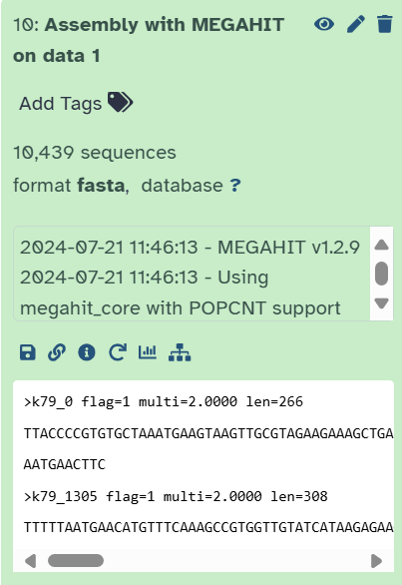

The count of contigs are equal to “10,439” records or sequences.

4-
Considering the last gene find index from the MetaGeneMark generated flle on Megahit Result , count of 14040 genes were found :
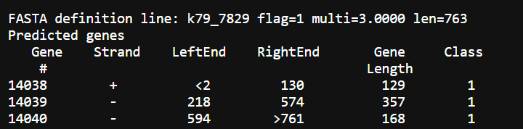

5- microorganisms associated with genes number 1-5
For gene number 1:
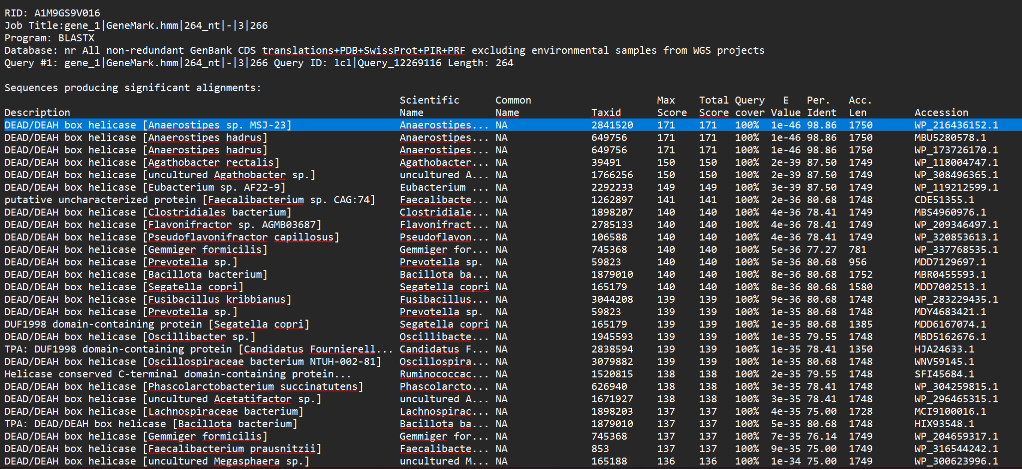
Top hit title = DEAD/DEAH box helicase [Anaerostipes sp. MSJ-23]
E-value = 1e-46
Organism = Anaerostipes sp. MSJ-23
Tax id = 2841520
Query cover = 100%
For gene number 2:
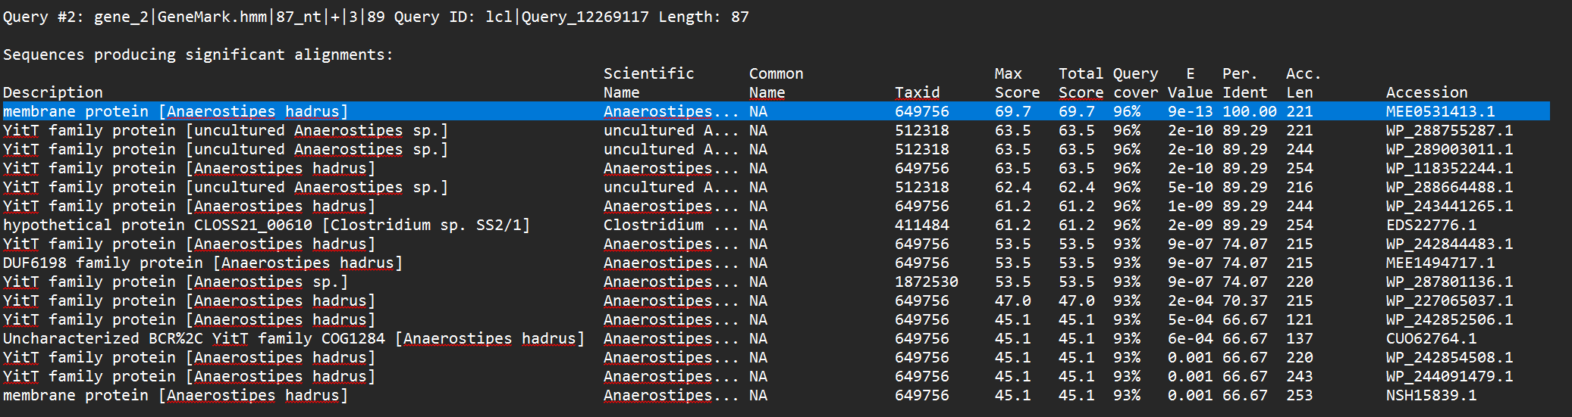
Top hit title = membrane protein [Anaerostipes hadrus]
E-value = 9e-13
Organism = Anaerostipes hadrus
Tax id = 649756
Query cover = 96%
For gene number 3:
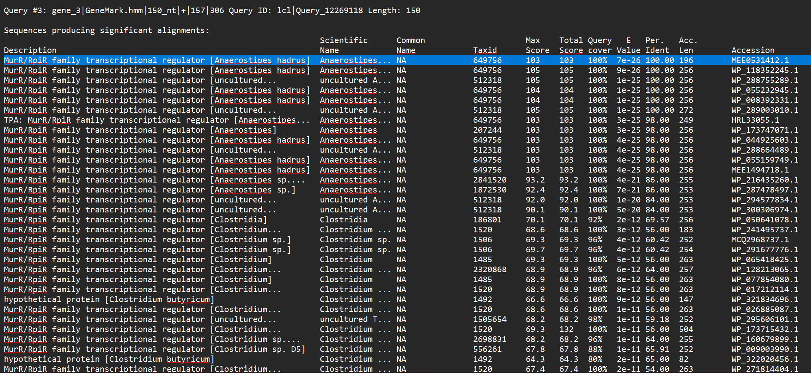
Top hit title = MurR/RpiR family transcriptional regulator [Anaerostipes hadrus]
E-value = 7e-26
Organism = Anaerostipes hadrus
Tax id = 649756
Query cover = 100%
For gene number 4:
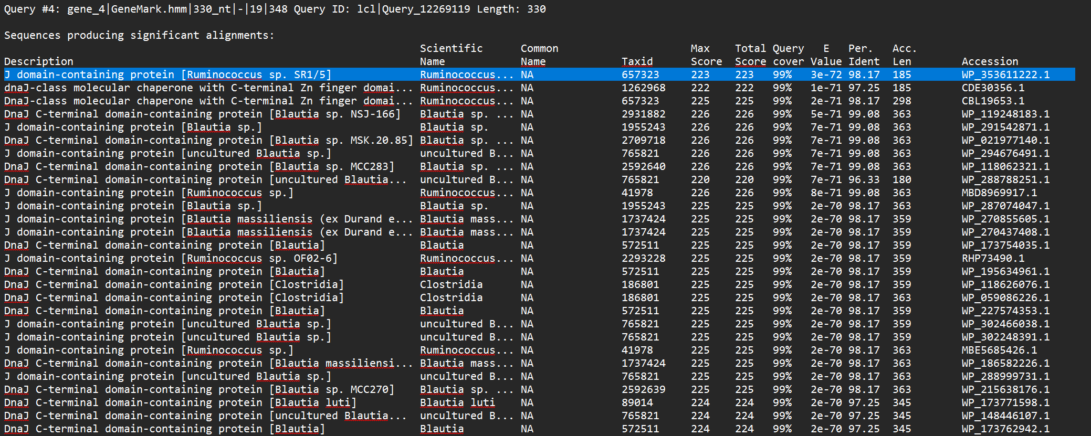
Top hit title = J domain-containing protein [Ruminococcus sp. SR1/5]
E-value = 3e-72
Organism = Ruminococcus sp. SR1/5
Tax id = 657323
Query cover = 99%
For gene number 5:
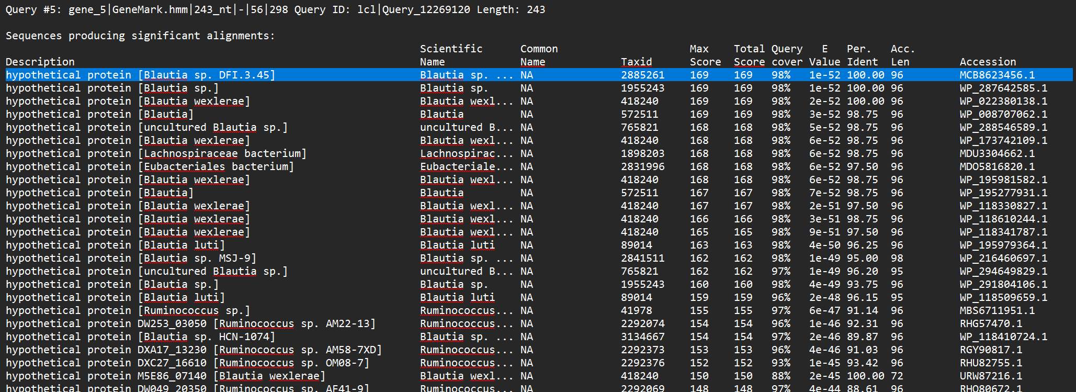
Top hit title = hypothetical protein [Blautia sp. DFI.3.45]
E-value = 1e-52
Organism = Blautia sp. DFI.3.45
Tax id = 2885261
Query cover = 98%

