Resume
Prasanna Ramireddy  ✉:ramireddyprasanna45@gmail.com  ✆:7780730913 | 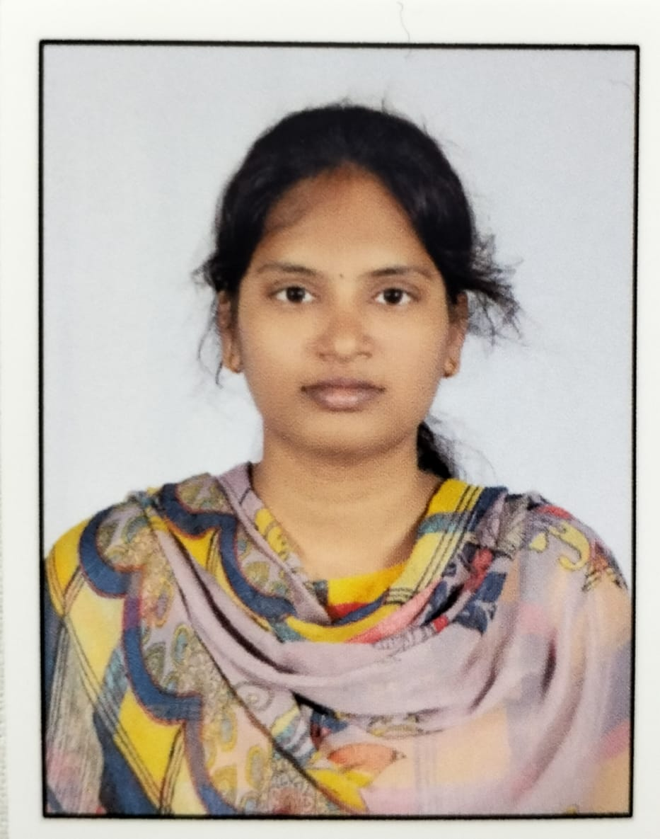

Career Objective:

To achieve a challenging satisfying position in any of the company to utilize and enhance my knowledge, skills and innovative thoughts efficiently that leads to develop myself and organization.
.

Educational qualifications:

GRADUATION 2021-2025

- University: Annamacharya University
- Institute: Annamacharya Institute of Technology and Sciences, Rajampet
- Course: Computer Science and Engineering
- CGPA: 8.1
INTERMEDIATE 2019-2021

- Board: SSC
- Institute:Vijayawada Nalanda junior college
- Course: MPC
- Marks:780
SSC 2018-2019

- Institute: Zilla Parishath High School(Z.P.H.S.),Akumalla
- CGPA: 9.2

Technical Skills:

- Programming Languages: Basics of C, Data Structures using Python, OOPS through Java, HTML, CSS, PowerPoint

Professional Skills:

- Good Communication skills
- Adaptability
- Self-motivation with a positive attitude
- Self-confidence and hard working
- Good interpersonal skills and team work

Achievements:
- ELITE NPTEL certificate in Industrial 4.0 and Data analytics with python.
- Participation certificate in applications of Artificial Intelligence Workshop.
- Participation certificate in Workshop on IOT.

Hobbies:

- Listening music
- Playing games

Interests:

- Kabaddi, Cricket,Ball Batmentton

Personal Details:

Name : Prasanna Ramireddy
Father Name : Chinna Obulreddy Ramireddy
Mother Name : Papulamma Ramireddy
Date of Birth : 10/06/2004
Gender : Female
Nationality : Indian
Languages Known : English, Hindi and Telugu.

Declaration:

I here by declare that the information furnished above is true to the best of my knowledge.

Signature
(Prasanna Ramireddy)

