**CODING CHALLENGE**

**Name:** Ramireddy Preethi

**Coding Challenge:** Virtual Art Gallery

create database virtual_art_gallery

use virtual_art_gallery

-- Create the Artists table

CREATE TABLE Artists (

ArtistID INT PRIMARY KEY,

Name VARCHAR(255) NOT NULL,

Biography TEXT,

Nationality VARCHAR(100));

-- Create the Categories table

CREATE TABLE Categories (

CategoryID INT PRIMARY KEY,

Name VARCHAR(100) NOT NULL);

-- Create the Artworks table

CREATE TABLE Artworks (

ArtworkID INT PRIMARY KEY,

Title VARCHAR(255) NOT NULL,

ArtistID INT,

CategoryID INT,

Year INT,

Description TEXT,

ImageURL VARCHAR(255),

FOREIGN KEY (ArtistID) REFERENCES Artists (ArtistID),

FOREIGN KEY (CategoryID) REFERENCES Categories (CategoryID));

-- Create the Exhibitions table

CREATE TABLE Exhibitions (

ExhibitionID INT PRIMARY KEY,

Title VARCHAR(255) NOT NULL,

StartDate DATE,

EndDate DATE,

Description TEXT);

-- Create a table to associate artworks with exhibitions

CREATE TABLE ExhibitionArtworks (

ExhibitionID INT,

ArtworkID INT,

PRIMARY KEY (ExhibitionID, ArtworkID),

FOREIGN KEY (ExhibitionID) REFERENCES Exhibitions (ExhibitionID),

FOREIGN KEY (ArtworkID) REFERENCES Artworks (ArtworkID));

-- Insert sample data into the Artists table

INSERT INTO Artists (ArtistID, Name, Biography, Nationality) VALUES

(1, 'Pablo Picasso', 'Renowned Spanish painter and sculptor.', 'Spanish'),

(2, 'Vincent van Gogh', 'Dutch post-impressionist painter.', 'Dutch'),

(3, 'Leonardo da Vinci', 'Italian polymath of the Renaissance.', 'Italian');

-- Insert sample data into the Categories table

INSERT INTO Categories (CategoryID, Name) VALUES

(1, 'Painting'),

(2, 'Sculpture'),

(3, 'Photography');

-- Insert sample data into the Artworks table

INSERT INTO Artworks (ArtworkID, Title, ArtistID, CategoryID, Year, Description, ImageURL) VALUES

(1, 'Starry Night', 2, 1, 1889, 'A famous painting by Vincent van Gogh.', 'starry_night.jpg'),

(2, 'Mona Lisa', 3, 1, 1503, 'The iconic portrait by Leonardo da Vinci.', 'mona_lisa.jpg'),

(3, 'Guernica', 1, 1, 1937, 'Pablo Picassos powerful anti-war mural.', 'guernica.jpg');

-- Insert sample data into the Exhibitions table

INSERT INTO Exhibitions (ExhibitionID, Title, StartDate, EndDate, Description) VALUES

(1, 'Modern Art Masterpieces', '2023-01-01', '2023-03-01', 'A collection of modern art masterpieces.'),

(2, 'Renaissance Art', '2023-04-01', '2023-06-01', 'A showcase of Renaissance art treasures.');

-- Insert artworks into exhibitions

INSERT INTO ExhibitionArtworks (ExhibitionID, ArtworkID) VALUES

(1, 1),

(1, 2),

(1, 3),

(2, 2);

-- QUERIES

/* 1. Retrieve the names of all artists along with the number of artworks they have in the gallery, and list them in descending order of the number of artworks. */

select a.Name,count(aw.artworkID) as Number_of_Artworks from artists a

inner join artworks aw on a.artistid=aw.artistid

group by a.name order by Number_of_Artworks DESC

Output:

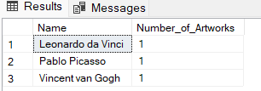

/* 2. List the titles of artworks created by artists from 'Spanish' and 'Dutch' nationalities, and order them by the year in ascending order.*/

select aw.Title from Artworks aw

inner join Artists a on aw.ArtistID=a.ArtistID

where a.Nationality in ('Spanish','Dutch')

order by aw.year ASC

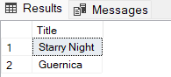Output:

/* 3. Find the names of all artists who have artworks in the 'Painting' category, and the number of artworks they have in this category. */

Select a.Name , count(aw.ArtworkId) as Num_of_Artworks from Artists a

inner join Artworks aw on a.ArtistID= aw.ArtistID

inner join Categories c on aw.CategoryID=c.CategoryID

where c.name='Painting'

Group by a.Name

Output:

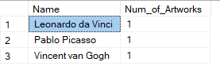

/* 4. List the names of artworks from the 'Modern Art Masterpieces' exhibition, along with their artists and categories. */

select aw.Title as ArtworkTitle,a.Name as ArtistName,c.Name as CategoryName from Artworks aw

inner join ExhibitionArtworks ea on aw.ArtworkID = ea.ArtworkID

inner join Exhibitions e on ea.ExhibitionID = e.ExhibitionID

inner join Artists a on aw.ArtistID = a.ArtistID

inner join Categories c on aw.CategoryID = c.CategoryID

where e.Title = 'Modern Art Masterpieces'

Output:

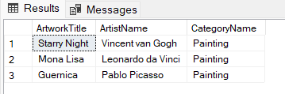

/* 5. Find the artists who have more than two artworks in the gallery.*/

select a.Name , count(aw.ArtworkID) as ArtworkCount

from Artists a

join Artworks aw on a.ArtistID=aw.ArtistID

group by a.Name

Having count(aw.ArtworkID) >2

Output:



/* 6. Find the titles of artworks that were exhibited in both 'Modern Art Masterpieces' and 'Renaissance Art' exhibitions*/

select a.Title from Artworks a

join ExhibitionArtworks ea on a.ArtworkID = ea.ArtworkID

join Exhibitions e on ea.ExhibitionID = e.ExhibitionID

where e.Title = 'Modern Art Masterpieces'

and a.ArtworkID in (

select ea2.ArtworkID from ExhibitionArtworks ea2

join Exhibitions e2 on ea2.ExhibitionID = e2.ExhibitionID

where e2.Title = 'Renaissance Art'

)

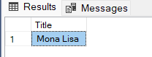Output:

/* 7. Find the total number of artworks in each category */

select c.Name AS CategoryName,count(aw.ArtworkID) AS TotalArtworks from Categories c

left join Artworks aw on c.CategoryID = aw.CategoryID

group by c.Name

Output:

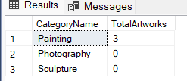

/* 8. List artists who have more than 3 artworks in the gallery.*/

Select a.Name FROM Artists a

JOIN Artworks Aw ON A.ArtistID = Aw.ArtistID

GROUP BY A.Name

HAVING COUNT(Aw.ArtworkID) >3;

Output:

/* 9. Find the artworks created by artists from a specific nationality (e.g., Spanish).*/

Select aw.title as Artwork_title, a.Name, aw.year from artworks aw

join artists a ON aw.ArtistID = a.ArtistID

WHERE a.nationality = 'Spanish';

Output:

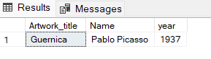

/* 10. List exhibitions that feature artwork by both Vincent van Gogh and Leonardo da Vinci.*/

select e.Title from Exhibitions e

JOIN ExhibitionArtworks ea1 ON e.ExhibitionID = ea1.ExhibitionID

JOIN Artworks aw1 ON ea1.ArtworkID = aw1.ArtworkID

JOIN Artists a1 ON aw1.ArtistID = a1.ArtistID

JOIN ExhibitionArtworks ea2 ON e.ExhibitionID = ea2.ExhibitionID

JOIN Artworks aw2 ON ea2.ArtworkID = aw2.ArtworkID

JOIN Artists a2 ON aw2.ArtistID = a2.ArtistID

WHERE a1.Name = 'Vincent van Gogh' AND a2.Name = 'Leonardo da Vinci';

Output:

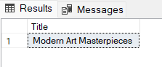

/* 11. Find all the artworks that have not been included in any exhibition.*/

select aw.title, a.Name From Artworks aw

Join Artists a on aw.ArtistID=a.ArtistID

Left join ExhibitionArtworks ea on aw.ArtworkID=ea.ArtworkID

where ea.ExhibitionID IS null;

Output:



/* 12. List artists who have created artworks in all available categories. */

select a.Name from Artists a

join Artworks aw on a.ArtistID = aw.ArtistID

GROUP BY a.Name

having COUNT(DISTINCT aw.CategoryID) = (select COUNT(CategoryID) from Categories)

Output:



/* 13. List the total number of artworks in each category.*/

select C.Name AS CategoryName,COUNT(Art.ArtworkID) AS ArtworkCount FROM Categories C

left join Artworks Art ON C.CategoryID = Art.CategoryID

GROUP By C.Name

Output:

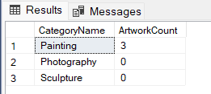

/* 14. Find the artists who have more than 2 artworks in the gallery**/

Select a.Name,count(aw.artworkid) as artworkcount FROM Artists a

JOIN Artworks Aw ON A.ArtistID = Aw.ArtistID

GROUP BY A.Name

HAVING COUNT(Aw.ArtworkID) >2;

Output:

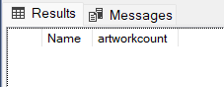

/* 15. List the categories with the average year of artworks they contain, only for categories with more than 1 artwork.*/

Select c.Name, AVG(Aw.Year) AS Average_Year FROM Categories c

JOIN Artworks Aw ON c.CategoryID = Aw.CategoryID

GROUP BY C.Name

HAVING COUNT(Aw.ArtworkID) > 1

Output:

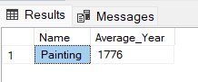

/* 16. Find the artworks that were exhibited in the 'Modern Art Masterpieces' exhibition.*/

select Aw.Title from Artworks Aw

join ExhibitionArtworks ea on Aw.ArtworkID = ea.ArtworkID

join Exhibitions e on ea.ExhibitionID = e.ExhibitionID

WHERE e.Title = 'Modern Art Masterpieces'

Output:

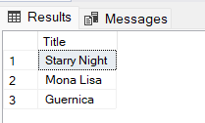

/* 17. Find the categories where the average year of artworks is greater than the average year of all artworks. */

select c.Name as CategoryName from Categories c

join Artworks aw on c.CategoryID = aw.CategoryID

GROUP BY c.CategoryID, c.Name

HAVING AVG(aw.Year) > (select AVG(Year) from Artworks)

Output:



/* 18. List the artworks that were not exhibited in any exhibition. */

select aw.Title as artworks from Artworks aw

LEFT JOIN ExhibitionArtworks ea on aw.ArtworkID = ea.ArtworkID

WHERE ea.ArtworkID IS NULL

Output:



/* 19. Show artists who have artworks in the same category as "Mona Lisa."*/

select distinct a.Name as artists from Artists a

JOIN Artworks aw on a.ArtistID = aw.ArtistID

WHERE aw.CategoryID = (select CategoryID from Artworks WHERE Title = 'Mona Lisa')

Output:

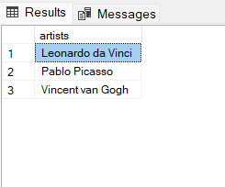

/* 20. List the names of artists and the number of artworks they have in the gallery.*/

select a.Name, COUNT(aw.ArtworkID) as ArtworkCount from Artists a

JOIN Artworks aw on a.ArtistID = aw.ArtistID

GROUP BY a.Name

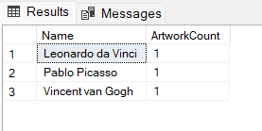Output: