Ramirez, Maria Nicole C. November 11, 2019

BSTM/HRO 191 PROGCON

Activity Four (4)

Flowgorithm is an application where you can create your flowchart easily. Contingent upon the language, this can either be simple or frustratingly troublesome. By utilizing flowcharts, you can focus on programming ideas as opposed to every one of the subtleties of a normal programming language. In addition to that the application called ‘flowgorithm’ is a graphical authoring tool which allows users to write and execute programs using flowcharts. The approach is designed to emphasize the algorithm rather than the syntax of a specific programming language. The flowchart can be converted to several major programming languages. It is a free application and you can easily download it like you won’t hesitate to download it and you will not worry about the virus. Using a flowgorithm app you can easily choose what shape you should use because it will guide you in creating your flowcharts. The application have its shapes called Input, Output, Declare, Assign, If (For decision), Call, While, for and Do.

When it comes to my experience in the activities given to us, to be honest I can’t understand the lesson or the procedure in creating a flowchart using the flowgorithm application but when our professor explained how to use it I had an idea on how to use it and of course I thank my seatmate for helping me when there are things I don’t know what to do. For me, using a flowgorithm is a lot helpful for us students and for me as a person who’s not into technologies and such. I also liked the “Run” method in the application because you will immediately know if you created your flowchart correct. I salute the creator of the application because not only he or she will benefit to it but also the professors and the students. I also thank my Professor in PROGCON because she is the one who introduce Flowgorithm to us.

Following are the activities given to us;

Machine Activity 1 – Adding two numbers

Machine Activity 2- Finding the Area of a circle using the Diameter and or the Radius

Machine Activity 3- Identifying if the number given is Odd or Even

Machine Activity 1 – Adding Two Numbers

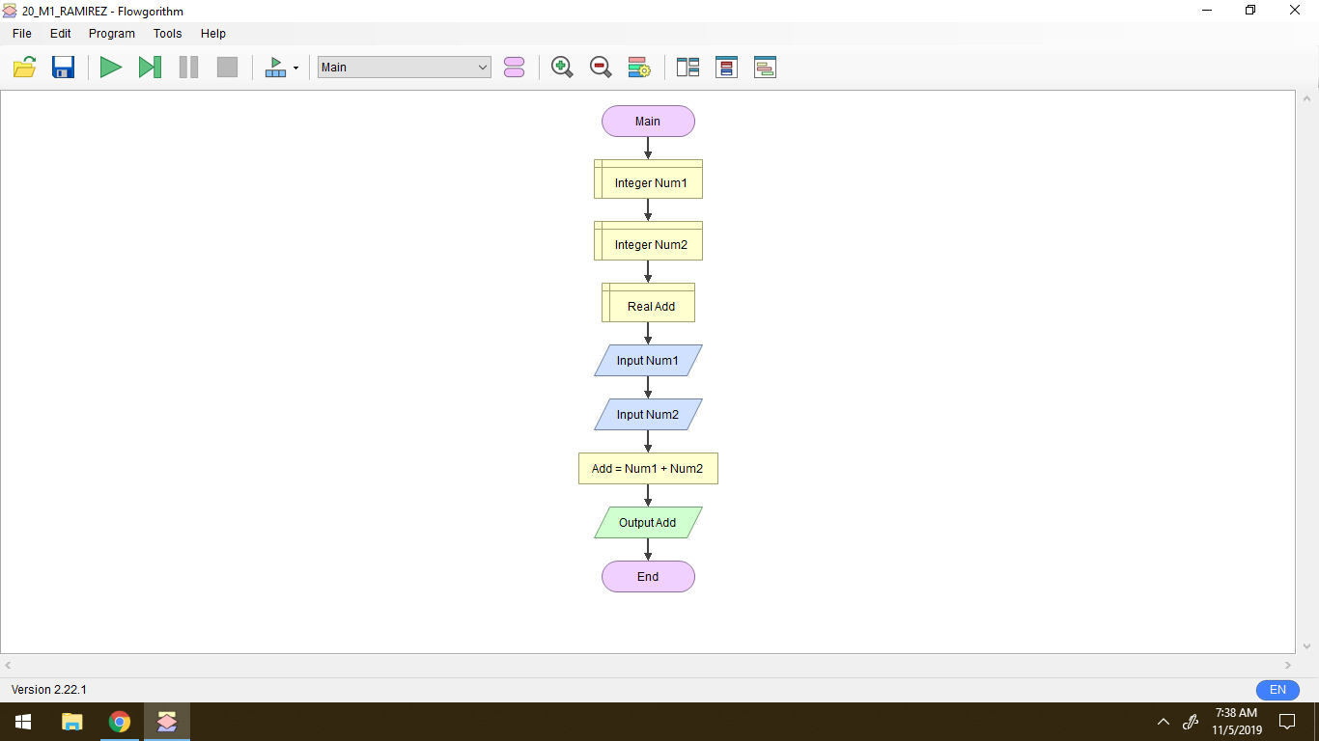

Machine Activity 2 – Finding the Area of a Circle using the Diameter and or the Radius

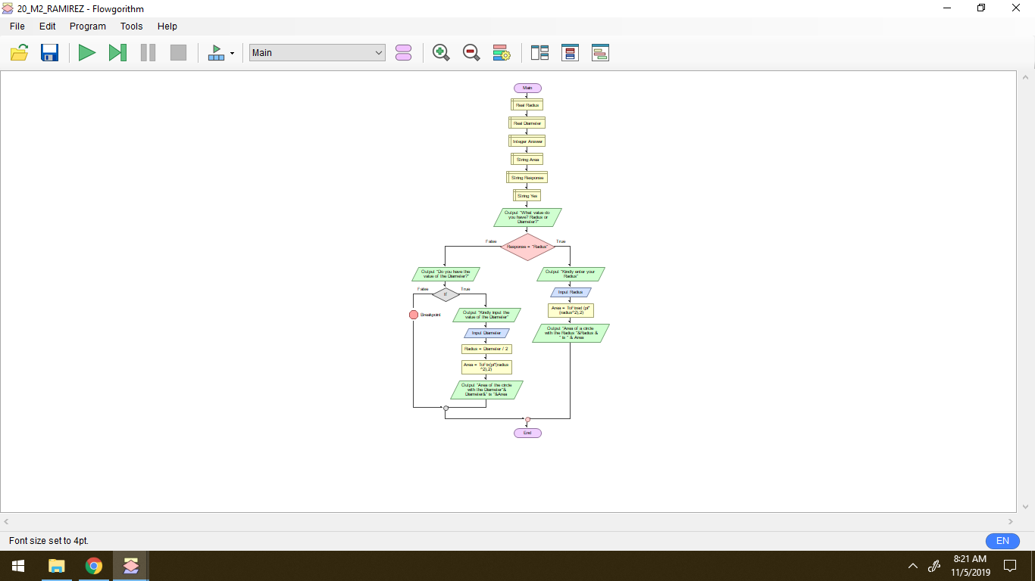

Machine Activity 3 – Identifying the Given Number if it is Odd or Even

